BIOLOGY 211: HUMAN ANATOMY & PHYSIOLOGY
*********************************************************************************************************
USE OF THE LIGHT MICROSCOPE
**********************************************************************************************************
Reference: Saladin, KS: Anatomy & Physiology, The Unity of Form and Function, 8th ed (2018).
Please review Chapter 5 before beginning this lab.

INTRODUCTION:
The microscopes we have in the A&P lab are “bright-field compound” microscopes. That means visible light is passed through a thin section of a specimen and then through two lenses to magnify the image that reaches your eye. While more complex microscopes can be used to observe specific details, this is the simplest and easiest to use. Individual cells or a thin section of a tissue or an organ can be cut and placed on a glass slide, after which stains are added to give color to the specimen. A light source illuminates it from below, and the image is then passed through the first, or objective, lens and then through a second set of lenses (one for each eye) called ocular lenses.

Ocular Lenses
Head
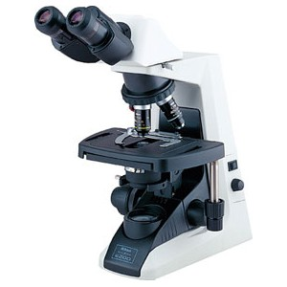
Base
Course and Fine Focus
Condenser with Iris Diaphragm
Stage
Slide Holder
Objective Lenses
Fine Focus
On / Off Switch
Arm
Knobs for
Moving Slides
Light Intensity Control
Substage Light Source

PARTS OF A LIGHT MICROSCOPE:

Obtain a microscope from the cupboard in the back of the lab, carry it to your lab bench, and plug it in. Using the diagram on the previous page, identify the following parts of the microscope:

Objective lenses: Receive the image from the specimen slide and enlarge it. Three or four lenses are
usually located on a revolving nosepiece. Longer lenses are higher power and thus
enlarge the image more.

Ocular lenses: Receive the image from the objective lens, enlarge it, and project it to your eyes.

Head: Top part of the microscope. Contains mirrors which reflect images to the ocular
lenses. Can rotate if set-screw is loosened.

Arm: Vertical piece. Supports the head of the microscope, the stage, the condenser,
and the focusing controls.

Base: Horizontal piece. Supports the microscope.

Stage: Platform which supports the slide. Hole in center allows light from condenser to
pass through. Supports slide holder.

Substage light source: Located above the base. Includes the field diaphragm and adjusting ring used
to control the width of the light beam passing through.

On/Off switch: Turns the light source on and off.

Intensity Control: Changes the intensity (brightness) of light from the light source.

Condenser: Series of lenses which focus light on the specimen slide. Can be moved up and
down by a knob on the side.

Iris diaphragm: Controls width of light beam passing through the condenser to the specimen slide.

Slide holder: Holds the specimen slide in position. Controls movement of the slide.

Knobs for moving slides: Control fine movement of the slide holder, front-to-back and side-to-side.

Course focus control: Moves the stage up and down to bring the image of the specimen into
approximate focus.

Fine focus control: Moves the stage up and down to bring image into final focus.

PREPARING THE MICROSCOPE FOR USE:

1. Examine each of the objective lenses carefully. You will notice that each lens has a number on its side indicating its magnifying power. The lowest power objective lens on a light microscope, also the shortest, usually magnifies 4 or 10 times (written 4x or 10x). The highest power objective lens, also the longest, typically magnifies 40x to 60x.

What are the powers of the three objective lenses on your microscope? ______, ______, ______

2. Turn the microscope on. Be sure the iris diaphragm of the condenser is wide open. Move the condenser as high as it will go, then move it down approximately 5 mm. Swing the lowest power objective lens into position. Look through the ocular lenses and use the light intensity control on the base of the microscope to adjust the light to a comfortable level - a common mistake is to use too bright a setting.

3. Select a prepared, stained slide and place it on the stage, making sure it is placed squarely and securely into the slide holder at its edges. While watching from the side (not through the ocular lenses!), use the slide movement knobs to move the slide until the light coming through the condenser is passing through the specimen. Be sure the lowest power (shortest) objective lens is in place, then use the course focus knobs to move the stage all the way up, watching carefully from the side of the microscope to be sure the slide never hits the lens.

FOCUSING THE IMAGE:

4. While looking through both ocular lenses, use the course focus knobs to carefully move the stage down, away from the lens, until the image comes approximately into focus. Never, ever, under any circumstances should you use the course focus knobs to move the stage up, toward the objective lens – that can damage the lens, and it is expensive to replace. Use the fine focus knobs to bring it into the best focus you can.

5. Identify the ring at the bottom of the substage light source. While observing the tissue through the ocular lenses, use this ring to adjust the light width until the edge is just outside your field of view.

6. While still observing the tissue through the ocular lenses, adjust the iris diaphragm lever on the condenser until the light is just barely wider than your field of view. A common mistake is to use substage light source or iris diaphragm to adjust the brightness instead of the light intensity control – don’t do that since it will distort the quality of the image you see.

7. Since each of your eyes focuses differently, it may be necessary to focus each ocular lens separately. Notice that each ocular lenses can be gently twisted to finely focus the image coming through it. Close the eye over one of the ocular lenses and use the fine focus knobs on the arm of the microscope to bring the image into focus to the open eye. Then close that eye, open the other, and use gently twist the ocular lens to focus the image to that eye. You should not need to focus the ocular lenses again today, but you probably will need to do so each time you use the microscope because other people will focus it for their eyes

CHANGING MAGNIFICATION:

8. After you have brought the image into focus using the lowest power objective lens, you can use higher power lenses to examine the specimen with more magnification. Take your eyes away from the ocular lenses and, while watching carefully from the side, swing the next higher power objective lens into position until it "clicks" in place. If the image was properly focused using the lowest power objective, the lens will not hit the slide as you do this. However, if you did not focus the image under low power first, changing objective lenses could cause the lens to hit the slide, damaging both and costing you a lot of money to repair.

9. While looking at the specimen through the ocular lenses, carefully use only the fine focus knob to move the stage away from the lens until the image is in focus. You will probably need to readjust both the light source and the iris diaphragm lever each time you change magnification.

CALCULATING THE MAGNIFICATION OF THE IMAGE YOU SEE:

The light passing through the specimen passes through two lenses before it reaches your eyes. Therefore, it is magnified twice as it passes through the objective and ocular lenses. The total magnification is the product of the magnifications of these two – “product” means you multiply them.

Examine the objective lens which is in place and note its magnification. Examine the ocular lenses which are in place and note their magnification (usually 10X for our microscopes). Multiply these two together to determine the magnification of the specimen from the slide to your eye.

Example: A specimen observed through a 40X objective lens and a 10X ocular lens
would be magnified (40) x (10) = 400X.

Calculate the magnifications for each of the objective lenses on your microscope:

____________ x ____________ = ____________
(objective) (ocular) (total)

____________ x ____________ = ____________
(objective) (ocular) (total)

____________ x ____________ = ____________
(objective) (ocular) (total)

PREPARATION OF TISSUES FOR MICROSCOPY:

Note that the microscope slides you will be examining in this course are flat, two-dimensional sections which have been cut from larger, three-dimensional organs. Thus, it is important that you understand how you expect these sections to look based on what you know about the three-dimensional structure of each organ.

This is illustrated in these images of an egg, a macaroni noodle, and a corkscrew tube, along with how they would appear when sectioned – a color version is Figure 5.1 in your Saladin text. Be sure you understand this relationship between appearance when sectioned (thin, two dimensions) and real structure (three dimensions). Each time you examine a slide with the microscope you should try to mentally translate the image you see into the true three-dimensional structure of the tissue or organ.

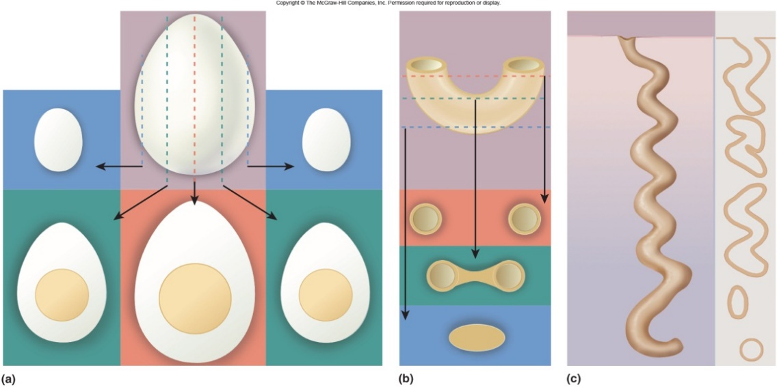

Select slide #16, labeled "kidney", from your slide set and examine it with the naked eye. This is from a small animal such as a rat or mouse. Note that while the specimen on your slide is indeed what we call "kidney shaped", it is a thin flat slice rather than the full organ.

Like the human kidney, it consists of hundreds of thousands of small coiled tubes called nephrons. Obviously, this thin two-dimensional sample can’t include all of the structure of the three-dimensional organ, nor can it include intact three-dimensional coiled nephrons. Instead, you will see nephrons cut many different times and at many different angles as the knife passed through different parts of them, and parts of the kidney through which the knife did not cut can’t be seen at all.

Place the slide of the kidney under the microscope and examine it. Think about how the three-dimensional structure of a kidney results in the appearance you see through the microscope after that organ is sectioned and a thin slice placed on the microscope slide. Note also that the specimen was stained so that nuclei of cells appear blue while the rest of the cells appear reddish.

You are now ready to use the microscope to examine slides of human tissues.
Please use it carefully. Refer back to this exercise in future labs if necessary.

