BIOLOGY 211: HUMAN ANATOMY & PHYSIOLOGY
*********************************************************************************************************
HISTOLOGY – THE EXAMINATION OF TISSUES
**********************************************************************************************************
Reference: Saladin, KS: Anatomy & Physiology, The Unity of Form and Function, 8th ed. (2018)
Please review Chapter 5 before beginning this lab.

INTRODUCTION:

We will use this lab period to study the tissues which comprise the organs of the human body. Use your textbook (Chapter 5) to help you learn to recognize each type of tissue and to differentiate among different tissues which are similar in appearance. We will not study all of the tissues found in the human body, but instead we will focus on the most common and most important of them.

If necessary, you should review the proper care and use of the light microscope before beginning this exercise.

All tissues are groups of cells and their products which share a common structure and/or function. Tissues, in turn, work together to form organs. With rare exceptions (such as pregnancy and some unusual tumors), all tissues of the body can be classified into one, and only one, of four basic types:

Epithelium (plural = epithelia) lines the surface of the body, hollow organs, and spaces.
Muscle tissue contracts to generate a pulling or squeezing force.
Nervous tissue allows electrical information to be carried from one place to another.
Connective tissue provides support, fills in spaces, connects other tissues to each other.

Within each of these categories, however, are various subtypes and specializations, each of which has distinctive characteristics and functions which you will need to recognize and understand. Within an organ, each tissue has a particular role in the function of that organ, and all of the tissues which are present must function correctly in order for the organ to function correctly.

Your objective in this lab exercise is to study each of the slides listed below to learn to recognize the tissues which form the organs of the human body. Most of the slides you will be studying are prepared sections of organs so they will contain many types of tissue besides the one you are interested in. When studying each of the tissues below, you should focus primarily on identifying and recognizing the tissue rather than identifying the organ. Use your book to know what you are looking for and where you should look for it before you look through the microscope. After you have learned to recognize the tissues, you can put them together to see how they fit together to form an organ.

A. EPITHELIUM:

Epithelium lines both external and internal surfaces of the body, including the inside of hollow organs such as blood vessels, bladder, or intestines. It also forms all of the glands in your body. The functions of epithelia include protection, absorption, secretion, and filtration. In many places, the epithelium is subject to abrasion which damages the cells, so most epithelia have a relatively high rate of cell division to replace damaged cells with new ones. All epithelia lie next to a supporting layer of connective tissue which they depend on for their survival and function because the blood vessels do not reach into the epithelium itself. The epithelium and connective tissue are separated by a thin structure called a basement membrane.

Epithelia are classified according to two criteria (see Figure 5.3):

a) How many cell layers form the lining.
If there is only one layer, it is called a simple epithelium.
If there are two or more layers, it is called a stratified epithelium.
Plus, in one case, there is really one layer but it looks like there are many layers,
and this is called pseudostratified epithelium.

b) The shape of the surface layer of cells.
Flat cells are called squamous.
Cells which are approximately as wide as they are tall are called cuboidal.
Cells which are much taller than they are wide are called columnar.
Note that only the shape of the top, or surface, layer of cells is used in naming an
epithelium - the shape of underlying cell layers is not used.

Plus, many organs of the urinary system are lined internally by an epithelium containing cells which go back and forth between being flat and cuboidal (depending on how stretched out the organ is by urine). This is called transitional epithelium.

Simple Squamous Epithelium: (Figure 5.4)

As its name tells you, this is a single layer of flat cells.

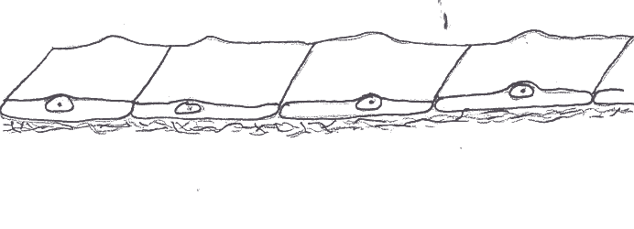

1. Under the lowest power of your microscope, examine slide #3, labeled “artery, vein, and nerve”. Identify the artery, which is a hollow, circular organ with a thick wall (see Figure 20.1 in your text).

At higher magnification, examine the epithelium on the innermost surface of the artery, inside the darkly stained, rippled border (which is connective tissue, not epithelium!). With the light microscope, you will only be able to identify the nuclei running parallel to the surface of the organ. The cytoplasm it is too thin to see under a light microscope since you are looking at the edge of the cells, so you will not be able to identify this.

Return to low power and identify the vein on the same slide. At higher power, identify the simple squamous epithelium which lines this vessel. Create a mental image of what these blood vessels and the squamous (flat) cells which line them look like in three dimensions.

2. Under the lowest power of your microscope, examine slide #2, labeled “Human lung”. The simple squamous epithelium appears as thin partitions between the numerous air spaces called alveoli. See Figure 22.11 in your textbook. This is at relatively low magnification, but at higher magnification it should be obvious to you that you are looking at flat cells lining the air spaces of the lung. See if you can create a mental image of what these air spaces and their lining epithelial cells look like in three dimensions.

Simple Cuboidal Epithelium: (Figure 5.5)
As its name tells you, this is a single layer of cube-shaped cells. It often forms microscopic tubules within the body, so the cells are usually arranged circularly rather than in sheets.

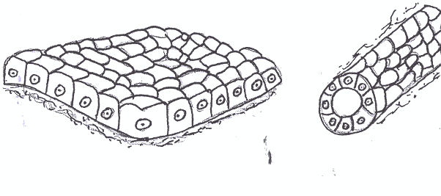

3. Examine slide #16, the kidney, with your unaided eye and get a feeling for its general shape. Then examine it under the lowest power of your microscope and identify the cortex (outer third or so) and medulla (inner two thirds) - these should appear quite different from each other.

Switch to higher power and examine both parts. In the outer region (cortex) you should see simple cuboidal epithelium forming coiled tubes which are cut in many different orientations (see Figure 23.7 in your text). Figure 5.5 in your text shows the appearance of tubules of the central region (medulla) of the kidney, also formed by simple cuboidal epithelium. The boundaries between cells are often hard to see, but you can assume each nucleus represents one cell. Nuclei are fairly large and round. Create a mental image of what the kidney, consisting of thousands of small coiled tubes formed by cuboidal cells, looks like in three dimensions.

4. Examine slide #20, the pancreas. Find lighter-staining, circular ducts in this organ as shown in Figure 25.22. These are another good example of simple cuboidal epithelium arranged into tubular structures. Create a mental image of what these ducts, formed by cuboidal cells, look like in three dimensions.

Simple cuboidal epithelium also forms ducts in many other organs, including salivary glands (Figure 25.10), the stomach (Figure 25.13), and liver (Figure 25.20).

Simple Columnar Epithelium: (Figure 5.6)

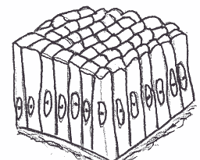
As its name tells you, this is a single layer of cells which are much taller than they are wide. It lines all of your digestive system distal to the esophagus (stomach, small intestine, large intestine), and is found in a few other places.

5. Examine slide #5, the small intestine of a frog, under low power. Identify the fingerlike projections, or villi, which project toward the center of the organ (see Figure 25.25). The blank area in the center of the section, of course, is the space, or lumen, inside the intestine where the partially digested food is passing through. The simple columnar epithelium completely lines the outside of the villi where they touch the lumen.

Examine this under higher power. Note the tall cells with large, oval nuclei. As in previous slides, the boundaries between cells may be too small for the light microscope to resolve, but you can assume that each nucleus represents one cell. Some cells appear much lighter than others - these are one-celled mucous glands called goblet cells. Create a mental image of what these villi, lined by columnar cells, look like in three dimensions (as if you were very small and inside the intestine with a good light).

6. Examine slide #19, the oviduct or Fallopian tube, in the same way. The inner surface of this organ is also folded, and the lumen is lined by a simple columnar epithelium in which the cells have long, hair-like cilia projecting from them into the lumen. Identify this tissue at higher magnifications. Create a mental image of what the inside of the oviduct, lined by columnar cells, looks like in three dimensions.

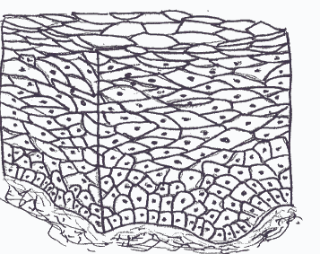
Stratified Squamous Epithelium: (Figures 5.8, 5.9)

As its name tells you, this tissue consists of multiple layers of cells (“stratified”) with those in the outermost layer (nearest the free surface) flattened (“squamous”). It is found in places subject to a lot of mechanical abrasion such as the skin, mouth, esophagus, and vagina.

7. Using the same technique as before, examine slide #18, the scalp. Like skin everywhere on the body, this consists of a thick layer of connective tissue, called the dermis, covered by the stratified squamous epithelium, called the epidermis. Use Figures 6.1 and 6.6 to help you identify these two layers, and be sure you can identify the free surface.

Examine the epidermis under higher power and ignore the rest of the slide for now (we will come back to it). The epithelium consists of many layers of cells which flatten as they get closer to the free surface of the skin, as shown in Figures 5.8.

Here again, you can assume that each nucleus represents one cell even though the borders between adjacent cells are below the resolving power of the light microscope. The outermost layer consists of flattened cells which have died, so their nuclei are not visible and all you see is a rather poorly detailed layer of cytoplasm. This layer often separates from the rest of the epithelium when slides are made for microscopy. It is this layer which helps prevent water loss through the skin. Create a mental image of what the epidermis, with its many layers of cells, looks like in three dimensions.

8. Examine slide #9, labeled “stratified squamous epithelium”. This is really a slide of the esophagus (a tubular organ), so it will have other types of tissues as well. Identify the stratified squamous epithelium, noting that it is similar to slide #18 except that there is no outer layer of dead cells. Nuclei are visible in all layers (Figure 5.9). Create a mental image of what this epithelium looks like in three dimensions as if you were very small and inside the esophagus.

Stratified Cuboidal (Figure 5.10) and Stratified Columnar Epithelia:

While these two types of epithelium exist in the human body, they are rare and hard to identify with the light microscope. Therefore, we will not look for them, but you should be able to visualize what they might look like.
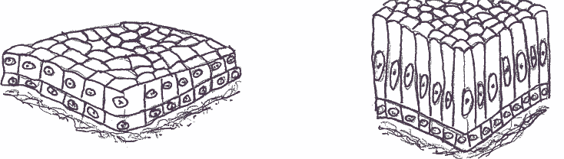

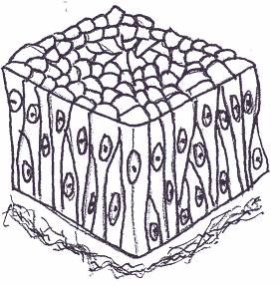
Pseudostratified Columnar Epithelium: (Figure 5.7)

Although this tissue appears to have multiple layers of cells under the
light microscope (or, more accurately, multiple layers of nuclei since the boundaries between cells can’t be resolved), more detailed examination
with the electron microscope (which can easily resolve the boundaries between cells) has revealed that this is not the case. Many cells lie near
the base of the tissue, next to the connective tissue, but only a few of
these reach the surface of the tissue. Thus, there will be many more
nuclei at the base than at the surface. Those that do reach the surface
are columnar in shape.

This is the only type of pseudostratified epithelium in the body. There are no pseudostratified cuboidal or pseudostratified squamous tissues.

9. Examine slide #7, the trachea, and identify its inner surface lined by epithelium. This is shown in Figure 5.7. Notice the higher numbers of nuclei closer to the base than there are closer to the surface of this tissue. If you look closely, you should be able to see hair-like cilia lining the free surface of this epithelium, which may be so thick they appear as a “fuzzy” layer. Create a mental image of what this epithelium looks like in three dimensions.
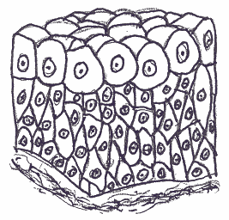
Transitional Epithelium: (Figure 5.11)

This is a stratified type of epithelium in which the cells are cuboidal when the tissue is relaxed, but can become flattened as they get stretched out. Not surprisingly, this is found in the parts of the urinary system which are stretched out as they fill with urine.

10. Examine slide #8, the urinary bladder. This slide was made when the tissue was relaxed (the bladder was empty), so it has folded over and the lumen may appear as a narrow empty space lined with epithelium on both sides. Notice that the surface cells are large and relatively clear, while deeper cells are packed more closely together. Create a mental image of what this epithelium looks like in three dimensions. Visualize how this would change as the bladder fills with urine, empties, fills again, empties . . . .

As you would expect, all of these types of epithelia can have different appearances depending on how they were sectioned and stained. Borrow slides of epithelia from other tables and be sure you can identify the various types of tissue on them as well as on your own slides.

B. CONNECTIVE TISSUES:

Connective tissues are widely distributed throughout the body and have many functions. Unlike epithelia, which all consist of cells packed tightly together, connective tissues have fewer cells and a large amount of space between them. This space is called the extracellular matrix, best shown in Figure 5.14, and is very important. It is produced and maintained by cells in all tissues, not just connective tissues, but here it is what gives connective tissues their characteristic appearances and functions.

As shown in Figure 5.14, extracellular matrix has two components, ground substance and fibers. The ground substance consists of water with many other molecules dissolved in it, mostly proteins and polysaccharides (please go back to Chapter 2 in your Saladin textbook and review these types of molecules if necessary). Depending on the specific molecules it contains the ground substance can be liquid, gel-like, or solid. The other component of the extracellular matrix, the fibers, are large strands of protein which are not soluble in water.

Three types of fibers are typically seen in the extracellular matrix of connective tissues: collagen fibers (large, poorly defined bundles of the protein collagen), elastic fibers (small bundles of the protein elastin), and reticular fibers (small groups of collagen). Collagen and elastic fibers are abundant in many tissues which we will examine, while reticular fibers are only found in a few organs and we will not attempt to identify these.

All of the connective tissues arise from the same type of undifferentiated tissue in the embryo, called mesenchyme. Be sure you understand this common origin from your reading of Chapter 5 in the Saladin text.

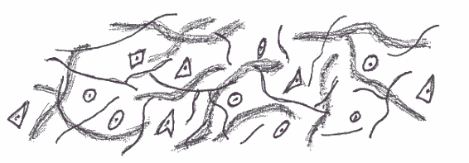
Loose (Areolar) Connective Tissue: (Figure 5.14)

This is a common type of ordinary connective tissue which
cushions and protects many internal organs. As its name tells
you, it has a loose structure with a lot of extracellular matrix.
It contains many different types of cells, and different types of
fibers as well. The ground substance is quite liquid, but you will not see any detail of this because it was washed away when the tissue was prepared for microscopy.

11. Examine slide #10, labeled areolar tissue. With the help of Figure 5.14 in your text, identify the darkly staining nuclei of cells and the surrounding extracellular matrix. Note the large numbers of fibers in the latter. You should be able to identify both collagen fibers, which appear as poorly defined wavy bundles, and elastic fibers, which appear as distinct dark lines. Note that these fibers are going in different directions throughout the tissue. Most of the cells are fibroblasts with dark oval nuclei (you rarely can identify the borders of their cytoplasm) but you may also be able to identify mast cells, which are larger and have distinct granules in their cytoplasm. You should be able to create a mental image of what this type of tissue looks like in three dimensions (imagine you are very small, about the same size as one of the cells, and can easily fit between the fibers).

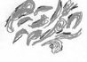
Dense Irregular Connective Tissue: (Figure 5.17)

As its name tells you, the fibers (collagen and elastic) in this ordinary connective tissue are denser and are not arranged in any particular direction. It is found in organs, such as the skin and surrounding the kidneys, which need both structural strength and flexibility.

12. Examine slide #18, the scalp, again, and identify the epidermis (stratified squamous epithelium) you examined before (Figure 6.5). Directly underneath this is the tissue we will now examine, the thick dermis composed of dense irregular connective tissue as shown in Figure 5.17. Most of this tissue consists of large bundles of collagen fibers. Many elastic fibers are also present, but they are masked by the collagen fibers and can not be easily identified without special staining. The fibroblasts appear as oval nuclei squeezed between the fibers. Here again, you should be able to visualize what this type of tissue looks like in three dimensions based on its appearance on the slide.

Dense Regular Connective Tissue: (Figure 5.16)
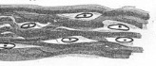
This ordinary connective tissue appears similar to dense irregular connective tissue except that all of the fibers are oriented in the same direction. These are straight in life, but appear wavy under the microscope because of shrinkage during preparation for microscopy. This type of tissue is found in such places as tendons and ligaments which must withstand stress (pulling forces) in a single direction.
13. Examine slide #11, labeled white fibrous tissue. This is actually a slide of a tendon, which connects a muscle to a bone, and some slides may have s slight amount of muscle at one end which you can ignore for now. Figure 5.16 shows dense regular connective tissue. Notice that the collagen fibers all run the same direction, and nuclei of the fibroblasts are tightly squeezed between the fibers so they appear very elongated. Create a mental image of what this tissue must look like in three dimensions.

Adipose Connective Tissue: (Figure 5.18)
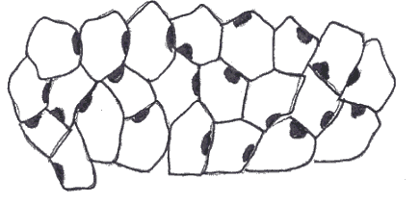
Also known as “fat”, this is considered an “ordinary” connective tissue by some histologists and a “specialized” connective tissue by others. Although it is often found next to or within ordinary connective tissues, it is structurally distinct.

14. Examine slide #18, the scalp, again. (yes, this is at least the third time you have looked at this slide, but remember that a single organ, such as the skin, contains many different types of tissues). If necessary, identify the epidermis and dermis again, but now look deep to the dermis. You may see large areas of adipose tissue with its characteristic “honeycombed” or “chicken-wire” appearance as shown in Figure 5.18, or you may find it as smaller “pockets” within other forms of connective tissue. Cells of adipose tissue are called adipocytes. All you see of an adipocyte is a thin rim around the cell where its cytoplasm was squeezed. The large, empty space in the middle was occupied by a droplet of liquid fat during life, but this washed out when the tissue was prepared for microscopy so it is now empty.

Adipose tissue is also a normal component of almost all organs: don’t be surprised when you see adipose tissue with other organs. Make sure to look again at slide 3 (nerve, artery, vein). You will probably find a very good example of adipose tissue in between the blood vessels and nerve. What would adipose tissue look like in three dimensions?

Cartilage

Cartilage is a specialized connective tissue which provides flexible support. It is found primarily in the respiratory system where it holds air passages open, and in the skeletal system where it forms parts of joints and cushions the ends of bones. Its extracellular matrix is a gel, similar to very well-set Jello. Thus, there must be spaces, called lacunae, in this semi-solid material for the cells of cartilage, called chondrocytes (think of the space which a piece of fruit might occupy in Jello).

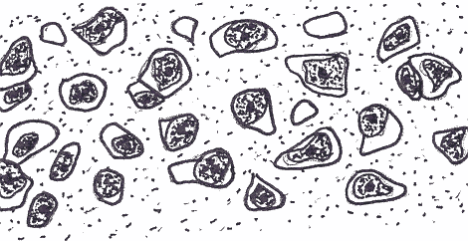
The most common type of cartilage is hyaline cartilage, so named because its collagen fibers are not easily visible and it has a smooth, glass-like (‘hyaline”) appearance in the living body. In some parts of the body you will find elastic cartilage and fibrous cartilage, which you can think of as hyaline cartilage within which additional elastic fibers or collagen fibers have been deposited in the extracellular matrix.
Hyaline Cartilage: (Figure 5.19)

15. Examine slide #13. This is labeled “hyaline cartilage”, probably part of a costal cartilage at the anterior end of a rib. Thus, the slide may also have skeletal muscle and fat which you can ignore for now. The hyaline cartilage consists of a thin strip in the center of the tissue. Use Figure 5.19 to help you identify the appearance of this tissue. Notice that the cells are in lacunae. The extracellular matrix stains a dark blue around the lacunae, but this fades into lighter shades (or even disappears) farther away from them. Another characteristic feature of cartilage is that cells in their lacunae are often “grouped” with two or three cells close together. These are called isogenous groups. Figure 7.12 shows hyaline cartilage in a growing bone.

Elastic Cartilage: (Figure 5.20)

16. Examine slide #38, labeled “elastic cartilage”. This is actually a section through the ear of an animal, so other types of tissue are present you can ignore for now and there may be skin on the surface. Identify the elastic cartilage in the center and notice that the cells are in lacunae, as they were in hyaline cartilage, but there are many dark elastic fibers in the extracellular matrix. You should notice many isogenous groups of two or three cells.

Fibrous Cartilage: (Figure 5.21)

17. Examine slide #37, labeled “fibrocartilage”. This is a section of a developing joint between two bones, so it will also contain many other types of tissue, including hyaline cartilage. Look for cells in lacunae, indicating that the extracellular matrix is the firm gel-like material of all cartilages, with large collagen fibers in the extracellular matrix.

Bone Tissue: (Figures 5.22, 7.4)
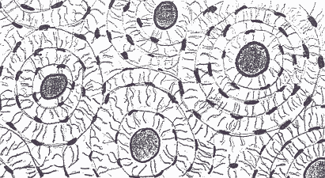
This type of tissue makes up most of the organs we call bones, such as the femur, temporal bone, or vertebrae. However, please remember that as organs, these contain other types of tissue as well - they do not consist simply of bone tissue. Also, there is a tendency by some students to consider bone as dead, non-cellular material. Don’t make this mistake! Bone is a living, cellular tissue
just like all others in the body, and it has a very large number of blood vessels and nerves supporting it. Its extracellular matrix contains large amounts of an insoluble calcium salt, which makes it rigid, but it is possible to remove this material and make bone quite flexible.

18. Examine slide #14. BE CAREFUL: this slide is very thick, so you should only use low power objectives, and you should watch carefully as you move the stage to be sure the slide doesn’t hit the lens. Because bone is so hard, it could not be sectioned (cut), so this slide was prepared by grinding a bone down (imagine using a file on a piece of wood or metal) until it was thin enough for light to pass through it. You can easily identify bone by the concentric rings, or lamellae, of extracellular matrix around central dark cavities. This is shown in Figures 5.22 and 7.4. In life, these dark cavities are called central canals and contain blood vessels and nerves, but these living structures were destroyed by the grinding process. Each central canal and all of the lamellae around it are called an osteon - you should be able to identify a dozen or more osteons on this slide.

The cells of bone are called osteocytes. In living bone, they are found in small spaces, or lacunae, between each ring or lamella - identify these lacunae on the slide (the cells themselves were destroyed by the grinding process). These also appear as dark spaces in ground bone, and have small dark lines radiating away from each one. These lines are called canaliculi (singular is canaliculus), and in life are occupied by microscopic projections of the osteocytes. Although it does not look the same as the extracellular matrix of other forms of connective tissue, the lamellae of bone are also composed of collagenous fibers. With the help of your textbook, you should be able to visualize the three-dimensional appearance of bone tissue based on the appearance you see under the microscope.

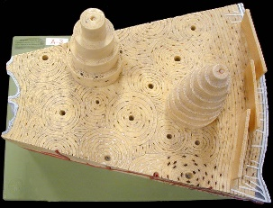
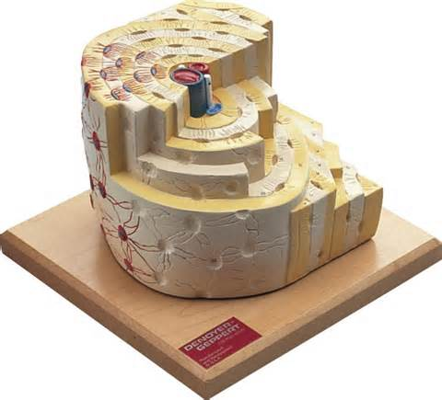
19. Examine the three-dimensional models of bone.
Identify many central canals, containing small blood vessels, and note how both the extracellular matrix (with many collagen fibers) and the osteocytes in their lacunae wrap around these canals to form lamellae, with canaliculi connecting the osteocytes. Notice how each central canal and the lamellae around it form an osteon. On the outer surface of the larger bone model, identify the periosteum, which is composed of dense irregular connective tissue.

C. MUSCLE TISSUES:

There are three types of muscle tissue in the human body, all of which share the characteristic of being able to generate a pulling force by contracting. The contractile cells are called myocytes. These three types of muscle tissue are found in different regions and having different appearances and different functions: skeletal muscle, cardiac muscle, and smooth muscle.

Skeletal Muscle Tissue: (Figure 5.25)
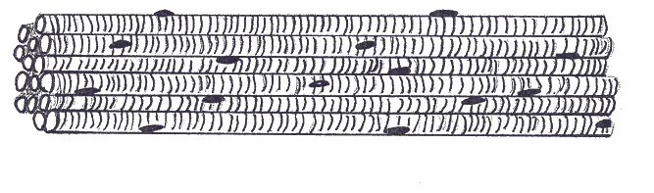
This is the most common type of muscle tissue
in the body. Skeletal muscle is used for voluntary movement of bones (as in walking), cartilages (as
in vocalization in the larynx), and skin (as in smiling). It is always under the direct control of the central nervous system (brain and spinal cord) and can not contract unless it receives electrical stimulation through a nerve. Myocytes are very long, cylindrical cells and have many nuclei per cell which are always found at its periphery, or edge. The proteins which actually produce the force of contraction are arranged within the cytoplasm to give these cells a banded or striated appearance under the light microscope as shown in Figures 5.25, 11.1, and 11.7.

20. Examine slide #15. This contains sections of skeletal muscle cut in both longitudinal and cross sections (see Figure 10.1 for orientation) so be sure you examine both and can differentiate them from each other. Note the peripheral (out at the edge of the cells) nuclei in both orientations, as well as the small amount of extracellular matrix between cells. On the longitudinally sectioned myocytes, identify the striations or alternating dark and light bands across the cell (they may be faint, so look carefully). This tissue is often confused with dense regular connective tissue, but can be differentiated from it by the striations and the appearance of the nuclei. Go back and forth between these two slides until you can differentiate dense regular connective tissue from skeletal muscle two. You should be able to create a mental image of what skeletal muscle tissue looks like in three dimensions - very long cylinders whose nuclei bump up underneath the plasma membrane).

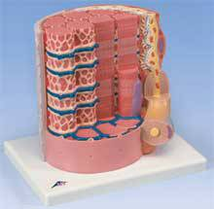
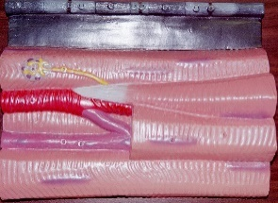
21. Examine the three-dimensional model of skeletal muscle tissue. There are two of these – one showing multiple myocytes (lower magnification) and one showing just a small portion of one myocyte (higher magnification). On both models, identify the peripheral nuclei of the myocytes and the myoneural junction. On the lower-magnification model, observe how all of the myocytes are oriented in the same direction so their force of contraction will all be in the same direction and identify the capillaries (small blood vessels) in between the cells – these are actually running through a layer of loose areolar connective tissue called the endomysium. A small portion of this connective tissue is shown on the higher magnification model, but you should realize that it completely surrounds all of the myocytes. On this model, identify the contractile proteins which are organized into structures called sarcomeres – we will learn more about these in a later lab.
.

Cardiac Muscle Tissue: (Figures 5.26, 19.11)
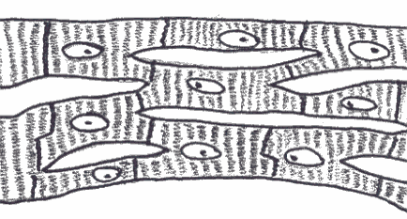

This tissue is found only in the heart. It also has a striated appearance when seen in longitudinal section, as shown in Figures 5.26 and 19.11, although this pattern is less obvious than it is in skeletal muscle. Cardiac muscle is not under the direct control of the central nervous system - in fact, cardiac myocytes can (and do) contract spontaneously without any external stimulation, and they can do so even when the heart is completely removed from the body. Myocytes in cardiac muscle are much shorter than those in skeletal muscle and they often branch as shown in Figure 19.11 of your Saladin text. There are only one or two nuclei per cell, located in the center of the cell. Cardiac myocytes are strongly attached to each other end-to-end by structures called intercalated disks.

22. Examine slide #1, which is a section through the wall of the heart and thus shows cardiac muscle tissue. Be sure you can differentiate it from skeletal muscle. Because the myocytes are oriented in different directions within the heart, the cells on the slide will not all be oriented the same way. Scan around carefully until you identify a region where the cells are cut parallel to their long axis. Note the less prominent banding pattern and the centrally placed, pale oval nuclei. Identify the intercalated disks. They are difficult to identify at first, but after you learn what to look for you will see them all over the slide. You should be able to visualize the three-dimensional appearance of this tissue.
Smooth Muscle Tissue: (Figure 5.27)
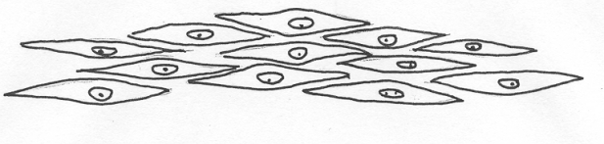
This type of muscle tissue is found in many different organs. Smooth muscle tissue, for example, moves food along your intestines, narrows or widens air passages in your respiratory system, narrows or widens blood vessels, contracts during childbirth, changes the diameter of the pupils of your eyes, and causes the hairs of your skin to stand up. Myocytes in this type of muscle tissue are small and “spindle shaped” - wide at the center where the nucleus is, then tapering to points at either end. As shown in Figure 5.27, smooth muscle cells often pack so closely together that you can not distinguish the boundaries of the cells. No striations are visible with the microscope. These myocytes may contract spontaneously, or they may be stimulated to contract by nerves or hormones.

23. Carefully examine slide #5 (again!) of the small intestine. You have already identified the epithelium which lines the inside of this organ, so now you should note the smooth muscle which makes up most of the wall of this organ, running circularly deep to the epithelium and connective tissue. Just deep to this (further from the lumen), another layer of smooth muscle is seen with its myocytes cut in cross section. You can identify the characteristic nuclei, but there is little extracellular matrix so cell boundaries can not be defined. Notice that striations are not present in this type of muscle. Figure 25.25 shows the appearance of this organ, but not very well. The same arrangement of tissue layers is present in all of the tubular organs of the digestive system, so Figure 25.2 of the esophagus may help you visualize it. ALSO, identify smooth muscle in the wall of an artery or vein (Slide #3), thin walled veins clearly have less smooth muscle than thicker walled arteries (See Figures 20.1, 20.2).

24. Examine slide #8 again of the urinary bladder. You have already identified the epithelium which lines the inside of this organ, so now you should note the smooth muscle which makes up much of its wall. Examine #19, the oviduct or Fallopian tube and identify the smooth muscle which makes up most of the wall of this organ. You should be able to create a mental image of what this type of tissue looks like in three-dimensions.

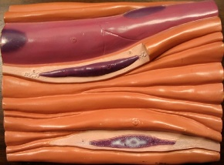
25. Examine the three-dimensional model of smooth muscle. Observe the shape of the myocytes – thicker in the middle where the central nucleus of each one is (find the nuclei of the cells which have been cut open) and narrowing at each end. Notice the many small capillaries which lie in between the cells.

D. NERVOUS TISSUE: (Figure 5.24)
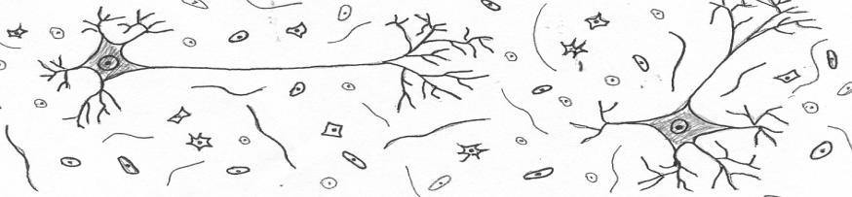
As its name tells you, this tissue is found in the nervous system. However,
it is also found in organs which are stimulated by nerves, such as muscles, the intestine, and skin. Although there are
no subtypes of nervous tissue, there are two types of cells: neurons, which actually carry the electrical signals, and supporting cells (called glial cells) which nourish and protect them.

26. Examine slide #17, cells of the spinal cord. Neurons appear as large, blue-staining structures with a number of projections as shown in Figure 5.24 of your text. Notice the lighter-staining nucleus within the neuron, with a darker staining nucleolus within it. Since this is a flat cut section, projections (called axons and dendrites) can be seen extending from the neurons in only two dimensions, but you should be able to visualize these projections extending in all directions, three-dimensionally, from each cell. Notice also the many smaller nuclei surrounding the neurons; these belong to supporting cells called glia.

**********************************************************************************************************

Please note that you will need to use a number of open lab periods for this exercise. You can not learn to recognize and identify tissues in just one or two lab periods, and we do not expect you to do so. You will need to come in and examine each of these tissues many times, so you must plan a number of additional open lab sessions for yourself.

The best way to approach this type of material is in repeated, short intervals. Don’t try to spend hours at a time examining tissues - it won’t work. Come in for twenty or thirty minutes at a time, review a few tissues, then go do something else for a while. If you finish another lab exercise early, spend a few minutes reviewing these tissues. It will help if you can do this with other students, quizzing each other about identification.

**********************************************************************************************************

