Biology 322: Human Anatomy
Blood Vessels

The cardiovascular system is a closed system that transports blood throughout the human body. Contraction of the heart provides the force that carries the blood, while the blood vessels provide the pathway. Blood leaves the left ventricle in very large, elastic arteries which decrease in diameter the farther they are from the heart. Blood returns to the right atrium via a series of veins which increase in diameter as they near the heart. In between the smallest arteries (ARTERIOLES) and veins (VENULES) are CAPILLARIES. These vessels possess extremely thin walls which allow gases (O₂ and CO₂), nutrients, waste products, and many other materials to be exchanged between the blood and the extracellular fluid surrounding the cells of a tissue.

Arteries and veins are not static structures. They are constantly changing diameter in order to maintain proper blood pressure. As the diameter of a blood vessel decreases, the pressure within that vessel increases. Similarly, an increase in blood vessel diameter will decrease the blood pressure within it. This ability to change diameter is critically important to the regulation of blood pressure in the body as a whole as well as the individual organs.

FIGURE 1: Microscopic anatomy (Fig. 22.1 of lab manual or 21.1 of your textbook)

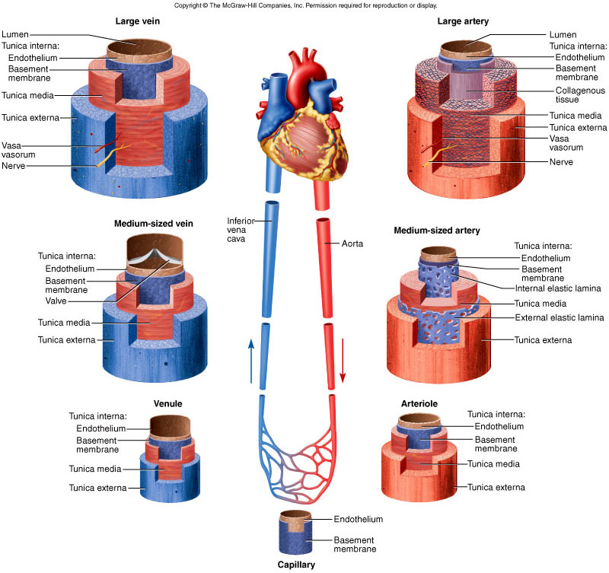
Exercise #1: Microscopic anatomy of blood vessels
With the exception of the smallest capillaries, all arteries and veins are composed of three layers called TUNICS.
- TUNICA INTIMA – the innermost layer of a blood vessel that is exposed to the blood. This layer consists of a thin layer of simple squamous epithelial cells called ENDOTHELIUM atop a basement membrane (like all epithelia). The endothelium secretes many factors that regulate blood clotting, leukocyte migration, and blood vessel diameter.
- TUNICA MEDIA – the middle layer. This is the thickest layer of the blood vessel and contains a great deal of connective tissue (collagen = strength and elastin = stretchiness) and smooth muscle. The smooth muscle in this layer allows the blood vessel to change diameter (vasoconstriction/vasodilation) according to needs of the body or tissue.
- TUNICA EXTERNA – the outermost layer. This layer contains a great deal of loose connective tissue that anchors the vessel in place, and allows nerves and other small blood vessels to travel alongside. Very large arteries and veins are so thick that they need their own dedicated blood supply. Special vessels known as VASA VASORUM supply blood to the outer layers of these vessels. Often times, the tunica externa of arteries and veins will blend together. This may be obvious in your slide.

Using the above figure and microscope slide #3 (artery, vein, nerve) you should be able to identify the three tunics of an artery and vein. You’ll note that arteries tend to have a thicker tunica media with more smooth muscle and elastic connective tissue that gives them a more uniformly round appearance as compared to veins. This is due to the fact that arteries carry blood from the heart that is under much greater pressure than blood returning to the heart via veins.
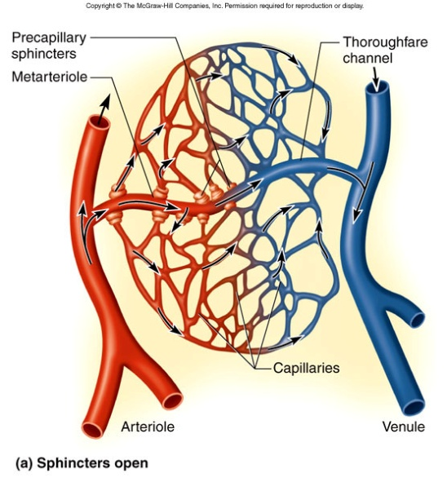
Keep in mind that the circulatory system is a closed system. Essentially, blood flowing through an artery will eventually travel through a series of capillaries known as a CAPILLARY BED and return to the heart through a vein. So, arteries and veins are actually connected to one another via the capillaries. This is illustrated well in figure 24.10(a) of your lab manual or 21.9 of your textbook.

Exercise #2 : Major Blood Vessels of the Human Body

Using the torso models, heart/lung models, heart models, and your books, you should begin to identify some of the major arteries and veins in the body. On these models, arteries carrying blood away from the heart are colored red and veins carrying blood back to the heart are colored blue. Of course you’ll remember that the pulmonary artery carries deoxygenated blood to the lungs are will be colored blue, while the pulmonary veins will be colored red since they are carrying oxygen-rich blood back to the heart. Beginning with the great vessels, make sure you understand how the inferior and superior vena cava return blood to the right atrium, while the aorta receives blood from the left ventricle to be carried to distant parts of the body.

Arteries
Figure 22.3 and 22.5(a) and 22.6(a)
Aorta (ascending and descending segments)
Aortic arch
Brachiocephalic
Right and Left common carotid
Right and Left subclavian
Right and Left pulmonary arteries

Figure 22.8 (lab manual)
Superficial temporal artery
Vertebral artery
Internal carotid
External carotid
Common carotid
Subclavian
Maxillary
Occipital
Facial
Brachiocephalic

Figure 22.7
Axillary
Circumflex humeral
Brachial
Radial
Ulnar
Deep palmar arch
Superficial palmar arch
Digitals
Right and left subclavian
Intercostal arteries (figure 22.5)

Figure 23.1, 23.2, 23.3
Celiac trunk
Hepatic artery (branch of common hepatic artery; also called hepatic artery proper)
Common hepatic
Right gastric
Splenic
Celiac trunk
Renal
Superior mesenteric
Gonadal
Inferior mesenteric
Common iliac

Figure 23.3, 23.4
Common iliac
Internal iliac
External iliac
Femoral
Popliteal
Anterior tibial
Posterior tibial
Fibular

Veins
Figure 24.1, 24.4
Popliteal
Fibular
Anterior tibial
Dorsalis pedis
Dorsal venous arch
Common iliac
Internal iliac
External iliac
Femoral
Great saphenous

Figure 24.5
Inferior vena cava
Gonadal
Renal
Common iliac
Internal iliac
External Iliac

Figure 24.3
External jugular
Vertebral
Internal jugular
Axillary
Subclavian
Brachiocephalic

Figure 24.2
Brachiocephalic
Subclavian
Axillary
Cephalic
Basilic
Brachial
Median cubital
Radial
Ulnar

