3 - DESCRIPTIVE METHODS FOR CATEGORICAL AND NUMERIC VARIABLES
For this example we will be using the data on hot dogs. Throughout we will try to connect to the material as presented in the text, however some techniques shown will not be in the text.
The data we will be working with is found in the Hotdogs.JMP file in one of sample data folders included with JMP. You can download it by clicking the link above.
The variables in the data file along with data type in parentheses are:
- Product Name - name of hotdog (nominal/categorical)
- Type - Beef, Meat, or Poultry (nominal/categorical)
- Taste - Bland, Medium, or Scrumptious (nominal/categorical)
- $/oz - dollars per ounce (continuous)
- $/lb protein - dollars per pound of protein (continuous)
- Calories - calories per hotdog (continuous)
- Sodium - sodium per hotdog (continuous)
- Protein/Fat - protein/fat ratio (continuous but recorded very discretely!)

Section 3 – Index of Topics
3.1 Graphical Displays and Frequency Distribution for Categorical/Nominal Variables
3.2 Contingency Tables, 2-D Mosaic Plots and Correspondence Analysis
3.3 Histograms

Summary Statistics
  - Measures of Typical Value/Central Tendency
  - Measures of Variability
  - Measures of Relative Standing

  - Graphical Displays and Summary Statistics for Numeric Variables in JMP
- Moments
- Quantiles
- Outlier Boxplots
- Comparative Boxplots
- CDF Plots
3.8 Bivariate Relationships Between Numeric Variables
- Correlations and Scatterplots

3.1 - Graphical Displays and Frequency Distributions for
Qualitative/Categorical/Nominal Data
There are only to variables we might consider examining here - hotdog type and taste category. We might also be interested in the relationship, if any exists, between type of hotdog and taste. We will examine several ways of summarizing the univariate distribution of these variables and examining the bivariate relationship between them.
Frequency Distribution Table, Bar Graph, Mosaic Plot
To obtain a frequency distribution table and bar graph for these variables individual we select Distribution from the Analyze menu in JMP. Place both Type and Taste in the right hand box and click OK. The resulting bar graphs, mosaic plots, and frequency distribution tables are shown below.
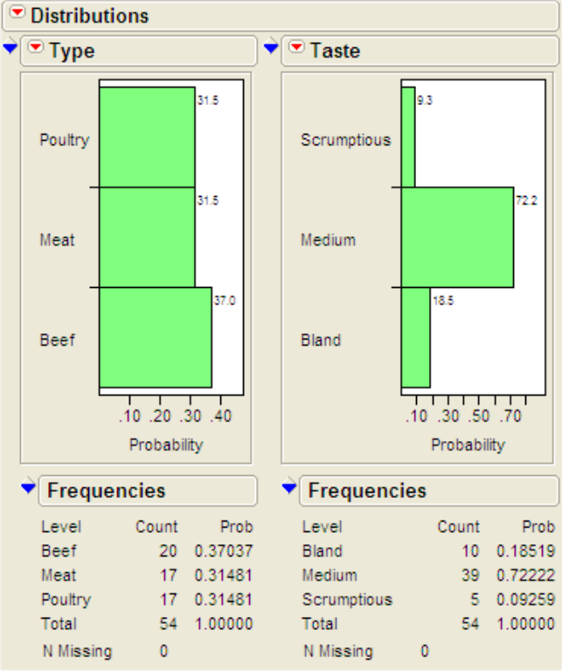
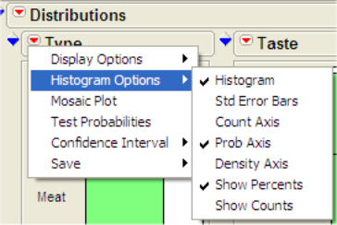
Pull-down and pull-out menus allow more options to be selected.
Here percents and relative frequency/probability axes have been added to both bar graphs

We can see that a very small percentage (9.2%) of hotdogs achieve the truly scrumptious taste distinction (what a surprise!). Most hotdogs (72.2%) are classified as having a medium taste. There appears to be an equal percentage of each hotdog type available on the market assuming this either represents all the hotdogs available or a simple random sample of those available. If you click on the bars in the distribution of Type we can see the corresponding breakdown of Taste for that type by observing the resulting in the bar graph for taste. An example is shown below with poultry hotdogs highlighted.
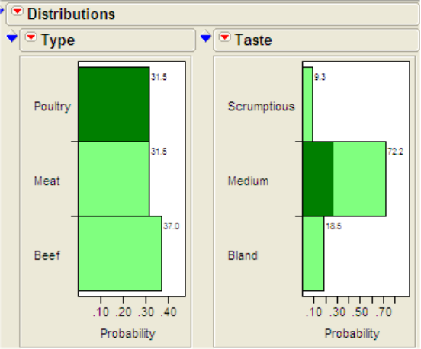
Nearly all of the poultry hotdogs are classified as having a medium taste with very few if any in the other taste categories. By clicking on the other hotdog types we can see their taste breakdown, e.g. we can see that meat hotdogs have the largest percentage in the scrumptious category.

3.2 - Contingency Tables, 2-Dimensional Mosaic Plots and
Correspondence Analysis
A better way to see the relationship between two categorical variables, hotdog type and taste here, is to use a two-dimensional mosaic plot or correspondence analysis. To do this in JMP return to the original data spreadsheet and select Fit Y by X from Analyze menu placing Type in the X box and Taste in the Y box and click OK. You will then obtain the following graph along with some numeric output we will discuss later.
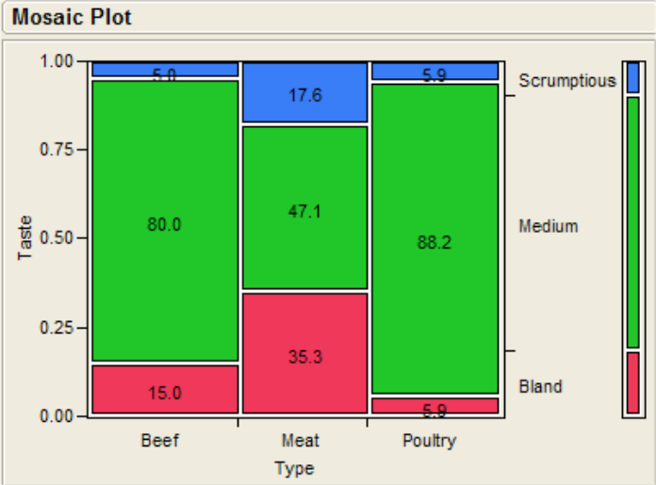
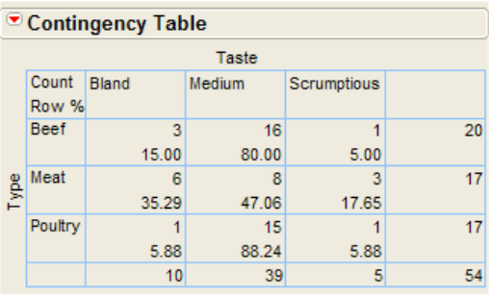
This plot is called a two-dimensional mosaic plot. This plot shows the distribution of taste within each hotdog type. The width of the vertical strips for each hotdog type is dictated by the number/percentage of hotdogs of each type. Here we see that the vertical strips are roughly of each width because the percentages associated with each type are nearly equal. The skinny strip on the right hand side of plot represents the marginal distribution of taste. The largest shading in that strip corresponds to the medium taste category because most hotdogs in these data are classified as having a medium taste. Within each vertical strip we see the distribution of the taste variable for the type of hotdog the strip represents. Meat hotdogs apparently have the best chance of tasting scrumptious but also tasting quite bland as well. From taste standpoint poultry hotdogs might be the best choice as nearly all of them are categorized as having a medium taste with very few in the bland category.

Below the 2-D mosaic plot we see the following numeric output.
Turn-off the Total % and Col % by unchecking them in the Contingency Table pull-down menu as shown below. The Row % gives the percent of hot dogs in each taste category within each of the types.
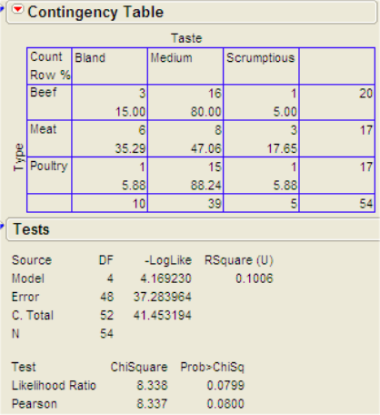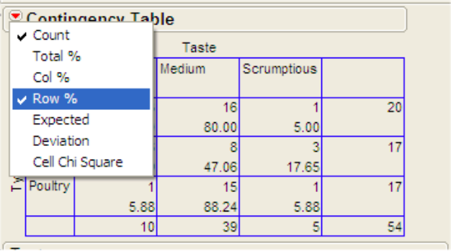

The Contingency Table section of the output contains a 3 X 3 contingency table associated with these variables. This table is sometimes referred to as a crosstab or cross-tabulation. Each cell in the table contains the number of hotdogs in each type/taste category. It is called a 3 X 3 table because there are 3 rows and 3 columns in the table corresponding to the three different levels of taste and type respectively. The second number in each “cell” of the table is the Row % which gives the percent of hotdogs in each taste category within type. The Tests section contains the results of statistical tests that are used to answer the question - "Is there a relationship between type of hotdog and taste?" or put another way “Is the distribution of taste the same for each hot dog type?”. We will discuss these test results in detail at a later date, for now we will ignore them.

Finally, a nice way to visualize the relationship between two categorical variables (only when both variables have more than two levels each) is to use correspondence analysis. To obtain this plot in JMP select Correspondence Analysis from the pull-down menu located above the mosaic plot. Then scroll down past the test results and you will see the plot on the following page.
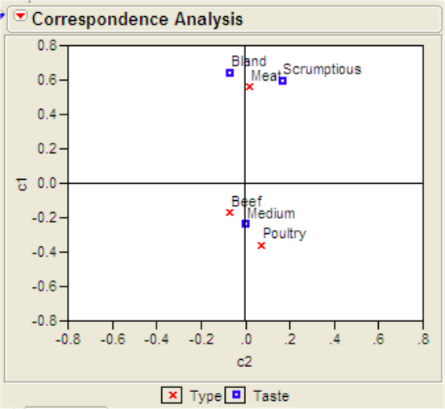

This plot displays the relationship between the row and column categories of a contingency table by placing row and column items that are related in close proximity to each other in the plot. We can see that beef and poultry hotdogs are closely associated with medium taste while meat hotdogs are associated with the bland or scrumptious taste categories. This may seem contradictory but remember most bland and scrumptious hotdogs were made from meat. What may also seem strange is that even though the medium taste category was the most commonly assigned taste for each of the hotdog types meat hotdogs are not placed in close proximity to medium taste. That is because the taste categories of bland and scrumptious are so completely dominated by the meat hotdogs that to give an accurate reflection of this fact, meat must be close to bland and scrumptious at the expense of lying away from the medium taste category.

3.3 - Histograms
The plots below shows the histograms for both cost-related variables with smooth density estimates added.
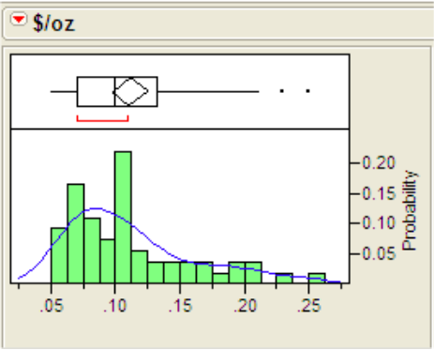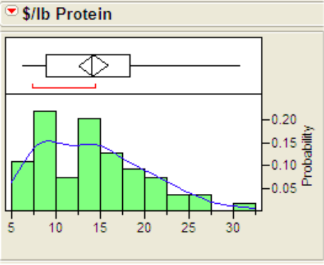
A histogram is essentially a bar graph for a numeric variable. The "categories" are created by constructing a series of non-overlapping equal-width intervals that cover the range of the data. The heights of the bars in the histogram are determined by the number of observations lying in the corresponding interval. The histograms show us the how values of the variable in question are distributed. There are three main things to consider when looking at histogram:
- Typical value
- Variation or spread about the typical value
- Shape of the distribution
Typical value - by examining the histograms below you should be able to identify a value of small interval of values that represent the typical value of the variable. This can be done several ways. The first is by looking for the mode, the highest bump, of the histogram. For the $/oz variable the mode appears to be around .075 or 7.5 cents. The distribution of $/lb Protein seems to have two modal regions, one around $8.00 and another around $14.00. One might classify this distribution as bimodal, i.e. it has two modes. This may be due to the fact we are considering three different sources of protein for the hotdogs. The first histogram below has poultry hotdogs highlighted. They are responsible for the first mode of $8.00. The second histogram has the meat and beef hotdogs highlighted, they are responsible for the second mode at $14.00.
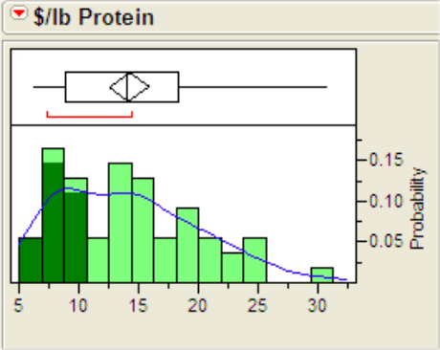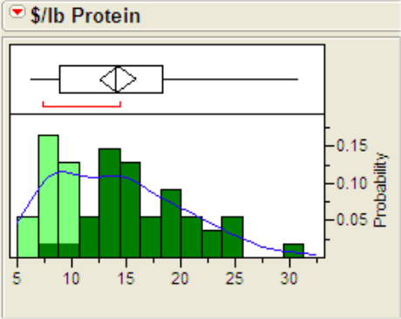
A second way to characterize typical value is to imagine that the histogram is made up of blocks of wood on a teeter-totter and try to find the place where you would place your finger to make the whole thing balance. This point is actually equal to the sample mean discussed above. A final way is to try to locate the median visually by finding the point where 50% of the observations are to the left and 50% are to the right.

Variability - when examining a histogram to assess variability consider how spread out the values are around the typical value. For both of these variables there appears to be considerable spread about the typical value. This is due in no small part to the fact that there are three types of hotdogs being examined in this study.

Shape- is exactly what is says, the shape of the distribution. In the histograms above we can see that both distributions have a long "tail" area extending to the right. These distributions could be characterized as being skewed to the right. If a distribution has long tail extending to the left we say the distribution is skewed left. If the distribution is bell-shaped in appearance we say the distribution is normally distributed. In the case of cost per pound of protein we might also characterize its shape as also being bimodal. Multimodality occurs typically when there are more than one population being examined, in this case poultry vs. beef/meat hotdogs. If we were to construct a histogram for the heights of a random sample of adults we would also see bimodality. Why?
To help visualize the shape of the distribution one can add a smooth curve estimate of the distribution by selecting the Smooth Curve option from the Fit Distribution pull-out located in the pull-down menu for the variable (see below). The smooth curves added to the histograms above suggest skewness to the right.
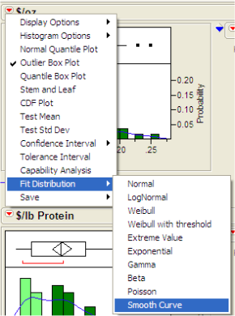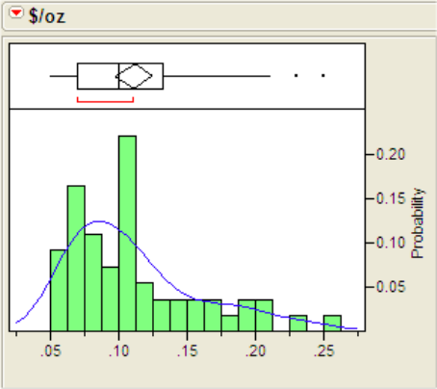
Features to look for in histograms and other ways of displaying distributional shape
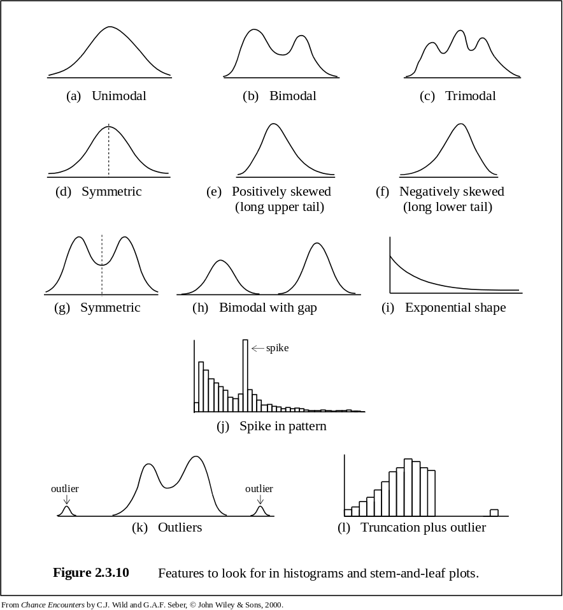
Summary Statistics (i.e. ways to summarize numeric data)
3.4 - Measures of Central Tendency or “Average” Value
3.5 - Measures of Spread/Variability
3.6 - Measures of Location/Relative Standing

3.4 – Measures of Central Tendency (mean, median, mode, others)
Observed Values of a Random Variable
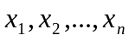 where 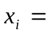i^{th} observed value of the variable x

Mean
Sample Mean 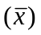 Population Mean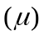
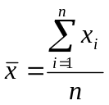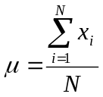

Example: (see Numerical Summaries ppt)
Why use the median rather than the mean to measure typical?

Median
Middle value when observations are ranked from smallest to largest.
These values are referred to as the order statistics and are denoted
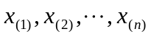, where 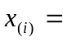i^{th} largest value.

Sample Median (Med) Population Median (M)
The same quantity calculated for the population.
Med = 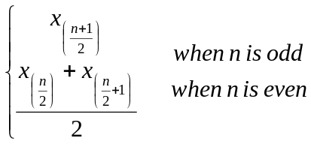

Example:

Mode
Most frequently observed value or for data with no or few repeated values we can think of the mode as being the midpoint of the modal class in a histogram.

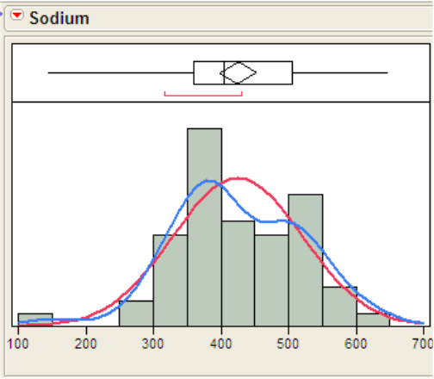
Here the modal class is 350-400 units, so we might use 375, the midpoint of this interval, as the model.

Others
x% Trimmed Mean – is found by first trimming of the lowest x% of the observed values and the x% of the highest observed values, then finding the sample mean of what is left.

Geometric Mean – one way to compute this measure of typical value is to first transform the variable to the natural log scale, then find the mean of the variable in the log scale, and finally transform the variable back to the original scale.

- Take natural log of the variable, ln(x).
- Find the sample mean in the log scale, 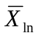.
- Geometric Mean of X = 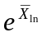.

This may seem strange, but will actually transforming variables to the log scale for other reasons later in the course. One thing the log transformation does is remove right skewness and what we often find is the distribution in the log scale is normal. Normality in the log scale is not uncommon and we will use this fact to our benefit.

3.5 - Measures of Variability (range, variance/standard deviation, and CV)

Range
Range = Maximum Value – Minimum Value = 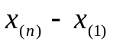

Variance and Standard Deviation
Sample Variance (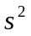) Population Variance (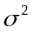)
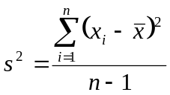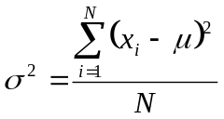

Sample Standard Deviation () Population Standard Deviation ()
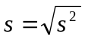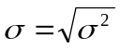
Example: Sample from Population A: 4, 6, 9, 12, 14
Which has more variation sample A or sample B?
Sample from Population B: 1, 5, 7, 13, 19

Compute the mean, variance, and standard deviation for both samples.
Sample mean 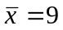

Sample from Population A Sample from Population B
x_{i} | 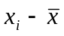 | 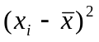
4 | 4 – 9 = -5 | 25
6 | 6 – 9 = -3 | 9
9 | 9 – 9 = 0 | 0
12 | 12 – 9 = 3 | 9
14 | 14 – 9 = 5 | 25
Total | 0 | 68
x_{i}
1 | 1 – 9 = -8 | 64
5 | 5 – 9 = -4 | 16
7 | 7 – 9 = - 2 | 4
13 | 13 – 9 = 4 | 16
19 | 19 – 9 = 10 | 100
Total | 0 | 200

Sample Variance for A Sample Variance for B
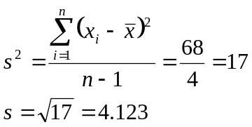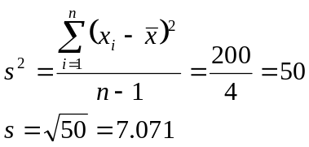

Sample B has greater variation than Sample A

Empirical Rule and Chebyshev’s Theorem:
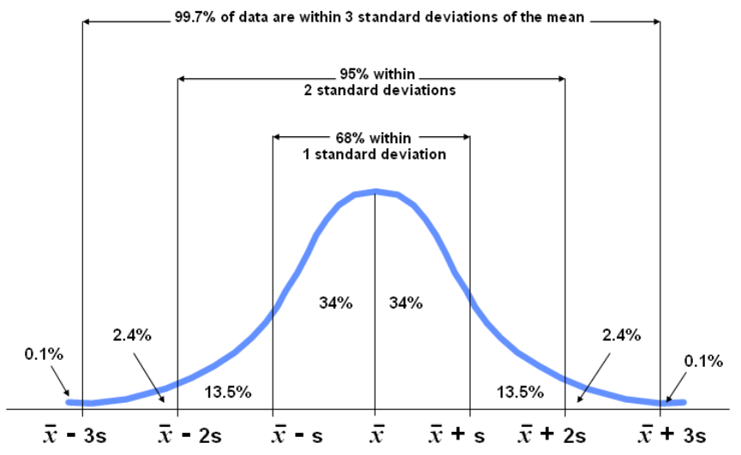

See Numerical Summaries Powerpoint for the following example.
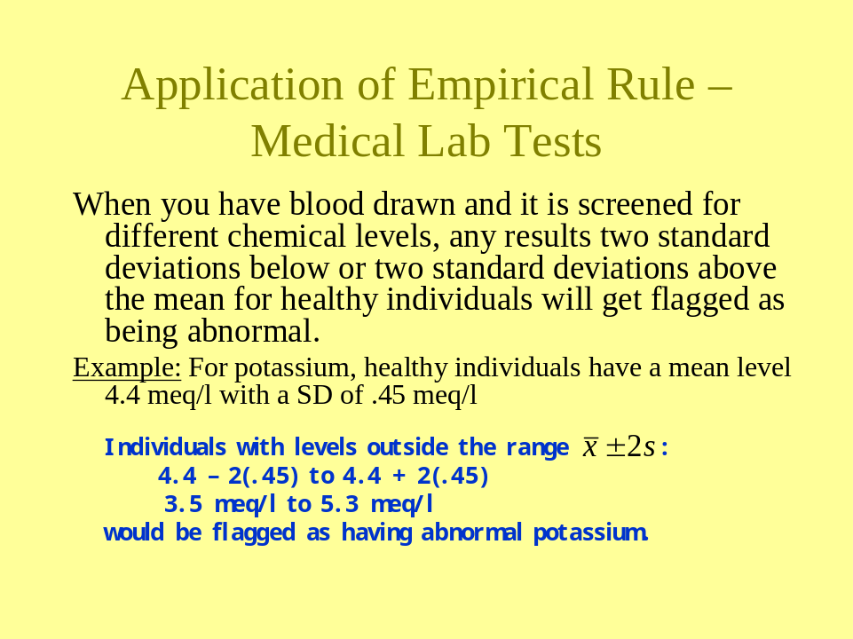

Coefficient of Variation (CV)
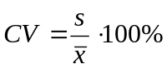

Ex: Which has more variation dollars per pound of protein or calories per hot dog?
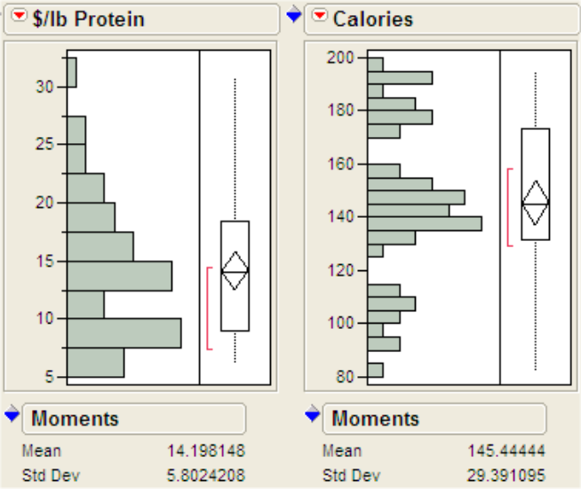

CV for $/lb Protein
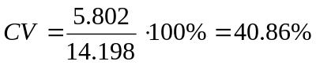
From the considering the coefficients of variation (CV) we conclude that cost per pound of protein has greater variability than calories per hot dog.

CV for Calories
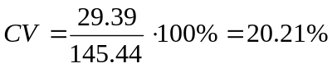

3.6 - Measures of Location/Relative Standing
(Percentile/Quantiles and z-scores/Standardized Variables)

Percentiles/Quantiles (percentiles and quantiles are the same thing)
The k^{th} percentile or quantile, P_{k}, is a value such that k % of the values are less than P_{k} and (100 – k)% are greater in value. For example the 90th percentile is a value such that 90% of the observations are smaller than P₉₀ and 10% are greater. The procedure for finding them involves ranking the observations from smallest to largest and finding the appropriate position for the given percentile. A better procedure is to use a computer.

Quartiles -
Q₁ = 25th percentile or quantile
Q₂ = 50th percentile or quantile = MEDIAN
Q₃ = 75th percentile or quantile

Interquartile Range (IQR) (another measure of spread)

IQR = Q₃ – Q₁ and gives the range of the middle 50% of our observed values.

Standardized Variables (z-scores)
The z-score for an observation  is 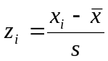 (sample) or 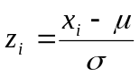(population).
The z-score tells us how many standard deviations above (if positive) or below (if negative) the mean an observation is.
NOTE: Many test statistics use in classical inference are z-scores with fancy formulae but the interpretation is the same!

z-Score Example:
Which is more extreme a hot dog with a sodium content of 22 or a calorie count of 170?
Sodium Calories
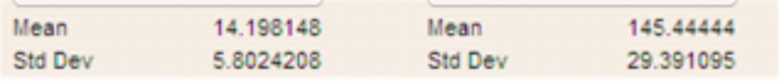

Compute z-scores for both cases
Because the z-score for a sodium level of 22 units is larger, i.e. more extreme, we conclude that a hot dog with a sodium level of 22 is more extreme than one with a calorie count of 170.

Sodium = 22 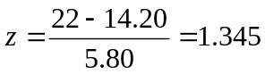

Calories = 170 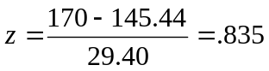

Empirical Rule for z-scores of Normally Distributed Variables

About 68% of observations will have z-scores between (-1 , 1)
About 95% of observations will have z-scores between (-2 , 2)
About 99.7% of observations will have z-scores between (-3 , 3)

A standardized variable is a numeric variable that has been converted to z-scores by subtracting the mean and dividing by the standard deviation. The histograms below show the sodium content of the hot dogs as well as the standardized sodium levels.
To standardize a numeric variable in JMP select
Save > Standardized from the variable pull-down menu. This will add a column to your spreadsheet called:
“Std variable name”
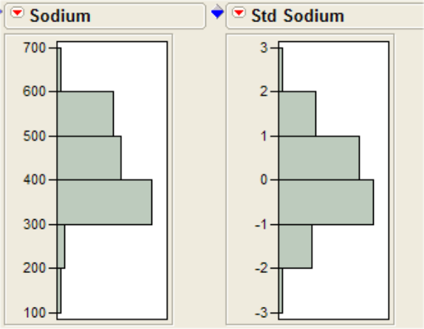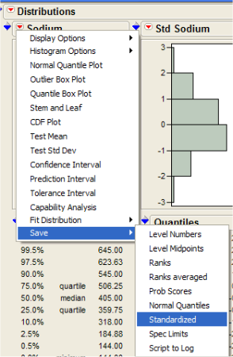

Outlier Boxplots – are a useful graphical display that is constructed using the estimated quantiles for a numeric variable. The features of an outlier boxplot are shown below. We classify any observation lying more than 1.5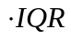below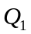or more than 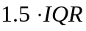above 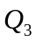are classified as an outlier.

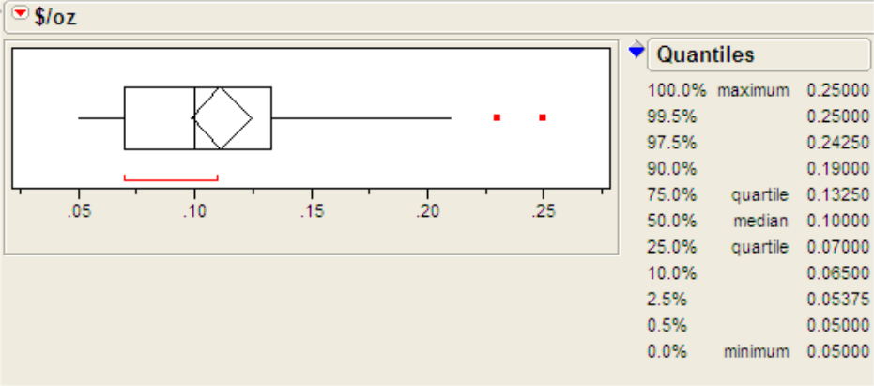

Comparative Boxplots
Boxplots are particularly useful for comparing different groups or populations to one another on a numeric response of interest. Below we have comparative boxplots comparing cost ($) per ounce of three different types of hotdogs.

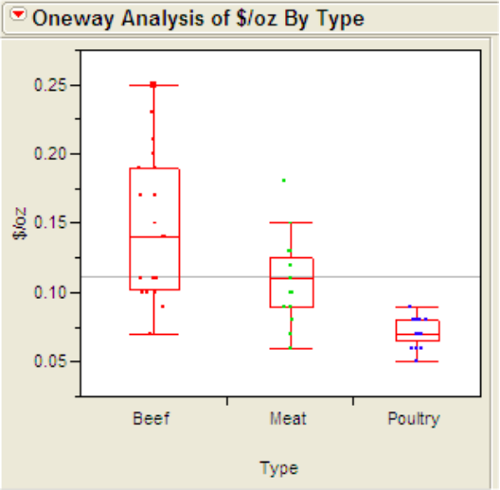
Interesting Findings from the Comparative Boxplots
- The three types of hotdogs clearly differ in cost per ounce with beef being the most expensive and poultry being the least.
- The variation in cost per ounce also differs across meat type with beef hotdogs having the greatest variation is cost.
- This illustrates a common situation in comparative analyses where the variability increases with the mean/median.
- There is on mild outlier in the meat hotdog group.

3.7 - Graphical Displays and Summary Statistics for Numeric Variables
in JMP (Datafile: Hotdogs)
To examine the distribution and summary statistics for a single numeric variable we again use the Distribution option from the Analyze menu. You can examine several variables at one time by placing each in the Y,Columns box of the Distribution dialog window. Let's consider the distribution of the cost-related variables $/oz and $/lb protein. Below is the resulting output from JMP.
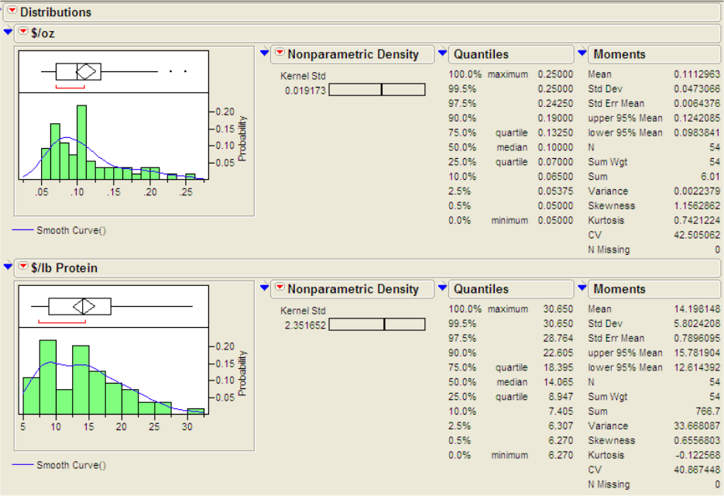
There is obviously lots of stuff here. We will discuss each of the components of the output using separate headings beginning with the numeric output.
Moments
The Moments box contains information related to the sample mean and variance. To focus our attention we will consider the moments box for the $/oz variable.
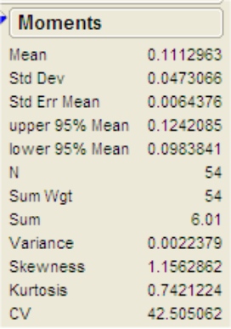
The sample mean is simply the average of the cost per ounce variable, approximately .11 here. This says that on average these hotdogs cost 11 cents per ounce.

The variance is .00224 which has units dollars squared. The variance is a measure of spread about the mean. It roughly measures this spread by considering the average size of the squared deviations from the mean. The standard deviation (s or SD) is the square root of the variance, .04731 here, and has units the same as the mean in this case dollars.
The standard deviation (denoted Std Dev in JMP) is more useful than the variance in many respects.

For example Chebyshev's Theorem says that for any variable at least 75% of readings will be within 2 standard deviations of the mean and least 89% will be within 3 standard deviations of the mean. For this reason an observation that is more than 3 standard deviations from the mean is considered fairly extreme. If the distribution is approximately normal then these percentages change to 95% and 99.7% respectively. For normally distributed data an observation more than 3 standard deviations away from the mean is quite extreme.

The standard error of the mean (Std. Err. of Mean) is the standard deviation divided by the square root of the sample size (n = 54 here). It is a measure of precision for the sample mean. Here the standard error is .00644. It is commonly used a +/- measure for a reported sample mean. When one is reporting a sample mean in practice one should always report the sample size used to obtain it along with the standard deviation. It is also common to combine this sample size and standard deviation information in the form of a standard error (usually denoted SE). The Upper 95% Mean and Lower 95% Mean give what is a called a 95% Confidence Interval for the Population Mean. It is obtained by roughly taking the sample mean and adding & subtracting 2 standard errors. What does this range of values given by these quantities tell you? There is a 95% chance that this interval will cover the true mean for the population. Here a 95% confidence interval for the mean cost per ounce of hotdogs is (.09838, .12421), i.e. if these data represent a sample of all hotdogs available to the consumer there is 95% chance that interval 9.8 cents to 12.42 cents covers the true mean cost per ounce of all hotdogs. We will discuss confidence intervals and their interpretation in more detail later in the course.

Skewness and kurtosis measure departures from symmetry and normality for the distribution of the variable respectively. While no rule of thumb guidelines exist for the size of these quantities we know that both should be zero if the variable is symmetric and approximately normally distributed.
If the skewness or kurtosis are less than -1 or greater than 1 then they might be considered extreme and very extreme if they exceed 2 in magnitude.
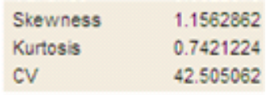

The coefficient of variation (CV) is a very useful measure when comparing the spread about the mean of two variables, particularly those that are in different units or scales. It is equal to the ratio of the standard deviation to the mean multiplied by 100%. The larger the CV the more spread about the mean there is for the variable in question. As an example, consider the two cost-related variables examined here. For $/oz the standard deviation s = .04731 dollars and $/lb protein the standard deviation s = 5.80242 dollars. Does this mean that the $/lb protein is more variable than the $/oz? NO... the readings for cost per ounce are all around .10 to .20 dollars while cost per pound of protein has values around 10 to 20 dollars! We will now consider the coefficient of variation for each. For cost per ounce the CV = 42.5% while for cost per pound of protein we have CV = 40.9%. Thus we conclude that both cost-related variables have similar spread about their means, however if we had to say which has more spread about the mean we conclude that the cost per ounce is more variable because it has the larger coefficient of variation.

Quantiles/Percentiles
The quantiles or percentiles for the cost per pound of protein is shown below.
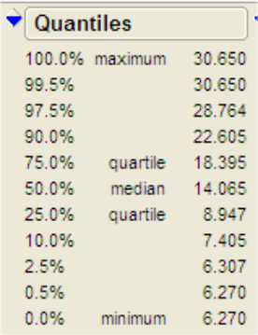
Quantiles (or percentiles) are measures of location or relative standing for a numeric variable. The k^{th} quantile is a value such that k% of the values of the variable are less than that value and (100 - k)% are larger. For example the 90th quantile, which is $22.605 here, tells us that 90% of the hotdogs in the study have cost per pound of protein less than $22.61 and 10% have a larger cost. The most commonly used quantile is the median or 50th quantile. The median, like the mean, is a measure of typical value for a numeric variable. When the distribution of variable is markedly skewed it is generally preferable to use the median as a measure of typical value. When the mean and median are approximately equal we can conclude the distribution of the variable in question is reasonably symmetric and either can be used. In practice one should generally look at both the median and mean, reporting both when they substantially different. Other common quantiles are what are called the quartiles of the distribution. They are the 25th, 50th (median) and the 75th quantiles - essentially dividing the data into four intervals with 25% of the observations lying in each interval. The minimum (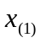) and maximum (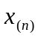) observed values are also reported in this box.
There are three measures of variation that can be derived from the quantiles reported.
- Range = maximum - minimum (tends to get larger as sample size increases, why?)
- Inter-quartile Range (IQR) = 75th quantile - 25th quantile (this gives the range of the middle 50% of the data)
- Semi-quartile Range (SQR) = IQR/2 (half the range of the middle 50% of the observations)

Outlier Boxplots
Below are outlier boxplots for the cost-related variables.
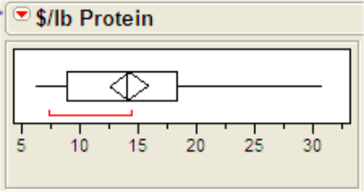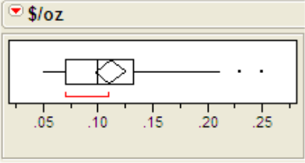

The outlier boxplot is constructed by using the quartiles of the variable. The box has a left edge at the first quartile (i.e. 25th quantile) and right edge at the third quartile (i.e. 75th quantile). The width of the box thus shows the interquartile range (IQR) for the data. The vertical line in the boxplot shows the location of the median. The point of the diamond inside the box shows the location of the sample mean. The whiskers extend from the boxplot to the minimum and maximum value for the variable unless there are outliers present. For the cost per ounce there are two outliers shown as single points to the right of the upper whisker. Any point that lies below Q₁ - 1.5 (IQR) or above
Q₃ + 1.5 (IQR) is flagged as a potential outlier. By clicking on these points we can see that they correspond to General Kosher Beef and Wall's Kosher Beef Lower Fat hotdogs. The square bracket located beneath the boxplot shows the range of the densest (most tightly packed) 50% of the data. Both of these boxplots exhibit skewness to the right.

Comparative Boxplots
Boxplots are particularly useful for comparing the values of variable across several populations or subgroups. Here we have three types of hotdogs and it is natural to compare their values on the given numerical attributes. To do this in JMP select Fit Y by X from the Analyze menu and place the grouping variable (Type in this case) in the X, Factor box and the numerical attribute to compare across the groups in the Y, Response box. Below is the comparative boxplots for $/oz with numerical summary statistics added. To add the boxes to the plot select Quantiles from the Oneway Analysis pull-down menu (see below). To stagger the data points in the plot select the option Jitter from the Display Options pull-out menu (see below). To obtain additional numerical summaries of cost for each the hotdog types you can Means and Std Dev from the Oneway Analysis pull-down menu.
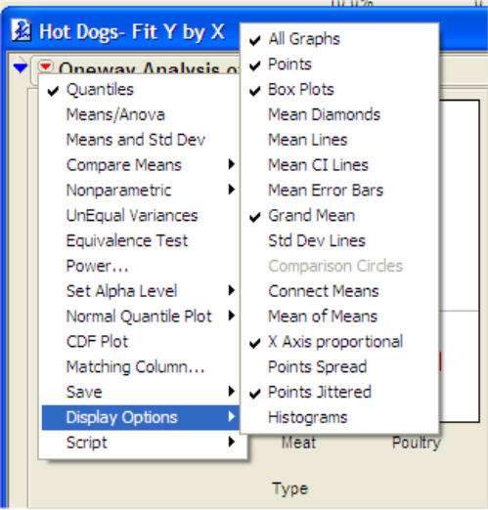
Adds histograms for each group on the side of the plot.
Turn this off if the sample size for some groups are much smaller than rest.

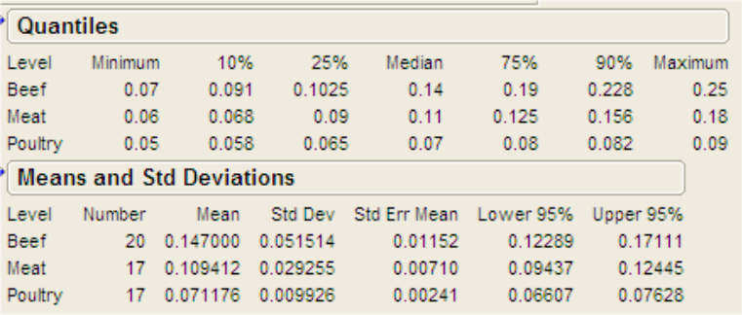
We can clearly see from the comparative boxplot that poultry hotdogs are the cheapest while beef hotdogs are the most expensive. The means and medians also support this finding (e.g. 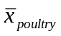= .071, 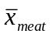= .109, 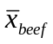= .147). Also notice there is very little variation in the cost of the poultry hotdogs while there appears to be substantial variation in the cost of the beef hotdogs. This fact is further reflected by the standard deviations of the cost for the three types (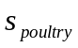= .0099, 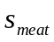= .0293, 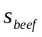= .0515). The coefficient of variation (CV) could also be calculated for each hot dog type (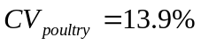, 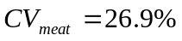, 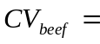35.0%). Similar comparative analyses could be performed using the other numeric variables in this data set or using taste category as the factor variable.

CDF Plots
A CDF plot shows what fraction of observations are less than or equal to each of the observed values of a numeric variable plotted vs. the observed values. The plot below gives the CDF plots for Calories levels for each the hot dog types. To obtain these select the CDF Plots from the Oneway Analysis... pull-down menu. We can see that approximately 25% of the poultry hotdogs have less than 100 calories, approx. 50% have less than 120 calories, and approx. 75% have 140 calories or less. For the meat and beef hot dogs however only about 25% have 140 calories or less.

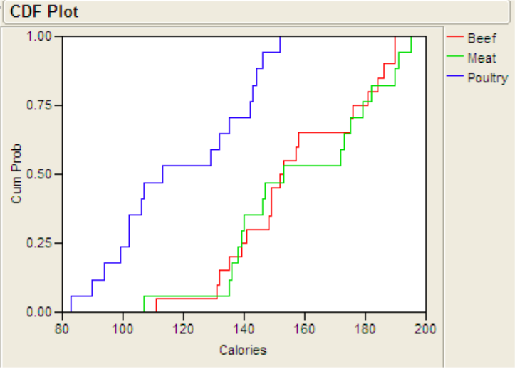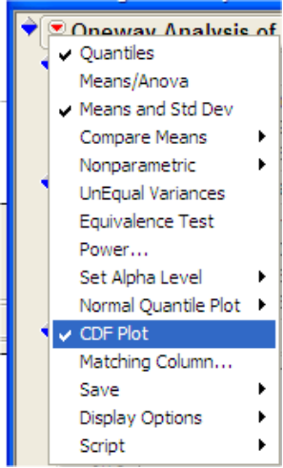
Example of how to read a CDF plot: About 70% of poultry hotdog brands have 140 calories or less.

3.8 - Bivariate Relationships for Numeric Variables
Correlations and Scatterplots
To numerically summarize the strength of the relationship between two numeric variables we typically use the correlation or more explicitly Pearson's Product Moment Correlation (there are others!). The correlation (denoted r) measures the strength of linear association between two numeric variables. The correlation is a dimensionless quantity that ranges between -1 and +1. The closer in absolute value the correlation is to 1 the more linear the relationship is. A correlation of 1 indicates that the two variables in question are perfectly linear, i.e. knowing the value of one of the variables allows you to say without error what the corresponding value of the other variable is. 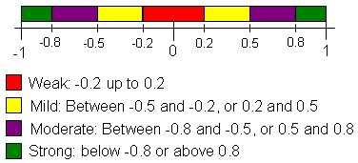

Visualizations of Correlation:
(Excellent visualization tool at: http://noppa5.pc.helsinki.fi/koe/corr/cor7.html )

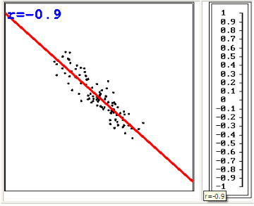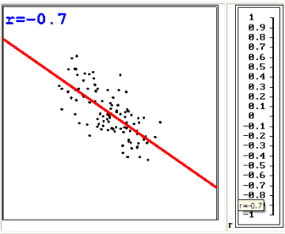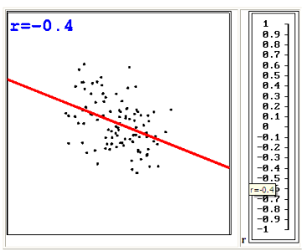
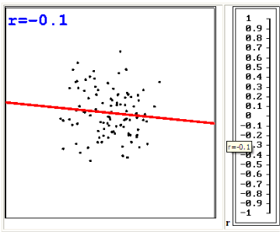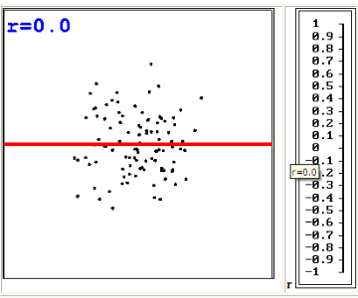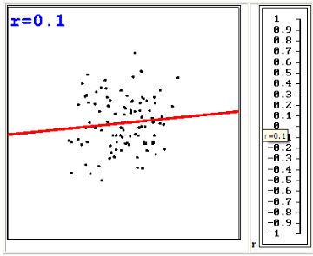
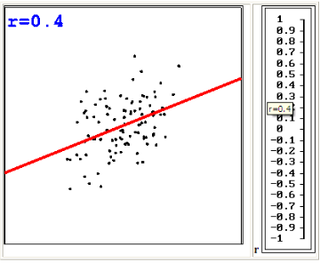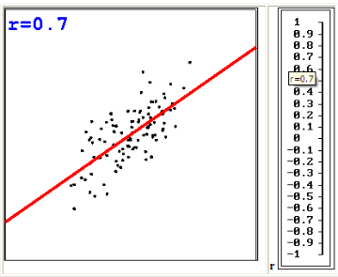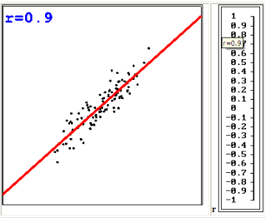

One should never interpret correlations without also examining a scatterplot of the relationship. Because correlation measures the strength of linear association we need to make sure the apparent relationship is indeed linear. The plot below is a scatterplot of the two cost-related variables. To construct a scatterplot of $/lb Protein vs. $/oz select Fit Y by X and place $/oz in the X box and $/lb Protein in the Y box. We would expect that these variables are closely related.
Fit Line – fit simple linear regression line
Fit Mean – adds horizontal line at
Fit Polynomial – fit polynomial function to data
Fit Special – has some useful options but too many to discuss now.
Fit Spline – non-parametric smooth fit that captures relationship between Y and X.
Fit Orthogonal – 1st option available here gives the sample correlation (r).
Density Ellipse – a confidence ellipse to plot
Nonpar Density – 2-D histogram w/ contours
Histogram Borders – gives histogram in margins of X and Y
Group By… - allows you to choose nominal variable to do conditional fitting on. For example fit a separate regression line for each level of chosen variable.

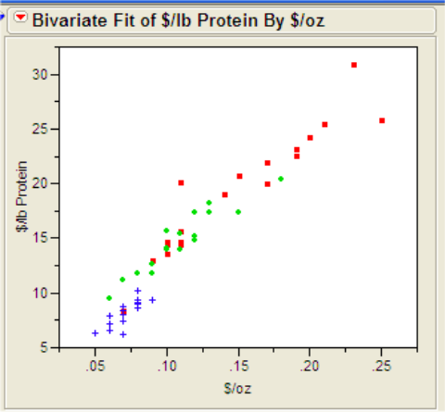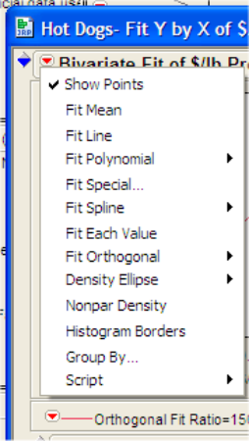

This plot clearly exhibits a strong linear trend, as cost per ounce increases so does the cost per pound of protein. Although it does not show well the points in this plot have been color coded to indicate type of hotdog. To do this in JMP select Color/Marker by Col... from the Rows menu and highlight Type with your mouse then click OK. Notice the poultry hotdogs are clustered in the lower left-hand corner of the scatterplot. This is due to the fact that poultry hotdogs are quite a bit cheaper than the other two types as we have seen in the comparative analyses above. Unfortunately there is no simple way to obtain the correlation associated with these variables from the current analysis window.
To examine correlations for a set of variables we select Multivariate Methods > Multivariate from Analyze menu and place as many numeric variables as we wish to examine in the right hand box. Below is a correlation matrix for all of the numeric variables in the hotdog data set.
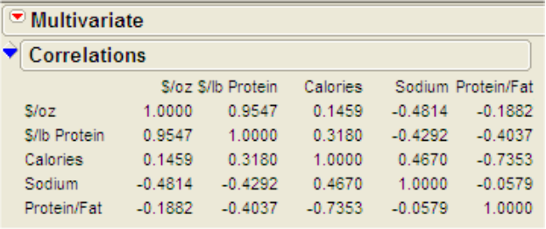
We can see that the correlation associated with $/oz and $/lb Protein is .9547. This is a very high correlation value indicating a strong linear relationship between the two cost-related variables exists, which is further substantiated by the scatterplot above. None of the other correlations are as high, although there appears to be a moderate negative correlation between Calories and the Protein/Fat ratio (r = -.7353). We can examine all pairwise scatterplots for these variables in the form of a Scatterplot Matrix which is shown on the following page.
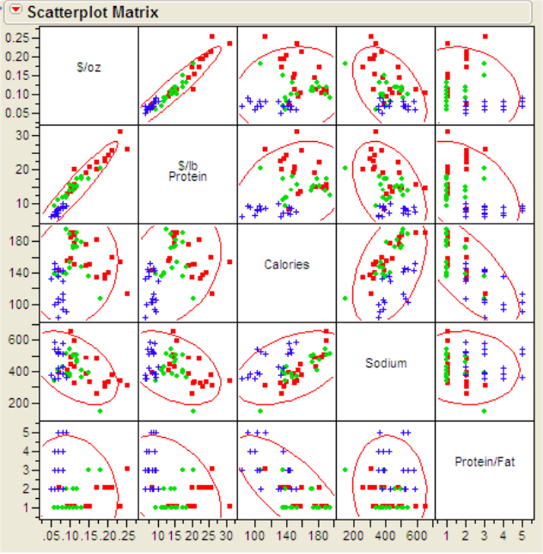
The ellipse drawn in each panel of the scatterplot matrix is drawn so that it contains approximately 95% of the data points in the panel assuming the relationship is linear. Points outside the ellipses are a bit strange and may be considered to be potential outliers. You can remove the ellipses from the plot by de-selecting that option from the pull-down menu located at the top of the scatterplot matrix. None of the scatterplots, outside of the cost-related variables, in the scatterplot matrix exhibit a strong degree of correlation. The stripes evident in the panels associated with the protein to fat ratio are due to the discreteness of that variable.

