Example 6.5: Cancer and Nuclear Power Plants
(Taken from example 7.49, Bernard Rosner’s Fundamentals of Biostatistics, 6th Edition)

The safety of people who work at or live by nuclear-power plants has been the subject of widely publicized debate in recent years. One possible health hazard from radiation exposure is an excess of cancer deaths among those exposed. One problem with studying this question is that the number of deaths attributable to either cancer in general or specific types of cancer is small, and reaching statistically significant conclusions is difficult, except after long periods of follow-up. An alternative approach is to perform a proportional-mortality study, whereby the proportion of deaths attributed to a specific cause in an exposed group is compared with the corresponding proportion in a large population.

Suppose, for example, that 13 deaths have occurred among 55-64 year-old male workers in a nuclear-power plant and that in 5 of them the cause of death was cancer. Assume, based on vital-statistics reports, that approximately 20% of all deaths can be attributed to some form of cancer.

Research Question: Is there evidence that the proportion of deaths from cancer in nuclear-power plant workers is greater than the proportion of deaths from cancer in men of comparable age in the general population?

The following graphic shows the results of 1,000 simulated trials. In each trial, we assumed the probability of dying from cancer for a nuclear-power plant worker was 20% (the same as that of the general population of males aged 55-64). Each time, we took a sample of 13 deaths and counted the number out of the 13 that were attributed to cancer.
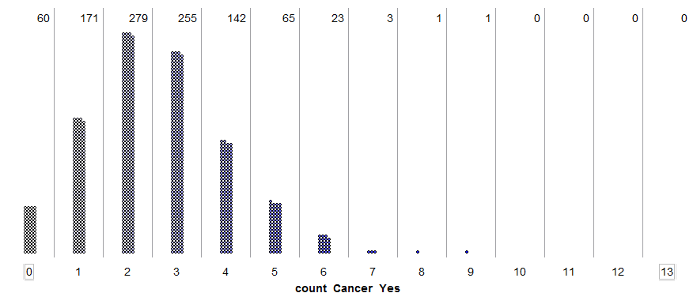
Note that this picture is quite similar to what we obtain when we use the binomial distribution with n = 13 and π = .20:

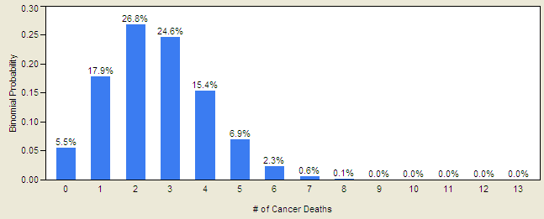

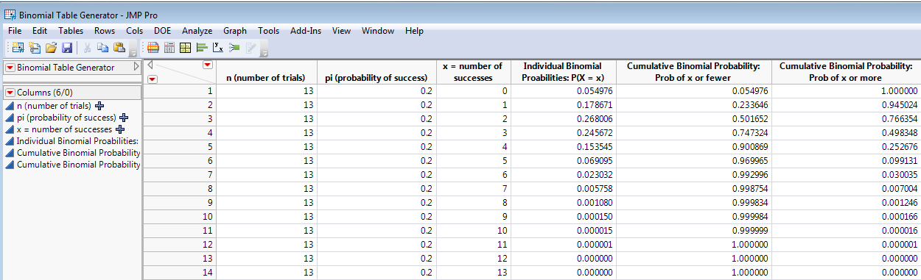

Questions:

- If we assume that the cancer death rate is the same for the nuclear-power plant workers as for the general population, how many cancer deaths did you expect to see in the sample? How does the observed value compare to this expected value?

- Assuming the cancer death rate is the same for the nuclear-power plant workers as for the general population, use the simulation results to estimate the probability of observing 5 OR MORE cancer deaths in our sample. Then, use the binomial distribution to find this exact probability.

- Does this provide sufficient evidence that the proportion of deaths from cancer in nuclear-power plant workers is greater than 20% (the proportion of deaths from cancer in men of comparable age in the general population)? Explain.

Example 6.6: Female Ecology Majors
A few years ago, this was the breakdown of biology majors by gender at Winona State University. At the time the data was taken, 66% of the student body was female. Note that in most majors offered by the Biology department, the percentage of males and females matches that of the university overall quite well. Biology: Ecology might be the one exception.

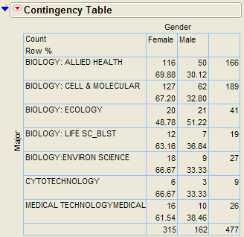

Research Question: Are females under-represented for the Biology: Ecology major at this point in time?

The following graphic shows the results of 1,000 simulated trials. In each trial, we took a sample of 41 Ecology majors and counted the number out of the 41 that were female. Moreover, the simulation was carried out under the assumption that females were NOT under-represented in Ecology (i.e., the probability an Ecology major was female was assumed to be 66%).

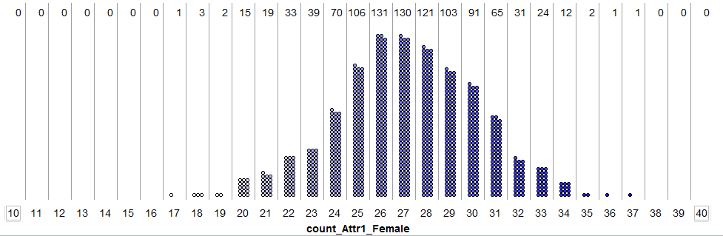
Note that this picture is quite similar to what we obtain when we use the binomial distribution with n = 41 and π = .66:

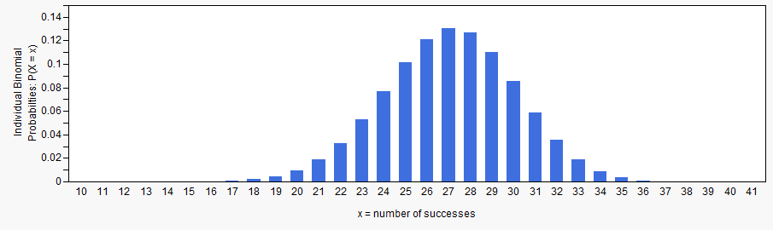

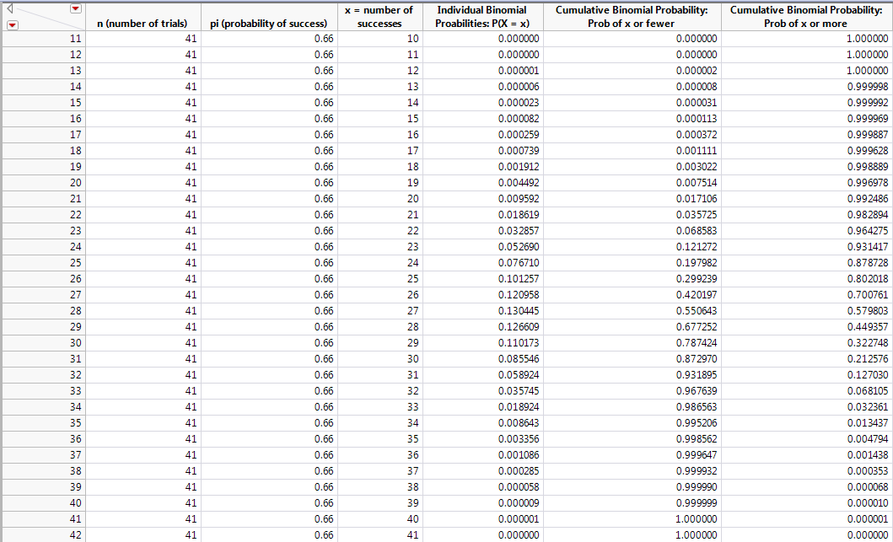

Questions:

- Assuming that females are not under-represented, use the simulation results to estimate the probability of observing 20 OR FEWER female ecology majors. Then, use the binomial distribution to find this exact probability.
- Does this provide sufficient evidence that females are under-represented in the Ecology major? Explain.

Example 6.7: Ear Infections
(from Bernard Rosner’s Fundamentals of Biostatistics)

A common symptom of otitis media (ear infection) in young children is the prolonged presence of fluid in the middle ear. The hypothesis has been proposed that babies who are breast-fed for at least 1 month may build up some immunity against the effects of the disease. A small study of 24 pairs of babies is set up, where the babies are matched on a one-to-one basis according to age, sex, socioeconomic status, and type of medications taken. One member of the matched pair is a breast-fed baby, and the other was bottle-fed. The researchers recorded the duration (in days) of fluid in the middle ear after the first episode of otitis media. The results from the 24 pairs are shown below:
Pair | Breast-fed duration | Bottle-fed duration
1 | 20 | 18
2 | 11 | 35
3 | 3 | 7
4 | 24 | 182
5 | 7 | 6
6 | 28 | 33
7 | 58 | 223
8 | 7 | 7
9 | 39 | 57
10 | 17 | 76
11 | 17 | 186
12 | 12 | 29
13 | 52 | 39
14 | 14 | 15
15 | 12 | 21
16 | 30 | 28
17 | 7 | 8
18 | 15 | 27
19 | 65 | 77
20 | 10 | 12
21 | 7 | 8
22 | 18 | 16
23 | 34 | 28
24 | 25 | 20

Research Question: Is there a statistically significant difference in the duration of ear infection between the breast-fed and the bottle-fed babies?
Because of the matched-pairs nature of the data, the comparisons should be made WITHIN each pair of babies. Therefore, it makes sense to consider the difference between the two groups.
Pair | Breast-fed duration | Bottle-fed duration | Difference = Breast - Bottle
1 | 20 | 18 | 2
2 | 11 | 35 | -24
3 | 3 | 7 | -4
4 | 24 | 182 | -158
5 | 7 | 6 | 1
6 | 28 | 33 | -5
7 | 58 | 223 | -165
8 | 7 | 7 | 0
9 | 39 | 57 | -18
10 | 17 | 76 | -59
11 | 17 | 186 | -169
12 | 12 | 29 | -17
13 | 52 | 39 | 13
14 | 14 | 15 | -1
15 | 12 | 21 | -9
16 | 30 | 28 | 2
17 | 7 | 8 | -1
18 | 15 | 27 | -12
19 | 65 | 77 | -12
20 | 10 | 12 | -2
21 | 7 | 8 | -1
22 | 18 | 16 | 2
23 | 34 | 28 | 6
24 | 25 | 20 | 5
Questions:

- In how many pairs did the breast-fed baby do better than the bottle-fed baby?
- In how many pairs did the bottle-fed do better?
- Pair #8 is a tie. What does this mean in the context of the problem? Does this pair provide evidence for bottle-fed doing better, breast-fed doing better, or neither? Explain.

Recall that we are restricted to considering only two outcomes when using the binomial distribution. So, we will not include Pair #8 in our analysis.
Questions:

- If the tie is removed, how many pairs do we have in the sample?
- If there is really no difference in the duration of ear infection between breast-fed and bottle-fed babies, what is the probability that the bottle-fed baby will do better than the breast-fed baby in any given pair?

Now, we can use the binomial distribution to investigate this research question.
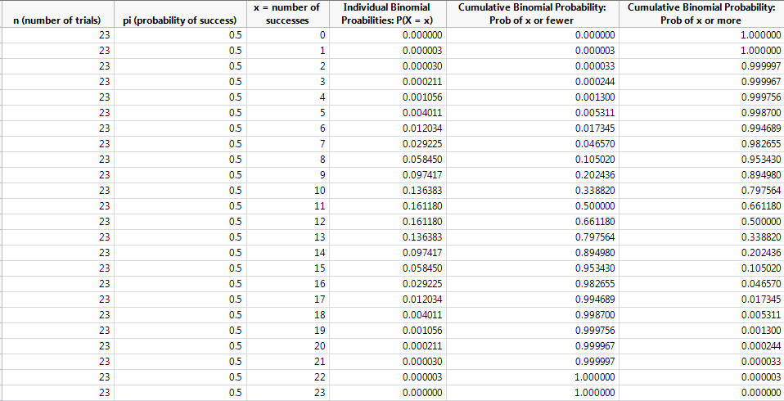
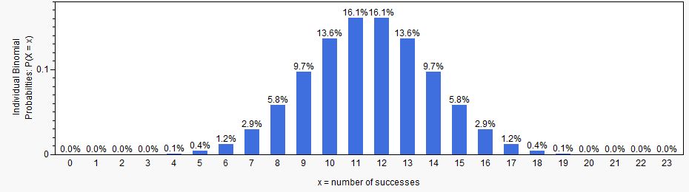
Questions:
- Was the observed value (16 pairs in which the breast-fed baby did better) unlikely to have happened by chance? What conclusion, if any, can we make regarding the research question?

FORMAL HYPOTHESIS TESTING

In the previous examples, we have used the binomial distribution to make statistical inferences in problems involving a single categorical variable. Next, we will add more structure to these statistical investigations by introducing a procedure which statistician’s call hypothesis testing.
Hypothesis testing is a procedure, based on sample evidence and probability, used to test claims regarding a population parameter. The test will measure how well our observed data agrees with a statement concerning the parameter of interest.

Before you begin a hypothesis test, you should clearly state your question of interest. For instance, let’s reconsider the research question from three of our previous examples.
Example | Research Question
Example 6.4: Congenital Malformations | Do these data provide statistical evidence of an excess risk of malformations in children born to Vietnam-veteran fathers?
Example 6.6: Female Ecology Majors | Is there statistical evidence that females are under-represented in the Biology: Ecology major?
Example 6.7: Ear Infections | Is there a statistically significant difference in the duration of ear infection between the breast-fed and the bottle-fed babies?

The hypothesis test is then carried out as follows.
Step One: Writing The Null And Alternative Hypothesis

- The null hypothesis, H_{o}, is assumed true until evidence indicates otherwise. This usually contains statements such as “there is no difference…”

- The alternative hypothesis, H_{a}, is what we are trying to show. Therefore, the question of interest is restated here in the alternative hypothesis. Also, this usually contains statements such as “there is a difference…” or “is greater than…” or “is less than…”
For our three examples, the null and alternative hypotheses are shown below.
Research Question | Hypotheses
Do these data provide statistical evidence of an excess risk of malformations in children born to Vietnam-veteran fathers? | H_{o}: The probability of congenital  malformations is the same for children  born to Vietnam-veteran fathers as for  the general population.  H_{a}: Children born to Vietnam-veteran  fathers have an excess risk of congenital  malformations.
Is there statistical evidence that females are under-represented in the Biology: Ecology major? | H_{o}: Females are not under-represented in the  Ecology major.  H_{a}: Females are under-represented in the  Ecology major.
Is there a statistically significant difference in the duration of ear infection between the breast-fed and the bottle-fed babies? | H_{o}: There is no difference in duration of  fluid between bottle- and breast-fed  babies.  H_{o}: There is a difference in duration of  fluid between bottle- and breast-fed  babies.

Step Two: Finding Either the Critical Value/Region or the p-value
Finding the correct critical value/region or p-value for a given problem depends on whether the test is upper-tailed, lower-tailed, or two-tailed.

Example 6.4 regarding congenital malformations is an example of an upper-tailed test because we were trying to show that the observed number with malformations was higher than expected if the null hypothesis were true.
To find the critical value/region or p-value for this example, we must consider a binomial distribution with n = 100 and π = .025. This example uses Binomial Probability Calculator in Excel.
Finding the Critical Value and Critical Region:
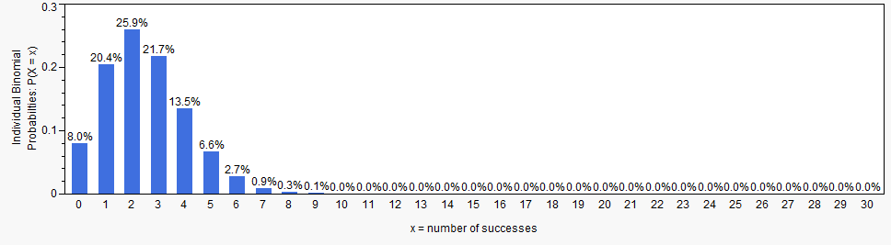

Finding the p-value:
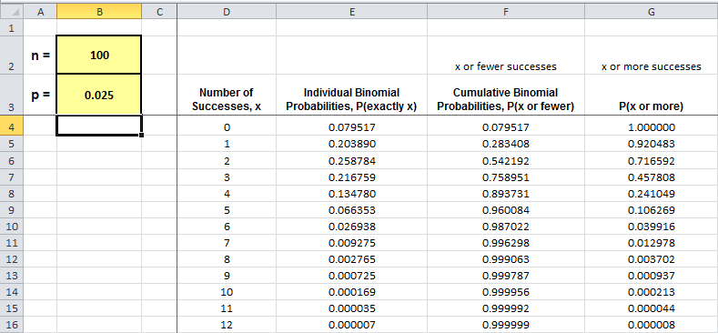
Example 6.6 regarding females majoring in ecology is an example of a lower-tailed test because we were trying to show that the observed number of females was lower than expected if the null hypothesis were true.
To find the critical value/region or p-value for this example, we must consider a binomial distribution with n = 41 and π = .66.
Finding the Critical Value and Critical Region:
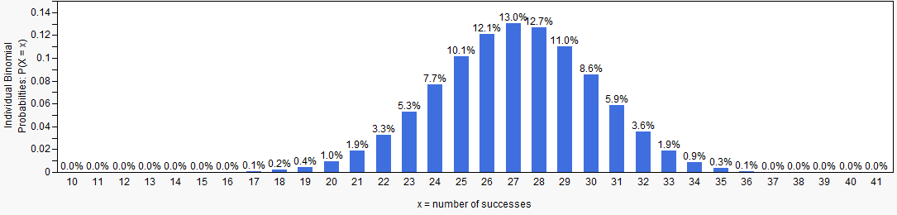

Finding the p-value:
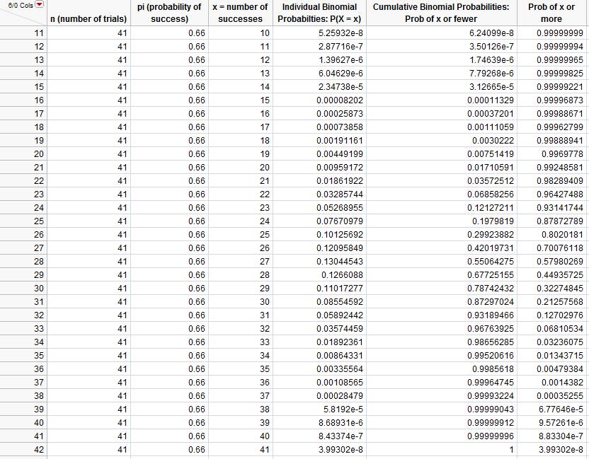
Example 6.7 regarding ear infections is an example of a two-tailed test because we were looking for a difference between the two groups.
To find the critical value/region or p-value for this example, we must consider a binomial distribution with n = 23 and π = .50.
Finding the Critical Value and Critical Region:
Finding the p-value:

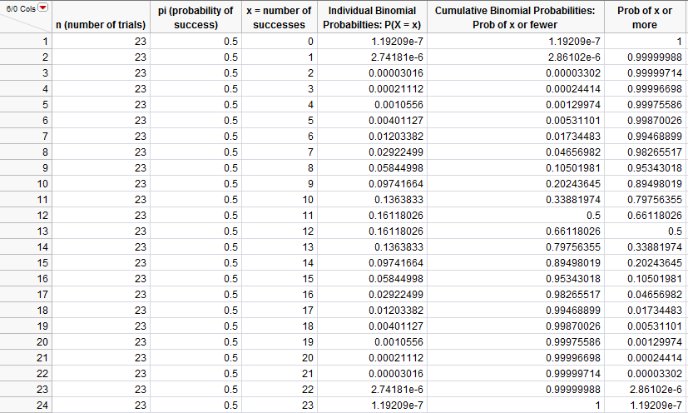

Step Three: Writing a Conclusion Regarding the Research Question

Critical Value/Region Method:
- If the observed value falls in the critical region, then we have evidence to support the alternative hypothesis (i.e., the research question).
- If the observed value does not fall in the critical region, then we say that we have no evidence to support the research question.

P-value Method:
- If the p-value falls below .01, we have very strong evidence to support the alternative hypothesis (i.e., the research question).
- If the p-value falls below .05, we have strong evidence to support the alternative hypothesis (i.e., the research question).
- If the p-value falls below .10 but above .05, we have “marginal” evidence to support the alternative hypothesis (i.e., the research question).
- If the p-value is above .10, we have no evidence to support the research question
Using these rules, write conclusions for each of our three examples:
Hypotheses | Conclusion
H_{o}: The probability of congenital
malformations is the same for children
born to Vietnam-veteran fathers as for
the general population.
H_{a}: Children born to Vietnam-veteran
fathers have an excess risk of congenital malformations.
H_{o}: Females are not under-represented in the
Ecology major.
H_{a}: Females are under-represented in the
Ecology major.

H_{o}: There is no difference in duration of
fluid between bottle- and breast-fed
babies.
H_{o}: There is a difference in duration of
fluid between bottle- and breast-fed
babies.

