R: Direct File Download
Example #1
Consider the following website: https://s3.amazonaws.com/tripdata/index.html
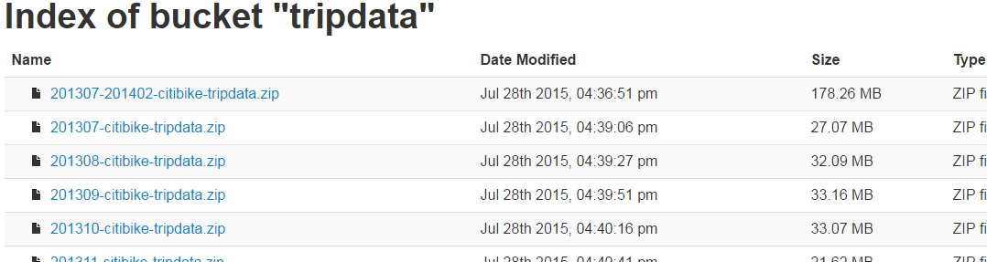
Citi Bike Website  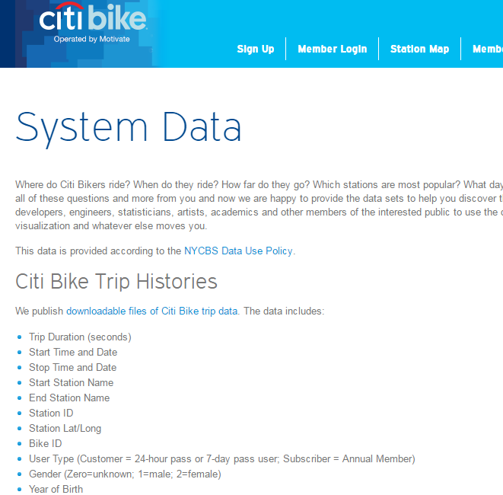 | HTML Code does not contain links  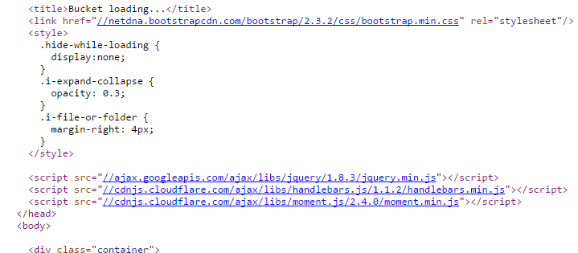

The following code produces no output.
library(rvest)
url<-"https://s3.amazonaws.com/tripdata/index.html"
page <- read_html(url)
temp<-html_text(html_nodes(page, "a"))
df<-as.data.frame(temp)
View(df)

Direct File Download
The download.file() function will allow one to directly download a file. The file being downloaded here is a compressed file (*.zip) and thus needs to be unzipped before using the read.csv().
#Using download.file to get file
#create a temporary file
temp <- tempfile()
download.file("https://s3.amazonaws.com/tripdata/201603-citibike-tripdata.zip",temp,mode="wb")
temp1 <- unzip(temp, "201603-citibike-tripdata.csv")
df <- read.csv(temp1, header=T, sep=",")
unlink(temp)

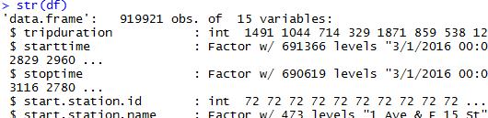

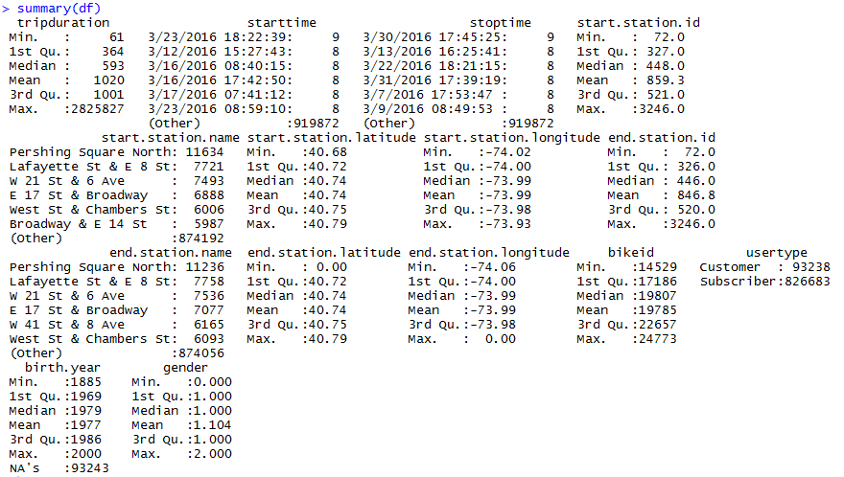

The download.file() function

trip<-subset(df,tripduration<3600,select=tripduration)
hist(trip$tripduration)

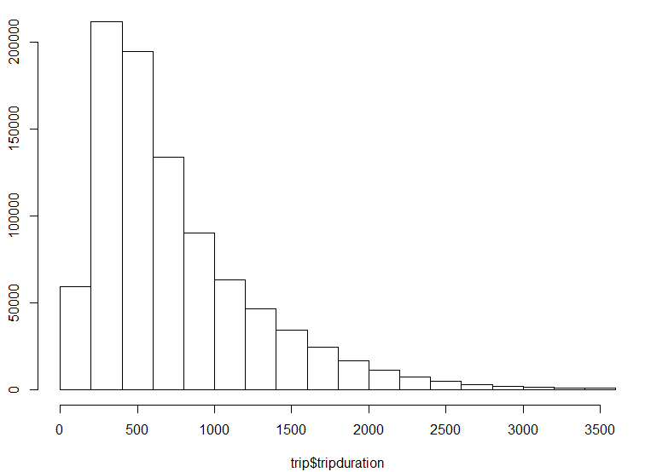

Example #2
Consider the following website: https://www.ssa.gov/oact/babynames/limits.html

#Reading in zip file that contains several files
zipdir <- tempfile()
dir.create(zipdir)
download.file("https://www.ssa.gov/oact/babynames/state/namesbystate.zip", temp, mode="wb")
unzip(temp, exdir=zipdir)
files <- list.files(zipdir, pattern="\\.TXT$")
df<-data.frame()
for(i in 1:length(files)){
filepath <- file.path(zipdir,files[i])
temp <- read.csv(filepath,header=F)
df<-rbind(df, temp)
}
unlink(zipdir)

