R: Web Scraping
Web scrapping in R is accomplished through the rvest package.
library(rvest)
Example #1
Website: http://course1.winona.edu/cmalone/dsci210/Exams/USQuickFacts_Webscrape1.html
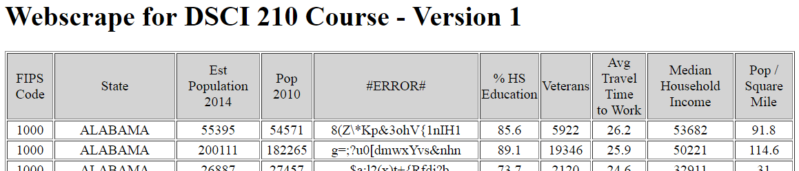

HTML Snipit
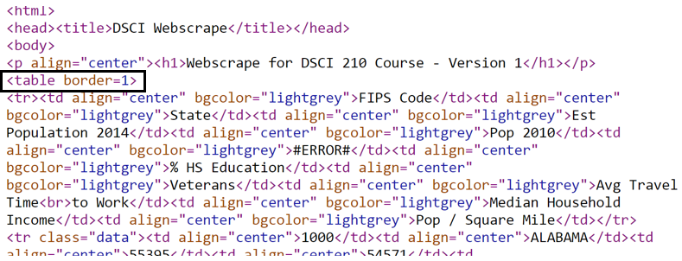

The data to be scraped sits inside a HTML table, thus the function html_table() should be used to put data into a useable R format.
url <- "http://course1.winona.edu/cmalone/dsci210/Exams/USQuickFacts_Webscrape1.html"
page <- read_html(url)
temptable <- html_table(page, header=TRUE)
df<-as.data.frame(temptable)

Data put into a data.frame in R
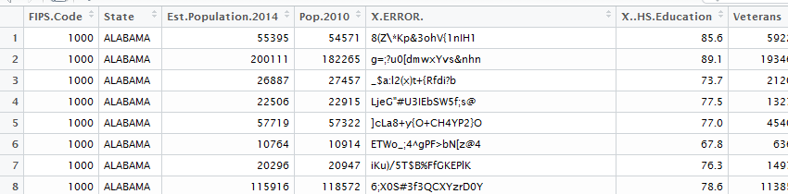

Getting summaries for Avg. Travel Time to Work
summary(df$Avg.Travel.Timeto.Work)
hist(df$Avg.Travel.Timeto.Work)
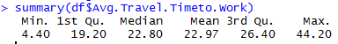
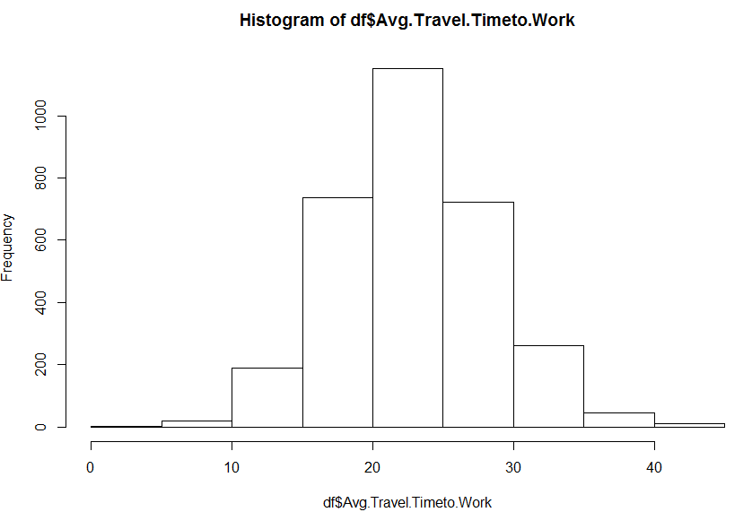

Example #2
Website: http://course1.winona.edu/cmalone/dsci210/Exams/USQuickFacts_Webscrape2.html

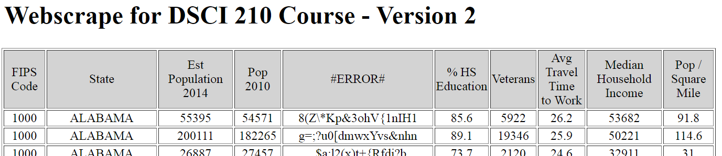
HTML Snipit
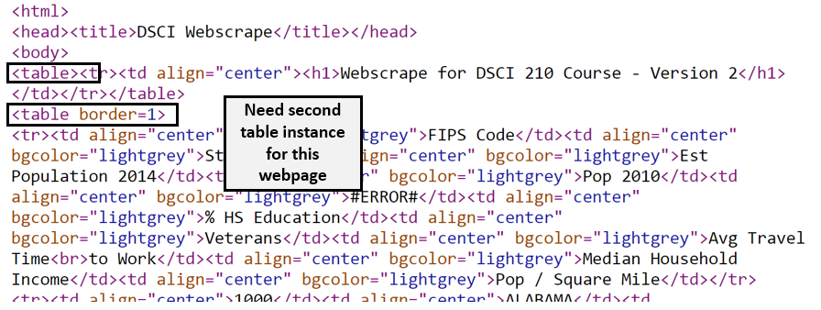

R code to read in this version of webpage. Note the [[2]] is pulling off the second table instance on this webpage.
url <- "http://course1.winona.edu/cmalone/dsci210/Exams/USQuickFacts_Webscrape2.html"
page <- read_html(url)
temptable <- html_table(page, header=TRUE)[[2]]
df<-as.data.frame(temptable)

This data as read in my R and put into a data.frame in R

Example #3
Website: https://www.ssa.gov/oact/babynames/numberUSbirths.html

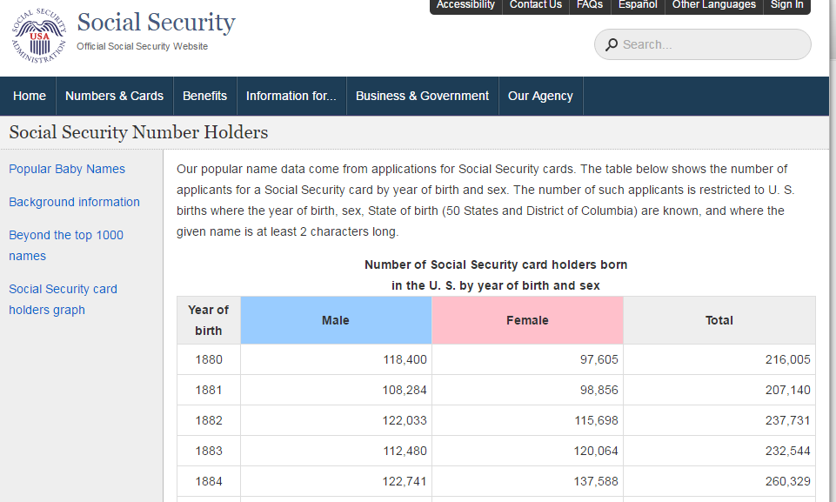

HTML Snipit

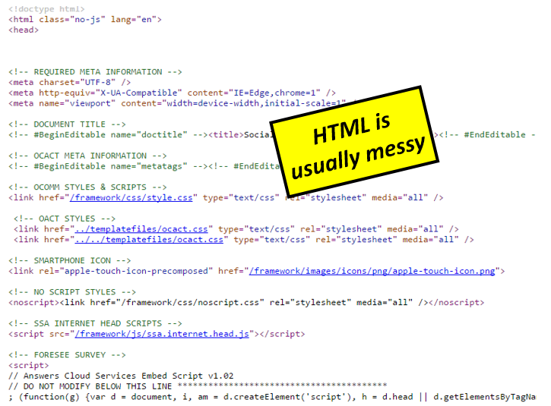

Chrome Extension: SelectorGadget

The SelectorGradget extension for Chrome will allow us to identify the location of content to be scraped.
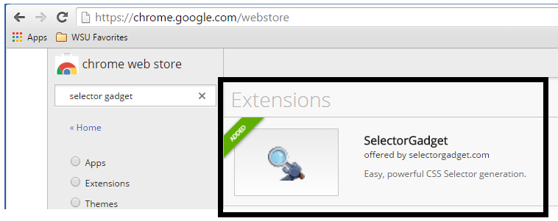

Using the SelectorGadget inside Chrome.

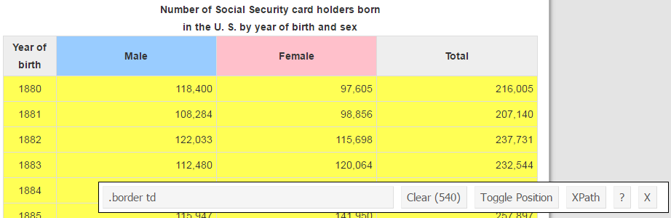

R code to scrape this data

url<-"https://www.ssa.gov/oact/babynames/numberUSbirths.html"
page <- read_html(url)
temp<-html_text(html_nodes(page, ".border td"))
df<-as.data.frame(temp)

Structure of data.frame is not correct, no rows…

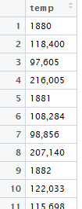

Data processing steps. Note: gsub() function is necessary to remove comma in counts before converting to numeric.
rowid<-rep(c(1,2,3,4),135)
Year<-as.numeric(as.character(df$temp[rowid==1]))
Males<-as.numeric(gsub(",","",df$temp[rowid==2]))
Females<-as.numeric(gsub(",","",df$temp[rowid==3]))

Getting a simple plot to compare trends over time between Males and Females.

plot(Year,Males,type='n')
lines(Year,Males,col="blue")
lines(Year,Females,col='pink')

