Variable Importance in R

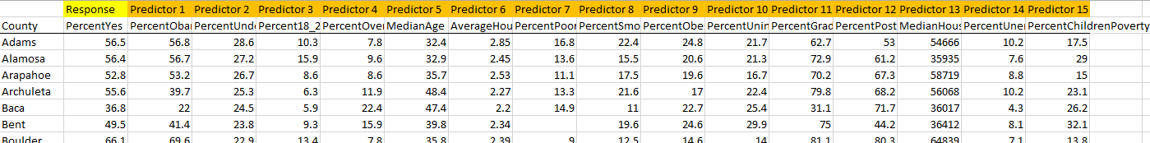

> pairs(CO[,2:17])

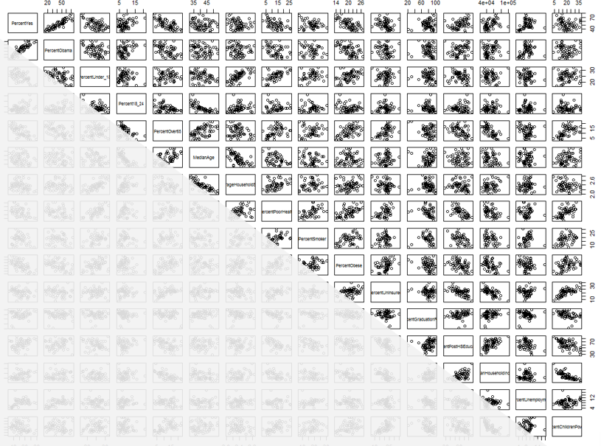

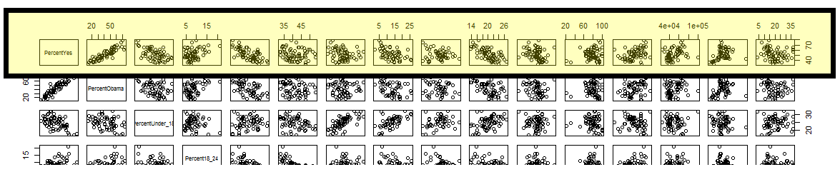

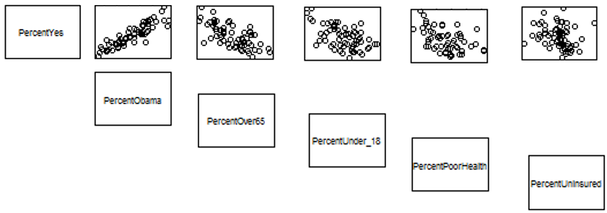

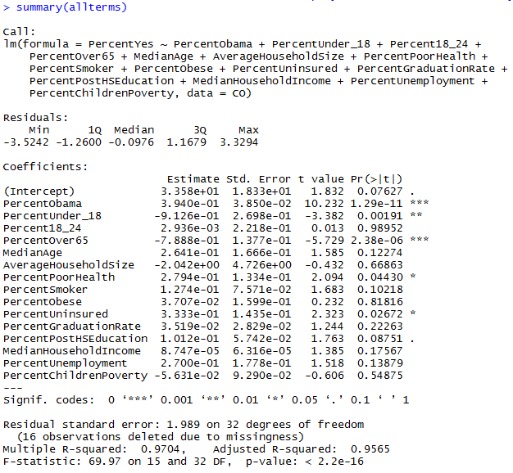

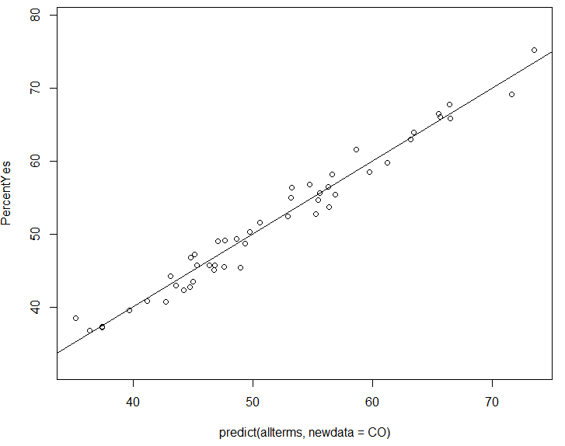

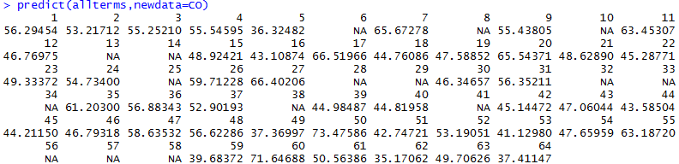

allterms <- lm(PercentYes ~ PercentObama + PercentUnder_18 + Percent18_24 + PercentOver65 + MedianAge + AverageHouseholdSize + PercentPoorHealth + PercentSmoker + PercentObese + PercentUninsured + PercentGraduationRate + PercentPostHSEducation + MedianHouseholdIncome + PercentUnemployment + PercentChildrenPoverty, data=CO_NoNA)

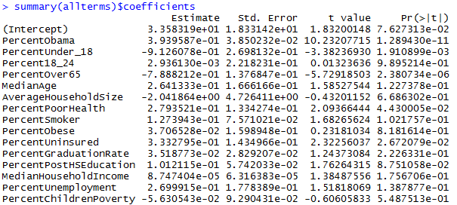

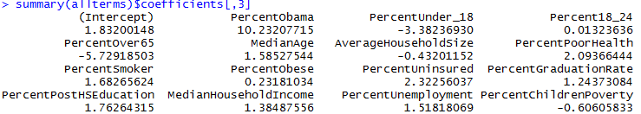

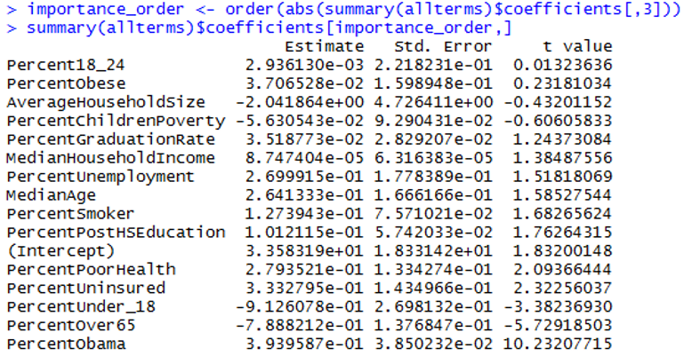

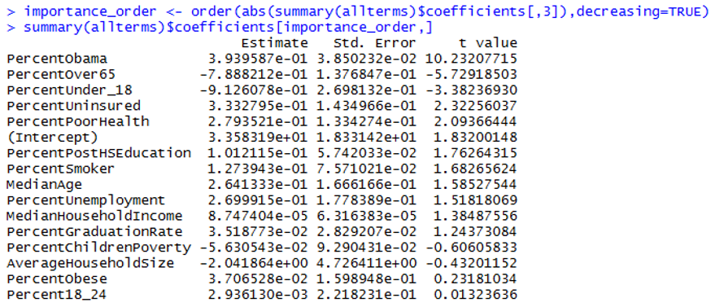

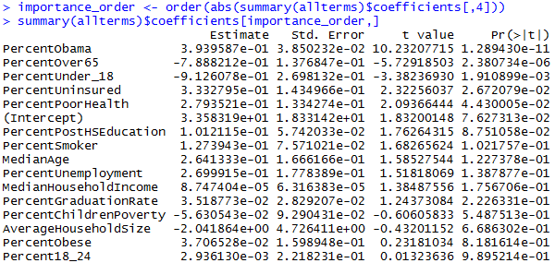

> avg_error_original <- mean(abs(CO_NoNA$PercentYes - predict(allterms,newdata=CO_NoNA)))
> avg_error_original
[1] 1.339041

> CO_NoNA_Temp <- CO_NoNA
> CO_NoNA_Temp[,3] <- sample(CO_NoNA_Temp[,3])
> avg_error_temp <- mean(abs(CO_NoNA_Temp$PercentYes - predict(allterms,newdata=CO_NoNA_Temp)))
> avg_error_temp
[1] 6.664014

avg_error_temp = data.frame(i=rep(0,15),error=rep(0,15))
#Looping through all predictors
for(i in 1:15){
CO_NoNA_Temp <- CO_NoNA
#View(CO_NoNA_Temp)
avg_error_temp[i,1] <- i
CO_NoNA_Temp[,(2+i)] <- sample(CO_NoNA_Temp[,(2+i)])
avg_error_temp[i,2] <- mean(abs(CO_NoNA_Temp$PercentYes - predict(allterms,newdata=CO_NoNA_Temp)))
}

> error_order<-order(avg_error_temp[,2],decreasing=TRUE)
> avg_error_temp[error_order,]
i error
1 1 7.346729
4 4 4.619174
2 2 3.610567
7 7 2.373233
10 10 2.136315
12 12 1.982633
5 5 1.960197
13 13 1.819093
8 8 1.532174
14 14 1.500116
11 11 1.438033
15 15 1.394988
9 9 1.372453
6 6 1.354339
3 3 1.340008

