STAT 110: Exam #3 Name:__________________________________

- Answer the following True/False questions.
a. | T | F | Suppose the scores on an exam range from 0 to 100. A score of 50 must be equal to the 50th percentile.
b. | T | F | The average is measured on the same scale as the data. That is, if the data is in dollars, then the average is expressed in dollars as well.
c. | T | F | The standard deviation is measured on the same scale as the data. That is, if the data is in dollars, then the standard deviation is expressed in dollars as well.
d. | T | F | The range is the most widely accepted method of measuring spread for a set of data by statisticians.
e. | T | F | The standard deviation uses all the data points in its calculation.
f. | T | F | Z-scores are used to identify outliers in a set of data.
g. | T | F | If a data point has a Z-Score below -2 or above +2, then it is considered an outlier.
h. | T | F | A p-value cannot be less than 0 nor greater than 1.
i. | T | F | A t-test can be used to expand the scope of inference beyond the data you have collected.

I live in Rushford and drive to Winona each day to get to work. It takes about 30 minutes to get to work, but the actual time varies due to: when I leave the house, conditions of the road, road construction, whether or not I have to wait for train, availability of parking spots, etc.

- In terms of my driving, which of the following would influence only the center (or location) of the distribution for “time it takes to get to work”.
- Drive faster every day or drive slower every day.
- Drive faster on some days and drive slower on other days.
- Changing your speed will not change the center of this distribution.

- In terms of my driving, which of the following would influence only the variability (or spread) of the distribution for “time it takes to get to work”.
  - Drive faster every day or drive slower every day.
  - Drive faster on some days and drive slower on other days.
  - Changing your speed will not change the variability of this distribution.

Consider location across Minnesota for which snowfall amounts have been collected. For this problem, you can assume that the further north the location, the more snow that location gets.
Original Data | New Data #1 | New Data #2

- Answer the following True/False questions.
a. | T | F | We would expect that New Data #2 would have the largest average snowfall amount.
b. | T | F | We would expect that the Original Data would have the smallest standard deviation because it has the fewest number of locations.
c. | T | F | We would expect that the average of the New Data #1 would be about the same as the average from the original data.
d. | T | F | We would expect the standard deviation to be about the same between the Original Data and New Data#1.
e. | T | F | We would expect that the standard deviation for New Data #2 to be smaller than the standard deviation from New Data #1.

- A test is given to 100 students, and the scores were calculated. After grading the test, the instructor realized that the 10 students with the highest scores did exceptionally well and decides to award these 10 students by giving them an additional 5 points. Which of the following statements is correct?

  - The average of the new scores will be smaller than the average of the old scores.
  - The average of the new scores will be larger than the average of the old scores.
  - The average will not change.
  - It is impossible to tell.

- A test is given to 100 students, and scores were calculated. After grading the test, the instructor realized that the 10 students with the highest scores did exceptionally well. She decides to award these 10 students by giving them an additional 5 points. Which of the following statements is correct?

  - The median of the new scores will be smaller than the median of the old scores.
  - The median of the new scores will be larger than the median of the old scores.
  - The median will not change.
  - It is impossible to tell.

Consider the following data in which bone density of 40 patients was measured in two different locations – Forearm and Spine. The goal of this study was to determine whether or not the bone density of the forearm could be used as a substitute for bone density of the spine. Measuring the bone density in the spine is the gold standard; however, this is expensive and investigators were hoping to use forearm bone density measurements as a substitute. Bone density is measured using T-Scores with higher values implying heathier and stronger bones.
Difference = Forearm – AP Spine

Differences computed as  Difference = Forearm – AP Spine  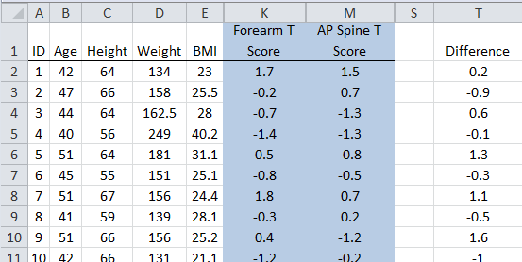 | Summaries from Excel  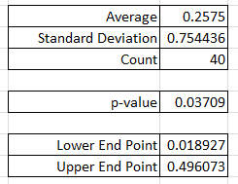
- Answer the following true/false questions. (2 pts each)

a. | All the differences need to be exactly zero before we can conclude in a statistical way that forearm bone density is a reasonable substitute for spine bone density. | TRUE | FALSE
b. | If all the differences are exactly 0.2, then the average difference will be 0.2. | TRUE | FALSE
c. | If all the differences are exactly 0.2, then the standard deviation of the differences will be 0.2. | TRUE | FALSE
d. | The average difference value of 0.2575 suggests that, for the people in this study, the forearm bone density tends to be higher than the spine bone density. | TRUE | FALSE
e. | The p-value given above (0.03709) is for the following question of interest:  Question of Interest: Is there a difference, on average, between a women’s forearm bone density and her spine bone density?  This p-value allows us to conclude that it is reasonable, on average, to use Forearm T Score as a substitute for Spine T Scores. | TRUE | FALSE
f. | The Lower and Upper Endpoints suggest that, on average, the Forearm T Scores tends to be higher than the Spine T Scores. | TRUE | FALSE

Consider the Vitamin Intake dataset that we discussed in class. Of interest in the investigation is the intake of Iron, an important mineral for us to consume. We will be making comparisons across two groups – Females and Males here. The units of measurement for this investigation is mg/day.

Iron Difference = Actual - DRI

Excel output for making comparisons.

PivotTable Output  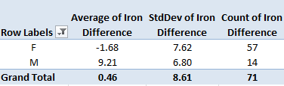 | CDF Plot  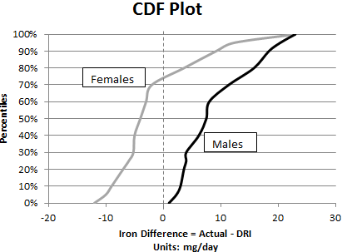

- Use the above output to answer the following True/False questions.

a. | T | F | The intake level for iron cannot go below zero, thus the average for females should be +1.68 instead of -1.68.
b. | T | F | A comparison of these averages suggests that, for the students in this study, males are taking in more iron relative to their daily recommended levels than females.
c. | T | F | A comparison of these averages suggests that, for all students at WSU, males are taking in more iron relative to their daily recommended levels than females.
e. | T | F | The CDF plot suggests that a majority of the females are taking in less iron than their daily recommended level.
f. | T | F | The number of females is different than the number of males in this study; thus, fair comparisons cannot be made between the two groups.

- Suppose the =TTEST() function was run using a spreadsheet for a two-sided test for comparing the Average Difference between Males and Females. Consider the following p-value output.

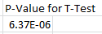

Note: The value 6.37E-06 is equal to 0.00000637.
Identify the most appropriate conclusion for this problem.
- We have enough statistical evidence to say the data supports the research question
(p-value = 6.37E-06).
- We have enough statistical evidence to say that, on average, a difference exists in the intake levels of iron between females and males (p-value = 6.37E-06).
- We have enough statistical evidence to say that, on average, a difference exists between the actual intake of iron and the daily recommended intake of iron (p-value = 6.37E-06).
- We have enough statistical evidence to say that, on average, a difference exists in the actual intake level of iron relative to their daily recommended intake level between females and males (p-value = 6.37E-06).

- Consider the following 95% confidence interval for this investigation.
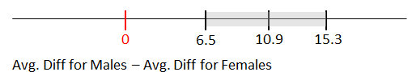
Answer the following True/False questions.

a. | T | F | This interval seems to suggest a difference, on average, between Females and Males.
b. | T | F | This interval suggests both Females and Males are taking in more iron, on average, then their daily recommended levels.
c. | T | F | The margin of error for this interval is about 8.8.

- The data below come from the 2005 Youth Risk Behavior Survey of American high schools students, which was conducted by a branch of the United States government. This study investigated the potential relationship between smoking and body mass index (BMI). Body mass index is one possible measurement of one’s fitness level. Generally speaking, the smaller the number the more fit someone is.
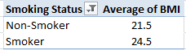
Research Question: "Does the average BMI differ between American high school students who smoke and those who do not smoke?"

- Smoking status is one of the variables of interest in this investigation and defines the two groups to be compared in this study. Is this variable categorical, or numeric?
Numerical Categorical
- The second variable being considered in this investigation is the subject's BMI. Is this variable categorical, or numeric?
Numerical Categorical
- Consider the research question stated above. Which of the following test should be used to compute a p-value to determine whether not this question is supported statistically? Circle only one answer.
  - A binomial test
  - A t-test
  - A chi-square test
- Conducting a statistical test will allow us to expand our scope-of-interest and permit us to make decisions beyond the data we’ve collected in our study. Identify which of the following would be considered within the scope of inference for this investigation.

Within Scope of Inference?  (Place X is one column) |  | Description
Yes | No
 |  | The individuals who took part in this study
 |  | 2005 American high school students who smoke
 |  | 2005 American high school students who do not smoke
 |  | Anybody in the world who was a high school student in 2005
 |  | American high school students who graduated in 1970 – a time when the perception of smoking was very different than 2005.

A study was conducted to investigate college students’ perceptions of how much time had actually passed in a given time interval. Twenty college students were randomly selected to participate in the study. They were not told the purpose of the experiment (so that they weren’t trying to count in their head), and they were asked to sit in silence. After 45-seconds had passed, the researcher asked the student how long (in seconds) they thought they had been sitting there. The results from the 20 subjects are summarized below.
 | Average  i.e. Mean | Standard Deviation
Perceived Elapsed Time | 47.85 | 9.35

Research Question: Do college students tend to overestimate the actual elapsed time? In other words, is the average perception of elapsed time greater than 45 seconds?

- Which of the following statements is most correct situation for setting up a simulation?
- The simulation study should be set up under the assumption that college students have an accurate perception of time (i.e., the average perception of elapsed time is equal to 45 seconds).
- The simulation study should be set up under the assumption that college students overestimate the actual elapsed time (i.e., the average perception of elapsed time is greater than 45 seconds).
- When setting up the simulation study, no assumptions are made regarding college students’ perception of time. Making such assumptions would be unfair and would bias the simulation study.

- Which of the following dotplots should be used to obtain a p-value for the research question above? Circle either Version A or Version B below.
VERSION A | 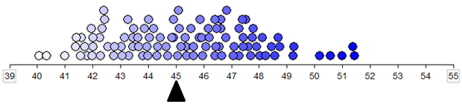  Note: The average value in this plot is about 45 seconds.
VERSION B | 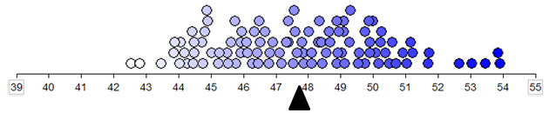  Note: The average value in this plot is about 47.8 seconds.

