STAT 110: Quiz #10 Name(s): _____________________________
Spring 2018
Points: 20 _____________________________

_____________________________

You should download the Vitiam Intake dataset from our course website for this quiz. The investigation here will be centered on intake of Calcium (mg/day).

Research Question: Do statistical differences exist, on average, between the actual and daily recommended intake of Calcium for college students at Winona State University?

- The goal of this study is to compare the Actual Intake of Calcium to the Daily Recommended Intake (DRI) of Calcium. A statistician would immediately calculate the differences between Actual and DRI and complete the analysis using these differences. Suppose instead your friend decides to complete his analysis by simply comparing the Actual column to the DRI column as is shown here.
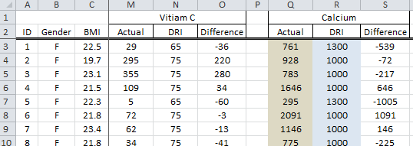 | Averages for each column

Why is this statistically a bad idea? Discuss. (3 pts)

For the remaining questions, assume the Difference column is used for the analysis.
Difference = Actual – DRI
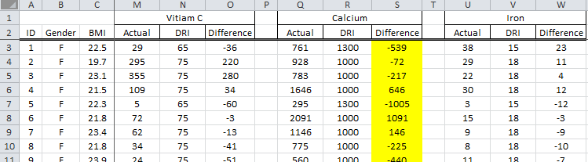
I computed the average of the difference column for Calcium and got -166.

- What does this value of -166 mean? That is, what is the practical interpretation of this value? Discuss. (3 pts)

- Conceptual, computing the p-value requires that our original summary measurement, i.e. the average value for the difference column, be compared against repeated outcomes under the situation of no difference between these two groups. Which version, i.e. A or B, should be used to compute the p-value for this problem? Provide a rationale for your selection. (3 pts)

Version A | Version B

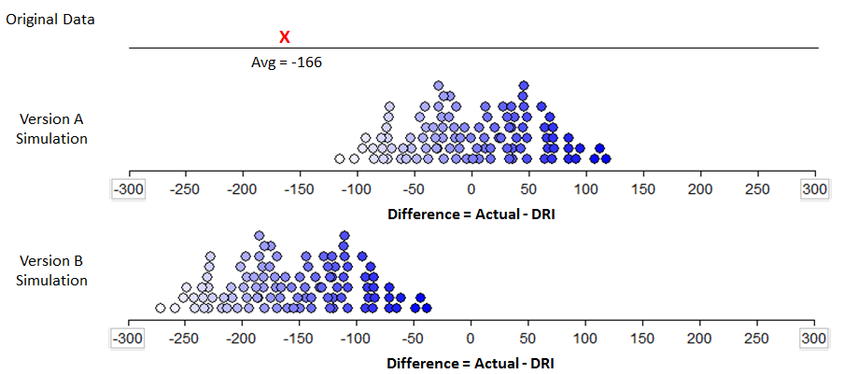

Rationale for your selection.

- Run the appropriate =TTEST() analysis in Excel for the following research question. (5 pts)

Research Question: Do statistical differences exist, on average, between the actual and daily recommended intake of Calcium for college students at Winona State University?

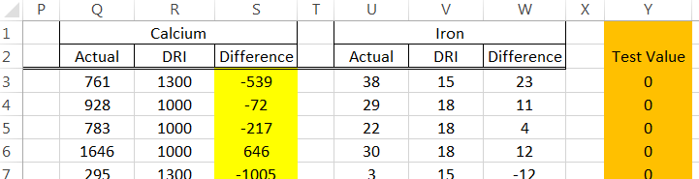

Use =TTEST(Array1, Array2, Number of Tails, Type of Test) function in Excel to get the p-value.
Identify the following values that you used in the =TTEST() function in Excel.
- Values used in Array1: ____________
- Values used in Array2: ____________
- Value used for Number of Tails: _____________
- Value used for Type of Test: _____________

What is the p-value returned by Excel?

- P-value: _______________

- Make a statistical decision and provide a conclusion using laymen’s language for the research question. (3 pts)
Decision:
  - Data supports the research question
  - Data does not support the research question

Conclusion. Use laymen’s language to give a conclusion for this analysis.

I have computed a 95% confidence interval for the average difference between actual intake and daily recommended intake for calcium.
Visual Representation of 95% CI | Formula Representation of 95% CI
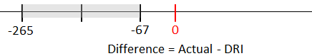 | $Lower Endpoint= -166-\left(1.99*\frac{418.7}{\sqrt{71}}\right)$=-265  $Upper Endpoint= -166+\left(1.99*\frac{418.7}{\sqrt{71}}\right)$=-67

- Interpret the meaning of this interval in the context of this problem? What is the practical interpretation of this interval? Discuss. (3 pts)

