STAT 110: Quiz #1 Name: _________________________________
Spring 2018
Points: 20

Hemifacial microsomia (HFM) is a term used to describe a specific type of abnormality in the development to the skull, jaw, or the ear before birth. A study published in the Journal of Craniofacial Surgery studied the effect of HFM on the left-handedness rate. Researchers were able to identify 86 people for this study each of whom had HFM. It was determined that 22 of the study participants were left-handed.

Research Question: Does HFM increase the rate of left-handedness compared to the rate in the general population?
Number in Study with HFM that were Left-Handed Left-Handedness Rate in the General Population  22 out of 86 10% | HFM Condition
Source: Rogers, Gary F.; Sullivan, Stephen R.; Mulliken, John B.; Greene, Arin K.; Oh, Albert K.(2009). “Increased Prevalence of Left-Handedness in Hemifacial Microsomia” Journal of Craniofacial Surgery. March 2009.

- Identify the following quantities on the number line below for the investigation of the research question stated above. (5 pts)
- Smallest possible value  - Largest possible value  - Location of pyramid  - Outcome from study | 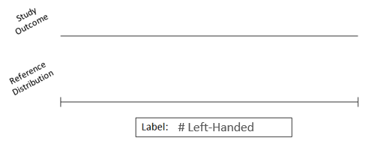

- Next, provide details for the setup of a simulation in Tinkerplots that would allow us obtain a total of 1000 simulated outcomes to investigate the research question stated above. (3 pts)

Identify the following  - Probability of heads  - Number of tosses  - Number of repetitions | 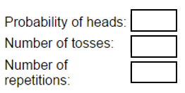

The following graph provides the outcomes for the 1000 repeated iterations of the simulation.

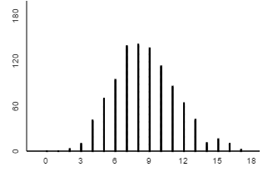
- Which of the following statements is most correct regarding the reference distribution? (3 pts)
- The dots on this reference distribution were constructed under the assumption that people with HFM have the same left-handedness rate as the general population.
- The dots on this reference distribution were constructed under the assumption that people with HFM have a greater prevalence of left-handedness because of the abnormality that developed before birth.
- The dots on this reference distribution were constructed under the assumption that people with HFM have a greater prevalence of left-handedness than the general population.

- Circle a single dot on the above dotplot. Complete this sentence to explain what this single dot represents. (3 pts).
For this particular simulated outcome, there were ______ out of a possible ______ left-handed people with HFM. This dot was generated under the assumption that _______________________ ___________________________________________________________________________________________________________________________________________________________________.
- The number of people in this study that were left-handed was 22. After referring to the simulated outcomes above, do you believe 22 provides enough evidence to support the research question? Explain your reasoning. (3 pts)

- The exact left-handedness rate in the general population varies somewhat depending on the reference used. A value of 10% was reported in the above article, but others suggested that the left-handedness rate in the general population may be as high as 15%. Suppose a second simulation is conducted using the 15% instead of the 10% rate. Are we more or less likely to say 22 is an outlier in this second simulation? Explain. (3 pts)

