STAT 110: Quiz #2 Name: _________________________________
Points: 20
Spring 2018

Consider the following snip-it of an article published in Sports Illustrated regarding young pitchers in Major League Baseball. This article is centered on 19 year-old pitching prospect that was drafted by the Baltimore Orioles in the 1st round. From 1981 through 2000, a total of 102 high school pitchers were selected in the first round. Of these, 44 never reached the majors.
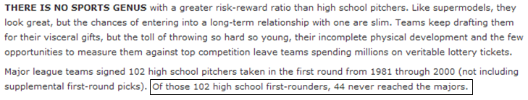
In an effort to determine whether or not pitchers are of a greater risk of failure, we must compare this against the general failure rate. The article to the right provided these figures.  Success/Failure Rate for 1st Round Draft Picks  - 66% of 1st round picks play in the major leagues, and  - 34% never play in the major leagues. | 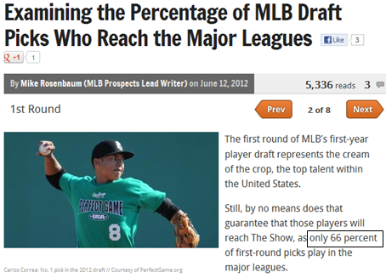
Research Question: Is the failure rate of high-school pitchers taken in the 1st round higher than the general failure rate for major league baseball?
- Identify the smallest possible value, largest possible value, location of the pyramid, and the outcome from the study for this situation on the number lines below. (5 pts)
- Smallest possible value  - Largest possible value  - Location of pyramid  - Outcome from study | 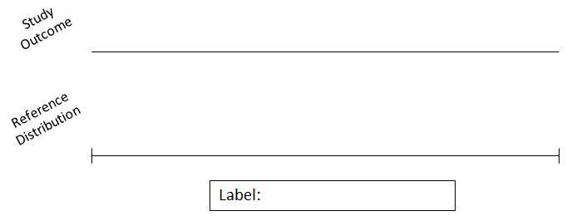  Did Not Make It

- Identify the appropriate set-up for the reference distribution Use 1000 simulated outcomes. (4 pts)

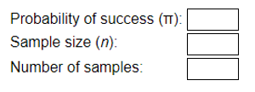

- Provide a rough sketch of the reference distribution here. (3 pts)

- Which of the following statements is most correct regarding the reference distribution? (3 pts)
- The dots on this reference distribution were constructed under the assumption that high-school pitchers taken in the 1st round have a higher failure rate than others.
- The dots on this reference distribution were constructed under the assumption that high-school pitchers taken in the 1st round have the same failure rate as others.
- The dots on this reference distribution were constructed under the assumption that high-school pitchers taken in the 1st round have a 50% failure rate and 50% success rate.

- Use the 5% rule to determine whether or not the outcome from this study is an outlier. That is, is is the outcome from the study in the top 5%, bottom 5% or outside 5%? Does the study outcome support the research question? Discuss. (5 pts)

