STAT 110: Quiz #3 Name: _________________________(1 pt)
Points: 20
Spring 2018

Williams-Beuren syndrome (WBS) is a rare neurodevelopmental disorder which is caused by the deletion of more than 25 genes from region q11.23 of chromosome 7. Subjects with WBS display smaller brain volumes than normal; however, they often show an excess of volume in the right occipital cortex region of the brain. There are many documented effects of WBS, e.g., increased risk of cardiac problems, higher risk of diabetes, etc. The study presented here is concerned with the left-handedness of people with WBS.

Number of Males in Study with WBS that were Left-Handed Left-Handedness Rate for Males in the General Population  8 out of 25 12.4% | Right Occipital Cortex  Region of Brain  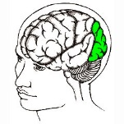
Source: Van Strien, J.W., Lagers-van Haselen, G.C, van Hagen, J.M, de Coo, I.F.M, Fens, MA, van der Geest, JN. (2005). “Increased prevalences of left-handedness and left-eye sighting dominance in individuals with Williams-Beuren syndrome.” Journal of Clinical and Experimental Neuropsychology. 2005 Nov;27(8):967-76.

Research Question: Do males with Williams-Beuren syndrome have a greater chance of left-handedness than males in the general population?
- Identify the smallest possible value, largest possible value, label for number line, location of the pyramid, and the outcome from the study for this situation on the number lines below. (6 pts)
- Smallest possible value  - Largest possible value  - Label for number line  - Location of pyramid  - Outcome from study | 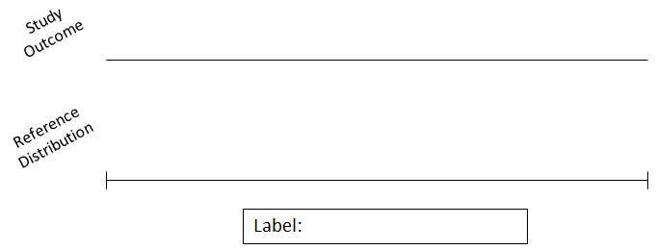

- Identify the following for the setup of the reference distribution. Suppose you want 100 repeated outcomes. (4 pts)
Identify the following  - Probability of heads  - Number of tosses  - Number of repetitions | 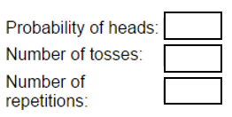

The 100 repeated outcomes are provided below.
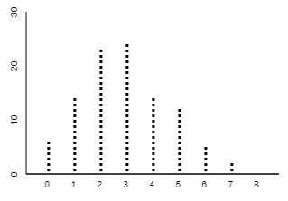

P-Value  (3 pts) | P-Value = the probability of observing an outcome as extreme or more extreme than the observed outcome  P-Value = ______________
Decision  (1 pt) | Decision Rule: If the p-value less than 0.05, then the data is said to provide enough evidence for research question.  - Data provides enough evidence for the research question  - Data does not provide enough evidence for research question
Conclusion  (5 pts) | Write a conclusion in laymen’s terms.

