STAT 110: Quiz #4 Name(s): _______________________________
Spring 2018
Points: 20 _______________________________
_______________________________

According to the National Institute of Mental Health, suicide is the 2nd leading cause of death for persons of age 15 – 34. The following data is from the Minnesota Department of Health. This data was published in a Suicide in Minnesota Data Brief in September 2013.
Source: http://www.health.state.mn.us/injury/docs/suicide/suicide_data_brief_2011.pdf

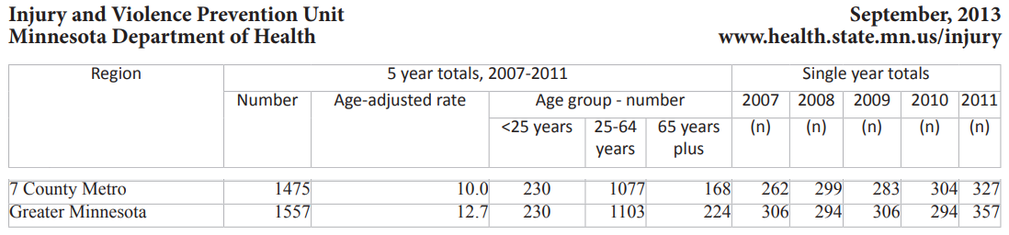
Your analysis for this quiz will be broken out into two parts.
Part 1: Research Questions
- RQ #1A: For the 7 County Metro Region, are the suicide rates over the 5 years inconsistent? That is, can we statistically say, that the suicide rates in this region vary more than what would be expected under the assumption that rates are staying constant over time?
- RQ #1B: For the Greater Minnesota Region, are the suicide rates over the 5 years inconsistent? That is, can we statistically say, that the suicide rates in this region vary more than what would be expected under the assumption that rates are staying constant over time?

- Write a conclusion for RQ #1A: (3 pts)

- Write a conclusion for RQ #1B: (3 pts)

- Provide a screen-shot of your Google Sheet output of your analysis for RQ #1A. (4 pts)
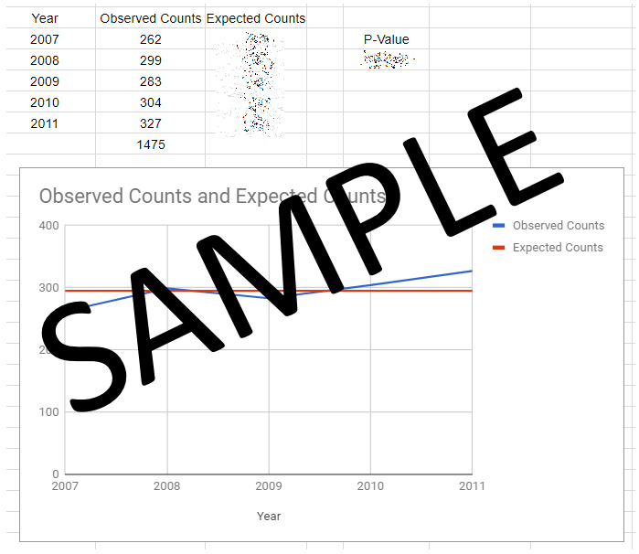
- Provide a screen-shot of your Google Sheet output of your analysis for RQ #1B. (4 pts)

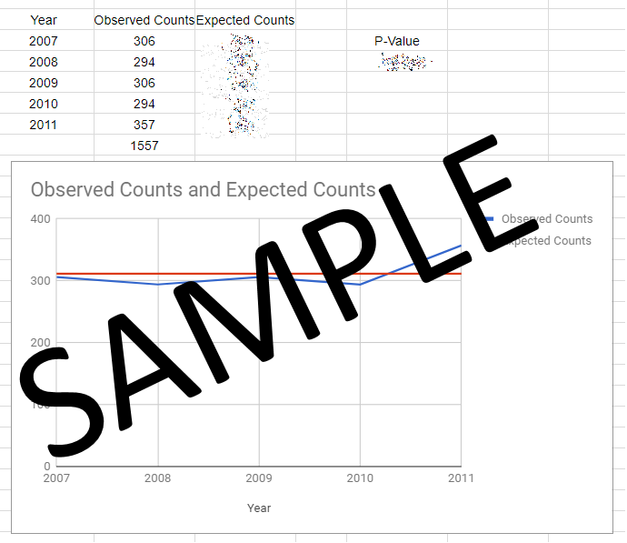
Some have suggested that suicide tends to effect young people more than other older people. The Suicide in Minnesota Data Brief published suicide deaths across three age groups -- the data is provided here.
Region | # of Suicides in each Age Group by Region
 | < 25 years | 25 – 64 years | 65 years plus
7 County Metro | 230 | 1077 | 168
Greater MN | 230 | 1103 | 224
In addition to the suicide information, I have gathered data on the age distribution of those living in these two regions of Minnesota from the U.S. Census Bureau.
Region | % of People in each Age Group by Region
 | < 25 years | 25 – 64 years | 65 years plus
7 County Metro | 38.20% | 51.58% | 10.22%
Greater MN | 37.16% | 48.17% | 14.67%

Part 2: Research Question
- RQ #2A: For the 7 County Metro Region, do the suicide rates across these age groups differ from the population rates across these age groups?

- RQ #2B: For the Greater Minnesota Region, do the suicide rates across these age groups differ from the population rates across these age groups?

I ran a CHITEST() for RQ #2A and for RQ #2B and found that the p-value was very-very small; thus, we can say that we have enough evidence to say that the suicide rates across these age groups differ from the population rates for the percentage of people in each age group.
- Your task here is to convince me that the reason the p-value was very-very small for these CHITESTs was because of the “<25 years” age group and not some other age group. That is, convince me that this data does indeed support the notion that suicide tends to effect young people more than older people – and that this is true in both regions.
Note: To receive full credit here, you must use the methods we’ve discussed in class. For example, calculating ((observed – expected) ^ 2 ) / expected would suffice or using graphs to justify your answer would work as well. (6 points)

