STAT 110: Quiz #5 Name(s): ___________________________
Spring 2018
Points: 20 ___________________________
___________________________

For this quiz, we will investigate information about Traffic Stops made by the St. Paul MN Police Department for 2017. I have collated the data from the original source and made a Google Spreadsheet version available on our course website. | 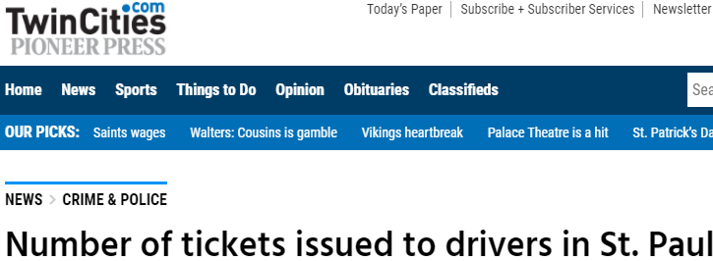
Data: https://docs.google.com/spreadsheets/d/1YwYAklmRHw8hzRCPoMLDudIu8XuM1xDG3yk_rRTn7nE/copy?usp=sharing

Article Source: https://www.twincities.com/2018/01/26/how-many-people-did-st-paul-police-pull-over-last-year-police-stops-by-the-numbers/
Original Data Source: https://information.stpaul.gov/Public-Safety/Traffic-Stop-Dataset/kkd6-vvns
Download the St. Paul Traffic Stop data from our course website. Use the Pivot table feature of Google Sheets to answer the following questions.
- How many citations were issued by the St. Paul Police Department in 2017? (1 pt)

Number: ___________
<Provide a screen-shot of table used to obtain this answer>

- What percentage of the stops resulted in a citation being issued? (1 pt)

Percent of Stops Resulting in a Citation being Issued: __________
<Provide a screen-shot of table used to obtain this answer>

- Recreate the following table and chart. (3 pts)

<Delete my version and paste a copy of your table and chart in its place >
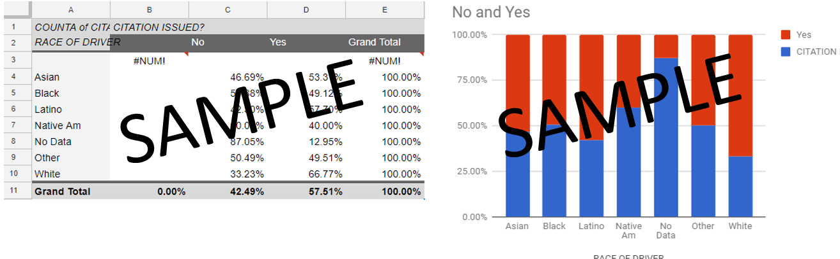
- Identify whether or not the following statements are TRUE or FALSE using the table/chart you obtained in Question 3 above. (2 pts each)

- Of the races considered here, whites were most likely to get a citation. | TRUE | FALSE
- Over 50% of the whites stopped received a citation. | TRUE | FALSE
- Blacks were more likely to receive a citation than whites. | TRUE | FALSE

- Consider the following statement: “Women are more likely to get a citation than men”. Provide a table and/or chart that either supports or refutes this statement. (2 pts).

<Provide a screen-shot of table or chart used to either support / refute this answer>

- Consider the following statement: “Women are more likely to get a citation than men; but, this is only true for some of the races.” Provide a table and/or chart that either supports or refutes this statement. (3 pts).

<Provide a screen-shot of table or chart used to either support / refute this answer>

- Is the pattern you discovered between Citations and Race (see problem 3) the same or different from the pattern than exists between whether or not a driver is Frisked and Race. A compare and contrast of the patterns between Citations vs. Race and Frisked vs. Race could be used to improve policing in St. Paul. Provide a suggestion based on your investigation here. (4 pts)

Suggestion:

<Provide a screen-shot of table(s) or chart(s) used to support your suggestion>

