STAT 110: Quiz #8 Name(s): ______________________
Spring 2018
Points: 20 ______________________
_______________________

The Fool’s Five is a major regional fundraising event for cancer. Fool’s Five raises tens of thousands of dollars each year for cancer research.
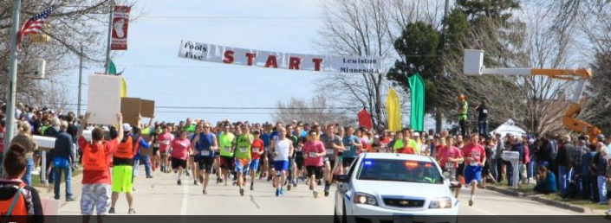 | Race results are provided online  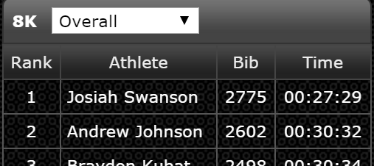

The results from the 2018 Fools Five race are provided on our course website. Download this file. The Pace variable will be the primary variable of interest for this quiz.

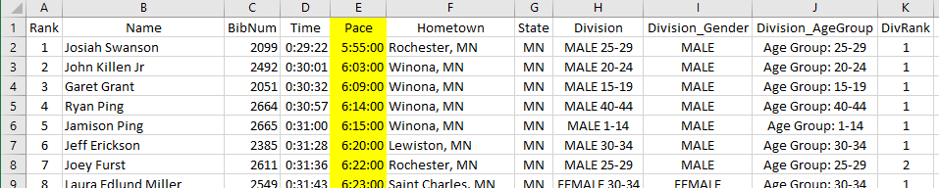

- Compute the average Pace for each age group. Fill in the following table. (5 pts)

Age Group | Average Pace |  | Getting cell formatting correct in Excel  - Specify Average under Value Field Settings  - Change cell format to Time  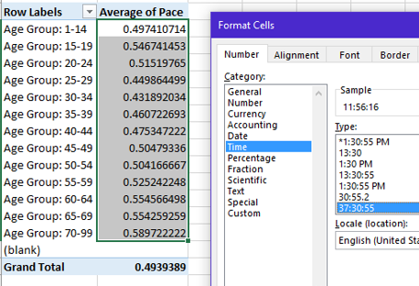
Age Group: 1-14
Age Group: 15-19
Age Group: 20-24
Age Group: 25-29
Age Group: 30-34
Age Group: 35-39
Age Group: 40-44
Age Group: 45-49
Age Group: 50-54
Age Group: 55-59
Age Group: 60-64
Age Group: 65-69
Age Group: 70-99

- What Age Group had the fastest Pace? (2 pts)
- Determine whether or not the Age Group specified above was the fastest for both Females and Males. (2 pts)
- Fastest Age Group for Females: ______________
- Fastest Age Group for Males: ______________

- Use PivotTables and Charts to create a plot that allow us to compare the average Pace times across the Age Groups for Females and Males separately. Delete my sample plot and paste your plot in its place. (4 pts)

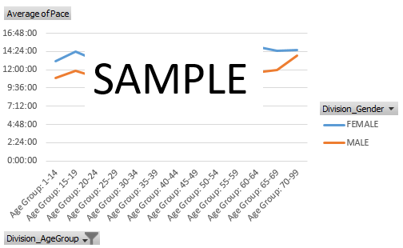

- Use PivotTable to determine which Age Group has the most consistent pace times. Which Age Group is this? (2 pts)

- Is the Age Group with the most consistent pace times the same for both genders? Briefly discuss. (2 pts)
- Consider the following CDF plot for Gender = Males, Age Group = 40-44.
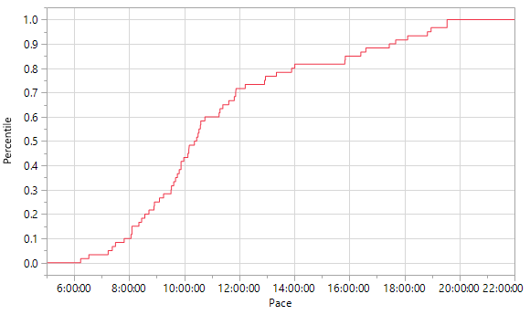
Answer the following (1 pt each)
- The median pace time is about ___________.
- About _________ % of the people in this group had a pace time under 10 minutes.
- About _________ % of the people in this group had a pace time between 10 and 14 minutes.

