STAT 110: Quiz #9 Name: ________________________________
Spring 2018
Points: 20

- Answer the following True/False questions. (1 pt each)
a. | T | F | Suppose that the lowest score on a quiz was a 10 and the highest score was a 20. The median quiz score will be 15.
b. | T | F | It is possible for the median to be less than zero.
c. | T | F | It is possible for the average to be less than zero.
d. | T | F | A CDF plot can be used to visualize the entire spectrum of a set of numerical measurements.
e. | T | F | The average is more affected by outliers than the median.
f. | T | F | The 50th percentile and the median value are always the same value in a dataset.

Your friend has collected a sufficiently large random sample of data from residents in three different states to investigate possible disparities in income.

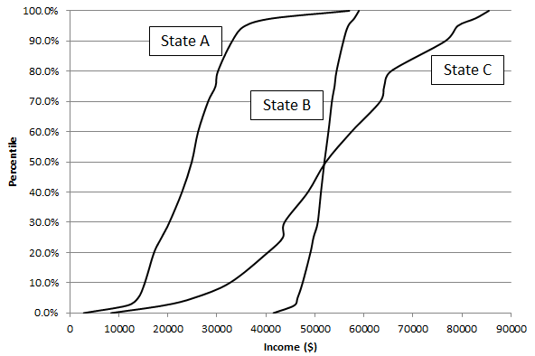
- Answer the following True/ False questions regarding this CDF plots made by your friend. (2 pts each)

a. | T | F | The median income levels for State A and C are about the same.
b. | T | F | State B is likely to have the most amount of disparity in income levels because this line is steepest.
c. | T | F | Consider only those people on the lower end of the income spectrum, i.e. below the median; State C appears to have the most amount of income disparity for this population of people.
d. | T | F | State B appears to have several outliers on the upper end.
Consider once again the snowfall amounts from various weather stations across Colorado. For this quiz, you should assume that snow storms in Colorado come from the North and West directions. Also, the mountains (shown as pyramids) are known to stop much of the snow resulting in large quantities of snow on the western side of these mountains. The dots in the following pictures represent weather stations in which snowfall amounts were collected.
Snow Patterns in Colorado  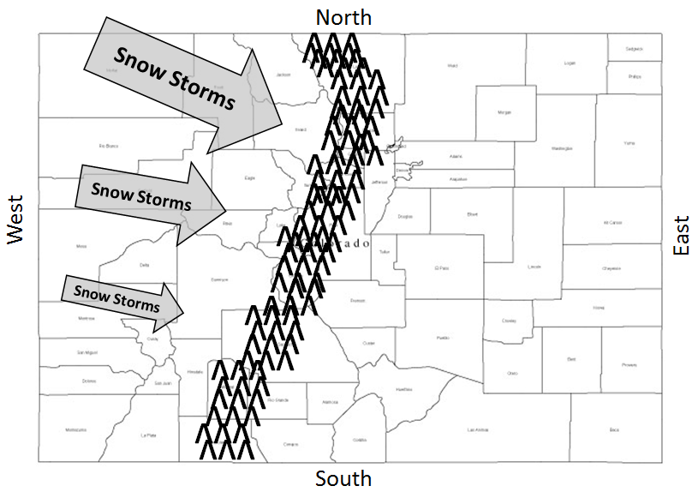 | Picture A  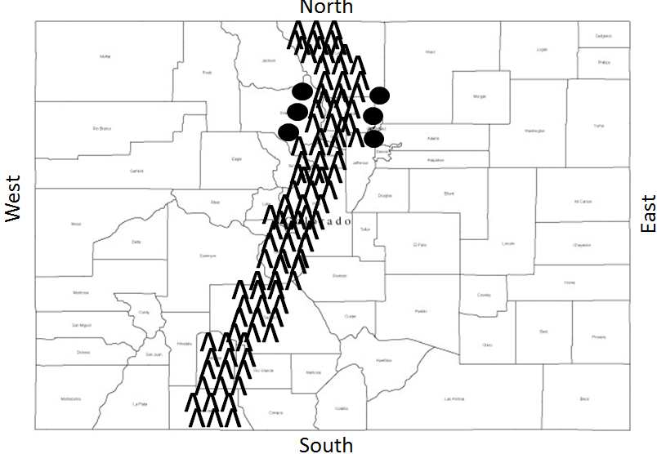
Picture B  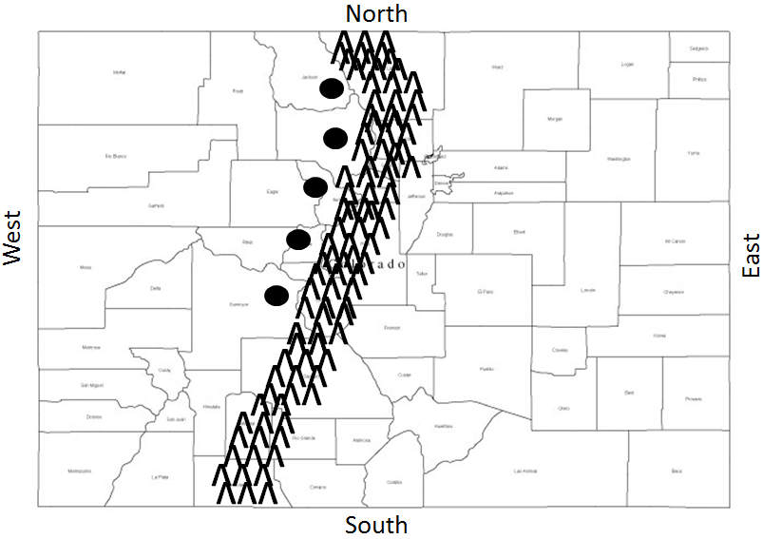 | Picture C  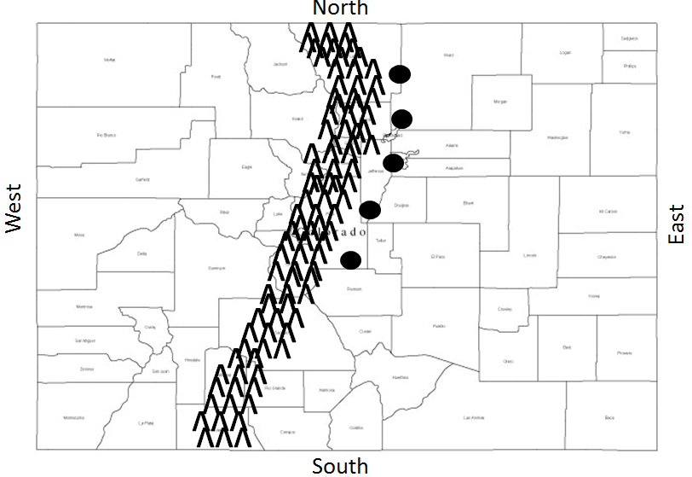

- Answer the following True and False questions. (2 pts each)
a. | T | F | Picture C is likely to produce the largest average snowfall amount.
b. | T | F | Picture B and C are likely to have very similar averages.
c. | T | F | Picture A will have the largest average because it has six stations instead of five.

