STAT 110: Quiz # 6 (MWF) | Quiz #7 (TU/TH) Name: _________________________________
Points: 20
Spring 2018

The September 2013 issue of Pediatrics reported a study involving 1,232 adolescents. They were classified according to whether or not they were adopted and whether or not they had attempted suicide. The data are summarized in the following contingency table.
 | Attempted Suicide | Did Not Attempt Suicide | Total
Adopted | 47 | 645 | 692
Not Adopted | 9 | 531 | 540
Total | 56 | 1176 | 1232

- Suppose you were to find the relative risk ratio for these data as follows:
$$Risk Ratio= \frac{Risk of attempting suicide if adopted}{Risk of attempting suicide if not adopted}$$
Which of these is the correct relative risk ratio? (3 pts)
  - (47/645) / (9/531) = 4.30
  - (47/56) / (9/56) = 5.22
  - (47/692) / (9/540) = 4.08
  - (47/1232) / (9/1232) = 5.22

- Provide the name for the statistical quantity that would be used to fill in the blank in the following sentence? “An adolescent in this study who was adopted is _____ times more likely to attempt suicide than an adolescent in this study who was not adopted.”
(3 pts)
  - risk difference
  - relative risk ratio
  - odds ratio

- Suppose you were to find the odds ratio for these data as follows:

$$Odds Ratio= \frac{Odds of attempting suicide if adopted}{Odds of attempting suicide if not adopted}$$
Which of these is the correct odds ratio? (3 pts)
  - (47/645) / (9/531) = 4.30
  - (47/56) / (9/56) = 5.22
  - (47/692) / (9/540) = 4.08
  - (47/1232) / (9/1232) = 5.22

- Compute the difference in risk to compare the risk of attempting suicide for those that have been adopted compared against those that have not been adopted. (2 pts each)

Show the math:

Interpret this value:

Consider the following graph that shows the relationship between Gender and Reason for Death in fatal car accidents for people whose age is between 18 and 24. This study included deaths from car accidents for 100 women and 200 males.
Goal of Investigation: To compare the Reason for Death across Gender.
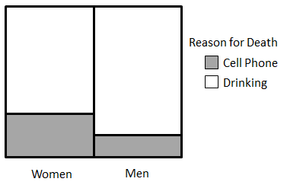
- Answer the following True or False (1 pt each)
a. | Cell phones are more likely to be the cause of the fatal car accident in women than men. | TRUE | FALSE
b. | Drinking is the cause for more fatal car accidents than cell phones for men. | TRUE | FALSE
c. | Drinking is the cause for more fatal car accidents than cell phones for men and women. | TRUE | FALSE
d. | A woman is less likely to have Drinking be the cause of the fatal car accident than men. | TRUE | FALSE
e. | The risk difference in this plot is zero. | TRUE | FALSE
f. | The outcomes from this investigation can be used to generalize about driving habits of senior citizens, say people over 65. | TRUE | FALSE
g. | This investigation is not fair because the number of women and men in this study were not the same. | TRUE | FALSE

