STAT 110: Quiz #6 (TU/TH) | Quiz #7 (MWF) Name(s): ____________________________
Spring 2018
Points: 20 ____________________________
____________________________

Example 4.4.6 The Minnesota Department of Corrections often creates reports for the Minnesota State Legislature to identify the importance of funding programs that are known to improve public safety. The following data was presented in one such report. The following question and supporting data were provided on p17 of their report.

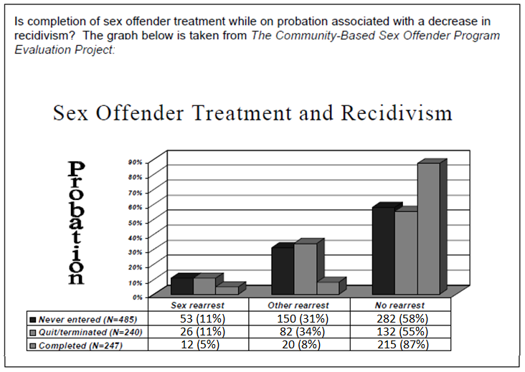

- Use the data provided above in the table to construct the more appropriate 100% stacked column graph for this data.

- Obtain the Expected Counts, p-value, decision, and conclusion for this investigation.
Research Question | Is completion of sex offender treatment while on probation associated with a change in the recidivism rate?
Analysis  in Excel | Conduct the appropriate analysis in Excel. You must calculate the Expected Counts for each cell in the table. Use the =CHITEST() function in Excel to obtain the appropriate p-value. (8 points)  What is the p-value from your test?  P-Value = __________________________
Decision | Make the appropirate statistical decision.  Decision: If the p-value < 0.05, then data is said to support the research question.  - Data supports research question  - Data does not support research question
Conclusion | Write an appropriate conclusion in context and in laymen’s terms.
- Suppose the Completed group was removed from consideration and only the Never Entered group was compared against the Quit / Terminated group. Would you expect the p-value from this analysis to increase, decrease, or not change? Briefly explain.

The p-value would: Increase | Decrease | Not Change
Explain:

