Handout #1: Introduction to (Experimental) Design Concepts

What is (Experimental) Design?

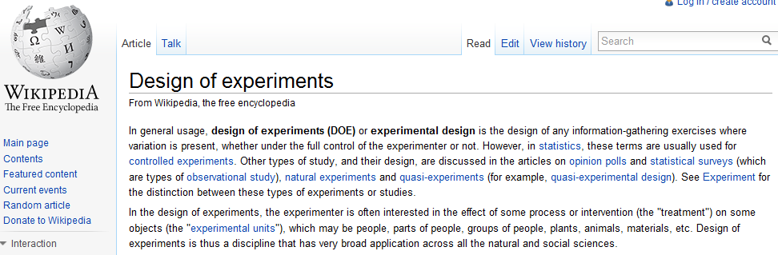

Effective experimentation will lead to a better understanding of the process, and such an understanding will give guidance to improving the process. In order to study a particular process, the investigator must identify the controllable and uncontrollable factors that influence the output (i.e. response variable).

The determination of how the controllable factors are to be used in an experiment is known as the experiment’s design. This design may also gives guidance in how to handle the uncontrollable factors of the process.

BIG PICTURE: The experimental design is the blueprint for the experiment.

Definition
Factor: An explanatory variable (i.e. input) to be studied in an investigation.

- Design Factors (Controllable Factors):

- Nuisance Factors:

Level: A particular form of a factor.

Response Variable: The variable that you measure (i.e. output) during or after an investigation.

Example #1

[WU and Hamada, p30] Mazumdar and Hoa (1995) conducted a manufacturing experiment of thermoplastic composites where laser-assisted process was used. The main outcome from this experiment was the bond strength of the composite as measured by a short-beam-shear test.

Laser Assisted Process | Short-beam-shear test
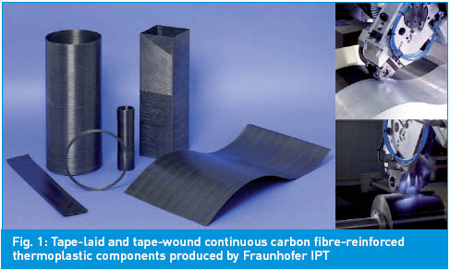 | 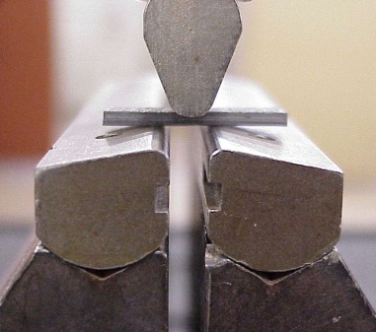

A possible design schematic

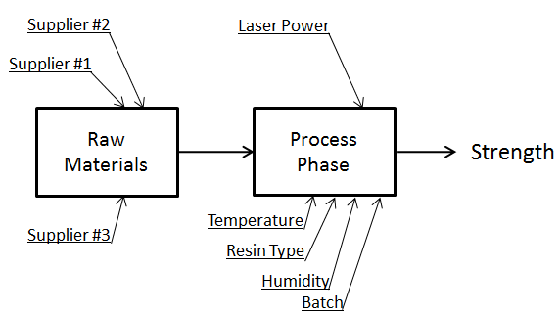

A more narrow-focused design schematic

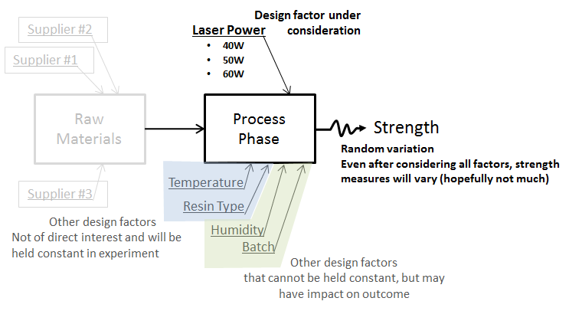

Questions

- Identify the design factor for this experiment

Factor(s)

- Identify the levels for this design factor

Factor Levels

- Identify any known nuisance factors for this experiment. How do we know they are nuisance factors? Explain.

- What is the response variable?

Response Variable

Guidelines for Effective Experiments

A well-designed experiment can greatly improve our understanding of a particular process. A poorly designed experiment will waste valuable resources. More importantly, a bad experimental design may mislead the investigator to which improvements are necessary.

A list of guidelines for effective experimentation is given below.

- Recognition of and statement of the problem: It is sometimes difficult to realize that a problem requiring experimentation exists, or it may not be easy to develop a clear and generally accepted statement of the problem. However, it is necessary to develop all ideas about the objectives of an experiment.

- Selection of the response variable: The response variable must be measurable. In addition, the investigator should be certain that the response variable really provides useful information about the process being studied.

- Choice of factors, levels, and ranges: All potential design factors and nuisance factors must be identified. Once the design factors have been identified, the experimenter must choose the range over which the factors will be varied and the specific levels at which the runs will be made.

- Choice of the experimental design: This involves consideration of sample size (the number of runs), selection of a suitable run order for the trials, and determination of whether or not blocking or other randomization restrictions are involved. The study objectives determine which design is most appropriate.

- Performing the experiment: It is vital to monitor the experiment as closely as possible. Any deviations from the experimental design should be avoided. If deviations are necessary, they should be carefully noted because such deviations will likely affect the eventual analysis.

- Analyze the data: Statistical methods should be used to analyze the data. Such analyses cannot make statements of proof, but can provide guidelines as to the reliability and validity of the experimental outcomes.

- Conclusions and Recommendations: The investigator must draw practical conclusions about the outcome of the experiment and recommend a course of action.

Example #2: Suppose you want to design an experiment to study the best methods to obtain microwave popcorn. Identify each of the following.

Outcome | Possible design and nuisance factors

- Possible response variable(s):

- Potential design factors and their respective levels:

- Potential nuisance factors:

Design Concepts

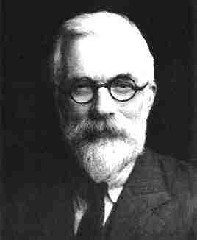
In his 1926 paper “The Arrangement of Field Experiments,” Sir Ronald A. Fisher presented three components which he felt were necessary in a good experimental design. Today, these concepts are taken as necessary practices for valid research results.

- Replication
- Controlling for Variability
- Randomization

Replication

A replication is an independent repeat of each factor or factor combination. This concept was in practice at the time, but Fisher was the first to explain how replication helps to provide an estimate of experimental error which can be used to compare factor or factor combination levels and set up confidence intervals. There are also a few other reasons for replicating an experiment:

- Replication demonstrates that the results are reproducible.
- It provides a degree of insurance against abnormal results in the experiment due to unforeseen accidents.
- It increases the precision for estimates of the mean response for factor levels.

Controlling for Variability

This concept refers to actions a researcher takes to reduce experimental error. There are several ways for a researcher to control the experimental error, but we will focus on two throughout the semester.

- Blocking: This is a design technique used to improve the precision with which comparisons among the factors of interest are made. Often blocking is used to reduce or eliminate the variability transmitted from nuisance factors. This allows for the factor levels to be compared within a more uniform environment, and the variability associated with differences among the blocks can be separated from the experimental error.

- Using Covariates: Covariates are variables that are related to the response variable of interest. The information on covariates is used to reduce experimental error in a procedure known as analysis of covariance, which we will discuss later in the semester.

Randomization

The allocation of the experimental material and the order in which the individual runs or trials of the experiment are to be performed must be randomly determined. Fisher argued that replication provides data to estimate the experimental error variance and that blocking provides a method of reducing that error. However, he asserted that these two principals were not enough to ensure that the estimate of the error variance was valid—randomization is also needed.

The Big Idea: Randomization eliminates the influence of extraneous factors not under direct control of the researcher so that comparisons between factor levels of interest measure only the pure factor level effects.

Richard Scheaffer, Professor Emeritus at the University of Florida, says it best:
“Blocking is used to control the factors you can see; randomization helps balance the ones you cannot see.”

