Handout 10: Introduction to Blocking and Confounding in 2^{k} designs

In an optimal world, it is best to replicate the entire experiment within each block.

Suppose we have a 2² factorial experiment. This experiment has 4 design points (i.e. (1), A, B, AB).

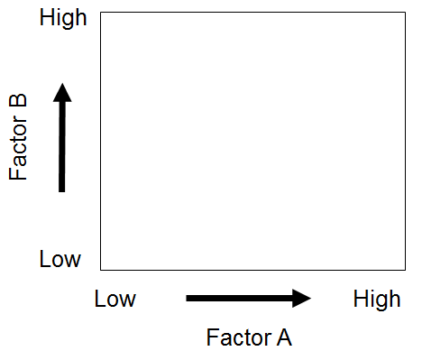 | 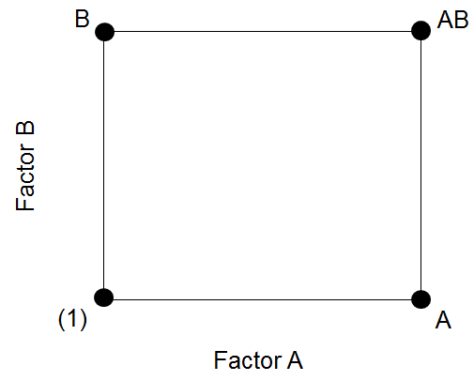

Running each design point in 3 blocks yields the following.

Experiment's Design
Block 1 | Block 2 | Block 3
(1) | (1) | (1)
A | A | A
B | B | B
AB | AB | AB

The outcomes observed from this experiment are as follows.

Experiment's Design / Responses
Block 1 | Block 2 | Block 3
(1): 28 | (1): 25 | (1): 27
A: 36 | A: 32 | A: 32
B: 18 | B: 19 | B: 23
AB: 31 | AB: 30 | AB: 29

Setting up this design in Minitab:

Step 1: Specify a 2² design | Step 2: Select 3 replicates in 3 blocks
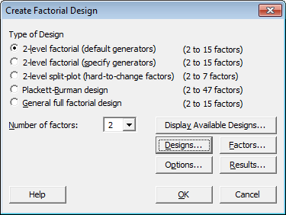 | 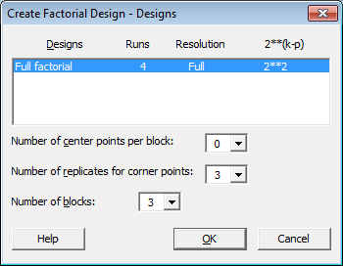

The Design Setup in Minitab

The resulting design structure from Minitab:

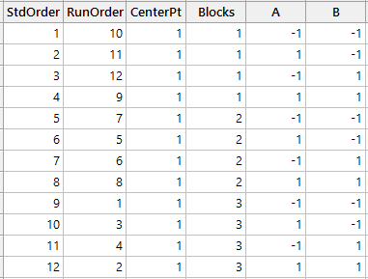

The design with responses entered…
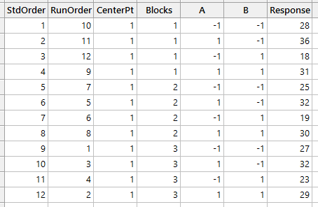

The Analysis in Minitab

The analysis would proceed as usual…
- Proceed with examining the estimated model
- Check the residual plots thoroughly
- Create any necessary model graphs
- Find optimal settings for desired responses

The ANOVA table:
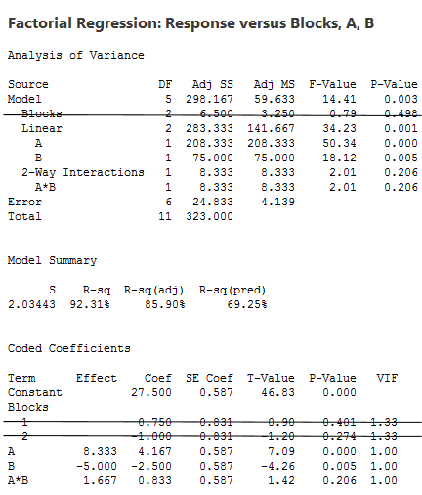

Questions:

- Which effects/factors are important?

- Why aren’t we interested in testing the blocking variable?

The normal probability plot…

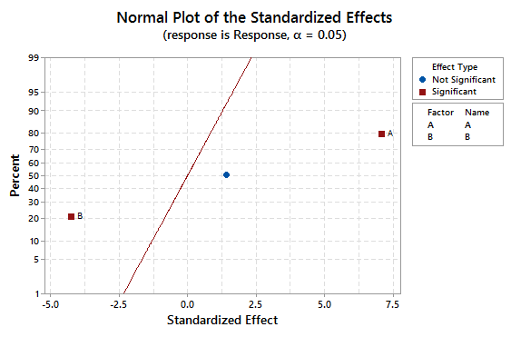

The Least Square Means…
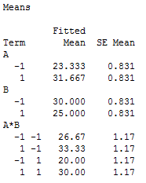

The residual plots…
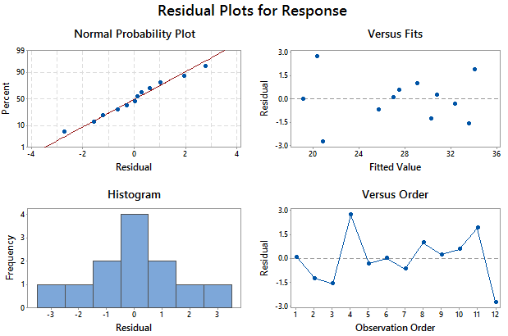

Interaction Plot, Main Effect Plots, Surface plot, and Contour plot…

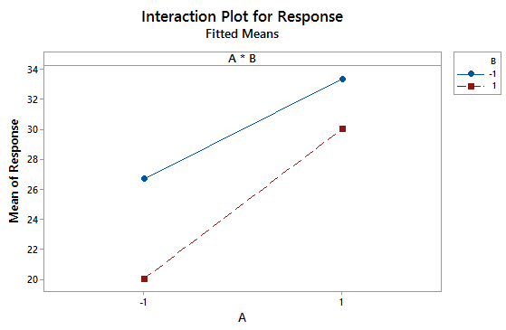 | 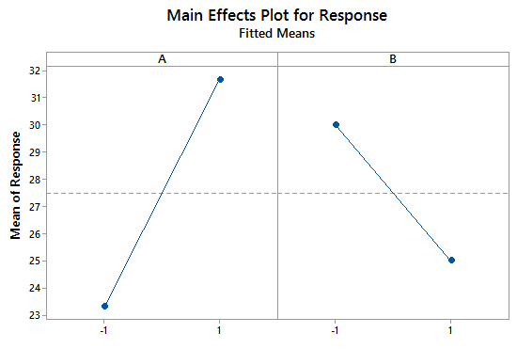

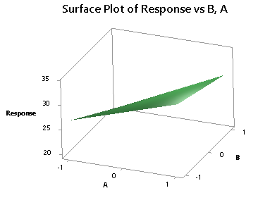 | 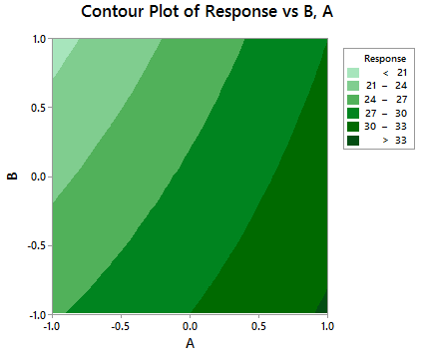

Example 2: A Reality Check
Often, 2^{k} experiments are carried out with a minimal number of runs to minimize cost and time to complete the experiment. Many times, investigators cannot replicate over several blocks. For other experiments, it may be physically impossible to avoid a blocking variable.

Consider the following example: Suppose we have another 2² experiment, but this time only 2 runs can be completed per block. Thus, one complete run of the experiment will require two blocks. How do we decide what factors to put in each block?

 | Experiment's Design
 | Block 1 | Block 2
1
2

The usual 2² design | Possible 2² designs in 2 blocks
No Loss of Information  The previous example (Example #1)  Note: Experiment is repeated in 3 blocks | Losing Information about Effect A  Losing Information about Effect B  Losing Information about Effect AB

Comment: We can see from above that the blocking structure dictates what information is lost.

LOSING INFO ABOUT FACTOR A |  | 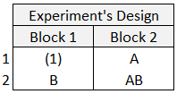 | 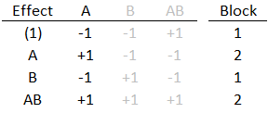
LOSING INFO ABOUT FACTOR B |  | 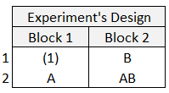 | 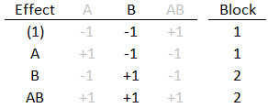
LOSING INFO ABOUT FACTOR AB |  | 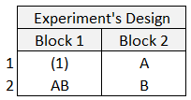 | 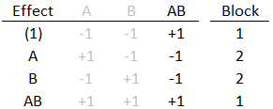

Confounding: This occurs when treatment effects become indistinguishable from the effects of blocking.

- Confounding occurs in experiments when not all experimental settings can be run in each block.

- Higher order interactions are usually the effects chosen to be confounded with blocks.

- If two treatment effects are indistinguishable (see Chapter 8), this is called aliasing and is different from confounding.

Thus, in the previous example, it would be best to use the following configuration:

Note that the treatment combinations within each block would be run in random order, and the order of the blocks would also be randomized.

Example 3: When k > 2

Consider a 2³ experiment in 2 blocks. We want to confound the ABC interaction effect with blocks in this example.

The easiest way to do this is to write out the design matrix with the +1’s and -1’s, as shown below.

Next, sort the ABC column by the -1’s and the +1’s as follows. Then, all the -1’s constitute block 1 and the +1’s constitute block 2.

How do we do the confounding in general? (p. 308 of Montgomery textbook)

A defining contrast is a linear contrast used to determine the confounding structure.
This contrast is written as follows:

$$L_{1}=α_{1}x_{1}+ α_{2}x_{2}+…+ α_{k}x_{k}$$
where
- α_{i} = 0 or 1 is the exponent on the i^{th} factor to be confounded, and
- x_{i} = 0 (low level) or 1 (high level) is the level for each factor.

The treatment combinations that produce the same value of L₁ (mod 2) will be placed in the same block. Recall that this defining contrast is used for a 2^{k} experiment in 2 blocks.

Applying this to our previous example:

This following defining contrast is used for a 2^{k} experiment which is to be run in 2 blocks. The effect to be confounded is ABC, so and so the defining contrast is given by

Doing this in a spreadsheet…
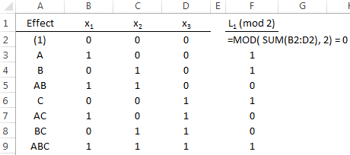
Example 4: More than Two Blocks

Suppose we have a 2⁵ experiment (32 units), and at most 8 experiment settings per block. Thus, we need 4 blocks of size 8 each.

In general, for a 2^{k} experiment to be arranged in 2^{p} blocks, p effects must be chosen to be confounded. For this example, we have:

k =
p =

Note that each block will contain 2^{k-p} runs.
So, we must select p = 2 effects to be confounded with blocks. Let ADE and BCE be used for the defining relation for this example.

For ADE:
For BCE:

These two defining contrasts are calculated mod 2 again and form 4 possible combinations which are used to specify which effects are placed in each block.

L₁ | L₂ | Pair | Block
0 | 0 | (0,0) | 1
1 | 0 | (1,0) | 2
0 | 1 | (0,1) | 3
1 | 1 | (1,1) | 4

Open the Confounding_Blocking speadsheet file. Use this file verify the blocking scheme below.

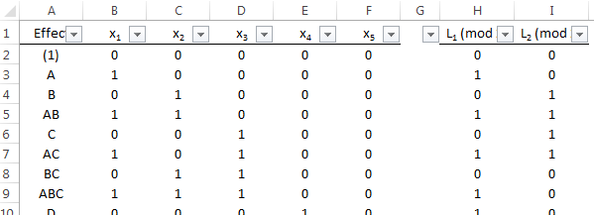
Use filtering in the spreadsheet to identify the blocks easily…

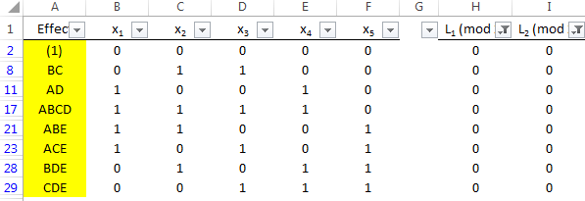

The resulting blocking structure for our design…

Generalized Interactions

Important Note: In addition to the p independent effects that are chosen to be confounded, exactly 2^{p} – p – 1 other effects will also be confounded with blocks. These are called generalized interactions of the p independent effects initially chosen. A generalized interaction is defined as the product of two effects mod 2. For example, we have (ADE)(BCE) = ABCDE² = ABCD also confounded with blocks. To see this, consider this partial table of plus/minus signs for Blocks 2 and 4 of the above design:

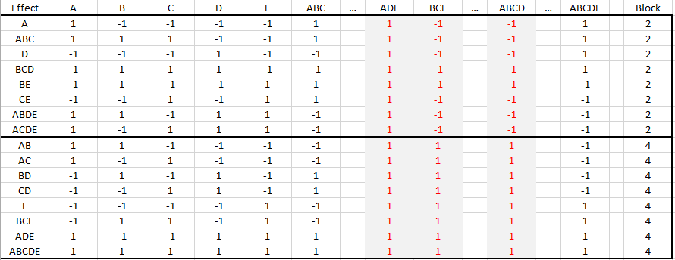

Creating This Design in Minitab:

Using the Default Generators in Minitab…

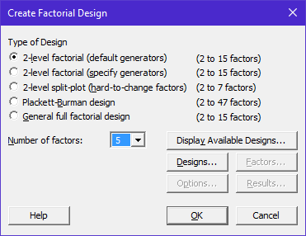

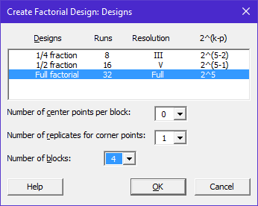

In the Session window, Minitab identifies the Block Generators used for this design setup

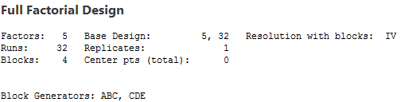

Minitab allows us to specify our own generators for Blocking…

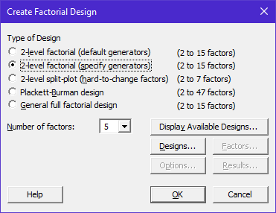

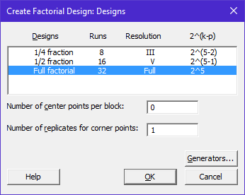

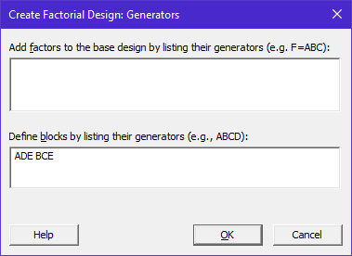
Notice now that Minitab is using our Block Generators to construct this design…

Verify that the design produced by Minitab matches what we came up with…

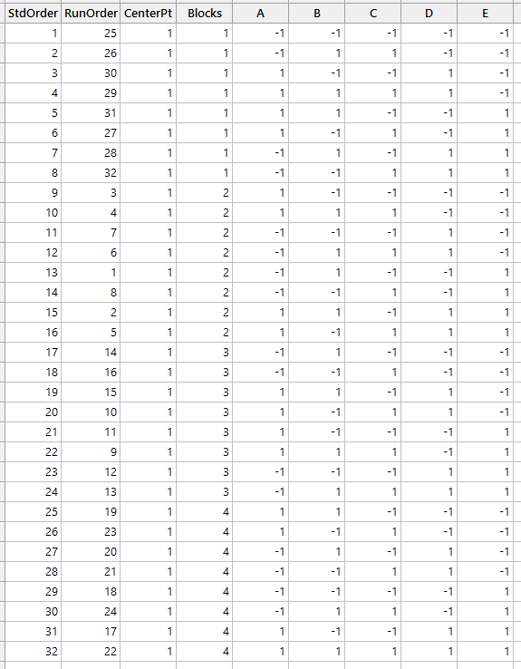
Suggested Blocking Arrangements…

Source: Montgomery (p277)

