Handout #12: More on Fractional 2^{k} Designs

A full 2⁵ design:
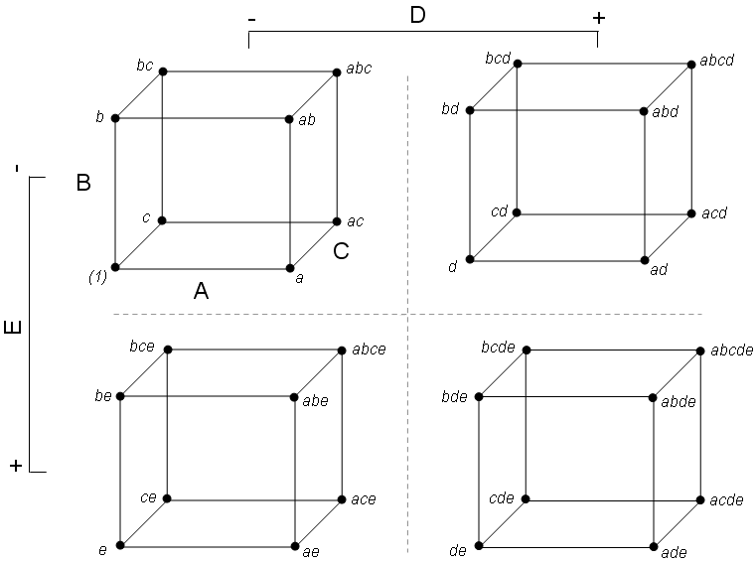

Consider a ¼ fraction of this full factorial experiment: 8 of the 32 possible runs are to be completed.

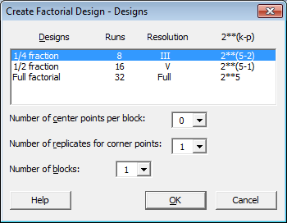

Consider the design generators and defining relation given by Minitab:

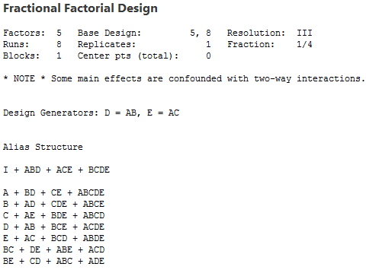
The Design Matrix – to determine which setting of the factors are actually run:

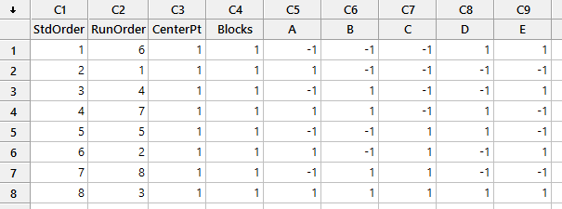

Notice that the design matrix selects opposite corners of each cube in each of the four quadrants.
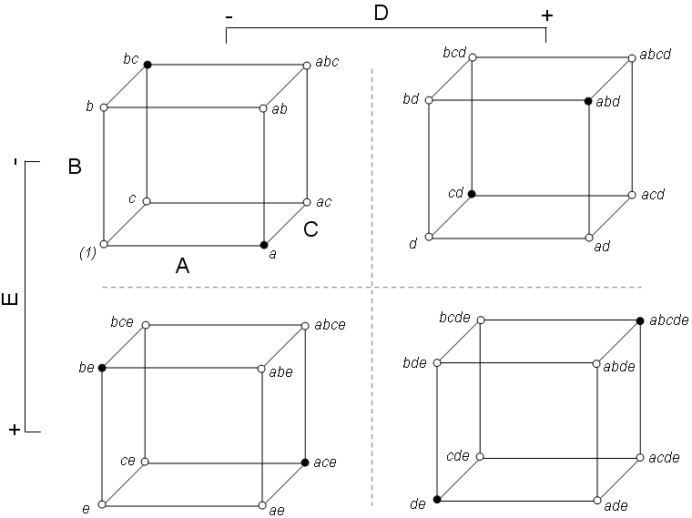
Example: Montgomery - Example 8.7

Consider the following study on human performance as related to eye focus time. Several factors are considered.

Factor | Description
A | Acuity or sharpness of vision
B | Distance from target to eye
C | Target Shape
D | Illumination Level
E | Target Size
F | Target Density
G | Subject

If a complete set of settings were run, then 128 runs would be necessary. The experimenter initially allowed for 8 runs – which produces a highly fractionated design!

Letting Minitab do all the work of building this complicated design.

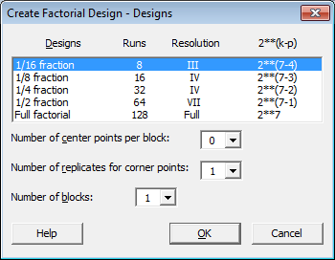

The default generators were used here. The use of other generators may be necessary for some situations.

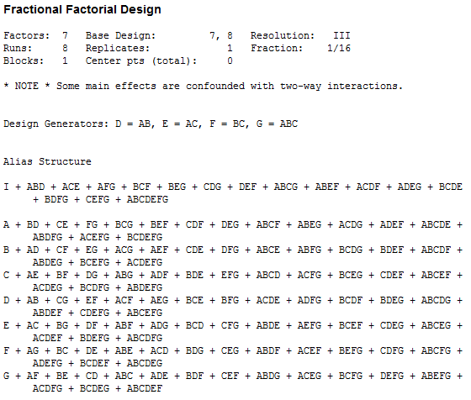

The design matrix:

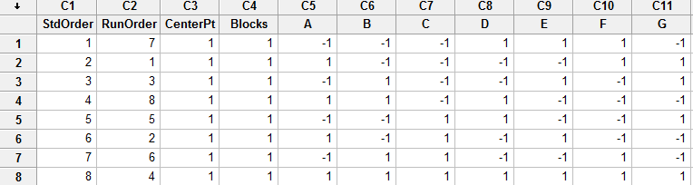

After the experiment was run the following responses were obtained:

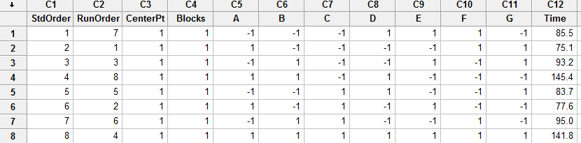

The analysis…

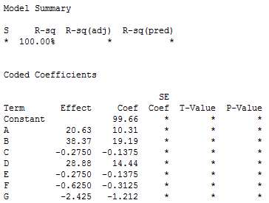

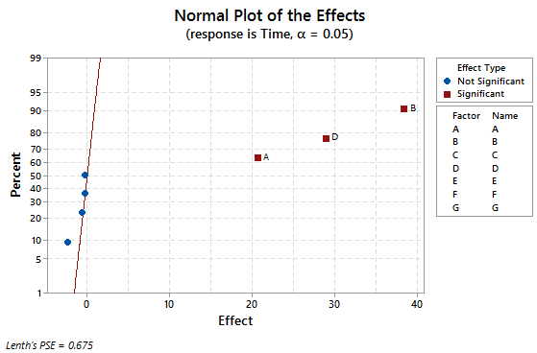 | Possibilities for Important Factors  A B D A B AB (D) A D AD (B) B D BD (A)
If irrelevant factors are removed from the model, the following factor level settings remain.

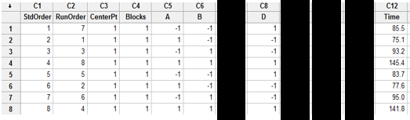

When this is done, the remaining design is a ½ fraction of a 2³ design with two replicates.

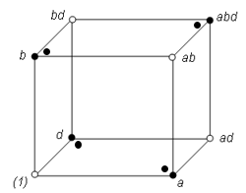
The analysis for the reduced model…

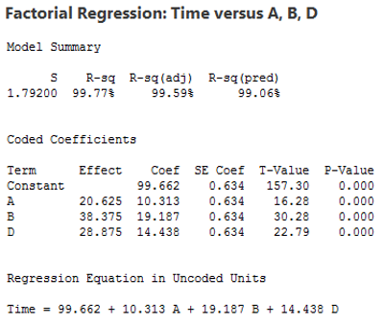 | Selected Terms for this model  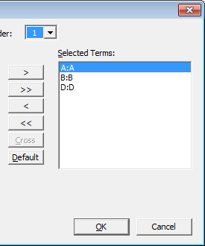

As mentioned above, the all main effects here are aliased with two-way interactions. | Possibilities for Important Factors
 | A  B  D | A  B  AB (D) | A  D  AD (B) | B  D  BD (A)

In order to separate the main effects and the two-factor interactions, a second fraction is run with all of the signs reversed (this is called a fold-over of this design).

Select Stat > DOE > Modify Design

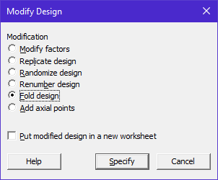

Minitab creates the design matrix, and the data from the second run are added to the spreadsheet. The response for these additional runs have been included here as well.

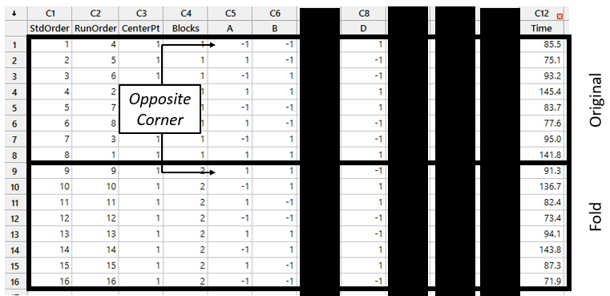

Notice, that the alias structure of this fold-over design now has main effects separated from two-way interactions.

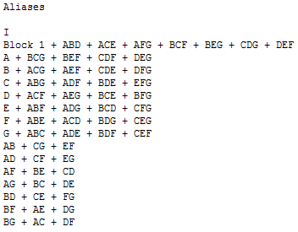
When all two-way interactions are included in the model, no effects remain for the estimating an error term.
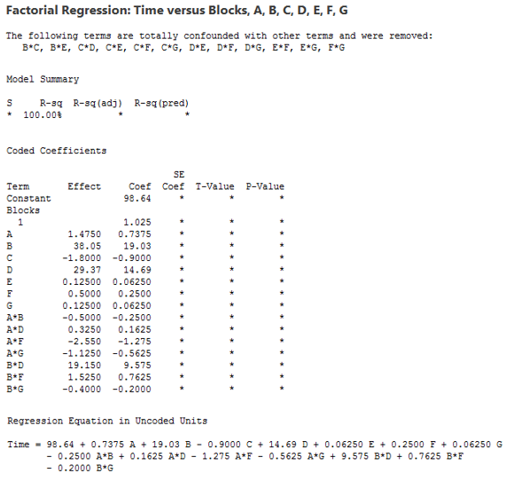

If you run the default in Minitab (all two-way interactions included), then Lenth’s procedure will necessary to identify important effects.

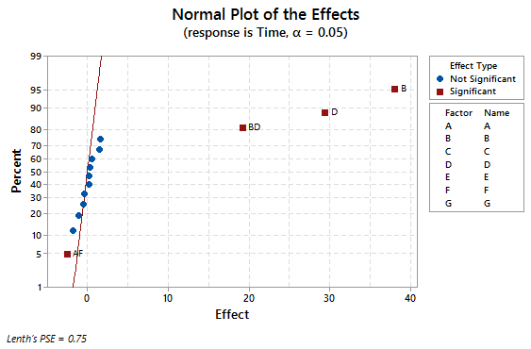

Suppose we force Minitab to fit a model with only the relevant main effects and two-way interactions, the remaining effects could be used to estimate an error term for the model.
Main effects | A, B, D, F
Two-way interaction effects | AB, AD, AF, BD, BF, DF

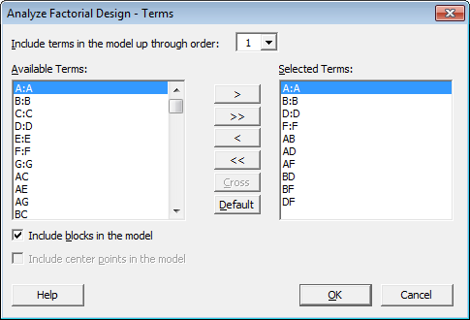

The output from the model fit above.
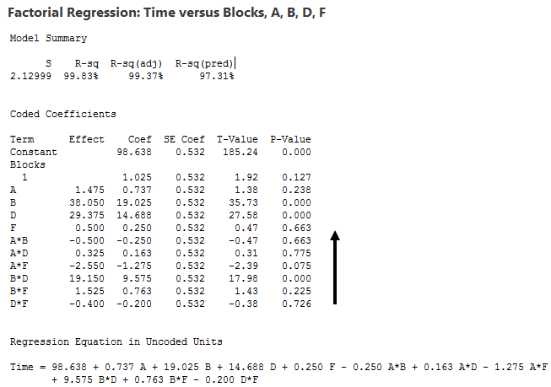

Additional plots for our investigation are provided here.

B * D interaction plot  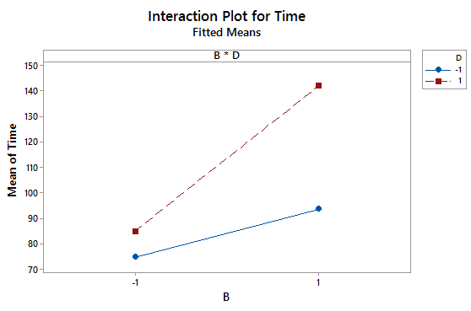 | Coutour Plot for B and D (holding A and F fixed)  