Handout 13: Response Surface Designs

Introduction
Response surface designs are used to develop, improve, and optimize a process. These types of designs are typically used to find an optimal setting of the controllable factors. The analysis of these types of designs requires some knowledge of analysis of variance, regression, and optimization techniques.

Example: Setting up Response Surface Design
Suppose that a chemical engineer is interested in the operating conditions that maximize the yield of a process. Two controllable variables are considered in this study – reaction time and reaction temperature. The current operating characteristics result in output yields of about 40%. The engineer would like to improve the yield rate and also examine two secondary response variables (viscosity and molecular weight).

In order to investigate the effect of reaction time and reaction temperature on these response variables, a central composite design (CCD) will be used. A CCD is one of the most common types of response surface designs. To create a CCD in Minitab, click Stat > DOE > Response Surface > Create Response Surface Design… In the Create Response Surface Design window, click Central Composite under Type of Design. Also, specify that the number of factors being considered is two.

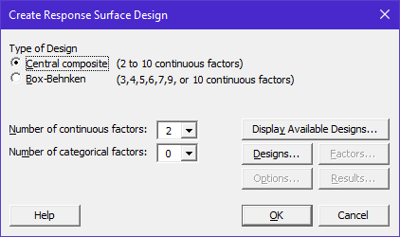

The Display Available Designs… tab can be used to investigate various designs that are available.

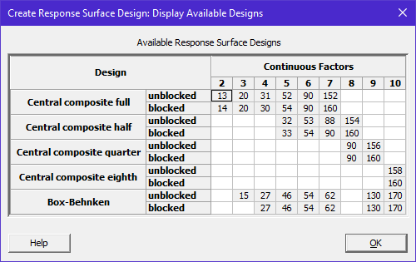
Click OK to return to the Create Response Surface Design window. Before continuing with the design, it is necessary to understand the following schematic. If each factor has two levels, then a cube is formed with four corner points. The design may contain a center point and axial points. The distance from the center of the design to an axial point is denoted by α.

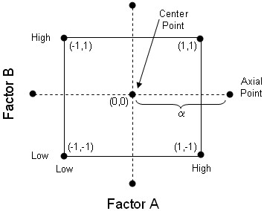

Click on the Designs… tab and click on the first row. Leave the other options as the default and click OK.

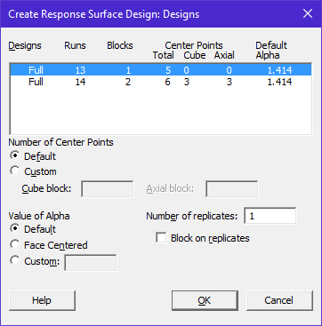

Next, click on the Factors… tab to specify labels for the factor and factor levels.

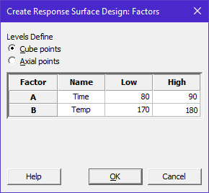
You can use the Options… tab to specify a Base for random generator so that this exact design can be recreated if necessary. Click OK and the design will be placed on a worksheet.

Note that some of the factor level settings in this design are outside the boundary limits specified in the design. These are the axial points.

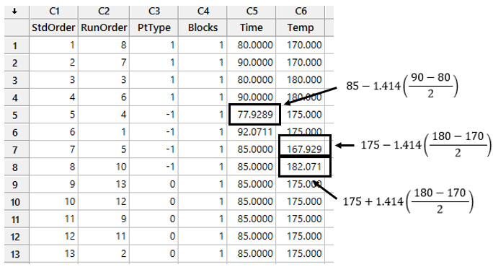

This experiment involves the study of three different response variables. Label three columns for the response variables.

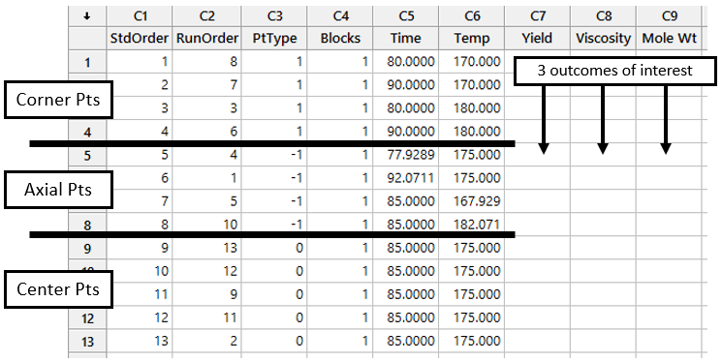

Analyzing the data from this experiment
The data from this experiment are shown below.

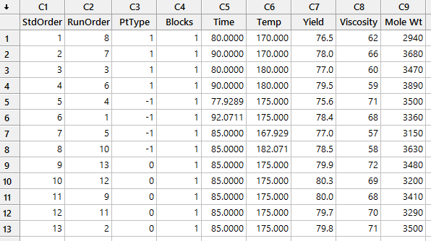

To start an analysis for Yield, click on Stat > DOE > Response Surface > Analyze Response Surface Design… In the Analyze Response Surface Design box, specify Yield.

Click on the Terms… tab to specify the structure of the model to be used. As an initial analysis, select Full quadratic. A full quadratic model is the most flexible type and is given by the following equation.

$$\begin{matrix}E\left(Response\right) & = & { β}_{0} \\ & & + β_{Time}*Time+β_{Time2}*{Time}^{2} \\ & & + β_{Temp}*Temp+β_{Temp2}*{Temp}^{2} \\ & & +β_{TimeTime}*Time*Temp\end{matrix}$$

Various model structures and their properties are listed below. Note that we are assuming the units are coded (i.e. low level = -1, center point = 0, and high level = +1).

Linear in Time and Temp:

$$\begin{matrix}E\left(Response\right) & = & { β}_{0} \\ & & + β_{Time}*Time \\ & & + β_{Temp}*Temp\end{matrix}$$

  - $β_{0}$= the expected level of the response when Time and Temp are set to zero
  - $β_{Time}$= the expected change in the response when Time is increased one unit (i.e. from the center to the edge of the cube).
Note: Often, ${2*β}_{Time}$ is used in this interpretation because this is the expected change when moving from the low to high level of Time (i.e., the effect).
  - $β_{Temp}$= = the expected change in the response when Temp is increased one unit
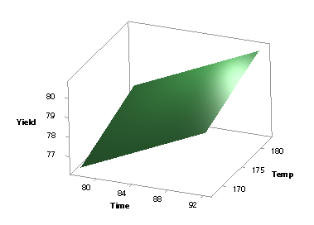

Quadratic in Time, Linear in Temp:

$$\begin{matrix}E\left(Response\right) & = & { β}_{0} \\ & & + β_{Time}*Time+β_{Time2}*{Time}^{2} \\ & & + β_{Temp}*Temp\end{matrix}$$
- See the above descriptions for $β_{0}$, $β_{Time}$, $β_{Temp}$
- $β_{Time2}$=: This value determines the degree of curvature in the surface as you move across the levels of Time.
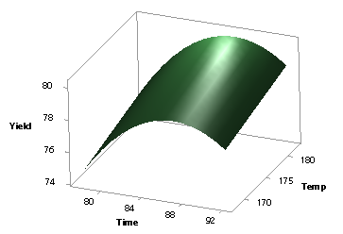
Quadratic in Time and Quadratic in Temp:

$$\begin{matrix}E\left(Response\right) & = & { β}_{0} \\ & & + β_{Time}*Time+β_{Time2}*{Time}^{2} \\ & & + β_{Temp}*Temp +β_{Temp2}*{Temp}^{2}\end{matrix}$$
- See the above descriptions for $β_{0}$, $β_{Time}$, $β_{Temp}$, $β_{Time2}$
- $β_{Temp2}$= this value determines the degree of curvature in the surface as you move across the levels of Temp.

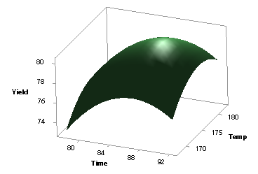

Full Quadratic:

$$\begin{matrix}E\left(Response\right) & = & { β}_{0} \\ & & + β_{Time}*Time+β_{Time2}*{Time}^{2} \\ & & + β_{Temp}*Temp+β_{Temp2}*{Temp}^{2} \\ & & +β_{TimeTime}*Time*Temp\end{matrix}$$

- See the above descriptions for $β_{0}$, $β_{Time}$, $β_{Temp}$, $β_{Time2}$, $β_{Temp2}$
- $β_{Time*Temp}$=: This term measures the joint effect due to interaction between Time and Temp. A significant interaction term will “twist” a response surface.

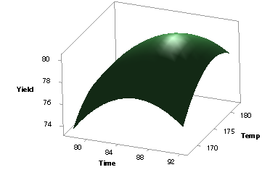

The full quadratic model is the most complicated model; however, we can check to see if this model can be simplified. Click OK in the Analyze Response Surface Design… window to continue with our initial analysis.

Note: Upon finding a reasonable model, we will check the validity of our model using residual plots and will create various graphs of predicted responses.

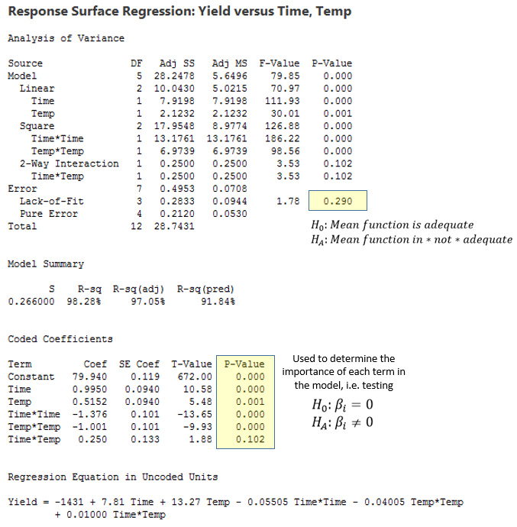

First, we should determine whether or not the mean function being used fits the data via a lack-of-fit test. Here, there does not appear to be problems with our mean function.

Also from the output, we can see that the Time*Temp Interaction term can be eliminated from the model because we cannot statistically say that the coefficient for the interaction term is different than zero.

Thus, a simplified model without the interaction term should be fit. Return to the Analyze Response Surface Design… window and remove AB from the model.

Under the Graphs… tab, click Normal plot and Residuals versus fits. In addition, place Time and Temperature in the Residuals versus variables: box so that variation across the levels of tine and temperature can be informally investigated.

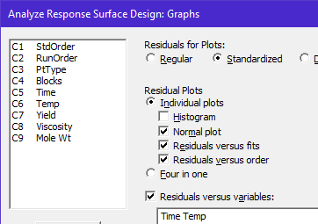

Click OK. Click OK in the Analyze Response Surface Design… window. A quick check of the Session window confirms that our current model is reasonable.

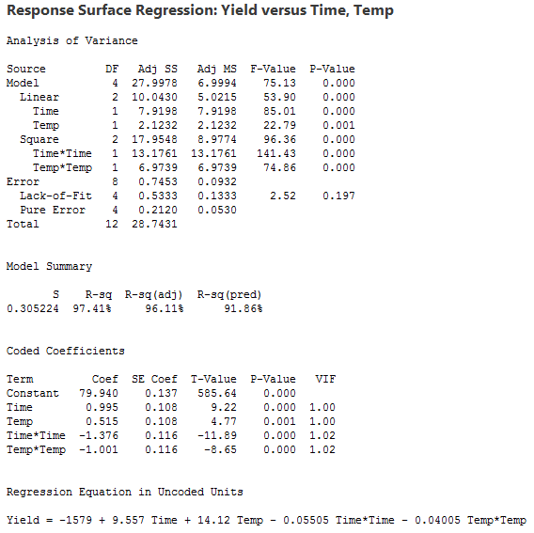

The validity of this model can be checked using the Residuals versus Fitted Values residual plot.

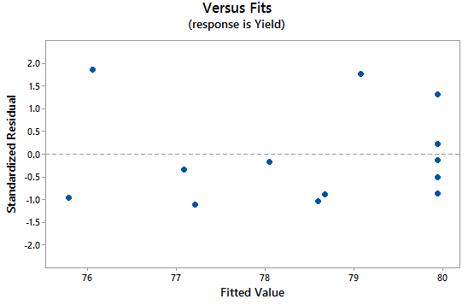
The Normal Probability Plot of the Residuals is shown here.

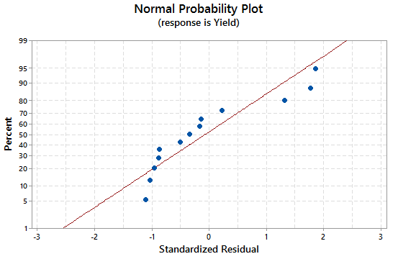

The following graphs plot the residuals across the levels of Time and Temp.

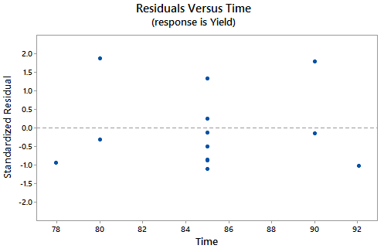 | 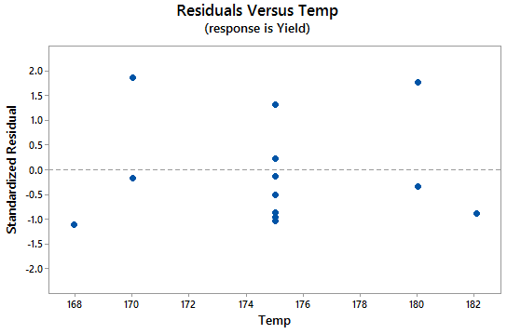

In order to investigate how the factor levels influence the mean of the response variable, various plots are created using the Stat > DOE > Response Surface > Contour/Surface plots… menu.

From these plots, we can see that Time should be set somewhere between 85 and 88 minutes and Temperature should be set somewhere between 174 and 178^{O}F.

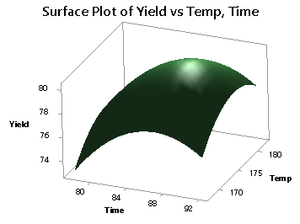

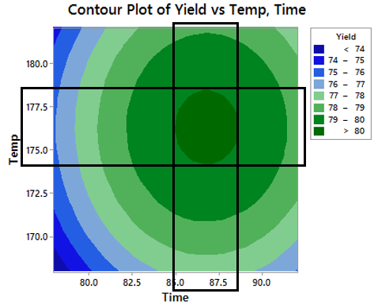

Now, we need to repeat the above procedures for the other two response variables under consideration in this experiment. Next, we model Viscosity.

The output from our (initial) full quadratic model for Viscosity is given next.

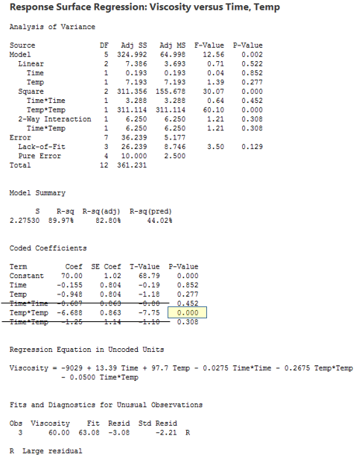

It appears that the Time*Temperature interaction term is not needed, the quadratic term for Time is not needed, and the linear factor for Time is not important, either. That is, Time does not appear to be influencing Viscosity. However, we will leave Time in the model at this point but will remove the interaction term and the quadratic term for Time.

The output from this model is shown on the next page.
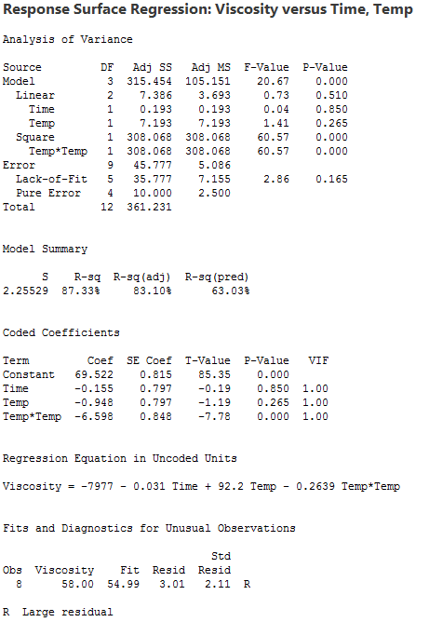

The validity of this model is checked using the Residuals versus Fitted Values plot.

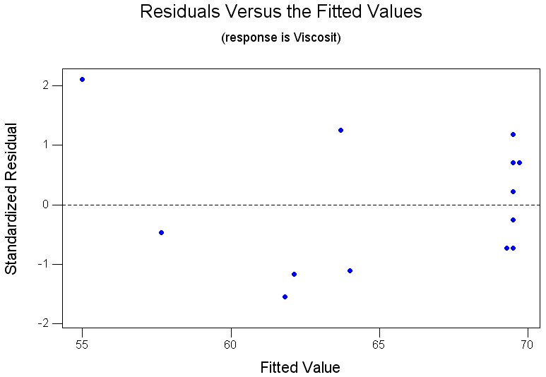

In order to investigate how the factor levels influence the mean of the response variable, contour and surface plots are created.

Note that the surface does not change much across the Time levels. This is because Time is not an important factor in this model. Similar to our analysis of yield, you can use these plots to determine optimal settings for our process.

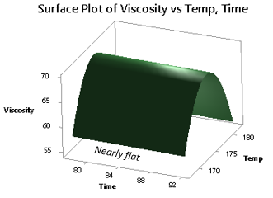

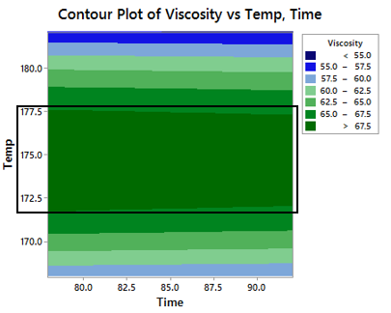

The output from the full quadratic model for Molecular Weight is given next.

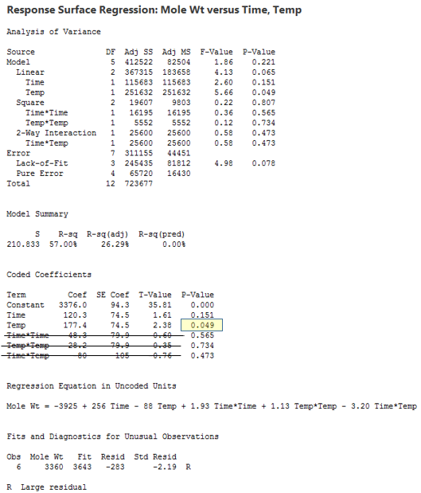

From this output, it appears that the Time*Temperature interaction term is not needed and that neither quadratic term is needed. The linear factor for Time does not seem to be important, either. Similar to what was done when modeling Viscosity, we will leave Time in the model. Thus, under the Terms… tab of the Analyze Response Surface Design window, place only Time and Temperature in the Selected Terms: box.

The output from this reduced model is given next.

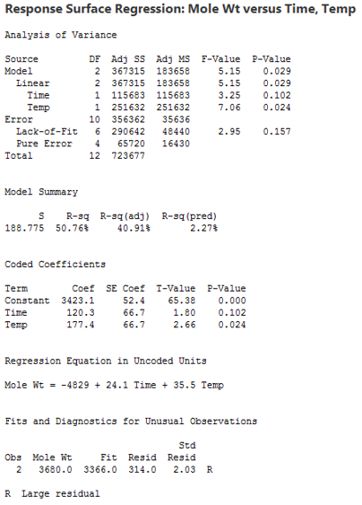
The residual plot is shown below:

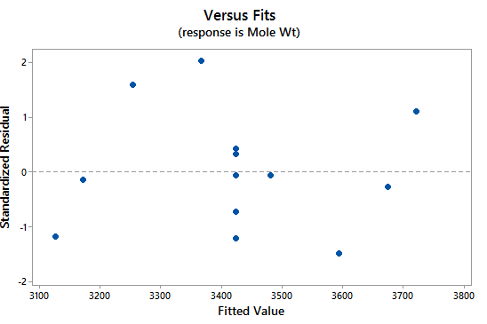

Contour and surface plots of the estimated model are provided next. The overall structure of this surface is simplified because only linear terms for Time and Temperature are required (in fact, only the linear term for Temperature is needed).

If the goal is to minimize the molecular weight, then Time and Temperature should be set at 80 minutes and 170^{O}F, respectively.

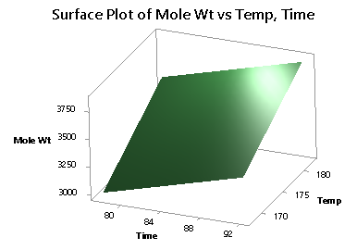

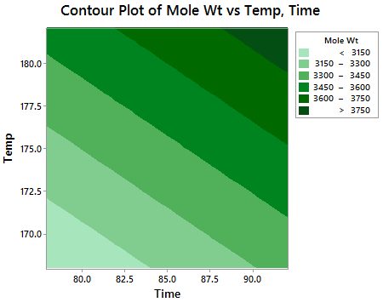

Optimizing a process

Consider the previous example. In our analysis, we found optimal Time and Temperature settings for each of the response variables. This optimization was done separately for each response variable. In this section, we consider optimal settings for all three variables jointly, where certain restrictions are placed on the response variables.

Suppose the restrictions for our response variables are given by
- Observed Yield ≥ 78.5%
- Viscosity between 62 and 68 (i.e 62 ≤ Viscosity ≤ 68)
- Molecular Weight ≤ 3400

Minitab permits you to use a graphical (and a numerical) approach to finding the optimal settings.

To use the graphical approach, select Stat > DOE > Response Surface > Overlaid Contour Plot… In the Overlaid Contour Plot window, place the three response variables in the Selected: box.

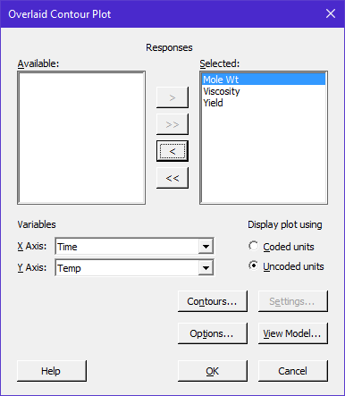

Next, click on the Contours… tab. In this window, we must specify over which regions we would like to optimize. In reality, we would not want to have an upper restriction on yield, but Minitab requires you to enter both upper and lower values for each response. Thus, enter 81 as an upper value for Yield and 2900 as a lower value for Molecular Weight.

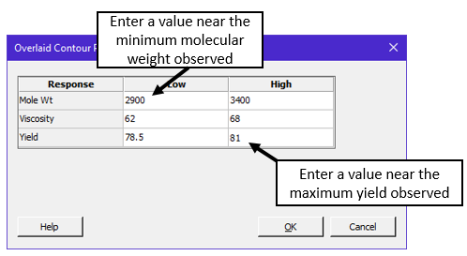

Under the View Model… tab

Model for Yield
Model for Viscosity
Model for Mole Wt

Click OK and click OK again on the Overlaid Contour Plot window. Minitab will return the following overlaid contour plot.

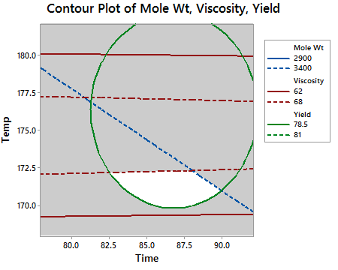

From this graph, we can view which Time and Temperature settings are expected to optimize the response values with the restrictions specified. Minitab labels this feasible region using white. We can see that Time=85 and Temperature=171 is within the feasible region. Likewise, a setting of Time=88 and Temperature=172 would be within the white area; however, a Time setting of 90 would not be optimal.

An alternative to the graphical optimization procedure is a numerical procedure provided by Minitab. This procedure can be found on the menu by selecting Stat > DOE > Response Surface > Response Optimizer…

Time = 85 and Temp = 171  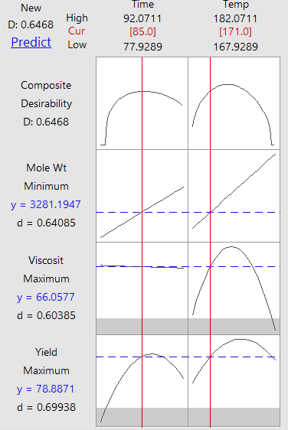 | Time = 88 and Temp = 172  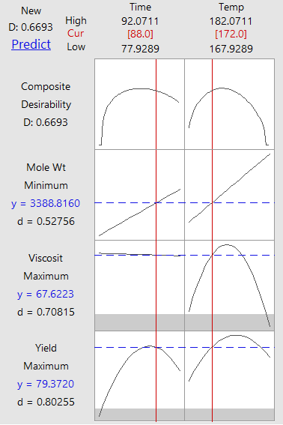
The D value, desirability value is somewhat higher for Time=88 and Temp=171; this setting is thus preferred.

