Handout 3: Experiments with a Single Factor – ANOVA and Multiple Comparisons

Example: Exercise 3.25 (p. 118)

Four catalysts that may affect the concentration of one component in a three- component liquid mixture are being investigated. The following represent the concentrations of the component in question. Our goal is to apply the treatments to the experimental material in what is known as a completely randomized design.

Treatment: Catalysts  - Levels: Catalyst #1 – Catalyst #4 | Experiment Units  - 20 sample available  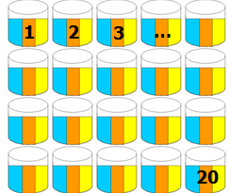

A completely randomized design implies that no restrictions were placed on the randomization of experimental units to treatment(s).

Propose a method of randomly assigning the experimental units to the treatments. Describe your method. What methods did your neighbors use? Identify the best method and use this method to provide a randomization plan for this study.

The data (concentrations) from this experiment are shown in the following table. Notice that not all levels have an equal number of outcomes. This resulting outcomes are said to be unbalanced.

Catalyst
1 | 2 | 3 | 4
58.2 | 56.3 | 50.1 | 52.9
57.2 | 54.5 | 54.2 | 49.9
58.4 | 57.0 | 55.4 | 50.0
55.8 | 55.3 |  | 51.7
54.9

The data can also be found on our course website. To import this Excel file into Minitab, select File > Open Worksheet.

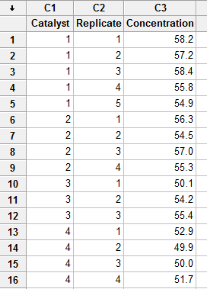

First, we must tell Minitab that the Catalyst variable is actually a grouping variable that identifies the four different treatments. Highlight this column and select Data > Change Data Type > Numeric to Text…

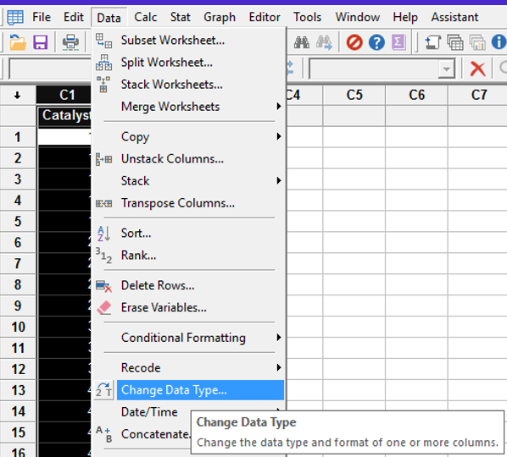

Enter the following and click OK.

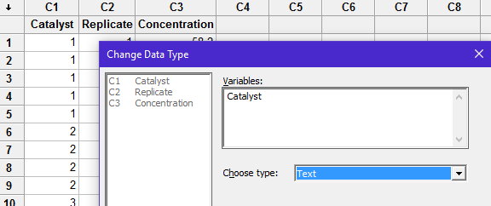

Now, we can create stacked dot plots to visualize the outcomes.

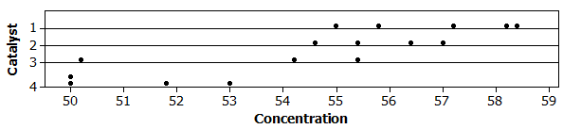

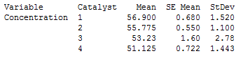

Questions:

- What is the apparent effect of these catalysts on the concentration? Discuss.

- Is it possible that these differences could have been observed purely because of random chance? Explain.

The procedure in which we statistically determine the effect of these catalysts on concentration is similar to what we’ve discussed in Handout #2. The procedure outlined in Handout #2 works for any number of treatment levels.

Concept of Variance, i.e. Error, when the treatment does *not* have an effect:

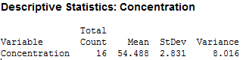

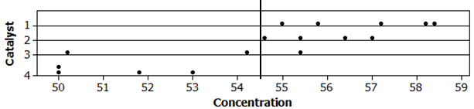

Total Variance (Seq SS Total): _________________________

Concept of Variance, i.e. Error, when the treatment does have an effect:

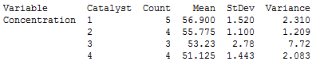

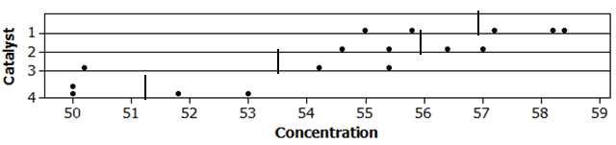

Total Variance (Seq SS Error): _________________________
Carrying out the ANOVA in Minitab

In Minitab, select Stat > ANOVA > General Linear Model. . Fit General Linear Model… Enter the following and click OK:

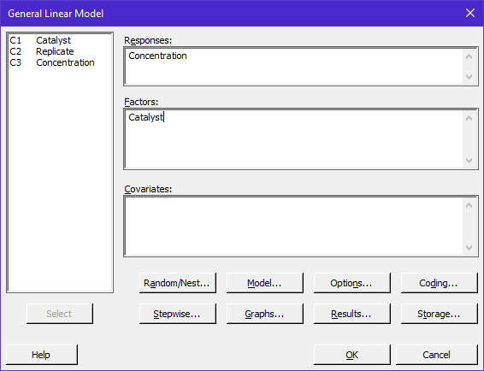

The ANOVA output.

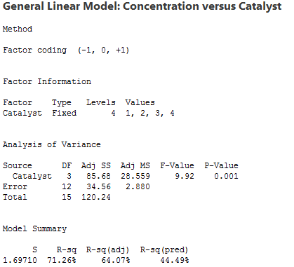

Questions:

- What is the total amount of error under the assumption the factor has no effect?

- What is the total amount of error under the assumption the factor does indeed have an impact?

- Explain how the following quantities were computed.

- DF Total =

- DF Error =

- DF Group =

- What does the F-statistic represent? Explain.

Getting the p-value

http://homepage.stat.uiowa.edu/~mbognar/applets/f.html

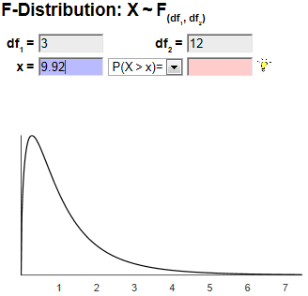

The Decision Rule: If the p-value is less than 0.05, then the data is said to support the alternative hypothesis.

H_{o}: The factor has NO effect on the response variable.
H_{a}: The factor has an effect on the response variable.

- What can we (statistically) conclude regarding the effect of catalyst on concentration?
Least Square Means and Standard Errors

Minitab is using a statistical model (more on this in Handout #4) to compute many quantities other than those provided in the ANOVA table. This model can be used to obtain improved estimates of means and standard errors. These improved estimates are called least square means and standard errors. The least square notation comes from that fact that such estimates are obtained under the condition of minimizing the unexplained variation, i.e the squared error (or residual) values.

Obtaining Least Square estimates in Minitab, Stat > ANOVA > General Linear Model> Predict

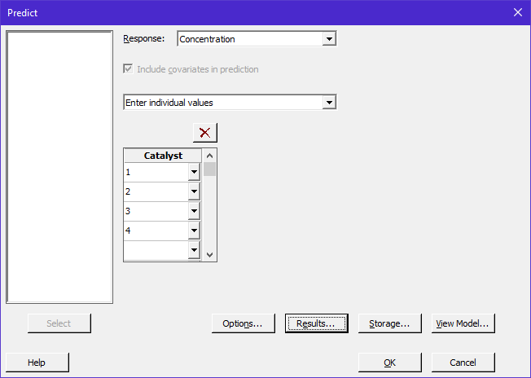

Comparing the least square estimates to the simple averages and standard errors.

Method of Least Squares  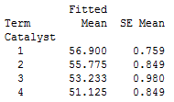 | Simple Method  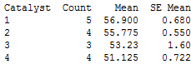

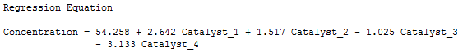

Questions:

- Do the means differ between the two approaches?

- How have the SE Mean values changed? Discuss.

Checking the Model Assumptions

In Handout 2, we briefly discussed checking the model assumptions. These assumptions are summarized below:

- All observations must be independent of each other.
- All factor levels must have the same amount of dispersion.
- The outcomes (or residuals) must follow a normal distribution.

Recall that if the assumptions for our model are not met, then the results of the analysis may not be valid. Therefore, checking assumptions is important, even if remedies are not readily available.

Select Stat > ANOVA > Test for Equal Variances.

Minitab returns the following:
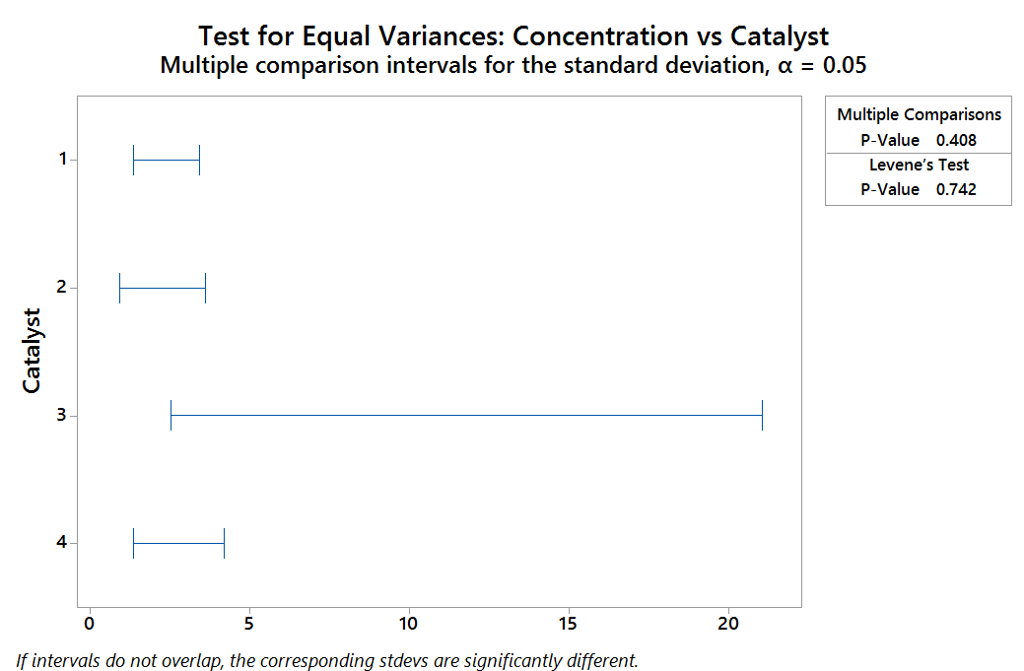

The following hypothesis is being tested by Barlett’s and Levene’s procedures.

The Decision Rule: If the p-value is less than 0.05, then the data is said to support the alternative hypothesis.

What do we conclude about this assumption? Discuss.

In Handout #2, we investigated the normality assumption by checking the normality assumption of the response for each group separately. When the number of treatment levels increase, a more simplest approach is to check the assumption using the residuals.

Concept of Residual

An entire cocktail of plots based on the residuals can easily be obtained in Minitab.

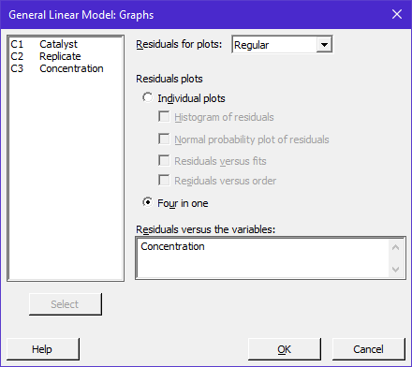

The Residual plots provided by Minitab.

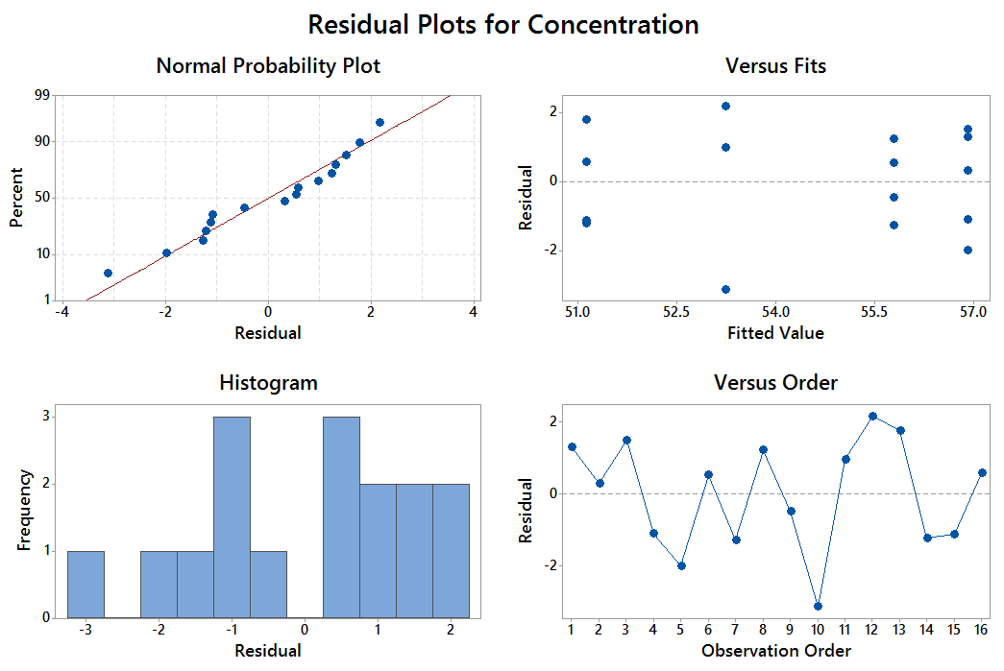

Discussions regarding these plots

- Normal Quantile Plot

- Residuals vs. Fits

- Histogram of Residuals

- Run Order Plot

The following output is provided directly beneath the ANOVA table in Mintab.

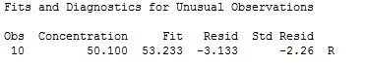

Multiple Comparison Procedures

Once we have determined that a difference exists, the question that naturally arises is WHERE are the differences? The stacked dot plots give us some idea of where differences exist, but remember that these summarize our sample data. We want to make statements, we want to ensure these outcomes are correct over repeated samples, not just for the one set of outcomes we obtained.

To determine where the differences exist, we will examine pairwise comparisons. If we analyze a data set in which k groups are compared, then we must potentially consider

pairwise comparisons.

For example, our Catalyst example compares four different groups (or catalysts). The ANOVA indicates that the mean concentration differs across these groups. To determine where, we must investigate the following pairwise comparisons:

Pair | Group 1 | Group 2 | Error Rate
1 | Catalyst 1 | Catalyst 2 | 5%
2 | Catalyst 1 | Catalyst 3 | 5%
3 | Catalyst 1 | Catalyst 4 | 5%
4 | Catalyst 2 | Catalyst 3 | 5%
5 | Catalyst 2 | Catalyst 4 | 5%
6 | Catalyst 3 | Catalyst 4 | 5%

Each of these three comparisons is controlled at an error rate of 5%. However, the error rate for the entire family of tests is actually larger than this. Therefore, we also need to ensure that the overall error rate is being controlled.

Methods available in Minitab to controlling error rates

To carry out multiple comparisons in Minitab, select the Comparisons… tab from the General Linear Model window. We will typically use Tukey’s method to control the overall error rate.

The Letterings

Letterings are commonly used to identify difference between treatments levels. Levels which do not have letters in common are statistically different.

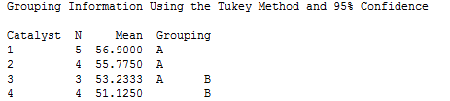

Use the letters above to determine which catalysts are different from the others.

 | Group 1 | Group 2 | Are the means statistically different?
1 | Catalyst 1 | Catalyst 2
2 | Catalyst 1 | Catalyst 3
3 | Catalyst 1 | Catalyst 4
4 | Catalyst 2 | Catalyst 3
5 | Catalyst 2 | Catalyst 4
6 | Catalyst 3 | Catalyst 4
The 95% Confidence Intervals

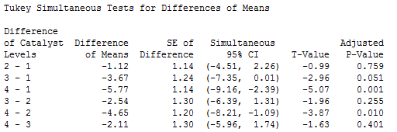

Use the outcomes above to identify the appropriate endpoints for making comparisons between catalysts. Identify whether or not the interval suggests a statistical difference between the catalysts.

 | Group 1 | Group 2 | Lower Limit | Upper Limit | Contain  0
1 | Catalyst 1 | Catalyst 2
2 | Catalyst 1 | Catalyst 3
3 | Catalyst 1 | Catalyst 4
4 | Catalyst 2 | Catalyst 3
5 | Catalyst 2 | Catalyst 4
6 | Catalyst 3 | Catalyst 4

The Test for the Pairwise Comparisons

Use the output provided above to verify the letterings given by Minitab.

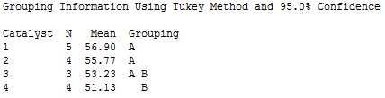

Appendix: The Analysis in JMP

Putting this data into the correct format for JMP

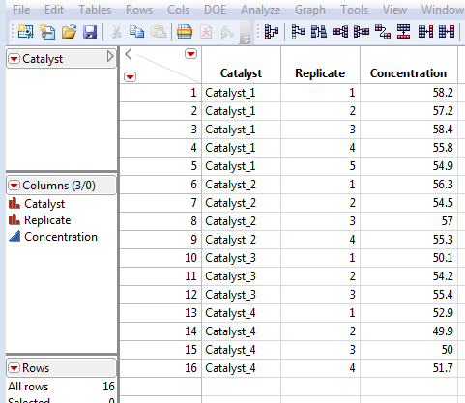

In JMP, select Analyze Fit Y by X.

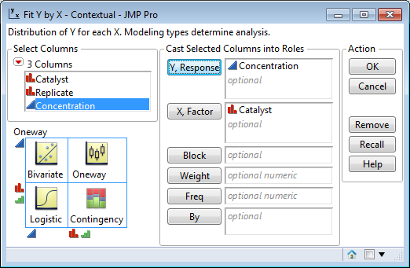

The dotplots to visual the effect of Catalyst.

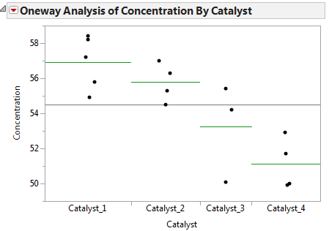
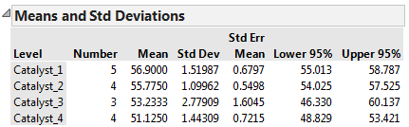

Carrying out the ANOVA in JMP

In JMP, select Analyze Fit Model. ter the following and click OK:

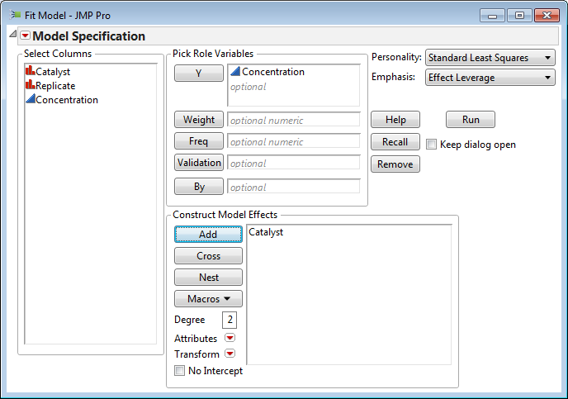

The output given by JMP.

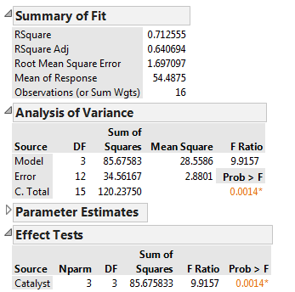

Least Square Means and Standard Errors

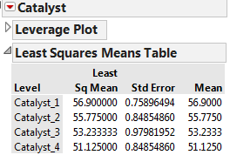 | 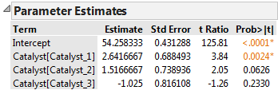

In simple experiments, the least square means are the same as the simple means for each group.

Checking the Model Assumptions

To obtain the necessary output for the assumptions in JMP, select Analyze > Fit Y by X. Place Concentration in the Y, Response box and Group in the X, Factor box.

- Select Unequal Variances from the red drop down menu for the Equal Variance tests.
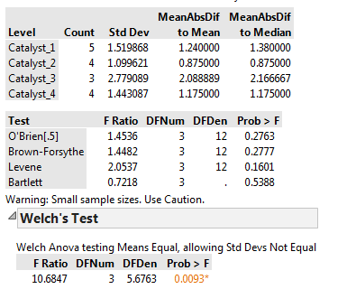

- Select Normal Quantile Plot from the red drop down menu for the normality assumption.

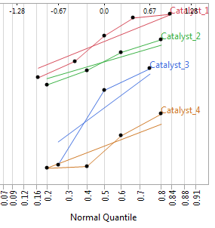

Multiple Comparison Procedures

- Select Tukey HSD from the red-drown menu to obtain to obtain the output for the multiple comparisons.

