Handout 5: 2² Factorial Designs

Sources: Montgomery -- Sections 6.1 and 6.2

Up to this point, we have considered the design and analysis of experiments in which the effects of only ONE treatment factor are investigated. Now, we are concerned with investigating the simultaneous effects of TWO treatment factors (each with two levels).

Example: A router is used to cut locating notches on a printed circuit board. The vibration level on the surface of the board as it is cut is considered to be a major source of dimensional variation in the notches. Two factors are thought to influence the vibration: bit size, say Factor A, and cutting speed, say Factor B. Two bits sizes (Small = 1/16 and Large = 1/8 inch) and two speeds (Slow = 40 and Fast = 90 rpm) are selected. This experiment will allow for testing four circuit boards at each of the four combinations. The response is vibration as a resultant of three accelerometers on each test circuit board.

Goal: Minimize vibration  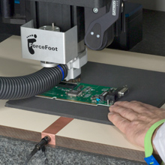 | Bit Size:  - Small  - Large  (Factor A) | 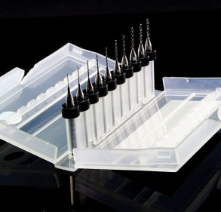
 | Speed:  - Slow  - Fast  (Factor B) | 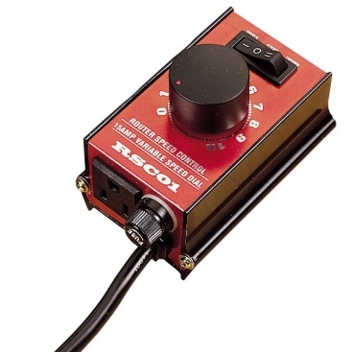

Data

Column Format  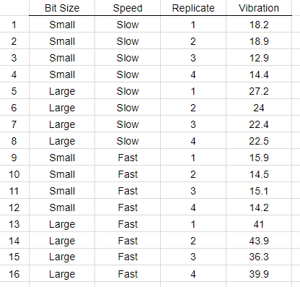 | Table Format  Bit Size Speed  Slow Fast  Small 18.2, 18.9, 12.9, 14.4 15.9, 14.5, 15.1, 14.2  Large 27.2, 24.0, 22.4, 22.5 41.0, 43.9, 36.3, 39.9

To summarize these outcomes, we might start with looking at the averages of each factor level combination. This can be done easily with PivotTables in Excel.

Looking at effect of  Bit Size | 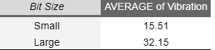
Looking at effect of  Speed | 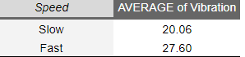
Looking at effect of  Bit Size/Speed in Combination  Bit Size * Speed | 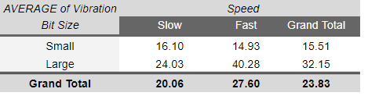

A plot of the effect of both factors on Vibration
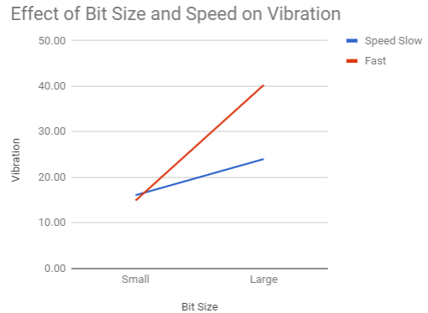

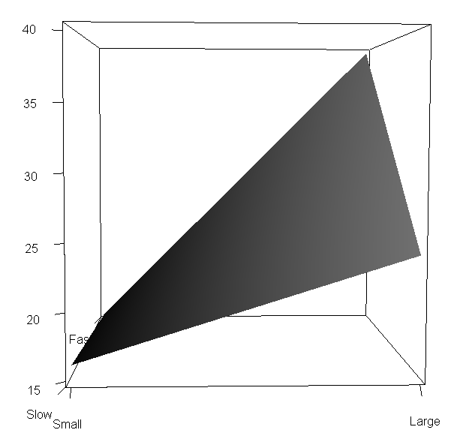

Getting the surface in R Studio

factor1=seq(-1,1,by=0.1)
factor2=seq(-1,1,by=0.1)

#Coefficient from model (-1 and +1 levels need to match, notice change in sign)
f=function(x,y){23.83+8.31*x+3.77*y+4.35*x*y}

#Using outer product to create surface
z=outer(factor1,factor2,f)

#Creating the plot
persp3d(factor1, factor2, z,col="gray",xlab="",ylab="",zlab="",axes=F)
axis3d("x",at=c(-1,1),labels=c("Small","Large"))
axis3d("y",at=c(-1,1),labels=c("Slow","Fast"))
axis3d("z")

Minitab’s Interaction Plot
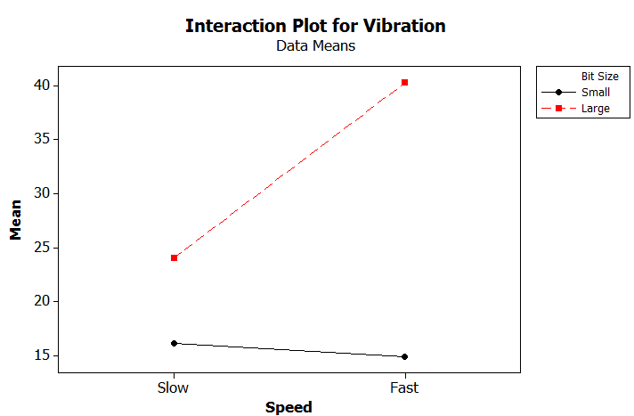

Understanding the Effects via a dotplot

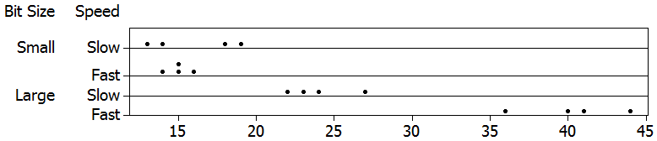

Creating a Factorial Design in Minitab

We can use Minitab to randomly assign the factor level combinations to the experimental material. Select Stat > DOE > Factorial > Create Factorial Design… to open the following dialog box:

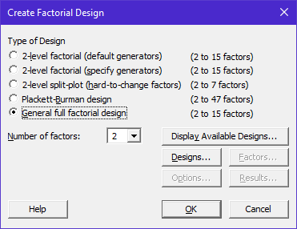

Click on Designs… to specify factor names, the number levels, the level names, etc.

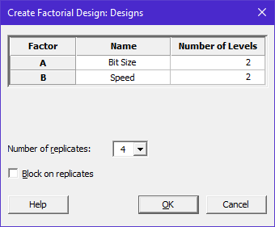

After you have completed the factor specifications, the Factors button becomes active. This allows us to specify level values for each factor:

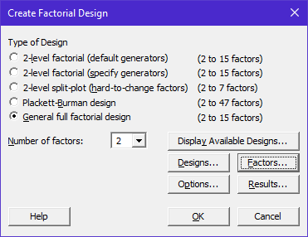

Click on Factors… and enter the following:
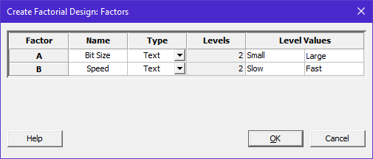

Also, click on Options… and enter the following:

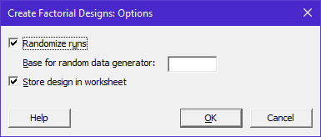

Output that is returned by Minitab. Notice the output is provided in random run order.

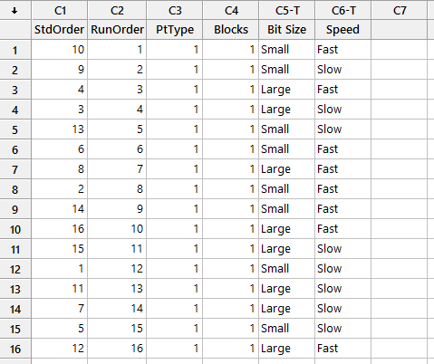

Sorting design matrix is standard order (StdOrder)

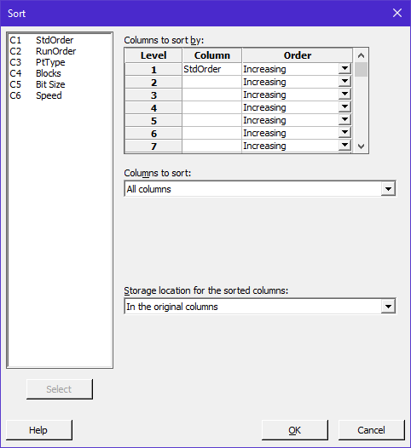 | 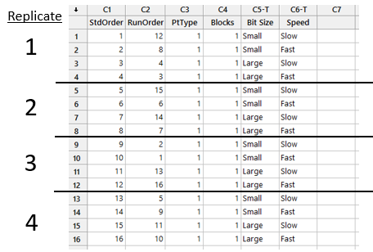

Final Step Add the response variable to the design.

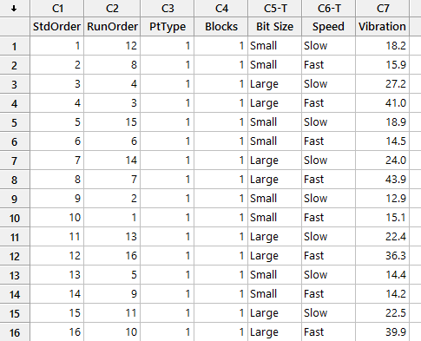

Carrying out the Analysis in Minitab

Select Stat > DOE > Factorial > Analyze Factorial Design…

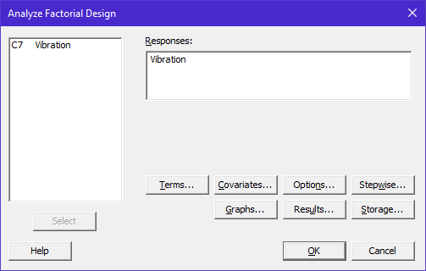

Minitab Output

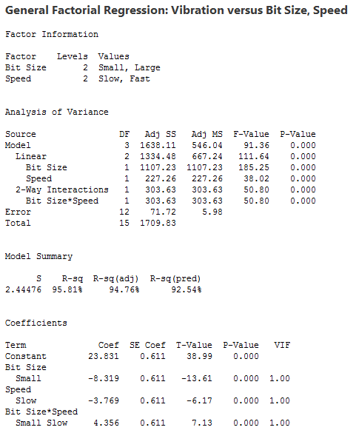

MODEL DIAGNOSTICS

Before undertaking any formal inference procedures, we need to evaluate the appropriateness of the model. As always, we will examine the residuals for normality and constancy of error variance.

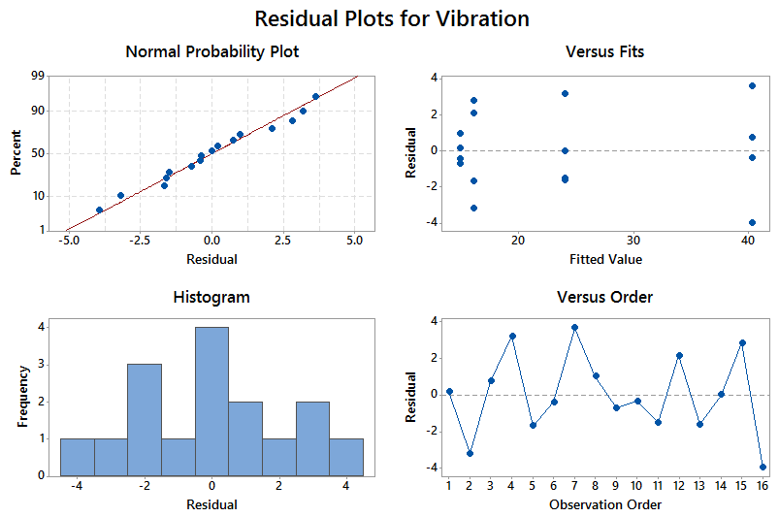

Understanding Model Sums of Squares

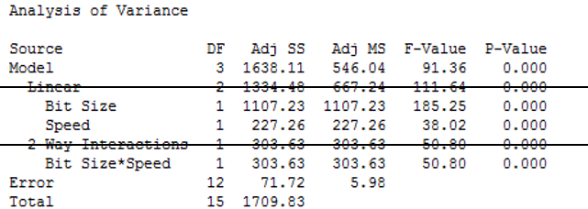

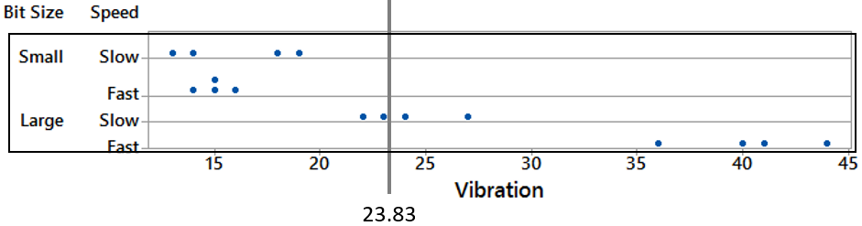

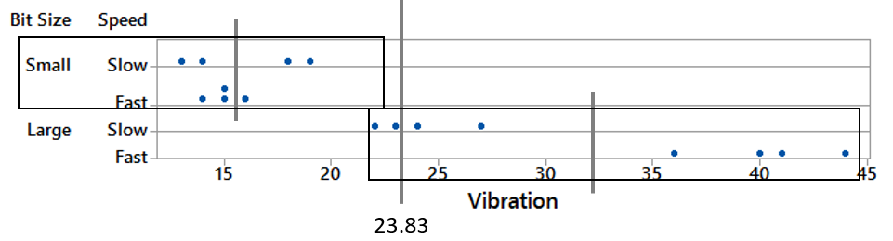
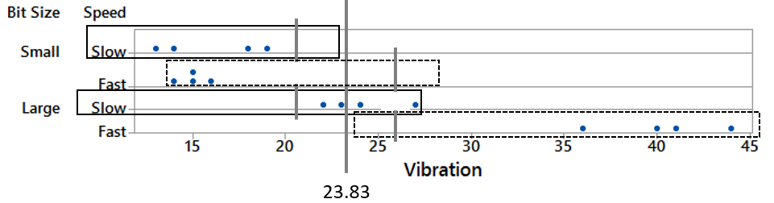
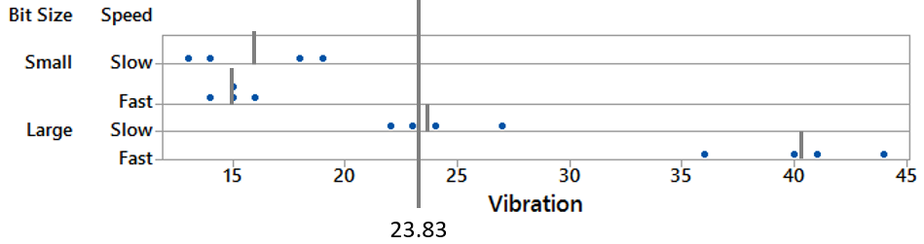

TESTS OF HYPOTHESES ABOUT FACTOR EFFECTS

Inferences about individual factor effects depend upon the presence or absence of interaction. The following flow chart indicates the steps you should take when analyzing data from a factorial design:

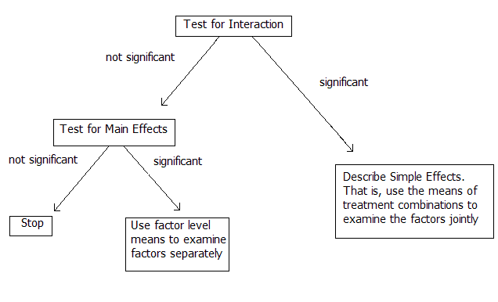
This flow chart is equivalent to using a “bottom-up” approach in processing through appropriate tests/p-values.

Testing for Interaction

The null and alternative hypotheses are given as follows.

H₀: Interaction term is *not* important
H_{a}: Interaction term is important

As we noted from an examination of the expected mean squares, the appropriate F-statistic is

.

Large values of this F-statistic indicate the existence of interactions. When the null hypothesis is true, then the F-statistic comes from an F distribution with df_{num} = 1, and df_{denom} = 12.

Testing for Factor A Main Effects

This test should be conducted only if no significant interactions exist. The hypotheses are as follows:

H₀: Factor A is *not* important
H_{a}: Factor A is important

As we noted from an examination of the expected mean squares, the appropriate F-statistic is

.

Large values of this F-statistic indicate the existence of Factor A main effects. When the null hypothesis is true, then the F-statistic comes from an F distribution with df_{num} = 1, and df_{denom} = 12.

Testing for Factor B Main Effects

This test should be conducted only if no significant interactions exist. The hypotheses are as follows:

H₀: Factor B is *not* important
H_{a}: Factor B is important

As we noted from an examination of the expected mean squares, the appropriate F-statistic is

.

Large values of this F-statistic indicate the existence of Factor B main effects. When the null hypothesis is true, then the F-statistic comes from an F distribution with df_{num} = 1, and df_{denom} = 12.

Results from Minitab

Questions:

- What do we conclude from this output?

- What should our next steps be in this analysis?

Examining Factor Plots:

From the General Linear Model Menu, choose Factor Plots…

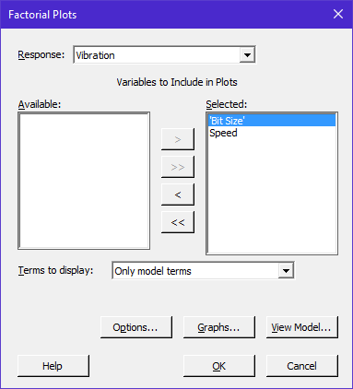

You can request to see both the main effects and the interactions plots.

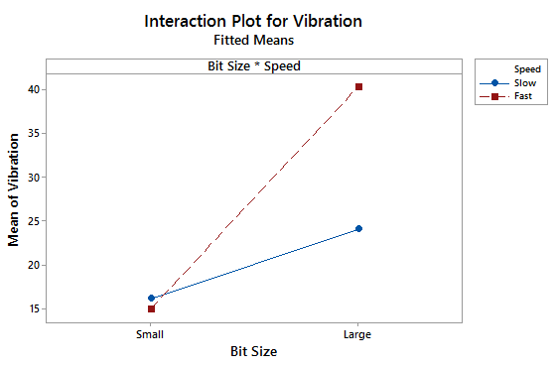

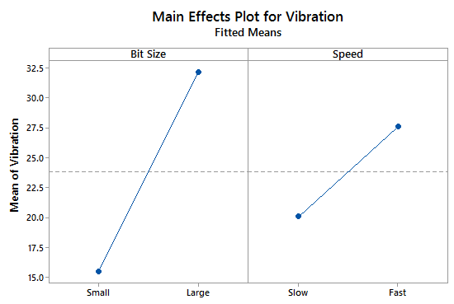

Example 5.2: (p234 of textbook) Consider an investigation into the effect of the concentration of the reactant and the amount of the catalyst on the conversion (yield) in a chemical process. The objective was to determine if adjustments to either of these two factors would increase the yield.

Goal: Maximize Yield  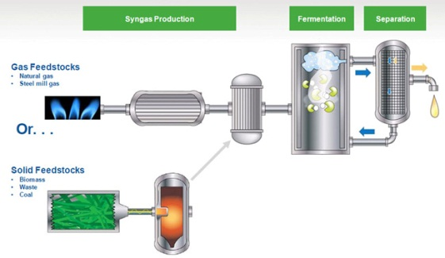 | Reactant Concentration  - Low: 15%  - High: 25%  (Factor A)
Catalyst:
- Low: 1 lb
- High: 2 lbs

(Factor B)

The experiment was replicated three times, so there are 12 runs.

Setting up the design in Minitab.

Create Factorial Design | Under the Design Tab  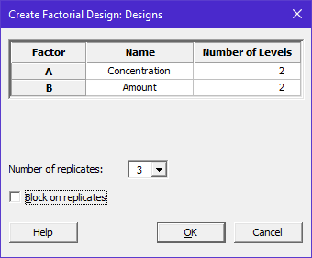

Option #1  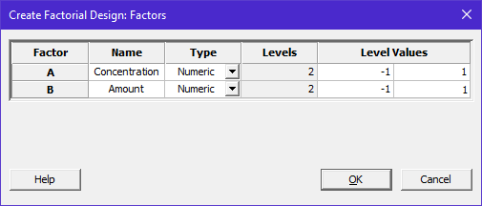 | Option #2  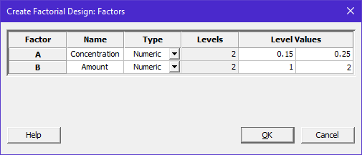
Option #3

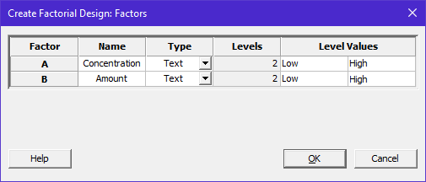

Design Output given in Session window.

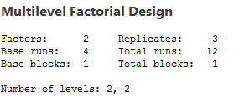

Data in Excel with simple summaries.

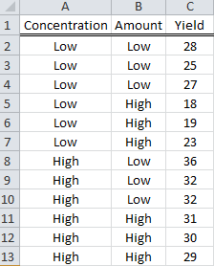 | Effect on Average Response  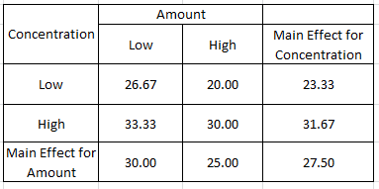  Effect on Standard Deviation of Response  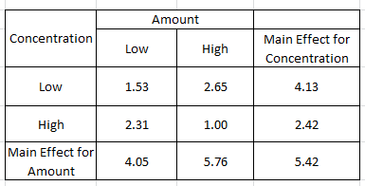

Design in Minitab with response, i.e. yield

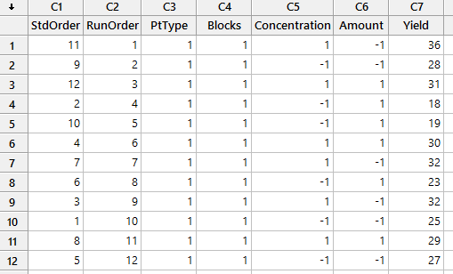

ANOVA Table in Minitab.

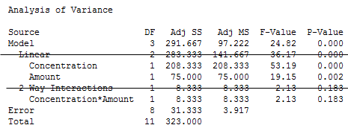

Discussion:

Residual plots to check assumptions

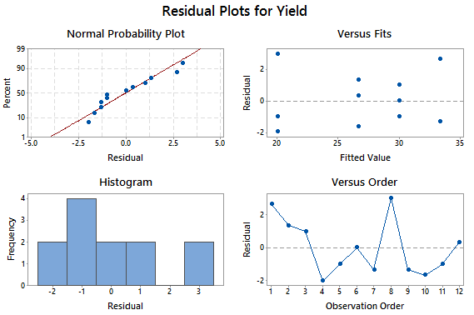

Discussion

Appropriate investigation of means

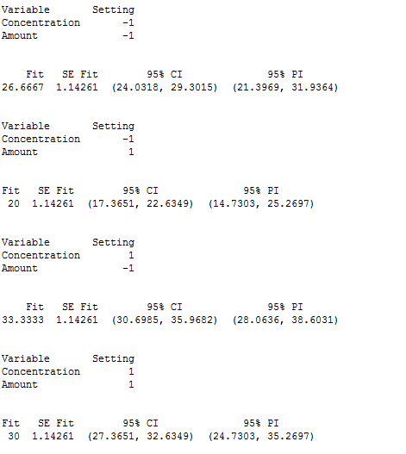

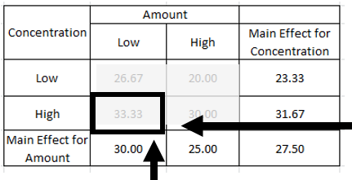

Discussion

Main Effect Plots:

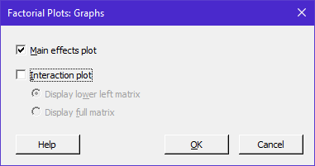

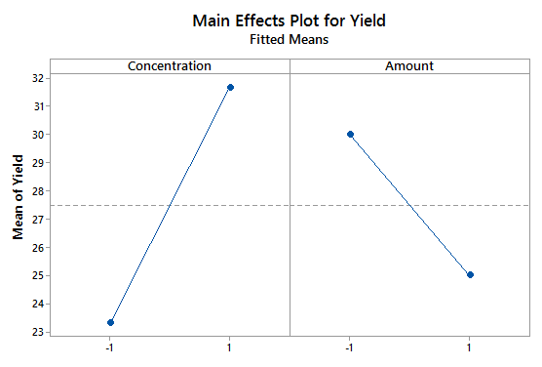

Interaction Plots (not necessary);

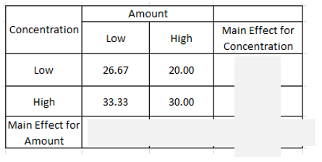

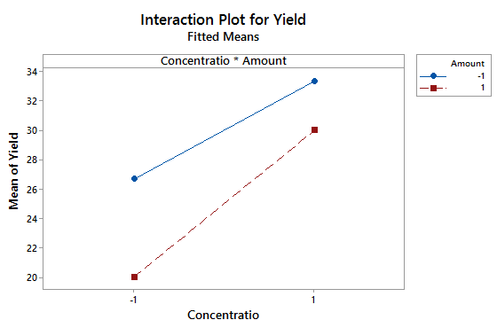

Appendix: Setup and Analysis in JMP

Creating a Full Factorial Design in JMP

We can use JMP to randomly assign the factor level combinations to the experimental material. Select DOE > Full Factorial Design to open the following dialog box.

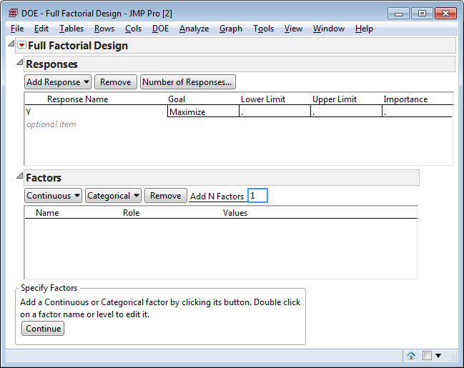

Next, enter information regarding the response variable of interest for this experiment. You should also specify the goal for the response variable. Multiple response variables can be entered here.

Specify the factors and their levels in the Factors box in this window.

Click Continue in the bottom-left corner.

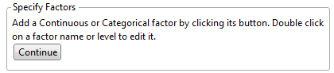

The specification of the number of replicates in specified in the following Output Options box. When finished click Make Table.

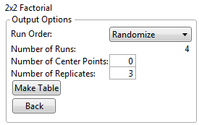

The output that is returned by JMP is shown below. Notice the output is provided in random run order.

Table returned by JMP.  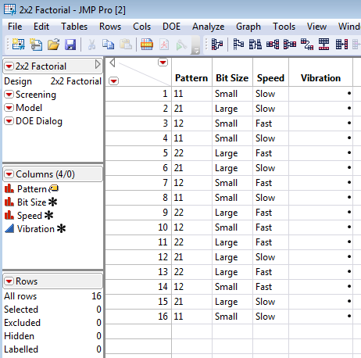 | After the experiment is run, the response variable should be entered into the JMP worksheet.  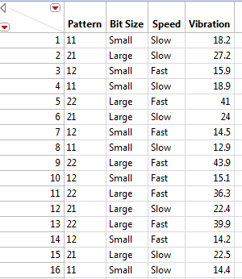

The dialog box near the upper-right corner contains options that will automatically produce appropriate output.

Pre-specified Dialog  Options in JMP  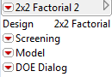 | Clicking Model produces the following Fit Model window.  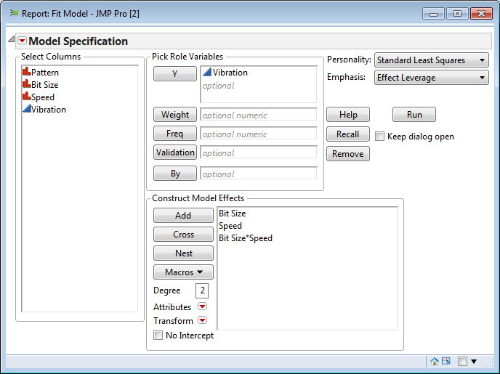

JMP Output from the Fit Model routine.

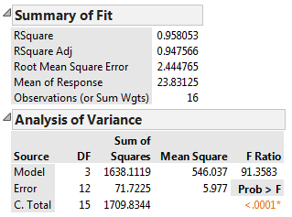
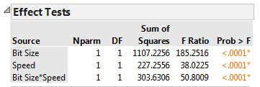

The Interaction plot can be easily obtained by clicking the red-down menu > Factor Profiling > Interaction Plots.

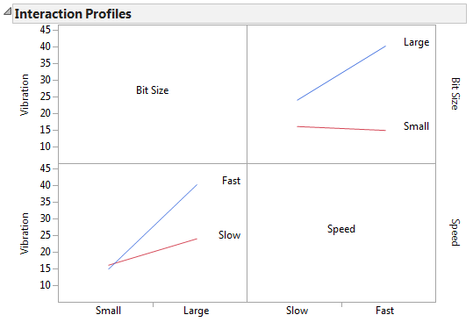

Main Effect (and Interaction) Plots can be obtained

Main Effect Plot for Bit Size  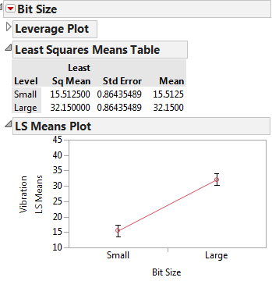 | Main Effect Plot for Speed  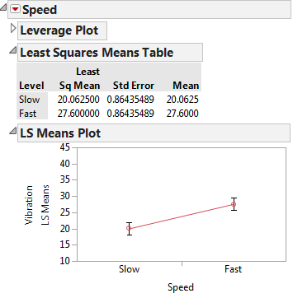
Interaction Plot for Bit Size * Speed

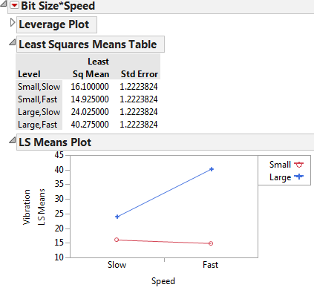

Additional plots of possible interest produced by JMP for this design.

