Handout 7: 2⁴ Factorial Designs

Example: [Source: Exercise 6.15, page 266, Montgomery]. A nickel-titanium alloy is used to make components for jet turbine aircraft engines. Cracking is a potentially serious problem in the final part because it can lead to non-recoverable failure. A test is run at the parts producer to determine the effect of four factors on cracks. The four factors are

- pouring temperature (A)
- titanium content (B)
- heat treatment method (C)
- amount of grain refiner used (D).

Two replicates of a 2⁴ design are run, and the length of crack (in mm x 10⁻²) induced in a sample coupon subjected to a standard test is measured.

The Design
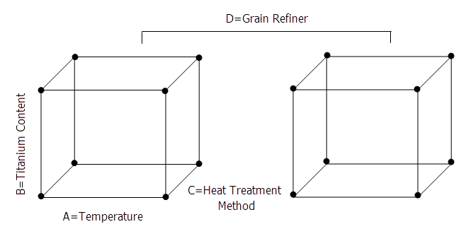

The cubes using standard notation to identify the design points…

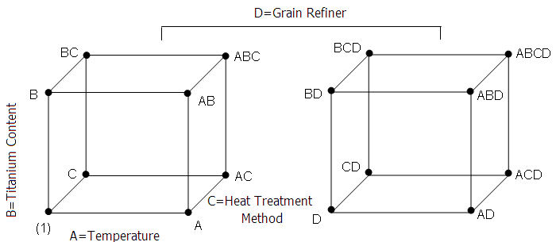

Creating and Analyzing the Design in Minitab

Select Stat > DOE > Factorial > Create Factorial Design… Specify the Number of Factors as 4 and then choose the Full factorial with 2 replicates under the Designs… tab.

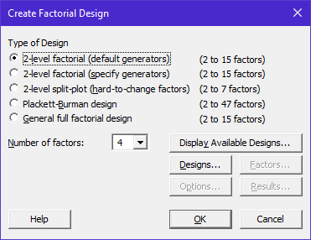 | 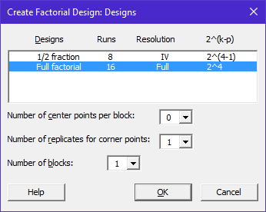

The data can then be entered into the spreadsheet (only a portion is shown below):

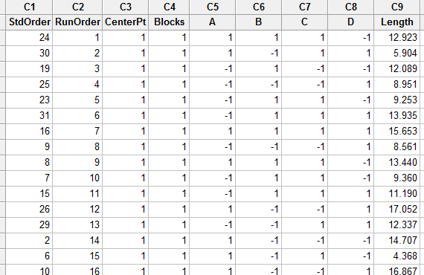

To analyze the design, select Stat > DOE > Factorial > Analyze Factorial Design…
Enter ‘Length’ as the response variable, and include the main effects and all possible interactions in the model.
Enter the response:  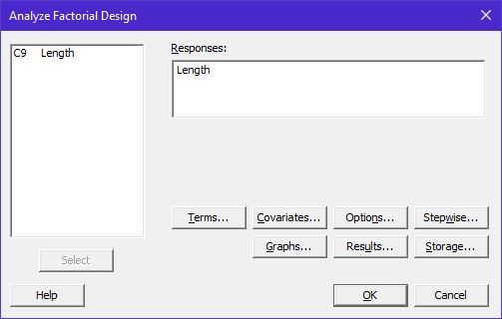 | Under the Terms… tab:  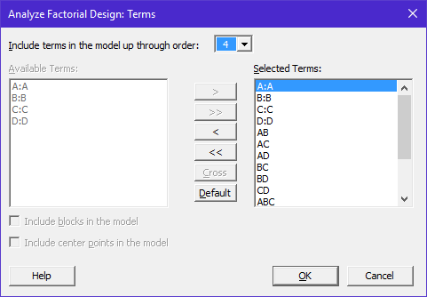
Under the Options… tab  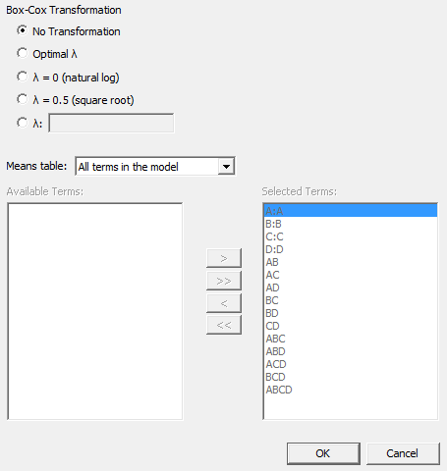 | Under the Results… tab  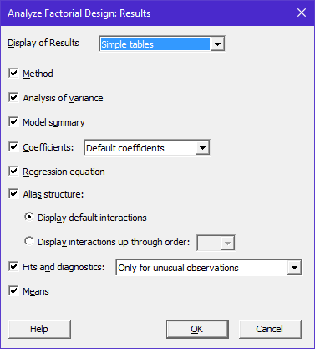
Under the Graphs… tab  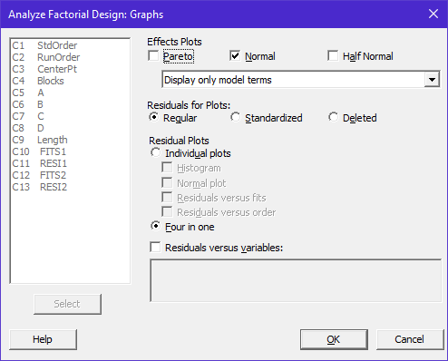 | Under the Storage… tab  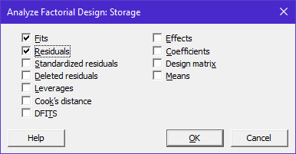

The Output

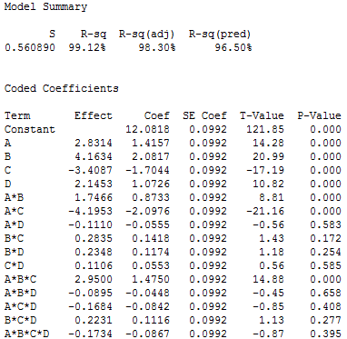

Questions:

- What are the important factors in this experiment? That is, what factors appear to have an influence on crack length?
- What is the estimated “error” in our model?

The Normal Probability Plot of the Standardized Estimated Effects is given below. Note that this graph agrees with the above output:

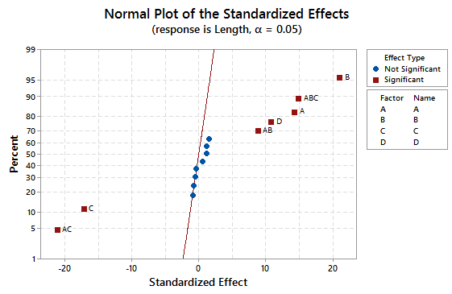

The Cube Plot

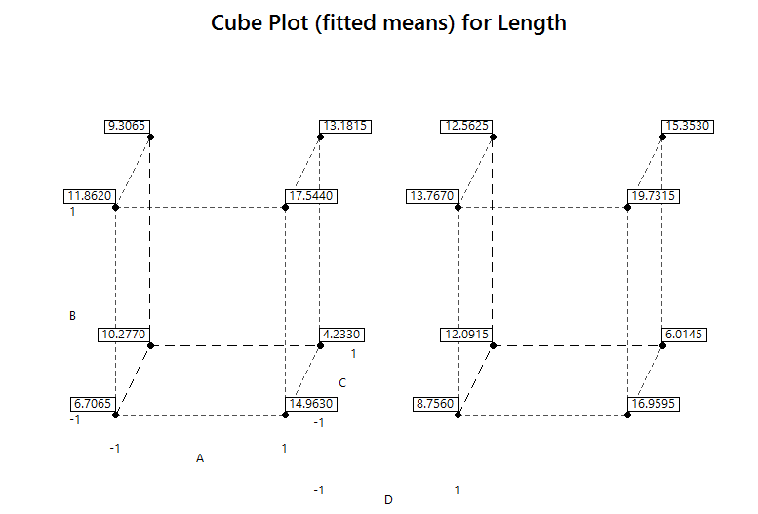

Interaction Plots

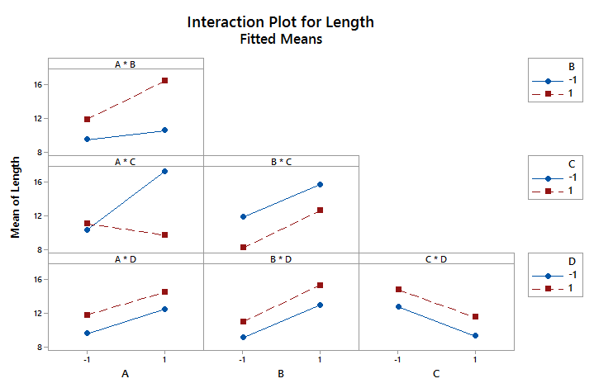
More About Interactions

Two-way interactions…

Mean SE Mean  A*B  -1 -1 9.458 0.198  1 -1 10.543 0.198  -1 1 11.875 0.198  1 1 16.453 0.198 | Mean SE Mean  A*D  -1 -1 9.538 0.198  1 -1 12.480 0.198  -1 1 11.794 0.198  1 1 14.515 0.198

Three-way interactions…

Mean SE Mean
A*B*C
-1 -1 -1 7.731 0.280
1 -1 -1 15.961 0.280
-1 1 -1 12.815 0.280
1 1 -1 18.638 0.280
-1 -1 1 11.184 0.280
1 -1 1 5.124 0.280
-1 1 1 10.935 0.280
1 1 1 14.267 0.280
Mean SE Mean
A*B*D
-1 -1 -1 8.492 0.280
1 -1 -1 9.598 0.280
-1 1 -1 10.584 0.280
1 1 -1 15.363 0.280
-1 -1 1 10.424 0.280
1 -1 1 11.487 0.280
-1 1 1 13.165 0.280
1 1 1 17.542 0.280

Checking the Model

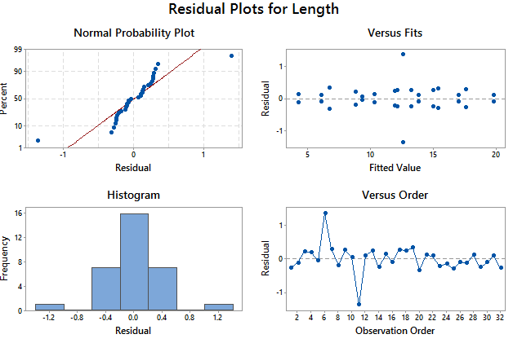
Example: Consider Exercise 6.29 from your text (page 270). An experiment was conducted on a chemical process that produces a polymer. The four factors being considered are:

- Factor A = Temperature at 100 and 120 ^{O}C  - Factor B = Catalyst Concentration at 4% and 8%  - Factor C = Time at 20 and 30 minutes  - Factor D = Pressure at 60 and 75 psi | 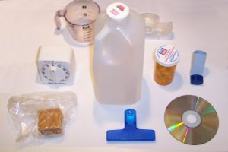

Two responses or outcomes were measured: molecular weight and viscosity.

The Design

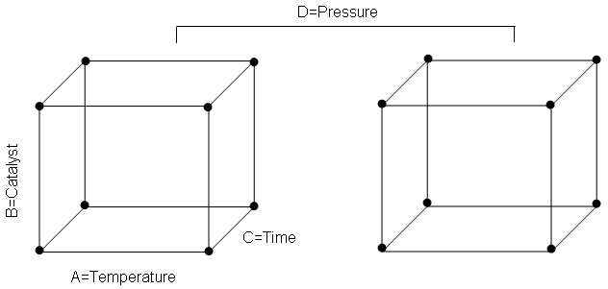

The cubes using standard notation to identify the design points…

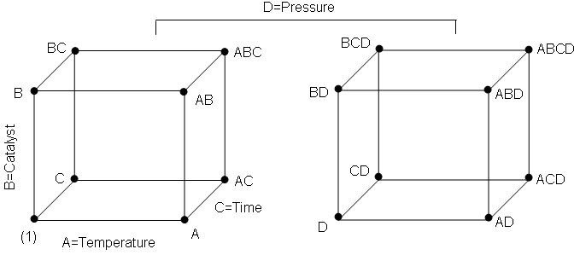
An Initial Analysis for Molecular Weight

Note that only a single replicate of each treatment combination was run. Consider the output from this analysis:

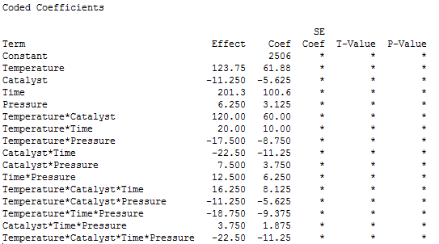

Fitted Values and Residuals:

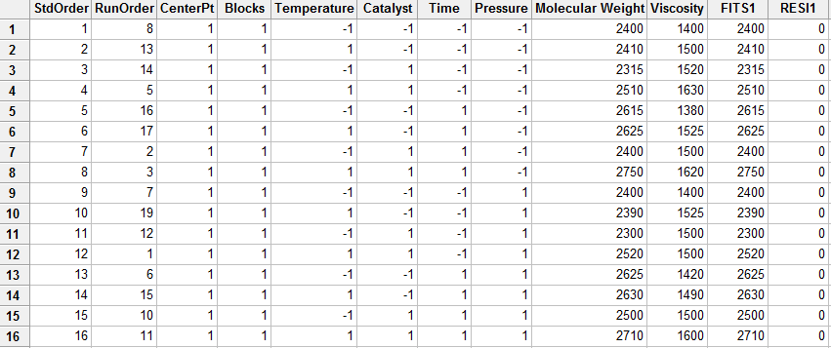

Comments:

This design is actually an UNREPLICATED design as there is only one observation at each design point. We see that the fitted values (i.e. the averages at the design points, as this design is indeed balanced) are exactly the same as the original observations. This causes problems. In particular, all residuals are 0. If all the residuals are zero, we might naively conclude that we have a PERFECT model.

Adding Center Points to Analyze an Unreplicated Design

In many applications of two-level factorial experiments, it is not feasible (or possible) to run more than a single replication of the treatment combinations. If this is the case, then there are 0 degrees of freedom available for obtaining an estimate of the error variance. One approach to analyzing an unreplicated design is to use replications at only the center point in order to obtain an estimate of the error variance.

A center point is a new factor level in which each of the factors is set at the midpoint of its range. For example, in this experiment, the center point treatment levels are:

- Factor A = 110 ^{O}C
- Factor B = 6%
- Factor C = 25 minutes
- Factor D = 67.5 psi

We will run four replicates at the center point.

The Data:
 | Factors |  |  |  | Responses
Label | A | B | C | D | Molecular Weight | Viscosity
(1) | Low | Low | Low | Low | 2400 | 1400
A | High | Low | Low | Low | 2410 | 1500
B | Low | High | Low | Low | 2315 | 1520
AB | High | High | Low | Low | 2510 | 1630
C | Low | Low | High | Low | 2615 | 1380
AC | High | Low | High | Low | 2625 | 1525
BC | Low | High | High | Low | 2400 | 1500
ABC | High | High | High | Low | 2750 | 1620
D | Low | Low | Low | High | 2400 | 1400
AD | High | Low | Low | High | 2390 | 1525
BD | Low | High | Low | High | 2300 | 1500
ABD | High | High | Low | High | 2520 | 1500
CD | Low | Low | High | High | 2625 | 1420
ACD | High | Low | High | High | 2630 | 1490
BCD | Low | High | High | High | 2500 | 1500
ABCD | High | High | High | High | 2710 | 1600
-- | Center | Center | Center | Center | 2515 | 1500
-- | Center | Center | Center | Center | 2500 | 1460
-- | Center | Center | Center | Center | 2400 | 1525
-- | Center | Center | Center | Center | 2475 | 1500

Setting up this design in Minitab

Select Stat > DOE > Factorial > Create Factorial Design… Specify the Number of Factors as 4. Under the Designs… tab, specify that we will have four center points for this design.
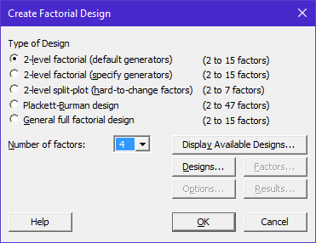 | 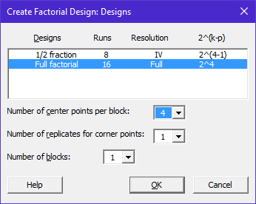

The Data in Minitab…

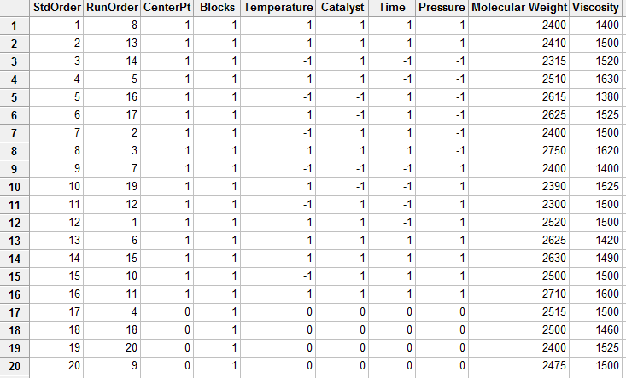

We can easily modify our design so that the uncoded units are used (e.g. Temperature = 100 ^{O}C and 120 ^{O}C; Catalyst = 4% and 8%; Time = 20 minutes and 30 minutes; and Pressure = 60 psi and 75 psi).

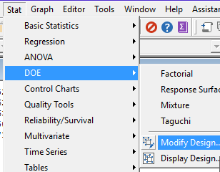 | 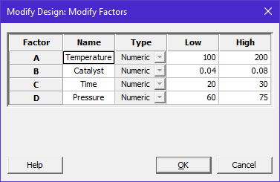

The data displayed using uncoded units…

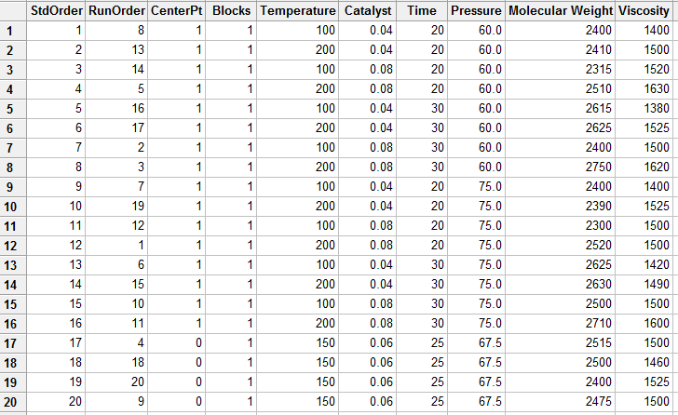

Getting the Analysis for Molecular Weight in Minitab

Select Stat > DOE > Factorial > Analyze Factorial Design…
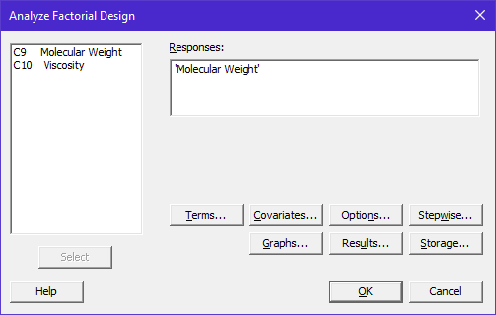 | Under the Terms… tab  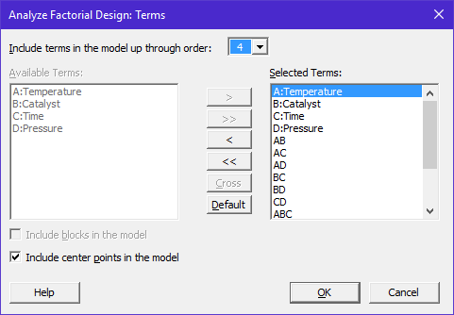
Under the Options... tab  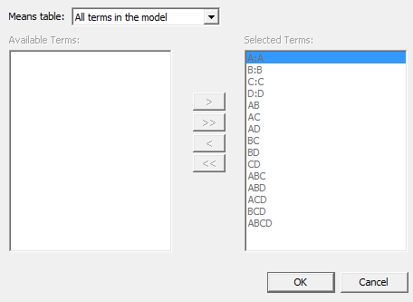 | Under the Graphs... tab  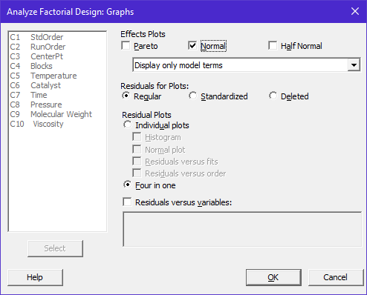
Under the Results… tab | Under the Storage… tab  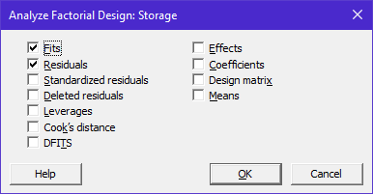

The Output for Molecular Weight

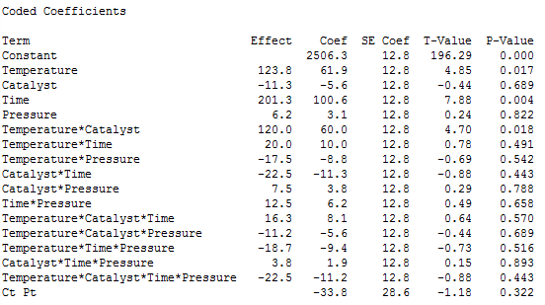

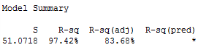

Questions:
- What are the important factors in this experiment? That is, what factors are said to have an influence on the molecular weight of this polymer? Discuss.

- What is the estimated “error” in our model?

- How does Minitab calculate the standard error of 12.77?
- How does Minitab calculate the standard error of 28.55?

- How are the t-statistics and p-values computed?

The Normal Probability Plot of the Standardized Estimated Effects is given here. Note that this graph agrees with what we saw above regarding the significant effects.

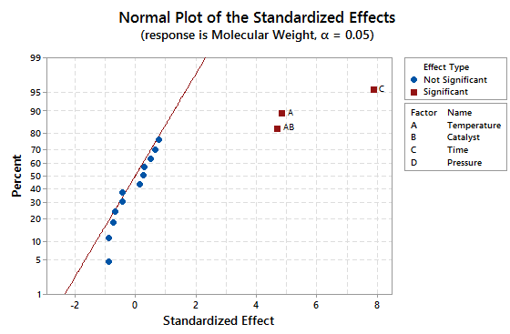
The estimated model coefficients…

Getting the fitted values using the -1 / +1 notation (i.e. coded units)…  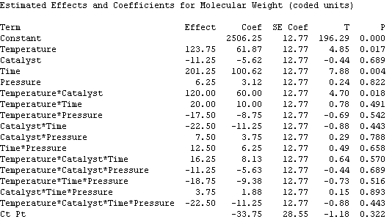 | Getting the fitted values using the uncoded units (Temp=100/120, Catalyst=4/8, Time=20/30, and Pressure=60/75)  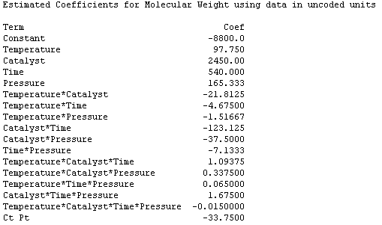

Least Squares Means for Molecular Weight

Mean SE Mean
Temperature
100 2444 18.06
120 2568 18.06
Catalyst
4 2512 18.06
8 2501 18.06
Time
20 2406 18.06
30 2607 18.06
Pressure
60 2503 18.06
75 2509 18.06
Temperature*Catalyst
100 4 2510 25.54
120 4 2514 25.54
100 8 2379 25.54
120 8 2623 25.54
Temperature*Time
100 20 2354 25.54
120 20 2458 25.54
100 30 2535 25.54
120 30 2679 25.54
Temperature*Pressure
100 60 2433 25.54
120 60 2574 25.54
100 75 2456 25.54
120 75 2563 25.54
Catalyst*Time
4 20 2400 25.54
8 20 2411 25.54
4 30 2624 25.54
8 30 2590 25.54

Catalyst*Pressure
4 60 2513 25.54
8 60 2494 25.54
4 75 2511 25.54
8 75 2508 25.54
Time*Pressure
20 60 2409 25.54
30 60 2598 25.54
20 75 2403 25.54
30 75 2616 25.54
Temperature*Catalyst*Time
100 4 20 2400 36.11
120 4 20 2400 36.11
100 8 20 2308 36.11
120 8 20 2515 36.11
100 4 30 2620 36.11
120 4 30 2628 36.11
100 8 30 2450 36.11
120 8 30 2730 36.11
Temperature*Catalyst*Pressure
100 4 60 2508 36.11
120 4 60 2518 36.11
100 8 60 2358 36.11
120 8 60 2630 36.11
100 4 75 2513 36.11
120 4 75 2510 36.11
100 8 75 2400 36.11
120 8 75 2615 36.11
Temperature*Time*Pressure
100 20 60 2358 36.11
120 20 60 2460 36.11
100 30 60 2508 36.11
120 30 60 2688 36.11
100 20 75 2350 36.11
120 20 75 2455 36.11
100 30 75 2563 36.11
120 30 75 2670 36.11
Catalyst*Time*Pressure
4 20 60 2405 36.11
8 20 60 2413 36.11
4 30 60 2620 36.11
8 30 60 2575 36.11
4 20 75 2395 36.11
8 20 75 2410 36.11
4 30 75 2628 36.11
8 30 75 2605 36.11
Temperature*Catalyst*Time*Pressure
100 4 20 60 2400 51.07
120 4 20 60 2410 51.07
100 8 20 60 2315 51.07
120 8 20 60 2510 51.07
100 4 30 60 2615 51.07
120 4 30 60 2625 51.07
100 8 30 60 2400 51.07
120 8 30 60 2750 51.07
100 4 20 75 2400 51.07
120 4 20 75 2390 51.07
100 8 20 75 2300 51.07
120 8 20 75 2520 51.07
100 4 30 75 2625 51.07
120 4 30 75 2630 51.07
100 8 30 75 2500 51.07
120 8 30 75 2710 51.07

More on the Center Points

The center points allow us to obtain an estimate of the left-over error in our model.

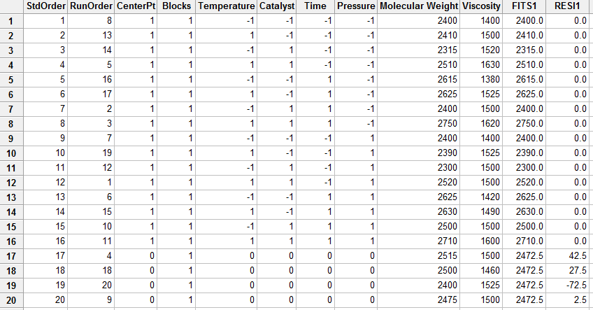

The table below gives us some information about how the residual error is computed for this problem.

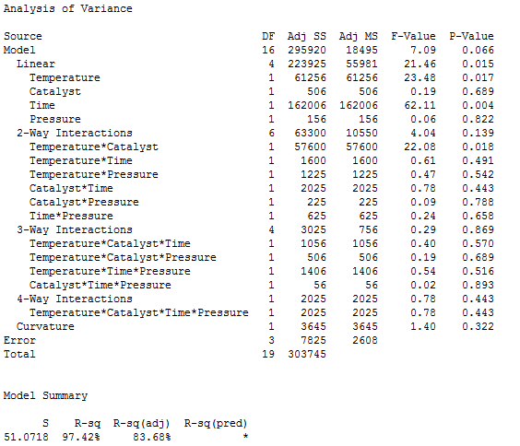

What do the center points do for me?

- Allow for an estimate of pure error, i.e. Error Term. Again, without these center points, the design would be considered an unreplicated design.

- Allows us to test for lack of fit (curvature) in the model. See Section 6.8 of your text for details. | 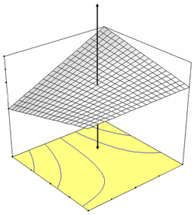

Checking the Model

List of unusual observations from Minitab…

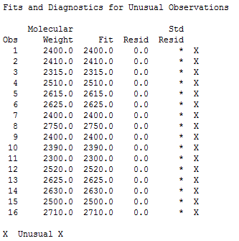

Residual plots from Minitab…

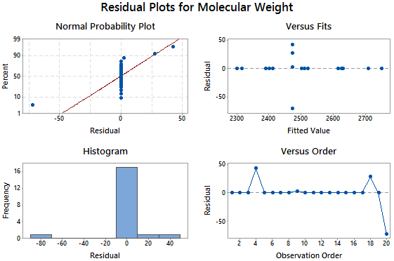

Graphs to Display the Effect of Factors on Molecular Weight

The two-way interaction plots…
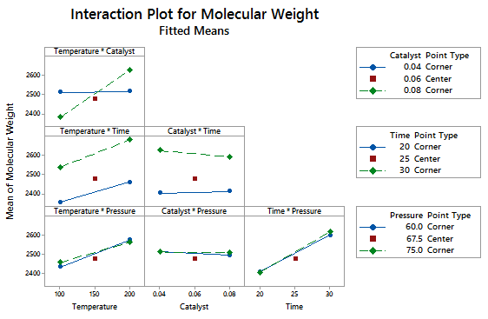

Main Effect Plots….

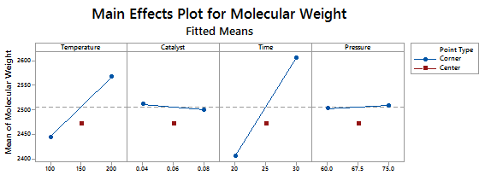

The Output for Viscosity

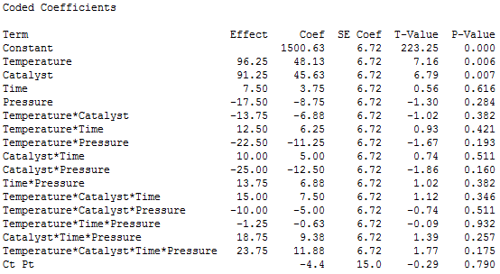

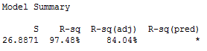
Questions:
- What are the important factors in this experiment? That is, what factors are said to have an influence on the molecular weight of this polymer? Discuss.

- What is the estimated “error” in our model?

The Normal Probability Plot of the Standardized Estimated Effects is given here. This graph agrees with what we learned above.

The Estimated Model Coefficients

Getting the fitted values using the uncoded units (Temp=100/120, Catalyst=4/8, Time=20/30, and Pressure=60/75)

Estimated Coefficients for viscosity using data in uncoded units

Term Coef
Constant 16870.0
Temperature -151.500
Catalyst -2665.00
Time -646.000
Pressure -253.333
Temperature*Catalyst 26.7500
Temperature*Time 6.20000
Temperature*Pressure 2.46667
Catalyst*Time 101.375
Catalyst*Pressure 43.2500
Time*Pressure 10.0667
Temperature*Catalyst*Time -0.993750
Temperature*Catalyst*Pressure -0.429167
Temperature*Time*Pressure -0.0966667
Catalyst*Time*Pressure -1.61667
Temperature*Catalyst*Time*Pressure 0.0158333
Ct Pt -4.3750

Least Squares Means for Viscosity
Mean SE Mean
Temperature
100 1453 9.506
120 1549 9.506
Catalyst
4 1455 9.506
8 1546 9.506
Time
20 1497 9.506
30 1504 9.506
Pressure
60 1509 9.506
75 1492 9.506
Temperature*Catalyst
100 4 1400 13.444
120 4 1510 13.444
100 8 1505 13.444
120 8 1588 13.444
Temperature*Time
100 20 1455 13.444
120 20 1539 13.444
100 30 1450 13.444
120 30 1559 13.444
Temperature*Pressure
100 60 1450 13.444
120 60 1569 13.444
100 75 1455 13.444
120 75 1529 13.444
Catalyst*Time
4 20 1456 13.444
8 20 1538 13.444
4 30 1454 13.444
8 30 1555 13.444
Catalyst*Pressure
4 60 1451 13.444
8 60 1568 13.444
4 75 1459 13.444
8 75 1525 13.444
Time*Pressure
20 60 1513 13.444
30 60 1506 13.444
20 75 1481 13.444
30 75 1503 13.444
Temperature*Catalyst*Time
100 4 20 1400 19.012
120 4 20 1513 19.012
100 8 20 1510 19.012
120 8 20 1565 19.012
100 4 30 1400 19.012
120 4 30 1508 19.012
100 8 30 1500 19.012
120 8 30 1610 19.012
Temperature*Catalyst*Pressure
100 4 60 1390 19.012
120 4 60 1513 19.012
100 8 60 1510 19.012
120 8 60 1625 19.012
100 4 75 1410 19.012
120 4 75 1508 19.012
100 8 75 1500 19.012
120 8 75 1550 19.012
Temperature*Time*Pressure
100 20 60 1460 19.012
120 20 60 1565 19.012
100 30 60 1440 19.012
120 30 60 1573 19.012
100 20 75 1450 19.012
120 20 75 1513 19.012
100 30 75 1460 19.012
120 30 75 1545 19.012
Catalyst*Time*Pressure
4 20 60 1450 19.012
8 20 60 1575 19.012
4 30 60 1453 19.012
8 30 60 1560 19.012
4 20 75 1463 19.012
8 20 75 1500 19.012
4 30 75 1455 19.012
8 30 75 1550 19.012
Temperature*Catalyst*Time*Pressure
100 4 20 60 1400 26.887
120 4 20 60 1500 26.887
100 8 20 60 1520 26.887
120 8 20 60 1630 26.887
100 4 30 60 1380 26.887
120 4 30 60 1525 26.887
100 8 30 60 1500 26.887
120 8 30 60 1620 26.887
100 4 20 75 1400 26.887
120 4 20 75 1525 26.887
100 8 20 75 1500 26.887
120 8 20 75 1500 26.887
100 4 30 75 1420 26.887
120 4 30 75 1490 26.887
100 8 30 75 1500 26.887
120 8 30 75 1600 26.887
Mean for Center Point = 1496
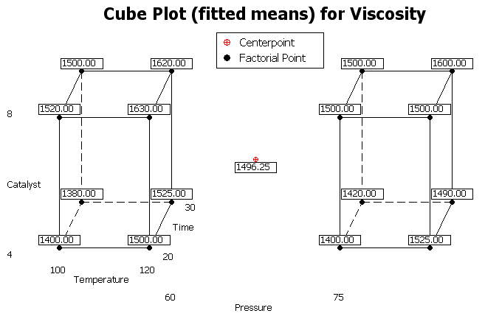

Checking the Model

List of unusual observations from Minitab…

Residual plots from Minitab…

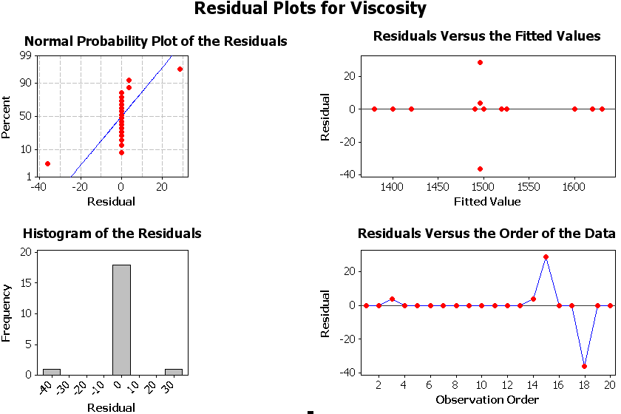

Graphs to Display the Effect of Factors on Viscosity

The two-way interaction plots…

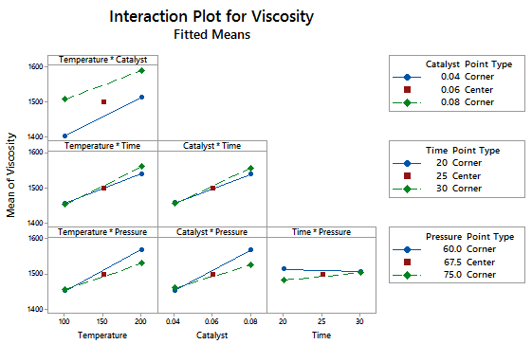

Main Effect Plots….
