Handout 8: 2⁴ Factorial Designs with No Replicates (Lenth’s Method)

[Section 6.5 Montgomery] Consider an experiment that was conducted to aid in the development of a nitride etch process on a single-wafer plasma etcher.

- Factor A = anode-cathode gap at 0.80 and 1.20 cm
- Factor B = pressure in reactor chamber at 450 and 550 (mTorr)
- Factor C = C₂F₆ gas flow at 125 and 200 (SCCM)
- Factor D = power applied to cathode at 275 and 325 (W)

The response is the etch rate for silicon nitride. A single replicate of this experiment was completed.

The Design:

The Data:
Factors |  |  |  |  | Response
Run ID | A | B | C | D | Etch Rate
1 | Low | Low | Low | Low | 550
2 | High | Low | Low | Low | 669
3 | Low | High | Low | Low | 604
4 | High | High | Low | Low | 650
5 | Low | Low | High | Low | 633
6 | High | Low | High | Low | 642
7 | Low | High | High | Low | 601
8 | High | High | High | Low | 635
9 | Low | Low | Low | High | 1037
10 | High | Low | Low | High | 749
11 | Low | High | Low | High | 1052
12 | High | High | Low | High | 868
13 | Low | Low | High | High | 1075
14 | High | Low | High | High | 860
15 | Low | High | High | High | 1063
16 | High | High | High | High | 729

The Data in Minitab (EtchRate.MPJ)

Coded Effects

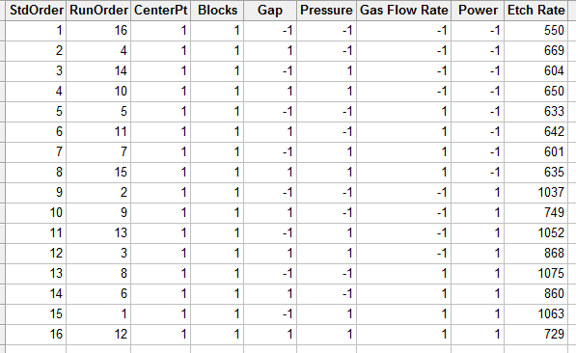
Uncoded Effects

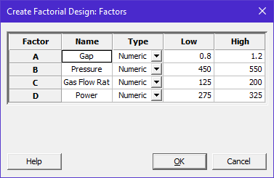

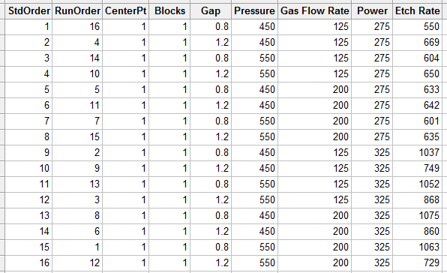
The Analysis

Under the Terms… tab, specify all factors to be included in our analysis…

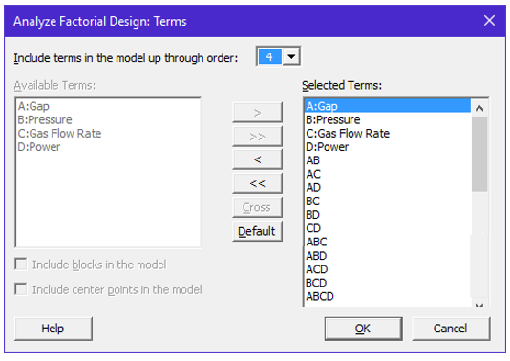
How many terms are in this model? How many design points do we have?

Realize, this is an unreplicated design with no center runs…

Once again, all residuals are zero and so an independent estimate of error cannot be obtained. This experiment is void of center runs which are what “saved us” on the last handout.

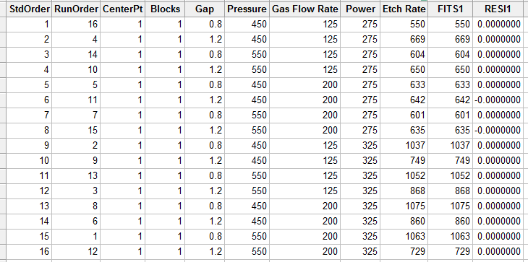

The output from Minitab is incomplete and does not provide a statistical test that can be used to identify significant factors.

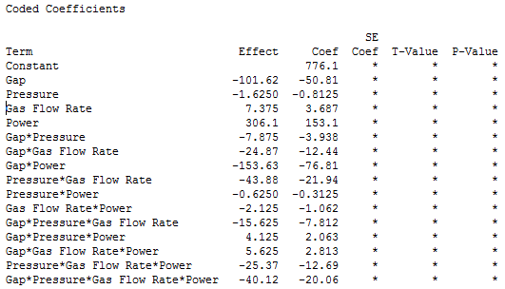
The alternative approach of using a Normal Probability Plot is possible in Minitab.
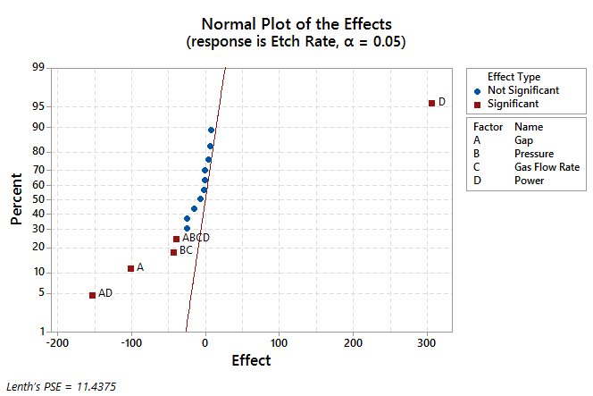

Minitab needed to obtain an estimate of experimental error before this plot could be created. Minitab used Lenth’s PSE method to obtain this estimate of error. See page 237 of textbook for Lenth’s procedure.

How does Minitab draw it’s blue line?

Normal probability plot
The method Minitab uses to draw the normal effects plot depends on the degrees of freedom for the error term.
If the error term has one or more degrees of freedom, Minitab plots the normal scores, probabilities or percentages versus the standardized effects. The line passes through the origin (or 0.50, 0 if probabilities or percentages are used) and has a slope of one because this is where the points are expected to lie if all effects are zero. Effects with p-values less than alpha are labeled significant on the graph. Minitab labels this graph Normal Probability Plot of the Standardized Effects.
If the error term has zero degrees of freedom, Minitab plots the normal scores, probabilities or percentages versus the nonstandardized effects. The line passes through the origin (or 0.50, 0 if probabilities or percentages are used) and the slope is 1/ Lenth's pseudo standard error. Effects with an absolute value exceeding the margin of error (ME) are labeled significant on the plot. Margin of error is:
ME = t*PSE
where t is the (1 - a / 2) quantile of a t-distribution with degrees of freedom equal to the (number of effects / 3). Minitab labels this graph Normal Probability Plot of the Effects.
For more information on how Minitab calculates PSE, see Lenth's pseudo standard error.

Obtaining Lenth’s Pseudo Standard Error (PSE)
The following procedure is used to compute Lenth’s pseudo standard error (PSE).

Step 1: Calculate s₀
$s_{0}=1.5*median\left( \left|Estimated Effect\right| \right)$

Step 2: Calculate the pseudo standard error (PSE)

$$PSE=1.5*median\left(\left|Estimated Effect\right| : \left|Estimated Effect\right|<2.5*s_{0}\right)$$

Identification of Significant Effects
After a pseudo standard error is obtained, Lenth’s approach is similar to our standard approach. A test statistic is computed for each effect as follows.
$$Test Statistic= \frac{\left|Estimated Effect\right|-0}{PSE}$$

Version | T – Cutoff value | T-Distribution
Version #1  When interest lies in only a single effect | $t\left(prob=α/2, df=m/3\right)$  where  $$α=0.05 \\ m=2^{k}-1$$  Spreadsheet: =TINV(0.025,5) | 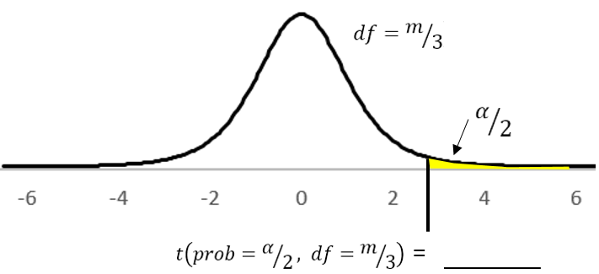
Version #2  When interest lies in all effects | $t\left(prob=γ, df=m/3\right)$  where  $$γ=1-\left(\left(1+{\left(1-α\right)}^{1/m}\right)/2\right) \\ m=2^{k}-1$$  Spreadsheet: =TINV(0.0017,5) | 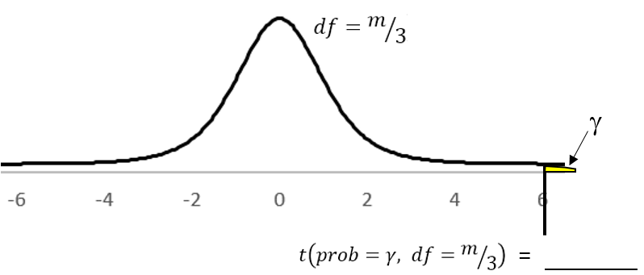

Lenth’s Decision Rule
Approach | Testing a Single Effect | Testing All Effects
Test Statistic | $$Test Statistic> t\left(prob=α/2, df=m/3\right)$$ | $$Test Statistic> t\left(prob=γ, df=m/3\right)$$
P-Value | $$p-value<α$$ | $$p-value< γ$$

A margin-of –error concept can also be obtained via Lenth’s procedure. Two forms exist based on which version from above is of interest.
- $Margin of Error= t\left(prob=α/2, df=m/3\right)*PSE$
- $Simultaneous Margin of Error= t\left(prob=γ, df=m/3\right)*PSE$

Doing the computations in Google Spreadsheet

The computations for Lenth’s procedure as shown here for our example.

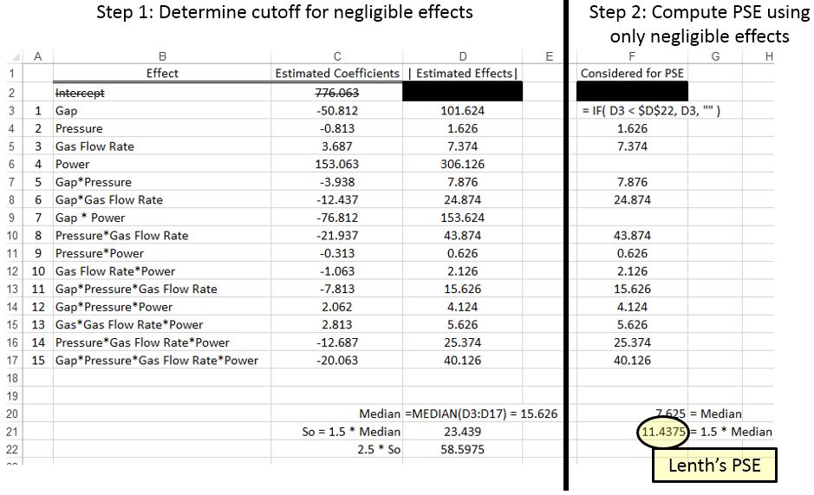

Notice the PSE here matches Minitab’s Lenth PSE reported on the Normal Quantile Plot:

The Test Statistics can be computed directly in Google Spreadsheet once an estimate of the standard error is obtained.

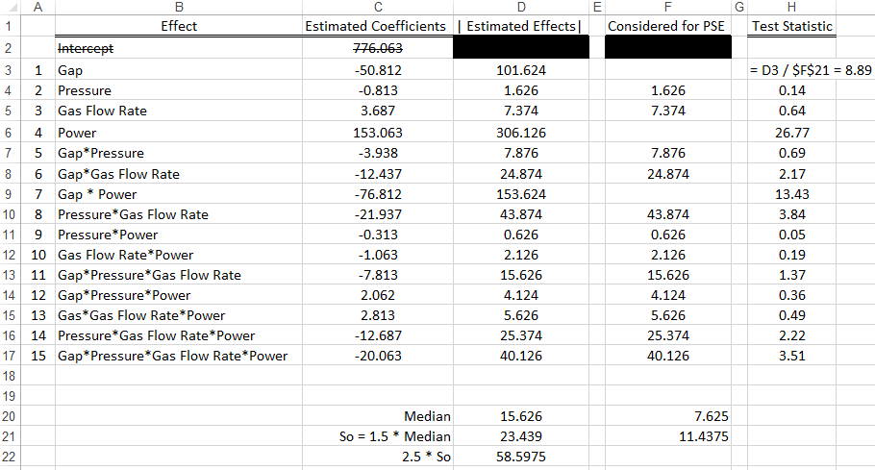

The =TINV() function in Google Spreadsheet can be used to obtain the T-Cutoff values discussed above. The test statistics can be compared directly against these value.

- Version #1: =TINV(0.025,5)
- Version #2: =TINV(0.0017,5)

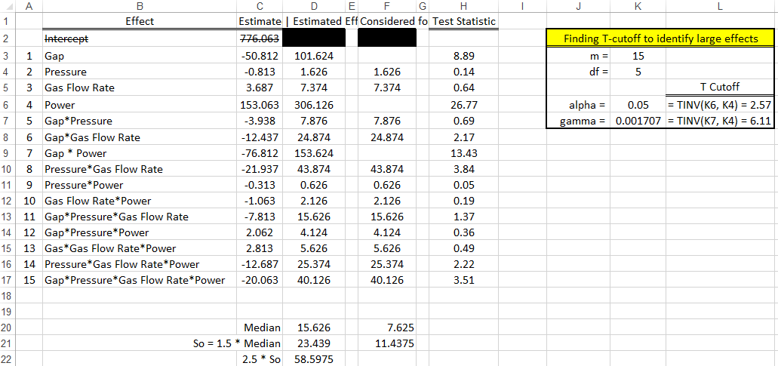

The p-value approach is preferred. The =TDIST() function can be used in Google Spreadsheet to obtain a p-value for each effect. Realize, the bottom-up approach should be used in the evaluation of significant effects. The “2” in the TIDST() function specifies a two-tailed test which is the desired test, i.e. just need an effect away from 0.

=TDIST( Test Statistic, df = m/3, 2)

- Version #1: Compare p-value against α
- Version #2: Compare p-value against γ

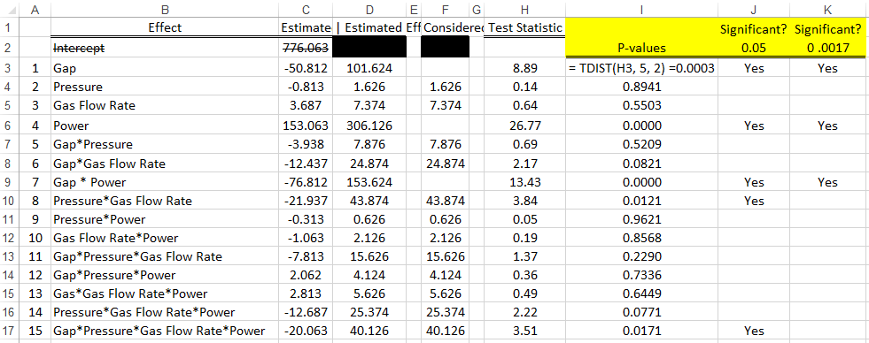

Questions:

- What are the significant effects using a standard error rate of 0.05?

- What are the significant effects using gamma?

- Discuss the similarities and/or differences…
A quick look at plots…

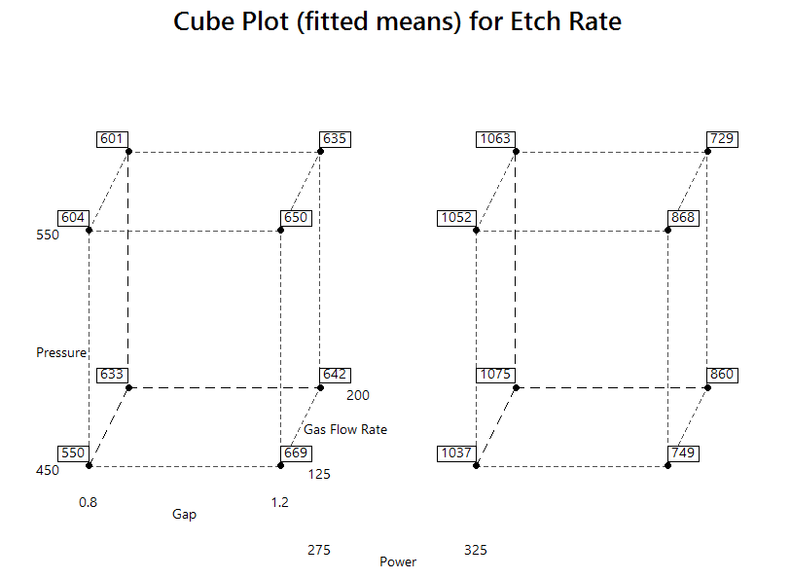
Note, proceed with caution in looking at these plots as the 4-way interaction is important in this example.

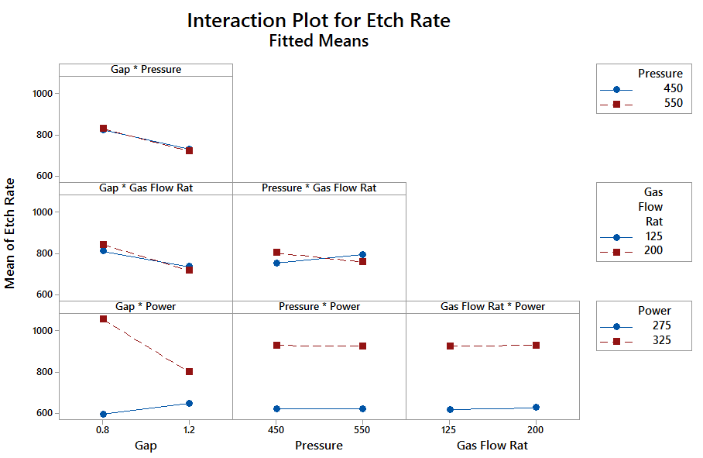

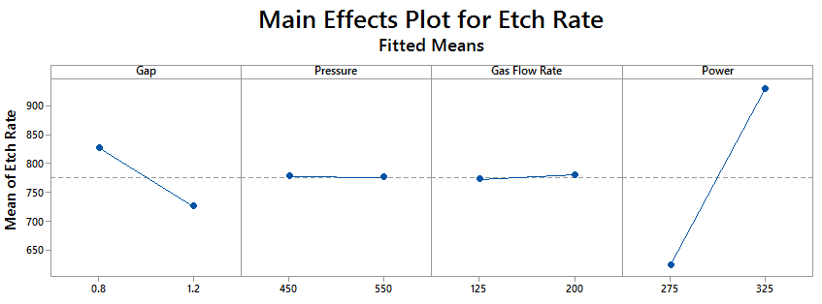

Plotting four-way interaction:

