STAT 321: Popcorn Names: __________________________
Spring 2018 __________________________
Points: 40 __________________________
For this assignment, your team will investigate the effect of three variables on the making of microwave popcorn. The response variable to be considered is # of unpopped kernels.
Factor Settings
Everyone must use Factor A. Choose 2 of Factors B, C, or D. Two reps should be run. Thus, you should have a 2³ with 2 reps.
- Factor A: Popcorn Type (Low: Light Butter / High: Extra Butter)
- Factor B: Cook-time (1:45 minutes / 2:15 minutes)
- Factor C: Power Level (Medium / High)
- Factor D: Hole-punched (No / Yes)
Blocks
The 8 factor settings x 2 reps give a total of 16 runs of the experiment. These 16 runs will be distributed over four different microwaves, i.e. blocks. Each block will consist of 4 runs.
Block #1  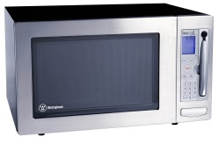 | Block #2  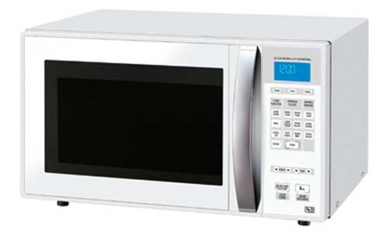 | Block #3  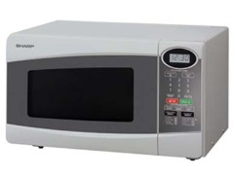 | Block #4  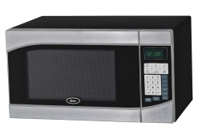
Designing and Running the Experiment
Use Minitab to create your design. Your design will require some factors to be confounded with blocks. Minitab will automatically create a design using an optimal confounding structure, i.e. highest possible order interaction will be confounded with blocks. Of interest is # of unpopped kernels,. Carefully enter your response data into your Minitab worksheet.
Use the methods we have discussed in class to conduct a complete analysis for the response variable.

Writing a Report
Your written report is NOT simply cutting and pasting computer output. You should assume that the reader knows nothing about your experiment. This should be similar to a scientific report, and it must contain the following sections.
1. An Introduction.
This should briefly state the research problem.
2. A Methods Section.
In this section, discuss the experimental setup, e.g. consider the following items.
- What type of design was utilized for your experiment?
- How many replicates were at each of the corner point?
- What is the response variable under consideration?
- What is the impact of having to run your experiment in four blocks?
3. A Results Section.
The technical outcomes from the analysis are provided in this section.
- A discussion of appropriate factors that are deemed statistically to have an impact on the response variable.
- You should include any relevant graphs associated with statistically important factors.
- A statistical evaluation of potentially optimal settings. Goal is to have number of unpopped kernels minimized.
- An evaluation of appropriateness of model assumptions, i.e. residuals plot evaluation.
4. A Discussion and Conclusions Section.
This section includes an overview or summary of your experimental findings. This section should be written so that a non-statistician can easily gain an understanding of your findings, i.e. less technical than Section 3. This section is often the only section read by design engineers or other decision makers, etc.

