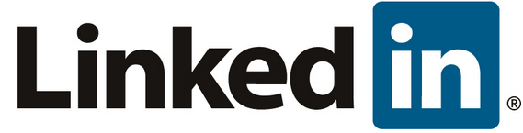
Deadline: Tuesday, Jan 21
Tasks that must be completed:
- Create a Linked In account. Provide a link for your profile for evaluation.
  - Update your profile to include
    - A professional looking picture
    - Specify relevant work experience
    - Specify education achievements
  - Attempt to make at least 2 professional “connections” - one with a peer and another with a working professional
  - Attempt to add at least one skill under your profile.
  - You must join at least one professional “group”
  - Provide an image/link/movie, etc. to work that you take pride in completing as a student here at WSU.

Answer the following:
- What is the difference between Linked In and a Facebook type profile?

- How does the endorsement of skills and expertise work on Linked In? In particular, how do you get specific skills listed for yourself?

- How will you use/promote your Linked In profile in future internship or job searches?

