Web-scraping with R
In this handout, we will explore web-scraping with R. For motivation, we will consider several plots. These plots could be used towards the beginning of an introductory statistics course to discuss different ways of thinking about data, and how interpretation of data can change depending on the context in which they are displayed. Not all ways of thinking about data are created equal!
As an example, consider these two plots:
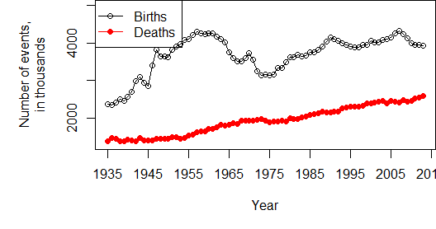
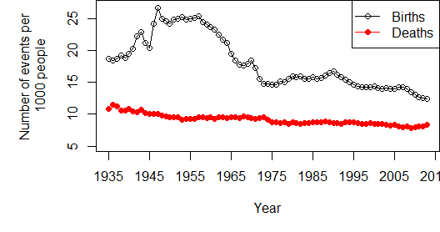
The first plot show births and deaths in the U.S, from 1935 until 2013. The second plot shows birth and death rates per 1000 people, over the same time period. There are a number of interesting discussion questions to ask about these plots in an introductory statistics class:
- Both plots show a peak in birth (or birth rate) between about 1950 and 1965. What do you think this peak represents?
- One plot shows a positive trend, while the other shows a negative trend. Why is this, and does this imply that these plots contradict each other?
- Which plot is better, and why?
- Given your answer to #3, what do we conclude about overall trend in birth and death rates in the U.S.?

A third plot shows a barchart of racial trends across the 50 states and the District of Columbia.
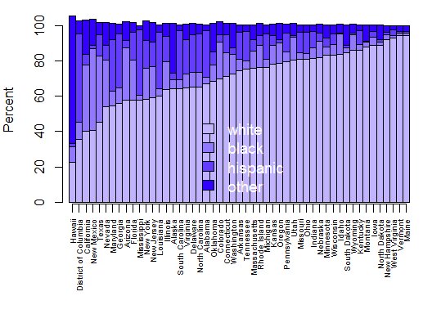
This plot can be used to ask several questions about which states are the most diverse. This would likely raise interesting questions about how to define diversity: is is the state with the lowest non-white population? The state with the most even race distribution? One would also definitely want to ask students if they can identify any strange things about this plot! (The percentages add to more than 100%; we will investigate this later.)

While these plots themselves might seem relatively simple to interpret, they are far from simple to create! These data were taken from the following Wikipedia page: http://en.wikipedia.org/wiki/Demographics_of_the_United_States. Scroll down to find the table called "Vital Statistics" and the race "Breakdown by State." These are the data tables we will be using to create the above plots. To scrape these tables, we will need to:
- Scrape the data into R;
- Find the relevant data tables;
- Clean the tables so they are in a format for plotting;
- Plot the data.
Along the way, we will cover some intermediate R topics such as:
- Object classes;
- String manipulation;
- Intermediate graphics;
- The three dimensions of color.
Web-scraping HTML tables is best done in R using the XML package. If you haven't installed this package before, install it and load it using the following commands:
install.packages('XML')
library(XML)
Once the XML package is installed, we will read in the Wikipedia page with the following command, and investigate a few elements:
all <- readHTMLTable('http://en.wikipedia.org/wiki/Demographics_of_the_United_States')
class(all)
## [1] "list"
length(all)
## [1] 39
Note that all is a list, where each element of the list is one of the HTML tables on the Wikipedia page. Not all of them are pretty, and only some are named. Run the following commands to investigate the all object:
names(all)
all[[1]]
all[[5]]
all[[6]]
all[[7]]
Note that the first element of all is the table titled "Demographics of the United States"; it doesn't look like your typical $n×p$ data format! The data that we want are in the 5th and 7th elements of all. It's best to rename the elements we want, so we can refer to them more easily, and investigate what we've created. We'll first start with the vital statistics data. Run the following commands:
bd <- all[[5]]
head(bd)
names(bd)
#Note that the "year" column doesn't have a name: let's change that
names(bd)[1] <- 'Year'
Now that we have the data, let's try plotting birth live births by year. This seems like it should be simple enough, but:
plot(bd$Year,bd$Live)
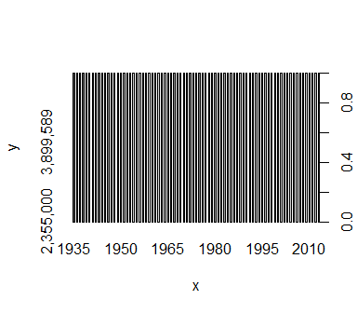
Yikes! This plot is meaningless. Although R has successfully scraped the relevant HTML table, there are several issues with the resulting data frame, bd. Run the following lines of code, and see if you can identify some of the issues.
class(bd[,1])
## [1] "factor"
for (i in 1:ncol(bd)) print(class(bd[,i]))
## [1] "factor"
## [1] "factor"
## [1] "factor"
## [1] "factor"
## [1] "factor"
## [1] "factor"
## [1] "factor"
## [1] "factor"
## [1] "factor"
Note that R is thinking of each of these variables as a "factor", which as we've seen is R-speak for "categorical". We need to change these variables to numeric. We can do this easily enough for Year. Run these lines of code and discover what happens.
as.vector(bd$Year)
as.numeric(as.vector(bd$Year))
class(as.numeric(as.vector(bd$Year)))
But what if we try this on "Live Births"? Run this line of code. What is the reason for the resulting output?
as.numeric(as.vector(bd$Live))
R is not a fan of the commas in the "Live births" variable. It would be nice if we had a customized function that eliminated commas (if present), and changed the resulting variable to numeric. The following function is one way to accomplish this:
#Get rid of commas (if present), change to numeric
cleanup <- function(vec) {
new <- gsub(',','',vec) #This searches for and eliminates any commas
new <- as.numeric(as.vector(new)) #Change the vector to class "numeric"
return(new)
}

Aside: function writing
After running the above code, R now knows about a new function that takes a vector as its single argument, removes any commas, and changes the class to numeric. This is the first time we've written our own function, so let's take some time to examine it. The basic form of function writing is as follows:
function.name <- function(arg1, arg2, ...){
Operations on arguments
output <- result of operations
return(output)
}
Our cleanup() function only has one argument, called vec. In our case, we expect to feed cleanup a vector and perform operations on that vector, specifically, remove commas and change the class to numeric. The cleaned up vector we call new, and we need to make sure to return new otherwise the function will carry out the operations, but not give us the result!
For example, suppose we had written a function cleanup2, that is identical to cleanup except for the return() command. Run the following code and see what happens.
#Get rid of commas (if present), change to numeric
cleanup2 <- function(vec) {
new <- gsub(',','',vec) #This searches for and eliminates any commas
new <- as.numeric(as.vector(new)) #Change the vector to class "numeric"
}
#Create a toy vector to feed to our function:
test.vec <- c('1,000','2,000','3,000')
cleanup2(test.vec) #No output!
cleanup(test.vec)

Mini exercise 1:
Write a function called area() that computes the area of a circle. The area() function takes a radius as its sole argument, and returns the area. Use this function to calculate the areas of circles of radius 3, 5, and 9.

Mini exercise 2:
Write a function called fullname() that takes 2 arguments, called firstname and lastname, each of which is a vector. The output should give the full name of the people fed to the function. Hint: use the paste() function within your function.

Exercise
Now back on task. Use a combination of apply() and cleanup() to clean the vital statistics data. Assign the cleaned data to a new object, bd2.

Key to exercise
bd2 <- apply(bd,2,cleanup)
bd2 <- data.frame(bd2)
head(bd2$Year)
class(bd2$Year) #Success!
head(bd2$Live)
class(bd2$Live) #Success again!
Now we are in business! The data is clean and ready for plotting. So, let's plot!

Exercise
Create the two scatter plots shown at the beginning of this handout.

Key to exercise
#Divide births and deaths by 1000 for cleaner output:
bd2[,3:4] <- bd2[,3:4]/1000
par(mar=c(5,5,1,1)) #Set the margins of the figure
plot(bd2$Year,bd2$Live,type='o',
ylab='Number of events, in thousands',
xlab='Year',
ylim=c(1300,5000),
xaxt='n')
#type: try 'n', 'l', 'h', 'p'
#xaxt: try NULL
lines(bd2$Year,bd2$Deaths,type='o',col='red',pch=19)
#pch: type ?pch for more
year.axis <- seq(1935,2015,by=10)
axis(1,at=year.axis,labels=year.axis)
legend('topleft',c('Births','Deaths'),
col=c('black','red'),
pch=c(1,19),
lty=1)
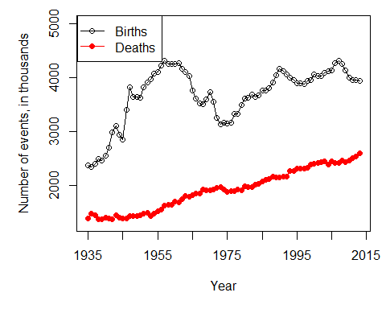
The birth rates per 1000 are plotted as follows:
par(mar=c(5,5,1,1)) #Set the margins of the figure
##Now plot birth rate
plot(bd2$Year,bd2$Crude.birth,type='o',
ylab='Rate per 1000',
xlab='Year',
ylim=c(5,27),
xaxt='n')
lines(bd2$Year,bd2$Crude.death,type='o',col='red',pch=19)
axis(1,at=year.axis,labels=year.axis)
legend('topright',c('Births','Deaths'),
col=c('black','red'),
pch=c(1,19),
lty=1)
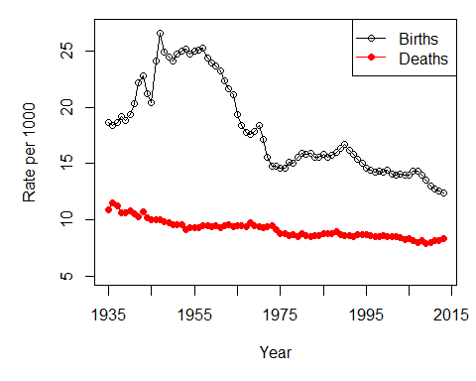

Now for the the racial rates by state. Recall that the racial data was in the 7th element of the list all. We'll call it races:
races <- all[[7]]
head(races)
for (i in 1:ncol(races)) print(class(races[,i]))

Exercise
Write necessary code to clean the races data so it is ready for plotting. Assign the cleaned data to an object called newrace.

Key to exercise
newrace<- data.frame(apply(races,2,cleanup))
head(newrace)
#Why do we need this line?
newrace[,1] <- races[,1]
## Warning in FUN(newX[, i], ...): NAs introduced by coercion

Exercise
Create the bar graph shown at the beginning of the handout.

Key to exercise
newrace<- newrace[order(newrace$Non.Hispanic),]
newrace$Other <- apply(newrace[,6:9],1,sum)
par(mar=c(7,4,1,1))
cols <- hsv(h=0.7,s=seq(0.3,1,l=4),v=1)
barplot(t(as.matrix(newrace[,c(3,4,5,10)])),
space=0,
xlim=c(1,50),
col=cols,
names.arg=rep('',51),
ylab='Percent')
axis(rep(1,51),seq(.5,50.5,by=1),newrace$State,cex.axis=.65,tick=T,las=2)
legend('bottom',c('white','black','hispanic','other'),fill=cols,
bty='n',text.col='white',cex=1.2)
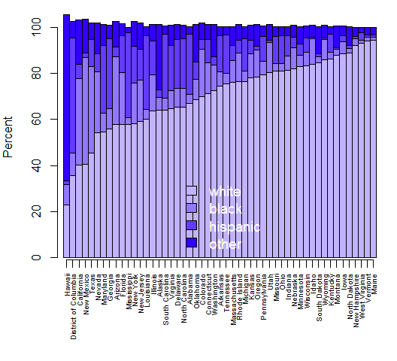
Tasks/Questions:
1. Change the values in the par(mar=c()) setting, and see what changes.
2. Play around with the space argument. What settings do you think look best?
3. What does the names.arg argument control? Why do we set it to rep('',51)?
4.How did we know where to put the horizontal axis tick marks? (Hint: try re-running the barplot() command, with the argument plot=FALSE.)
5. What does the las argument control? Run ?par and search for las. Try las = 0, las = 1, etc.
6. Note that the colors are set by way of the very powerful, but simple, hsv() function. HSV stands for the three dimensions of color: hue, saturation, and volume. These three dimensions are on a scale of 0 to 1; the hsv() function returns the appropriate color in hexadecimal form. To investigate the three-dimensional color space, run the following function and play around with setting h while keeping s and v fixed; setting s while keeping h and v fixed; and setting v while keeping h and s fixed.
plot.hsv <- function(h=NULL,s=NULL,v=NULL) {
x <- seq(0,1,l=100)
y <- seq(0,1,l=100)
if(!is.null(h)) {
plot(x,y,type='n',xlab='Saturation',ylab='Value',main=paste('Hue = ',h))
for(i in 1:100) points(rep(x[i],100),y,col=hsv(h,x[i],y),pch=15)
}
if(!is.null(s)) {
plot(x,y,type='n',xlab='Hue',ylab='Value',main=paste('Saturation = ',s))
for(i in 1:100) points(rep(x[i],100),y,col=hsv(x[i],s,y),pch=15)
}
if(!is.null(v)) {
plot(x,y,type='n',xlab='Hue',ylab='Saturation',main=paste('Value = ',v))
for(i in 1:100) points(rep(x[i],100),y,col=hsv(x[i],y,v),pch=15)
}
}
plot.hsv(v=1)
plot.hsv(h=0.8)
plot.hsv(s=1)
hsv() is especially nice for creating color gradients. For example, here's a redo of the vital statistics plot:
par(mar=c(5,5,1,1))
plot(bd2$Year,bd2$Live,type='o',
ylab='Number of events, in thousands',
xlab='Year',
ylim=c(1300,5000),
xaxt='n')
lines(bd2$Year,bd2$Deaths,type='o',col=hsv(h=0.3,s=1,v=seq(0,1,length=nrow(bd))),pch=19)
year.axis <- seq(1935,2015,by=10)
axis(1,at=year.axis,labels=year.axis)
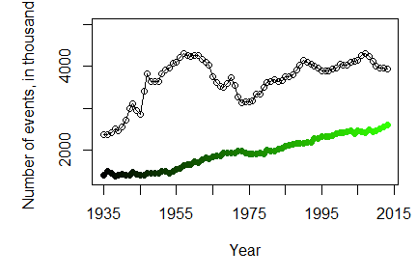

Finally, recall that the percents in the bar chart do not add up to 100%, but instead exceed 100%. The reason for this can be uncovered by noticing the footnote of the racial information table takes us to the U.S. Census Bureau's "Quick Facts" page. Doing some investigation on the Quick Facts website, we find the note that "Hispanics may be of any race, so also are included in applicable race categories." This seems to imply that people in the Hispanic/Latino category are probably being double-counted, and may belong to another racial category as well.

