Capstone Information for WSU

Timeline for Capstone Requirement at WSU
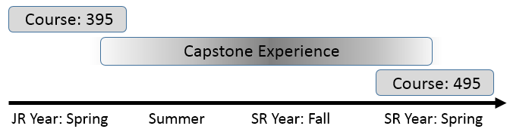
Course: 395 | The purpose of this course is to prepare a student for the successful completion of the capstone requirement. Capstone preparation and communication skills are emphasized in this course.
Capstone Experience | The capstone experience is a culmination of a student’s knowledge and abilities within their field of study.
Course: 495 | This purpose of this course is the dissemination of a student’s capstone outcomes. A poster, oral presentation, and paper are required for successful completion of this course.

What is a Capstone Experience?
The capstone experience is the culmination of the student’s major in both knowledge and abilities of a particular area of mathematics, statistics, or data science. The successful execution, individually or as a team, should integrate all skills learned across the field. A capstone experience should demonstrate the consummate achievement of each student’s academic career.
Who will be my advisor for the capstone?
All students will have a capstone advisor. Your capstone advisor may or may not be your academic advisor. Students should seek out a capstone advisor. Capstone projects often begin with simple informal conversations with faculty or from a class project that you enjoyed and would want to learn more about. It is the responsibility of the student to seek out their capstone advisor.
What are typical capstone requirements?
The required outcomes of a capstone requirement may vary. For example, the required outcomes of a research project will be different than an internship. The capstone advisor and student should agree upon the anticipated outcomes ahead of time. A student is expected to work 2 hours per week for each capstone project/internship credit taken, i.e. 6 hours per week for a 3 credit capstone experience. The expectation over the course of one semester is approximately 90 hours of work.
Is deviation from the above timeline acceptable?
The path to graduation varies from student-to-student. Thus, your academic advisor may decide to deviate from the timeline provided above. It is in the best interest of students to finish their capstone experience in a timely fashion. The expectation is that all nitty-gritty work of a capstone project be completed immediately after spring break of their senior year. The typical amount of time required to write up your outcomes, present, and create a poster is 4-6 weeks.
When should students start meeting with their capstone advisor?
A student should have identified a capstone project at least two semesters before their anticipated graduation semester. Capstone projects take a lot of time. This is especially true if a substantial literature review is necessary or you rely on others to provide you with data for your capstone experience.

