Forensic Geology Laboratory
written by Jeanne Franz, Winona State University
Recently a crime was committed and a dead body was discovered on the big island of Hawaii in the Hawaiian Islands. Based on the evidence you are supplied with in lab, you must determine whether the body was moved after the crime based upon the available geological evidence. You will be able to examine the soil found on the body and soils from three different locations on the island with the aid of an electron microscope and with standard chemical and biological tests.
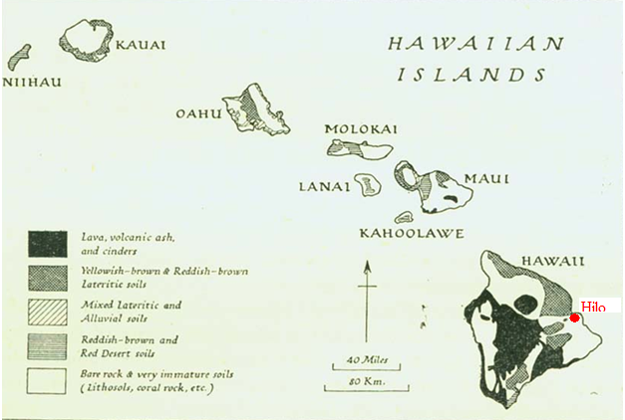
Background information:
Soil can vary quite a bit from location to location, in fact, two samples, collected ten feet apart can have quite different characteristics when compared on the electron microscope. The body in this crime was found near Volcano National Park in the Central part of the big island. The victim resided nearby. Interviews with family members indicated that he had not left the area in over ten days. Three days previously, it had rained hard. From the map above you can see the various types of soil that are found on the island, the northeastern coastal region just northeast of the city of Hilo features eroded soil abundant in microorganisms. The far eastern part of the island features soil abundant in microorganisms and is near a lot of coral. The central part of the island has very new soil that is composed of lava, volcanic ash, and cinders.
Pre-lab:
Safety:
This lab requires you to use vinegar, hydrogen peroxide, and universal indicator. Look up the MSDSs for each and summarize the important handling and disposal safety precautions in your notebook.
In addition to answering the above questions, also clearly state the goal of this experiment in your notebook.
Computer:
You will need at least one laptop computer per team for this experiment as you will be looking at actual electron microscope images captured on a scanning electron microscope.
Part 1: Electron Microscopy
Examine the three control samples provided to you by your instructor, the lava, the coral, and the sand. (Note: due to the availability of materials, the “lava” that you will be looking at is actually coal, the “coral” that you are looking at is actually limestone. For purposes of this experiment, the chemical characteristics of coal are the same as lava and the chemical characteristics of limestone are the same as coral.) In your notebook make observations about the average size of each of these samples, the relative uniformity, imperfections, and other important characteristics. Next, obtain from your instructor the electron micrograph images from the soil obtained on the victim’s body. Carefully examine these pictures. Does it appear the body was moved? Explain your reasoning. Just from the electron micrographs can you make any conclusions as to if it was moved, where it was moved from?
Part 2: pH
To determine the pH of soil, do the following:
1. Add the three pH standards to three separate Petri dishes.
2. Add two or three drops of universal indicator to each sample.
3. Place soil samples from the three possible locations, labeled soils A, B, C, and suspect into four other Petri dishes along with a little bit of water.
4. Add universal indicator to the soil dishes. Record the pH.
What conclusions can be drawn from this test?
Does this support the results found in Part 1? In which region of Hawaii does it appear the original crime was committed?
Part 3: Calcium Salt test
Recognizing that a good forensic scientist’s work is never done, a further test will be done to support the conclusion about whether or not the body was moved after the crime. This test will be run with the following procedure:
1. Add a small amount of calcium carbonate to a Petri dish. (What is the calcium carbonate supposed to represent?)
2. Add two to three drops of vinegar to the calcium carbonate, record your observations. What is the significance of this?
3. Next add two to three drops of vinegar to each of the other four samples. What conclusions can be drawn from this?
Part 4: Microorganism test
- Add a small amount of yeast to a Petri dish. (What is the yeast supposed to represent?)
- Add two to three drops of hydrogen peroxide to the yeast. Why does this observation happen?
- Add two to three drops of hydrogen peroxide to each of the four samples. Record your observations.
Summarize your results from the four parts. Do each of the four parts lead you to the same conclusion? If one or more of the tests appear inconclusive, repeat the test. All four tests should be consistent or at least not disagree.
In your report, clearly state whether you believe the body was moved after the original crime before it was found in the volcanic region of Hawaii. Your conclusion must include evidence from each of the four tests you performed above. In your conclusion also discuss the limitations, selectivity, and validity of each of the testing methods.
In addition, answer the following post-lab questions.
1) How do the characteristics of the soil in Central Hawaii differ from that on the far east coast and how do they differ from the soil found on the northeast coast? Think in particular about the chemical and biological characteristics. If necessary consult outside sources which talk about lava soil, eroded soil rich in microorganisms, and coral soil.
2) In this experiment you used universal indicator (for measuring pH), vinegar (for measuring the presence of calcium salts), and hydrogen peroxide (for detecting the presence of microorganisms). How were each of these useful in determining where a soil had originated from?
Acknowledgements: Development of this lab was supported by a grant obtained from the Department of Energy by the FEI Company.
This lab is a modification and enhancement of Shmaefsky, Brian “Forensic Analysis Demonstration via Hawaii Five-O” Journal of College Science Teaching, September 2006 pp. 14-16.

