Case Number 179400
The Case of the Unidentified Glass

Background:
Consider that broken class that has been found at a crime scene. A suspect is apprehended and additional glass fragments are recovered from this suspect’s clothing, shoes, etc. As a forensic science intern, your job is to establish whether or not the class found at the crime scene matches the glass found on the suspect. The most widely accepted method of comparing glass evidence is by measuring its refractive index. Visit the following web site to see how refractive index is measured.

http://www.lincoln.ac.uk/fabs/EquipmentList/TheGrim.htm

Unfortunately, you do not have access to a GRIM machine and so you are going to make comparison using the width of the glass fragments.

Safety:
This forensic investigation will require you to work with broken glass. The glass should be handled with forceps only. Safety goggles should be worn and other general lab safety procedures should be followed.

Pre-lab:
In your notebook, write the lab name, the purpose of the lab, and a brief summary of the statistical methods covered in class that have relevance to the interpretation of glass evidence.

Procedural Steps:
Each person will receive an evidence bag that contains several broken pieces of glass.

Step 1: Measure the width (using the caliper provided) of each piece of glass in your evidence bag. Earlier in the semester we used calipers for measuring. If you forgot how to use the calipers you may refer to the following web site or the following movie.
http://phoenix.phys.clemson.edu/labs/cupol/vernier/index.html
http://phoenix.phys.clemson.edu/labs/cupol/vernier/vernier8.mpg

Step 2: Open Microsoft Excel. Create two columns in Excel similar to what is below.

In the second column, enter the width measurements from your evidence bag.
Step 3: Once you have your values entered, ask another member of the class for the width measurements from their evidence bag.

Step 4: Once all width measurements have been entered for both evidence bags, save your Excel file. Close this file (don’t minimize it, close it).

Step 5: Next, open this file in JMP. In JMP, select File > Open. Change the Files of type to Excel Files (*.xlsm, *.xlsx, *.xlsb). Locate the Excel file with the width measurements and click Open.

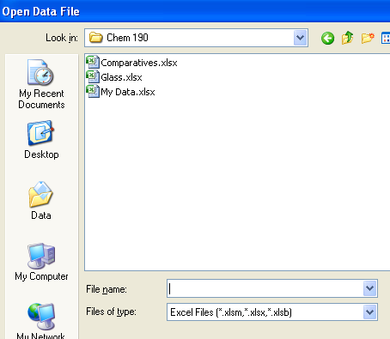

Step 6: (Numerical and Graphical Summaries) After the data file has been opened in JMP, select Analyze > Distribution. Place Width in the Y, Column box and EvidenceBag in the By box. Click OK.

Answer the following questions in your notebook:

- Discuss what a typical value is for Bag1. Is the typical value for Bag2 somewhat similar or different? Discuss.

- Discuss any similarities/differences in the spread of the widths between Bag1 and Bag2.

- Discuss any similarities/differences in the shape of the widths between Bag1 and Bag2.

- Using the boxplots provided in JMP, determine whether or not outliers are present. If outliers are present, which evidence bag did these outliers come from?

- Using the numerical and graphical summaries obtained here, do you think Bag1 and Bag2 contain the same type of glass? Discuss why or why not.

Step 7: (Density Estimation) From the red drop down menu, select Fit Distribution > Smooth Curve. Do this for both evidence bags. Move the Nonparametric Density slider back and forth until you feel comfortable with the general trends present in this data.

Answer the following questions in your notebook:

- What general trends are present in Bag1? Are these general trends similar to those found in Bag2? Discuss.

- Using all information obtained thus far (i.e. numerical summaries, graphical summaries, density estimates), do you think Bag1 and Bag2 contain the same type of glass? Discuss why or why not.

Step 8: (Making Comparisons) In JMP, select Analyze > Fit Y by X. Place Width in the Y, Response box and EvidenceBag in the X, Factor box. Click OK. This is shown here.

Answer the following questions in your notebook:

- Use the range method (i.e. Method #1, see class notes) to determine whether or not the glass in Bag1 “matches” the glass found in Bag2. What is your conclusion?

- Use the 3-Sigma method (i.e. Method #2, see class notes) to determine whether or not the glass in Bag1 “matches” the glass found in Bag2. What is your conclusion?

- Use Welch’s method (i.e. Method #3, see class notes) to determine whether or not the glass in Bag1 “matches” the glass found in Bag2. What is your conclusion?

- Using all information obtained thus far (i.e. numerical summaries, graphical summaries, density estimates, and methods of making comparisons), do you think Bag1 and Bag2 contain the same type of glass? Discuss why or why not.

Step 9: (Grouping Observations) For the sake of saving time, we will only consider the Partition Modeling method for grouping observations. Select Analyze > Modeling > Partition. Place EvidenceBag in the Y, Response box and Width in the X, Factor Box. Click OK.

There is only one variable in our dataset (i.e. width), thus, click Split once to obtain the very simple classification / regression tree for this data.

Answer the following questions in your notebook:

- What value did JMP use to create the single branch in this classification / regression tree?

- Discuss the meaning of at least one of the Prob values given in the classification / regression tree.

Conclusion:
In your notebook, give a brief but precisely written conclusion about whether or not you believe the two evidence bags contain the same type of glass. This conclusion should utilize the information obtained from your statistical analyses, but should be void of statistical jargon.

Sources:

- Aitken, C.G.G. and Taroni, F. (2004). Statistics and the Evaluation of Evidence for Forensic Science, John Wiley and Sons.
- Curran J. M., Hicks, T., and Buckleton, J. (2000). Forensic Interpretation of Glass Evidence, CRC Press.
- Curran J.M. (2003). The Statistical Interpretation of Forensic Glass Evidence, International Statistical Review, 71, 3, 497-520.
- Evett, I. W. (1977). The interpretation of refractive index measurements. Forensic Science International 9, 209-217.
- Lucy, D. (2005). Introduction to Statistics for Forensic Science, John Wiley and Sons.
- Walsh, K.A.J., Buckleton, J.S., and Triggs, C.M. (1996). A practical example of the interpretation of glass evidence. Science and Justice, 36, 213-218.

