Biology 201 – Human Anatomy
BLOOD/HEMATOLOGY (Exercise #20)

Blood is one of the most important components of the human body (obviously!). Blood is one of the ways that our bodies are able to transport materials (i.e., oxygen, carbon dioxide, hormones, waste products, nutrients, etc..) from one area of the body to another and allows tissues in distant areas to communicate with one another. In addition, blood plays a very important role in the protection of the body from harmful things like bacteria and viruses via the coordinated actions of a variety of different types of leukocytes (a.k.a. white blood cells). The average human body contains roughly 5 liters of blood that is constantly being forced through our arteries and veins by the heart.
Blood is technically a type of connective tissue that essentially consists of two fractions:
- Formed elements – the cells and cell fragments found in blood
  - Erythrocytes (red blood cells)
  - Leukocytes (white blood cells)
  - Platelets
- Plasma – the “liquid” portion of blood. Blood plasma contains a great deal of water, ions, proteins, antibodies, and clotting factors.
The analysis of blood and its components are very important clinically since the body often changes the composition of blood in response to various conditions (changes in physiology or disease). The clinical study of blood and its components is known as HEMATOLOGY.
In this lab exercise, we will examine the different components of blood as well as look at some of the basic diagnostic tests commonly used in hematology.

Working safely with blood
In this lab exercise we will be working with human blood (your own). While it is somewhat unlikely that someone in this class carries an infectious agent in their blood (bacteria, viruses) it is common practice in the lab to simply assume that every blood, tissue, or fluid sample you deal with is tainted with something harmful. As a result it is important to remember to wear disposable gloves whenever you are handling blood or any materials that have come into contact with blood (even if it is your own). In addition, it is important to wash your hands before leaving the lab after you have been working with blood. In addition to proper personal protection (i.e., gloves) it is important to clean any surfaces that may have become contaminated with blood (microscopes, bench tops, equipment, etc…). Disinfecting solutions will be supplied by the department and will be in the lab for your use. Anything that comes in contact with blood must be disinfected and materials that will be disposed of (microscope slides, gloves, lancets) must be placed in designated “biohazard” receptacles and NOT the regular trash!!

Blood Plasma:
In this lab exercise we won’t be doing a great deal of studying blood plasma, although this is an important component of hematology. As a result, it is important to understand some of its properties. Plasma makes up approximately 55-60% of our blood volume and is nearly 90% water. The remaining 10% of plasma consists of ions, many different proteins, antibodies, and hormones. When fresh blood is allowed to settle, the formed elements sink to the bottom and a tan-brown fluid rises to the top. This is the blood plasma. Blood plasma contains many important molecules such as antibodies needed to fight infections as well as critical clotting factors. These molecules are very much sought after for therapeutic/clinical applications, which explains why plasma centers often pay cash for poor college student’s blood plasma!!
Blood plasma is also very important physiologically. Since plasma is 90% water, it is a major reservoir for water in our bodies. When we become dehydrated our tissues pull water from our plasma into the tissues and cells. If we are over-hydrated, our tissues release water into the blood stream (plasma) where it can eventually be removed by the kidneys and excreted as urine. In addition to acting as a reservoir for water, plasma also plays an important role in maintaining the pH, or acid/base, balance of the body. Plasma contains buffer molecules which allow the blood and most other tissues of the body to maintain a relatively constant pH of roughly 7.4. Finally, plasma plays an important role in maintaining body temperature near 98.6 degrees. Water has a great capacity to absorb and release heat. As a result, on a hot day plasma supplies the water that is found in sweat that helps cool our bodies. On a cold day, warm plasma from our body’s core helps keep our extremities from freezing when we are outside enjoying the Minnesota winter!
It is important to be aware of the composition of plasma as we study our hematocrits later on in lab….

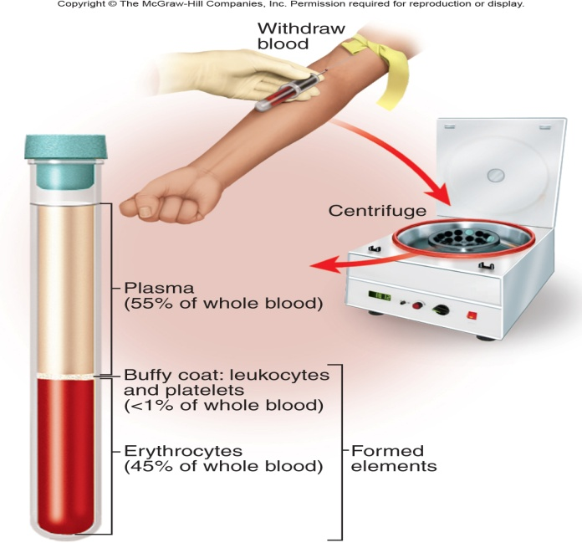
Formed elements of blood:
Keep in mind that the formed elements of blood consist of erythrocytes, leukocytes, and platelets.

Exercise #1:
In this exercise we will be studying the formed elements of blood using the blood smear slides found in your slide boxes (Slide #6). Since these slides are prepared and have been sterilized, you won’t be needing gloves for this exercise. In this exercise we will be studying the morphology of erythrocytes as well as the various different types of leukocytes found in human blood. NOTE: the identification of most of the different types of leukocytes is most easily accomplished by looking at the relative size of the leukocyte and also at the structure of the nucleus (remember, erythrocytes don’t have a nucleus). The vast majority of the cells that you see on a blood smear will be erythrocytes (no nucleus), so when identifying the different leukocytes, just look for cells that have a dark-stained nucleus.
That being said, you won’t be able to identify EVERY cell that has a nucleus since some cells will have been damaged during the processing of the slide. As you proceed make sure you look at the images in your lab book to familiarize yourself with what a “typical” cell looks like and search your slide for that rather than simply picking a random cell and trying to determine its identity. Check out Exercise #20 in your lab manual for images and descriptions of the different leukocytes (Figures 20.2, 20.3, 20.4) or use one of the Histology textbooks in the lab.

Erythrocytes: By far the most numerous of the cells you will see on a blood smear. Erythrocytes are small (~7.5 microns in diameter), round, and have an indented center. Basically, they look like little doughnuts that lack a nucleus.
Platelets: Platelets will often have an irregular shape and will be SMALLER than an erythrocyte. Platelets also lack a nucleus since they are really only fragments of a cell.
Leukocytes: There are two main categories of leukocytes in human blood, GRANULOCYTES and AGRANULOCYTES. Granulocytes will possess visible stained granules (look like speckles within the cell), while agranulocytes will not. Additionally, granulocytes tend to possess a nucleus which is more lobed in appearance (often makes them look like they are multinucleated), while agranulocytes tend to possess a more rounded nuclei that we commonly think of in most cells.

Granulocytes:
- Neutrophils – the most common granulocyte. These cells should be pretty easy to identify based on their sheer numbers. Neutrophils are phagocytic cells which play an important role both in the bloodstream as well as in tissues where infections may occur. Their numbers will increase dramatically when an individual is sick with a bacterial infection. This phenomenon is commonly referred to as an “elevated white cell count” by clinicians and is confirmed through a blood test. However, neutrophils are not the only cells which increase in number in response to an infection. Neutrophils typically possess a nucleus consisting of three or more “lobes” that often can be seen connected by thinner strands. However, some cells may simply appear to have more than one nucleus, even though in reality there is only one.
- Eosinophils – much less common that neutrophils and you may need to spend a few minutes to identify one. Eosinophils are phagocytic cells, like the neutrophils but contain large granules that tend to stain a distinctive orange or red due to the fact that the granules absorb and bind a stain known as EOSIN. Eosinophils possess a nucleus that consists of two large lobes.
- Basophils – MUCH LESS common than neutrophils and basophils. The granules of these cells posses histamine and heparin which is released in response to inflammation and tissue injury. As a result, these cells spend more time within a tissue than in the bloodstream and may be difficult to identify. Basophils are not phagocytic and contain many dark-staining granules than may hide the nucleus. When you can see one, the nucleus of a basophil often appears U- or S-shaped. You may have to look at a couple of slides before you see one, but at least be sure you are familiar with their appearance by looking at a photo in your textbook or lab manual!!

Agranulocytes:
- Lymphocytes – fairly common in the bloodstream. Since lymphocytes are agranulocytes, you won’t be able to see any granules in the cytoplasm of the cell. There are at least two different types of lymphocytes known as “B”-lymphocytes (or “B” cells) and “T”-lymphocytes (“T” cells). A major function of “B” cells is to produce and secrete antibodies needed by the immune system to fight infections. “T” cells play a slightly different role by secreting factors which recruit phagocytes and macrophages to an infection site, while some specialized “T” (NK-natural killer) cells are also able to directly attack damaged, infected, or cancerous cells. “B” cells and “T” cells are pretty much indistinguishable from one another on a microscope slide so don’t try to tell them apart. Lymphocytes can be identified by their very large rounded nucleus that sometimes may have a slight indentation. The nucleus actually is so large that you often will only be able to see a very small, thin ring of cytoplasm surrounding the nucleus. This is in contrast to most other human cells we’ve seen that have a smaller nucleus and a more expansive cytoplasm.
- Monocytes – relatively large agranulocytes, much less abundant than lymphocytes, but you should still be able to identify them on your slides. Monocytes have a smaller nucleus than lymphocytes which often has a large indentation and has a kidney bean appearance. Monocytes eventually will leave the bloodstream and enter tissues where they will mature into macrophages that phagocytose bacteria, viruses, and damaged cell debris.

Exercise #2:
In this exercise we will be performing what is known as a differential white blood cell count. The goal of this clinical test is to assess the relative numbers of different leukocytes in a given blood sample. This is an important test since the numbers of certain leukocytes will rapidly change in response to an infection or inflammation of a tissue.
Again using your blood smear slide (slide #6), you will start at one edge of the slide and systematically keep track of the numbers of different leukocytes you see. A good way to do this is to count all the different cells in one field of view and then move the slide either directly across or directly down and count the cells in the adjacent field of view, making sure you are not re-counting the same cells. You can ignore all of the erythrocytes and platelets you see since we are only interested in the leukocytes. Keep moving to new adjacent regions of the slide until you have counted and identified at least 50 leukocytes. Keep track of the numbers in the table below. As mentioned earlier, some cells will have been damaged during the processing of the slides or simply have a structure that is difficult to distinguish. We will call these cells “Skipocytes” and you should not count them .

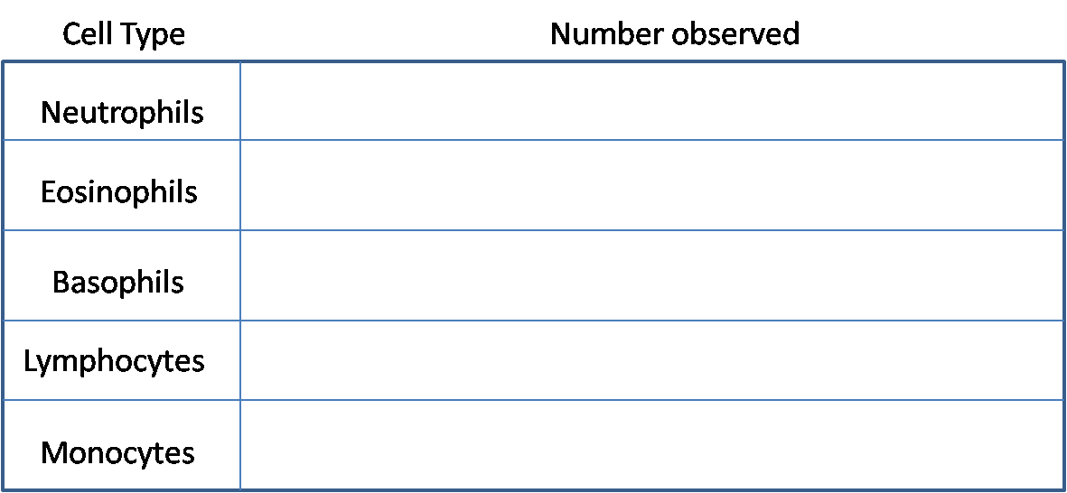

Exercise #3:
In this exercise we will be performing a very common clinical test known as a hematocrit, using your own blood. A hematocrit measures the volume of cells (formed elements) in a given sample of blood. In order to obtain your own blood you will be performing a “finger stick” using a lancet with a VERY small needle. If you happen to be diabetic you are probably a pro at this since diabetics need to test their blood sugar levels several times a day. For this exercise you will need an alcohol swab, capillary tube, a tray of clay for plugging the capillary tube, a lancet, and a paper towel.
- Hold the hand that you plan to obtain blood from below your waist for a minute or so to allow more blood to flow to the tips of your fingers.
- Using an alcohol swab, clean the end of your ring or middle finger.
- With your hand still below your waist, prepare the lancet (instructor will demonstrate) and press it firmly against the end or side of your finger (basically off to the side of your fingernail).
- Lance your finger and wipe away the first drop of blood that appears with a paper towel.
- As the second drop appears, hold a capillary tube in the drop of blood and allow the blood to fill the capillary tube about 1/2 to 2/3 of the way full. You may have to squeeze your finger a bit to keep the blood flowing (not too hard though). NOTE: If you are planning on doing the blood typing experiment you may want to harvest some blood at this time in order to avoid having to stick yourself a second time. For the blood typing exercise you will want to place two small drops of blood on a clean microscope slide. It is important to space these two drops apart on the slide (one drop on each half of the slide).
- Now using the tray of clay seal off the open end of the capillary tube and place it flat on the paper towel.
- Clean up any waste materials and disinfect contaminated objects.

In order to determine the proportion of formed elements versus plasma in your blood, we will spin the capillary tubes in a special centrifuge (instructor will do this). After a few minutes of centrifugation the heavier formed elements will accumulate at the bottom of the capillary tube and a tan/brown fluid will be seen at the top (this is the plasma). The vast majority of the formed elements seen at the bottom of the tube will be erythrocytes, with a smaller thin layer of leukocytes and platelets in between the erythrocytes and plasma.

You are now ready to determine the percentage of formed elements versus plasma in your blood. This can be accomplished simply by using a millimeter ruler or a fancier hematocrit reader (instructor will demonstrate).

Using a millimeter ruler:

Percentage of elements in blood = Height of the layer being measured (formed elements or plasma) X 100
Overall height of the total sample

% of formed elements = _______________
% of plasma=________________

You may also want to try to be a little more specific and identify the proportions of individual formed elements as well. To do this you will need to be able to identify the thinner middle layer that contains the leukocytes and platelets (often appears as a distinct layer that is not as red as the lower erythrocytes, and more reddish than the above plasma).

% of erythrocytes = _____________
% of platelets and leukocytes = _______________
% of plasma = ________________

“Normal” ranges of a hematocrit are in the range of 47.0 for males and 42.0 for women, however small deviations are common especially in women. An abnormally high hematocrit reading indicates an excessive number of erythrocytes and is known as POLYCYTHEMIA. A low hematocrit is indicative of ANEMIA.

Exercise #4:
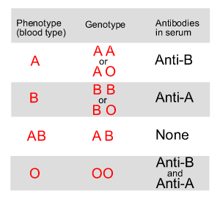
In this exercise we will be testing your blood type. Most cells in our bodies possess a characteristic group of glycoproteins on the cell membrane that specify “self” versus “non-self”. As a result our immune systems will react and attempt to destroy cells which it views as being foreign. This is a common problem when an organ from one person is transplanted into another person. These glycoproteins on the cell surface are known as ANTIGENS. Every person in this room has a slightly different set of antigens on their cells, making each of us unique. Erythrocytes also contain many antigens on their surfaces, but luckily for us there are only a couple of different antigens that are clinically most important. The ABO blood group describes a type on antigen found on erythrocytes in human blood. A person with Type A blood will have erythrocytes that only possess the “A” antigen, Type B blood only possesses the “B” antigen, Type AB blood contains both types of antigen, and Type O blood does not possess either “A” or “B” antigens but instead a smaller glycoprotein that is not particularly antigenic, which explains why Type O blood can be transfused into anyone.
In order for our bodies to keep track of “self” versus “non-self” cells, plasma from a person with Type A blood will contain antibodies that will detect the presence of cells possessing the “B” antigen. Plasma from a person with type B blood will contain antibodies against the “A” antigen, a person with type O blood will have antibodies against both “A” and “B” antigens, and a person with type AB blood will not contain any antibodies against either antigen. This is summarized in the table above.

Administration of the wrong blood type to a person often has devastating consequences. For example if a person with Type A blood receives Type B blood the plasma antigens will stick to the transfused Type B blood cells and cause them to clump together. This is called AGGLUTINATION. Large clumps of the transfused cells will quickly block off blood vessels, often leading to organ failure and death.

In this exercise we will be using antibodies against either the “A” antigen or “B” antigen to determine your blood type. Type A blood will form clumps in the presence of antibodies against the “A” antigen (these antibodies come from plasma of a person with Type B blood), Type B blood will clump in the presence of “B” antibodies, Type AB blood will clump in the presence of either antibody, and finally Type O blood will not clump at all in the presence of either antibody.
- Remember to wear your gloves!
- Using a wax pencil label one side of a clean microscope slide “A” and the other half “B”
- Place one drop of blood on each half of the microscope slide
- On the “A” side, place one drop of the Anti-A antibody NEXT to the blood drop, not on top of it. Do the same on the other side with the Anti-B antibody
- Using a clean toothpick carefully mix the drop of blood with the antibody
- After several minutes, examine the slide to see if the blood exposed to either antibody has clumped. If after 10 minutes you cannot detect any clumping in the presence of either antibody it can be safe to assume that you have type O blood.
- Remember to clean up your work area and place your used microscope slides in the appropriate biohazard container OR in a container of bleach/water.

Since Type O blood cells do not contain either the “A” or “B” antigen, they can be transfused into any person. So, a person with Type O blood is considered a “universal donor”. Blood cells from a person with Type AB blood will have both “A” and “B” antigens on their surface. Consequently, people with Type AB blood do not have antibodies against either type of antigen. So, people with Type AB blood are considered “universal recipients” since they can safely receive type A, B, AB, or O blood!

