Bio 201 – Human Anatomy
Objective list for Exercises #4-5

- Skeletal muscle
  - Slide #15 of skeletal muscle (cross-section and longitudinal section on same slide, usually). Be able to recognize an individual cell on longitudinal section and also a FASCICLE on cross-section.
  - Understand structure of sarcomere (everything on the image below)
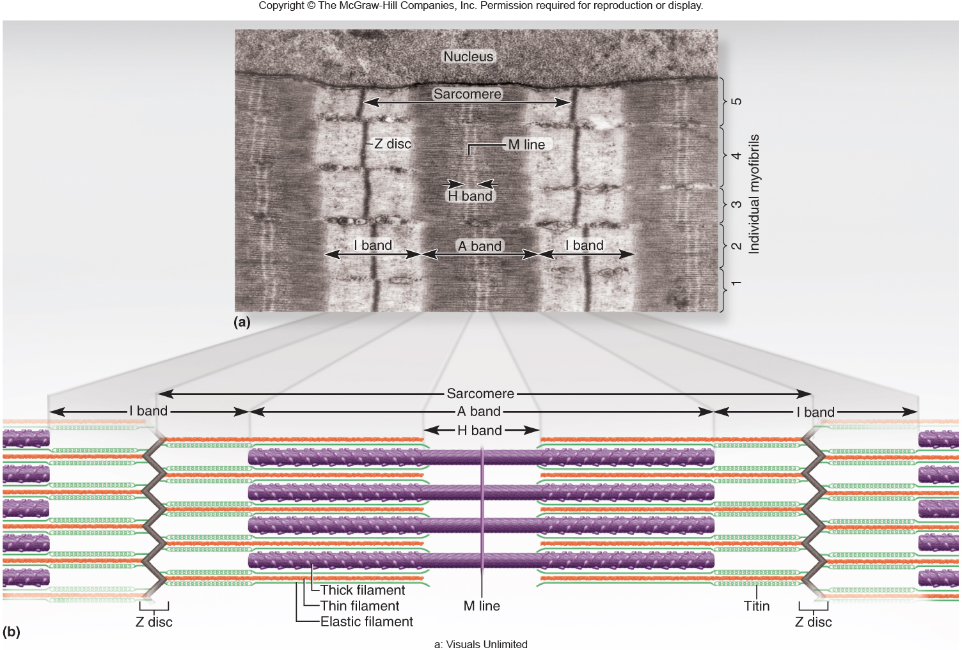

- Exercise #5 Integumentary system
  - Know the material in the lab book (similar to what we covered in lecture)
  - Be able to identify merocrine and sebaceous glands, hair follicle (bulb, root, shaft), arrector pili, epidermis (stratum corneum, stratum basale), dermis, dermal papillae, hypodermis on plastic skin model
  - On the skin slide (slide 18), be able to identify epidermis (stratum corneum, stratum basale), dermis, hair follicle (bulb, root), arrector pili muscle (probably will have to look at several slides before finding one), sebaceous gland, merocrine sweat gland (no apocrine glands in scalp).
  - On an image from the lab book or text book (Figure 5.1, 5.2, 5.3) you should be able to identify all five layers of the epidermis and both layers of the dermis (papillary and reticular)

