Bio 201 – Human Anatomy
Objective list for Muscle Tissue

- Skeletal muscle
  - Slide #15 of skeletal muscle (cross-section and longitudinal section on same slide, usually). Be able to recognize an individual cell on longitudinal section and also a FASCICLE on cross-section.
  - Understand structure of sarcomere (everything on the image below)
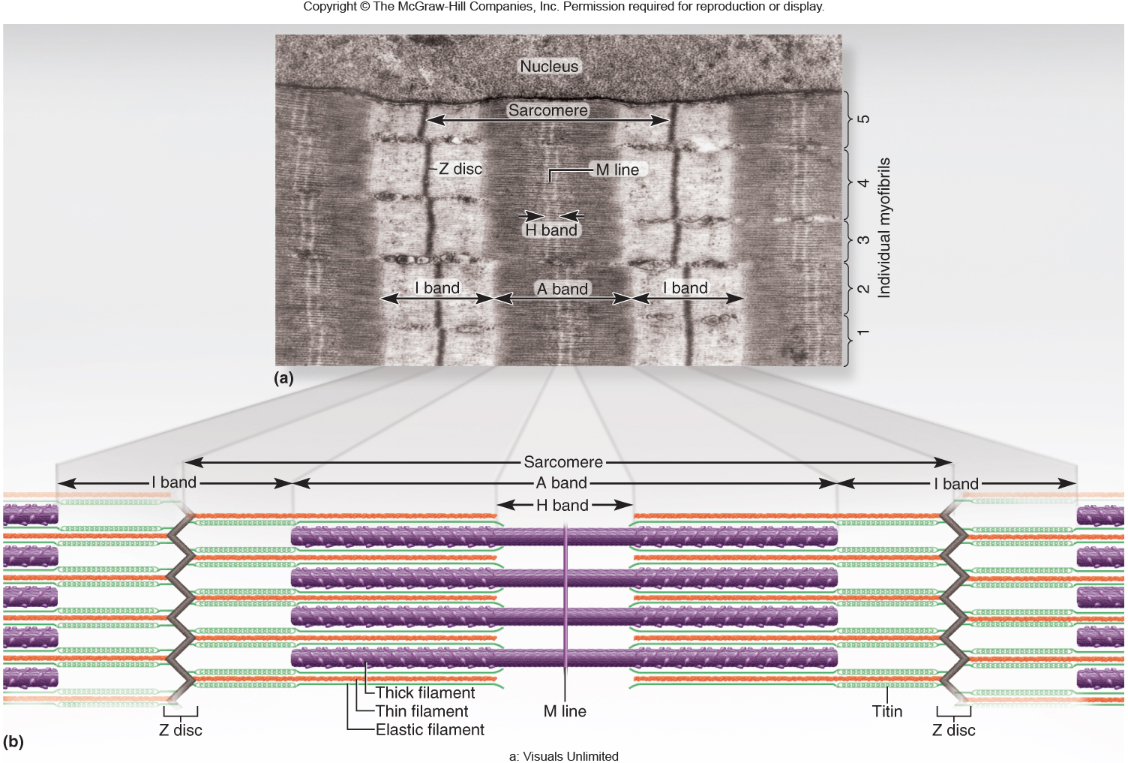

  - On the muscle cell models in the anatomy lab you should be able to identify the sarcolemma, sarcoplasmic reticulum, transverse tubule (T-tubule), myofibrils, endomysium, I-band, A-band.
  - You should also understand the organization of muscle cells. In particular understanding where you will find endomysium, perimysium, epimysium and how muscle cells are organized into fascicles and the bundling of fascicles into the larger muscle.
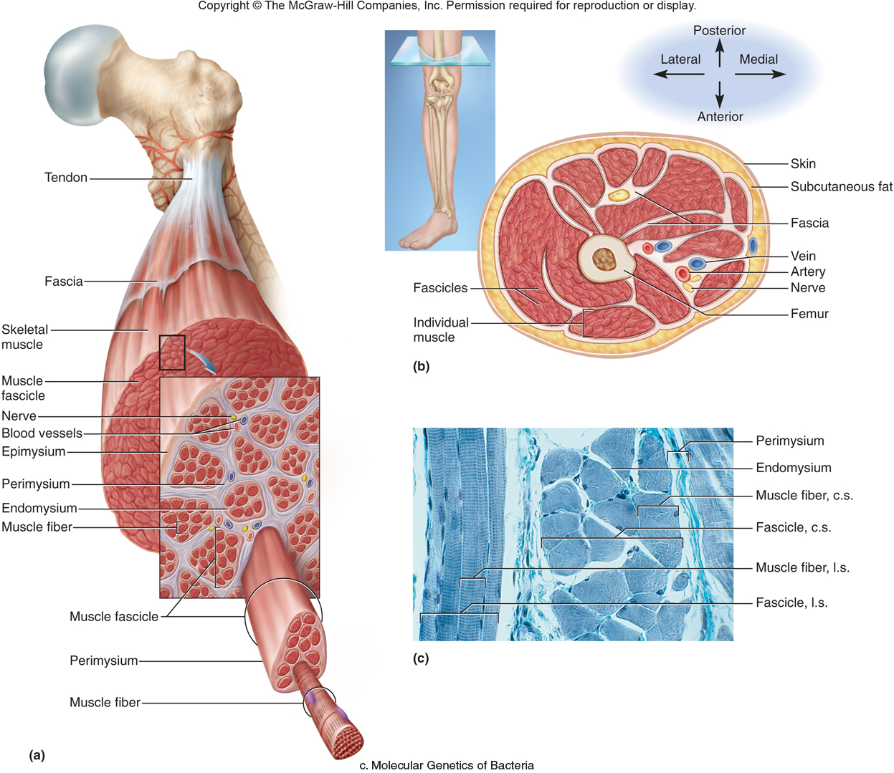

  - You should also of course be able to distinguish between skeletal muscle, cardiac muscle, and smooth muscle on a microscope slide!

