Blue Sucker
Cycleptus elongatus (Lesueur 1817)
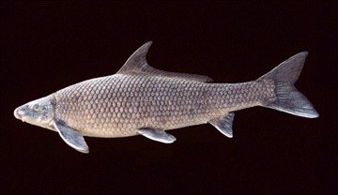

Status: MN – Special Concern
WI – Threatened

MN & WI Distribution: Mississippi River and the lower portions of its larger tributaries, including the Minnesota, St. Croix, Red Cedar, Chippewa, Black, La Crosse, and Wisconsin rivers

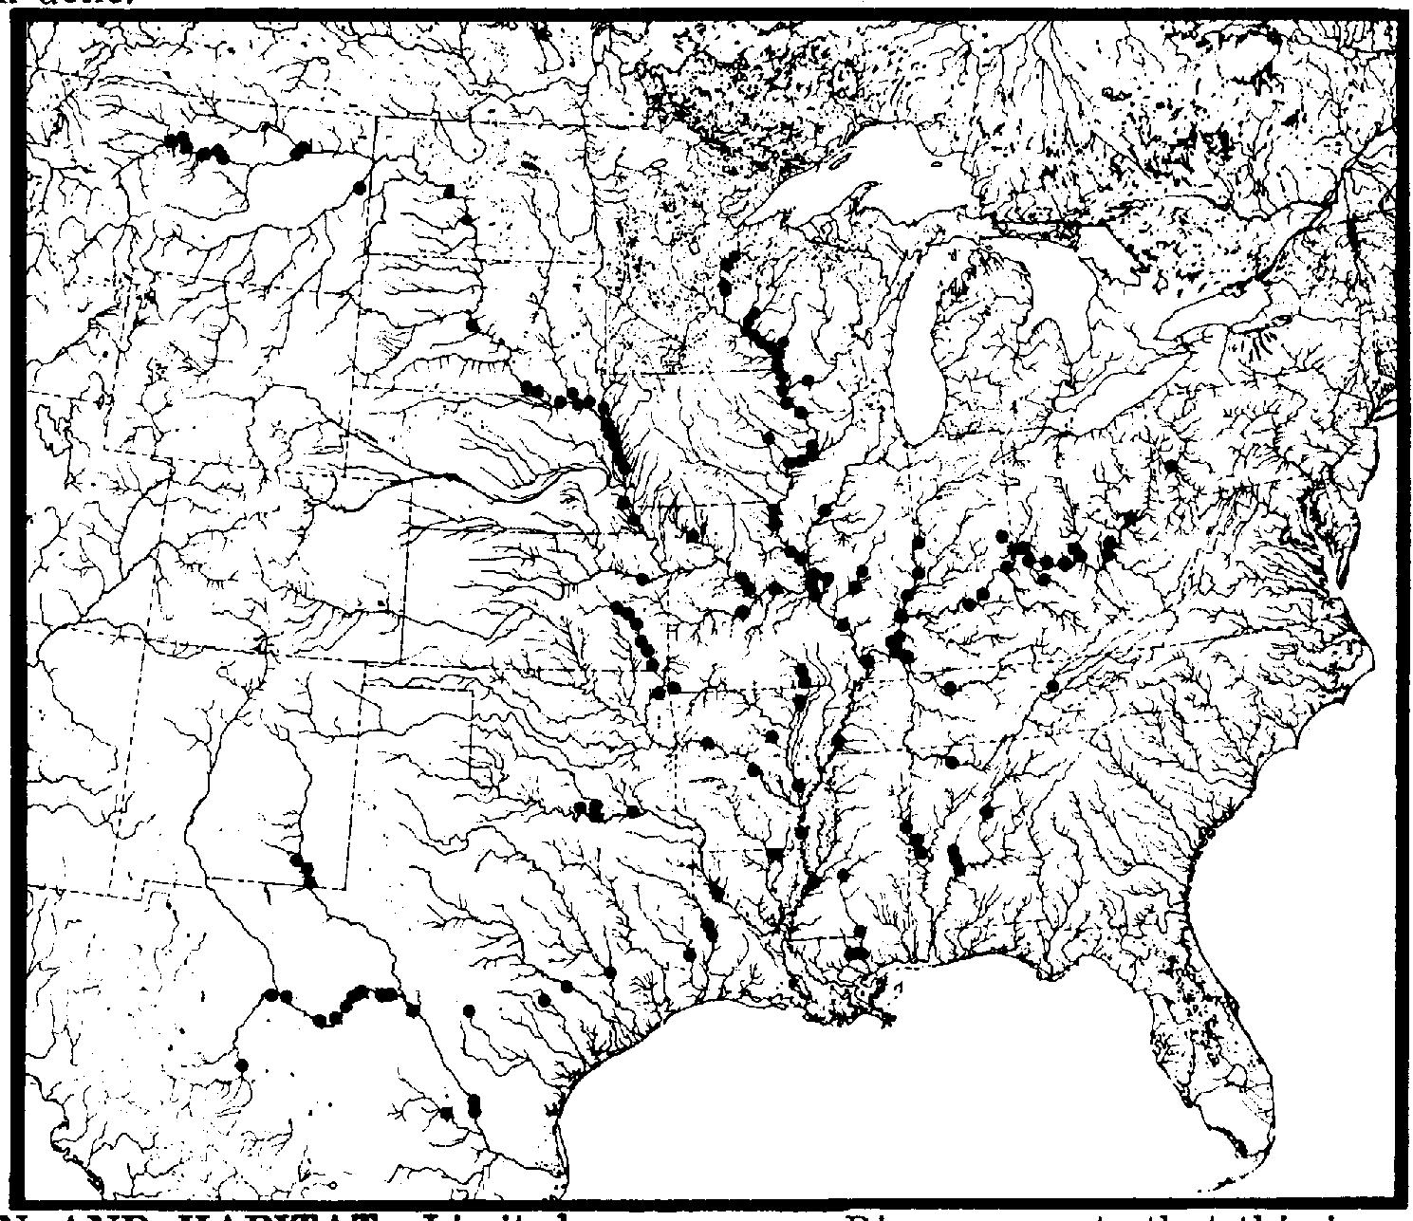
North American Distribution: Missouri, Ohio, and Mississippi rivers and their larger tributaries, as well as tributaries of the western Gulf of Mexico

Preferred Habitat: Deeper channels of larger rivers and reservoirs, usually with swift currents and bottoms of gravel and cobble

Food Habits: Bottom feeders consuming mostly aquatic insect larvae, crustaceans, plant materials, and algae

Natural History: The spawning season runs from late-April through mid-June at water temperatures of 10-15°C. Adults migrate to spawning areas with moderately swift flows and gravel bottoms. Newly hatched larvae drift downstream to shallow, slow areas over sand or fine gravel, where they are vulnerable to predation from fish-eating birds.

Conservation & Management: The species is intolerant of turbidity and pollution, and likely has been impacted by dam construction and other activities that interfere with free-flowing rivers. It is protected or of special concern in IN, KS, KY, MN, MS, ND, NM, OH, SD, TN, TX, WI, and WV.

Compiled by Neal Mundahl, 8 January 2004

