INFERENCE FOR A CATEGORICAL VARIABLE WITH MORE THAN TWO CATEGORIES
The analyses we have completed up to this point in the semester were for a single categorical variable with only two outcomes. For example, in the helper/hinderer study, the babies were choosing either one toy or the other. In the gender discrimination example, each employee selected for management was either male or female. Next, we’ll consider problems involving a single categorical variable which has more than two categories.
Example 2.7: The Minneapolis Police Department posts regular updates on crime statistics on their website. A colleague of mine has collected this data for the past few years on all neighborhoods in Minneapolis. A portion of the data set and the precinct map are shown below.
Minneapolis Crime Statistics – a snippet of the data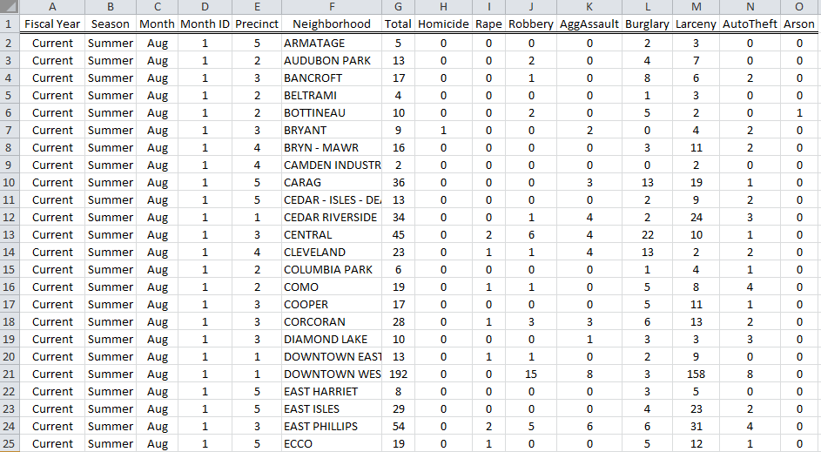 | Precinct Map  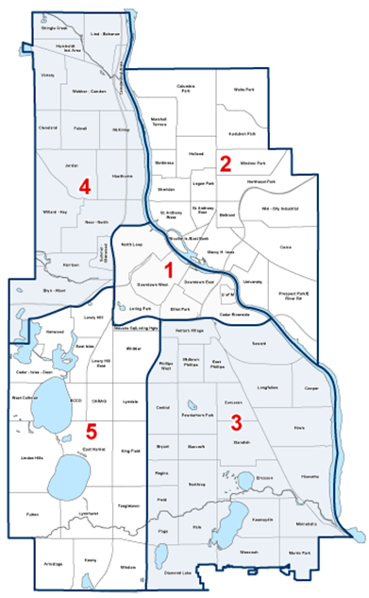

Source: http://www.minneapolismn.gov/police/crime-statistics/

Suppose the police chief for Precinct #2 has received a complaint from a permanent resident who lives in a neighborhood near the University of Minnesota. This resident has asked for additional patrol to take place in his neighborhood as he believes that crime rates vary over the course of the year.

Research Question: Is there evidence to suggest that crime patterns in the University of Minnesota neighborhood differ over the four seasons of the year?

Crime rates are reported by month, so we will use the following definitions for the seasons:
- Fall: September, October, and November
- Winter: December, January, and February
- Spring: March, April, and May
- Summer: June, July, and August
The Observed Data
Crimes classified as Murder, Rape, Robbery, Aggravated Assault, Burglary, Larceny, Auto Theft, and Arson are used in reporting the total number of crimes. The Minneapolis Police Department reported that a total of 103 crimes occurred in the University of Minnesota neighborhood in this particular year, and the table below shows the breakdown of these counts (and percentages) across season.
 | Season |  |  |  | Total
 | Fall | Winter | Spring | Summer
Observed Count | 32 | 17 | 30 | 24 | 103
Observed Percentage | 31.1% | 16.5% | 29.1% | 23.3% | 100%

Note that the police chief may consider conducting a hypothesis test to investigate the concern expressed by his resident. We can formalize hypotheses as shown below.

Minneapolis Crime Case Study
Research Question | Do these data provide enough evidence for the police chief to conclude that crime patterns in the University of Minnesota neighborhood differ over the four seasons of the year?
Parameters of Interest | The four parameters of interest are defined as follows:  π_{fall} = the probability of a crime occurring in the fall  π_{winter} = the probability of a crime occurring in the winter  π_{spring} = the probability of a crime occurring in the spring  π_{summer} = the probability of a crime occurring in the summer
Hypotheses | H_{o}: Crimes are equally dispersed over the four seasons  H_{a}: Crimes are not occurring with equal probability over the four seasons

A Simulation Study
The approach we will take to carry out this hypothesis test is very similar to what we have done previously.

- We will assume the crime patterns are occurring equally across the four seasons (i.e., that the null hypothesis is true) and then get a good idea of what outcomes we would expect to see if this were really the case.
- Then, we will check to see if the observed outcomes given in the data are consistent (or inconsistent) with what we expected to see under the null hypothesis.
- If the observed data are inconsistent with the outcomes expected under the null, then we will have sufficient statistical evidence to say crime rates vary across the four seasons.

Questions:

- Find the expected number of total crimes for each season under the assumption that crimes are occurring equally over the four seasons. How did you obtain these values?

 | Season |  |  |  | Total
 | Fall | Winter | Spring | Summer
Expected Count |  |  |  |  | 103

- Recall the actual crime statistics for the University of Minnesota neighborhood for that particular year. Even if in the long run crime patterns don’t really differ across season, do we anticipate these observed counts to match the expected counts exactly? Why or why not?
 | Season |  |  |  | Total
 | Fall | Winter | Spring | Summer
Observed Count | 32 | 17 | 30 | 24 | 103
Note that we must allow for some slight variations in the crime patterns over the four seasons, no matter what the true probability of a crime occurring in any particular season is. Over repeated samples, slight variations will occur in the crime patterns simply because of chance.
Our goal is to determine whether the difference between the expected and observed counts is greater than we would expect to see by chance. We could use Tinkerplots to give us an idea of how much deviation from the expected counts we should anticipate due to randomness.
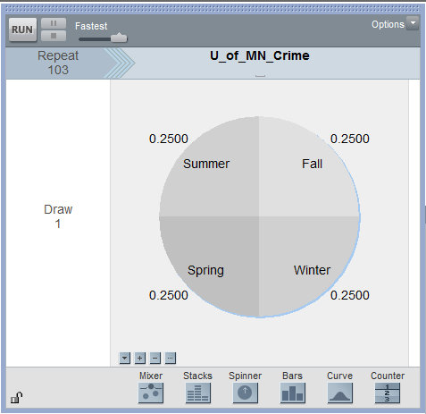

Questions:

- Why is the spinner set up with 25% for each season? Explain.
- Why is the repeat value set to 103? Explain.
Suppose that after running the first trial of the simulation, you obtained the following results:
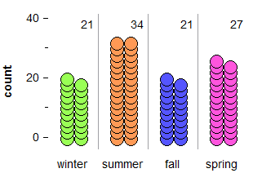

To keep track of the count for the number of crimes in each season over repeated trials of this simulation, we can right-click on each season’s count and select Collect Statistic. Note that this needs to be repeated for each season. Tinkerplots then creates a table as follows:

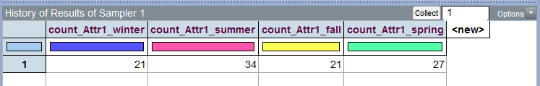
I placed 99 in the Collect box and then ran the simulation, so I ended with a total of 100 simulated trials.

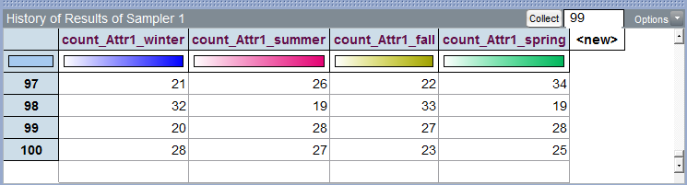

The following plot shows what outcomes our simulation study suggests we would anticipate for each season, assuming that crimes are equally likely to occur in any of the four seasons.
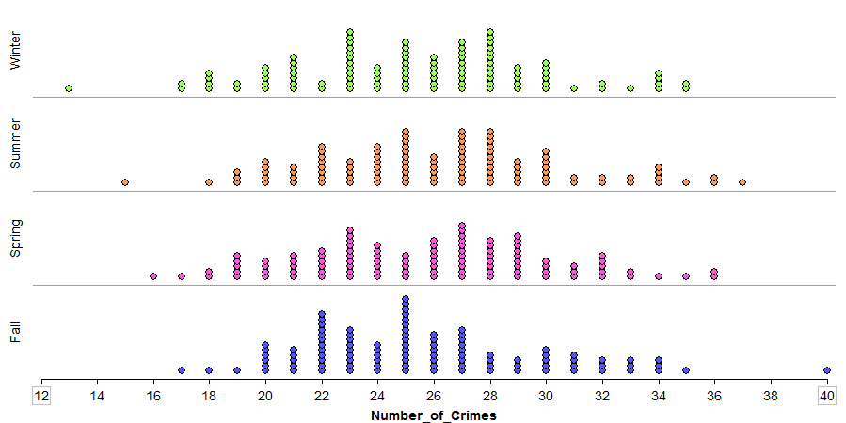

Next, recall the actual crime statistics for the University of Minnesota neighborhood for the past year.

 | Season |  |  |  | Total
 | Fall | Winter | Spring | Summer
Observed Count | 32 | 17 | 30 | 24 | 103
Plot these observed outcomes on the above graph. What do you think? Remember that our goal is to determine whether this observed result is inconsistent with what our simulation tells us to expect if there is really no difference in the crime rate across seasons.
Why is it more difficult to determine whether or not the observed data is considered an outlier in this situation than in the problems we dealt with previously?
Measuring Distance Between Observed and Expected Counts with Several Categories
One way to address this problem is to consider the overall distance between the observed and expected counts for all four seasons combined. This can be visualized as follows.
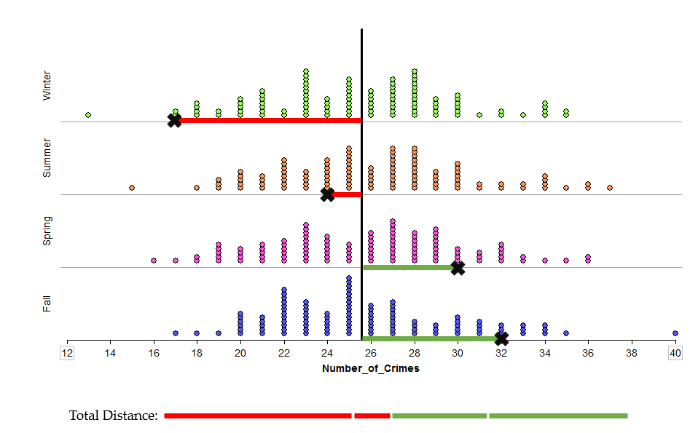

Compute the distance betweeen the observed and expected counts for each season in the table below.

 | Season |  |  |  | Total
 | Fall | Winter | Spring | Summer
Observed | 32 | 17 | 30 | 24 | 103
Expected | 25.75 | 25.75 | 25.75 | 25.75 | 103
Distance

Questions:
- Find the sum of the distances between observed and expected counts over all four seasons. What is this total distance? Does this value make sense for total distance? How might we overcome this issue?
So that the negative distances do not cancel out the positive ones, we will square each distance before adding them up. Note that the absolute value could have been used, as well, but the statistical hypothesis testing procedure we will soon be discussing uses the squared distances, so that’s what we will consider here.
 | Season |  |  |  | Total
 | Fall | Winter | Spring | Summer
Observed | 32 | 17 | 30 | 24 | 103
Expected | 25.75 | 25.75 | 25.75 | 25.75 | 103
Distance | 6.25 | -8.75 | 4.25 | -1.75 | 0.00
Distance² | 39.06 | 76.56 | 18.06 | 3.06 | 136.74 ≈ 137

The total squared distances summed up across all four seasons is about 137.
Note that we cannot determine whether or not this 137 is an outlier using our previous graph of the simulated results because the previous graphs considered each season individually.
Our new measure is the squared distance between the observed and expected counts summed over four seasons, so we now need a new graph that shows this value for all of our 100 simulated results in Tinkerplots to determine whether or not 137 is an outlier.
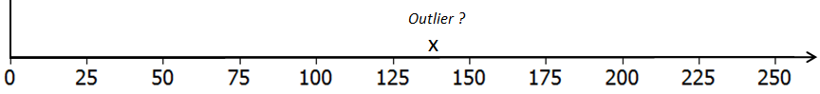

Questions:
- What would a value of 0 imply on the above number line? Explain why a value less than 0 is not possible when the distances are squared and summed across the categories.

- What would a large value imply? Is this evidence for or against the original research question? Explain.

- When squared distances are computed and summed across all categories, the appropriate test is an upper-tailed test. Explain why this is the case.
In Tinkerplots, a formula can be used in the History table to compute the squared distance between the simulated outcome for a single trial and the expected count for each season. These squared distance values are then summed across the four seasons.

The outcomes from the first ten simulated trials are shown below.
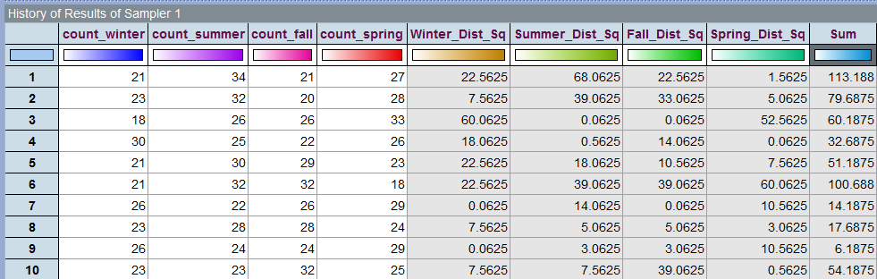

A graph of the sum of the squared distances from all 100 trials in Tinkerplots is given below. The p-value is determined using the proportion of dots greater than or equal to 137, the “observed outcome” from the study.
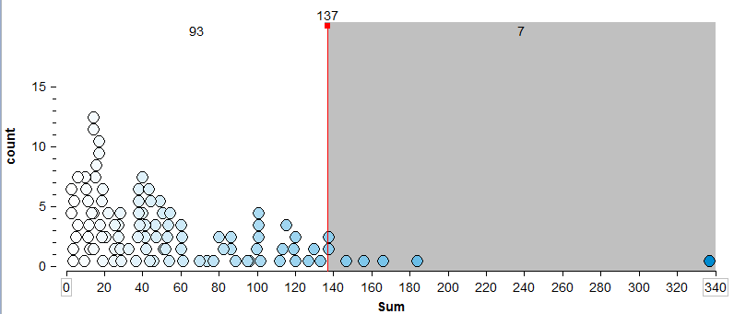

Questions:
- What is the approximate p-value from the above graph?
- What is the appropriate statistical decision for our research question?
Example 2.8: The Minnesota Student Survey (MSS) is a survey administered every three years to 6th, 9th, and 12th grade students. It is also offered to students in area learning centers and to youth in juvenile correctional facilities. This survey is an important vehicle for youth voice, as school districts, local public health agencies, and social services agencies use the survey results in planning and evaluation for school and community initiatives and prevention programming.

Questions are related to both the home and school life of students. Topics include family relationships, feelings about school, substance use, wellness activities, and more. Participation in the survey is voluntary, confidential, and anonymous.

For this analysis, we will consider Question # 105 from this survey. Data has been collected for Fillmore County, which is in Southeastern Minnesota. Fillmore County (population = 20,866) consists of several small rural communities.

Question #105 from MN Students Survey  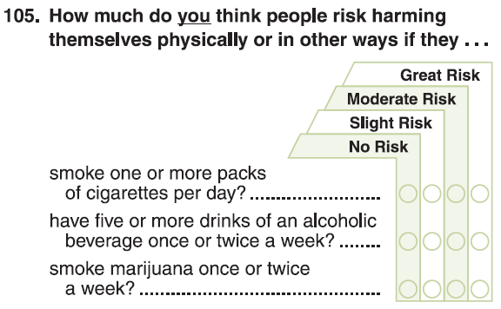 | Fillmore County is in  Southeastern Minnesota  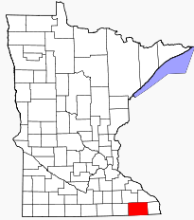

The following data was obtained from the Minnesota Department of Education website.
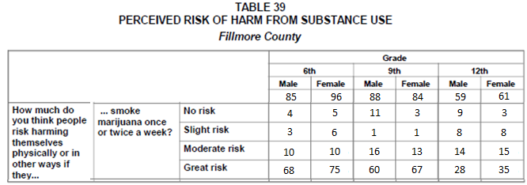
Source: Minnesota Department of Education http://education.state.mn.us/MDE/Learning_Support/Safe_and_Healthy_Learners/Minnesota_Student_Survey/index.html

Information regarding the historical patterns for Grade 6 students from across the state of Minnesota is given here and will be used for comparisons.

Historical Patterns for Grade 6 Students Across the Entire State of Minnesota:

- About 3 out of 4 students in Grade 6 respond to the third part of this question (i.e., “smoking marijuana once or twice a week” ) with “Great Risk”
- A very small percentage, only about 1%, respond to the third part of this question with “No Risk”
- The remaining students typically divide themselves between “Slight Risk” and “Moderate Risk” when responding to the third part of this question.

Fillmore County Marijuana Case Study
Research Question | Is there evidence to suggest that Grade 6 students from Fillmore County deviate from historical statewide patterns of the marijuana portion of Question 105?
Parameters | The four parameters of interest are defined as follows:  π _{no} = the probability a Grade 6 student from Fillmore County will  respond to the marijuana portion of this question with No Risk  π _{slight} = the probability a Grade 6 student from Fillmore County will  respond to the marijuana portion of this question with Slight Risk  π _{moderate} = the probability a Grade 6 student from Fillmore County will  respond to the marijuana portion of this question with  Moderate Risk  π _{great} = the probability a Grade 6 student from Fillmore County will  respond to the marijuana portion of this question with Great Risk
Hypotheses | H_{o}: Fillmore County Grade 6 students do not deviate from historical  statewide patterns  H_{a}: Fillmore County Grade 6 students deviate from historical statewide  patterns.

Consider the following table. The first row of this table contains the Observed Outcomes for Grade 6 students from Fillmore County (male and female tallies were combined). The second row contains the Expected Outcome (under the null hypothesis) for each of the possible survey responses.

Type of Outcome | Survey Responses for Fillmore County, 6th Grade |  |  |  | Total
 | No Risk | Slight Risk | Moderate Risk | Great Risk
Observed | 9 | 9 | 20 | 143 | 181
Expected | 1.81 | 21.72 | 21.72 | 135.75 | 181

Questions:

- How were the expected values computed?

- Why is the Expected count for the Great Risk category so much higher than the others?

- Suppose your friend computes the following percentages: No Risk: 9/181 ≈ 5%; Slight Risk: 9/181 ≈ 5%; Moderate Risk: 20/181 ≈ 11%; and Great Risk: 143/181≈ 79%. Your friend then makes the following statement: “There is enough evidence for the research question because these percentages are different from the historical percentages (i.e., No Risk = 1%, Slight Risk = 12%, Moderate Risk = 12%, and Great Risk = 75%).” Why is this statement statistically incorrect? Explain.

Once again, to understand the amount of acceptable deviation from the expected, we can consider the distance between the observed and expected counts for each of the possible choices for this question.
 | Survey Responses for Fillmore County, 6th Grade |  |  |  | Total
 | No Risk | Slight Risk | Moderate Risk | Great Risk
Observed (O) | 9 | 9 | 20 | 143 | 181
Expected (E) | 1.81 | 21.72 | 21.72 | 135.75 | 181
Difference (O - E) | 7.19 | -12.72 | -1.72 | 7.25 | 0

We discussed earlier the fact that we need to square the differences (i.e., distances) before summing because otherwise the positive and negative values cancel each other out. Upon careful inspection of these differences, there is another problem that also needs to be addressed.

Notice that the difference in the Great Risk category is 7.25, and the difference in the No Risk category is slightly smaller at 7.19. However, these distances alone fail to take into consideration the scale of the expected values. The following Test Statistic accounts for the scale of the expected counts:
$$Test Statistic= \sum{ \frac{{\left(Observed-Expected\right)}^{2}}{Expected}}$$

 | Survey Responses for Fillmore County, 6th Grade |  |  |  | Total
 | No Risk | Slight Risk | Moderate Risk | Great Risk
Observed (O) | 9 | 9 | 20 | 143 | 181
Expected (E) | 1.81 | 21.72 | 21.72 | 135.75 | 181
Difference (O - E) | 7.19 | -12.72 | -1.72 | 7.25
$${\left(O-E\right)}^{2}$$ | 51.7 | 161.8 | 2.96 | 52.56
$$\frac{{\left(O-E\right)}^{2}}{E}$$ | 28.56 | 7.45 | 0.14 | 0.39 | 36.5

The Test Statistic for this analysis would be:

Similar to what we have done in the past, now we must determine whether or not the Test Statistic from the observed data would be considered an outlier under the null hypothesis. Tinkerplots can be used to compute the Test Statistic over repeated samples under the null hypothesis.

The following graph shows the test statistic computed for each of the 100 simulations carried out under the null hypothesis in Tinkerplots:
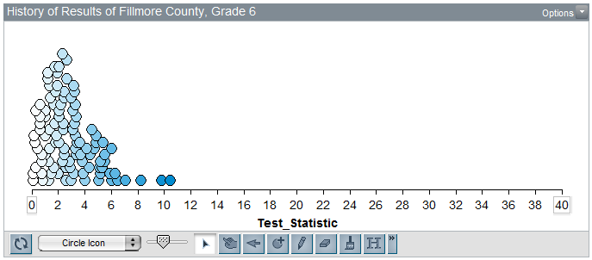
Questions:

- The Test Statistic for the observed data from our sample of Grade 6 students in Fillmore County is 36.5. Is this value consistent with results we would expect to see if Grade 6 students in Fillmore County do not deviate from historical statewide patterns for the marijuana portion of this question? Explain.

- Consider the formula for the test statistic. What would a value near 0 imply? What would a large value imply? Explain.

$$Test Statistic= \sum{ \frac{{\left(Observed-Expected\right)}^{2}}{Expected}}$$

- Use the simulated results to estimate the p-value, make a decision, and write a final conclusion in the context of the original research question.

The Chi-square Distribution

It can be shown that this test statistic actually follows what is known as the Chi-Square Distribution. This is different from the binomial distribution presented earlier.

- Unlike the binomial distribution, the chi-square distribution is not based on counts and is often skewed to the right.

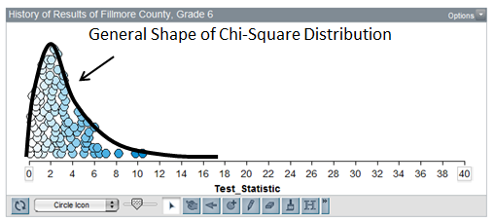

- The number of categories is taken into consideration through a quantity called the degrees of freedom, typically referred to as the df.
df = # of Categories – 1

The graph below shows several different chi-square distributions indexed by the degrees of freedom.

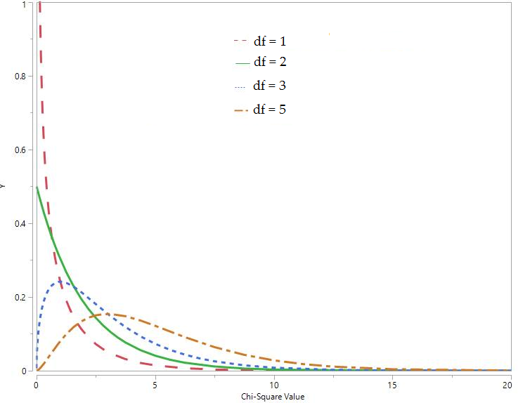

The Chi-Square Goodness of Fit Test
To test the hypothesis that Fillmore County sixth-graders deviate from historical statewide trends on this question, the researchers can conduct the test as follows:
- First, they set up their hypotheses.
H_{o}: Fillmore County Grade 6 students do not deviate from historical statewide patterns
H_{a}: Fillmore County Grade 6 students deviate from historical statewide patterns.

- Then, they try to get an understanding of what to expect if the null is true. Instead of using a simulation study to determine what to expect, we can use the chi-square distribution. The theory behind the chi-square test tells us that if the null hypothesis is true, the chi-square test statistic should follow a chi-square distribution with df = 3.

Question: Why is df = 3 in this case?
The chi-square distribution with df = 3 looks like this. This distribution helps us see what test statistics are likely (or unlikely) to occur if the null hypothesis is true.
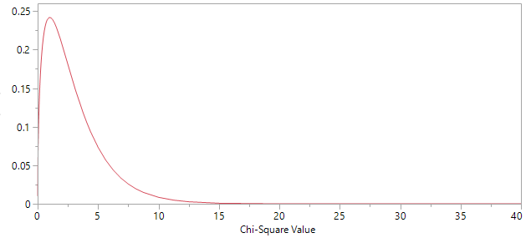
- Finally, they determine whether the test statistic computed from their data is consistent with what is expected under the null hypothesis. Recall that our test statistic was computed as follows:
Clearly, a test statistic as large as 36.5 is very unlikely to happen by chance, so the p-value in this case will be very small. The survey results provide very strong evidence that Fillmore County Grade 6 students deviate from historical statewide patterns.

To find the p-value, we could use a chi-square probability calculator (like we did with the binomial distribution). To make life easier, however, we will simply let JMP calculate the p-value for us.
Carrying out the Chi-Square Goodness of Fit Test in JMP
This hypothesis testing procedure easily implemented in JMP when given the raw data. For example, consider the following data set:
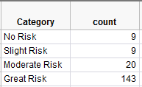
To get the test statistic and p-value in JMP, select Analyze > Distribution. Enter the following:
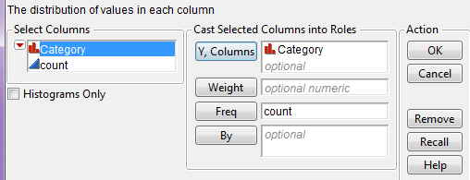
On the output that appears, select “Test Probabilities” from the red drop-down arrow:
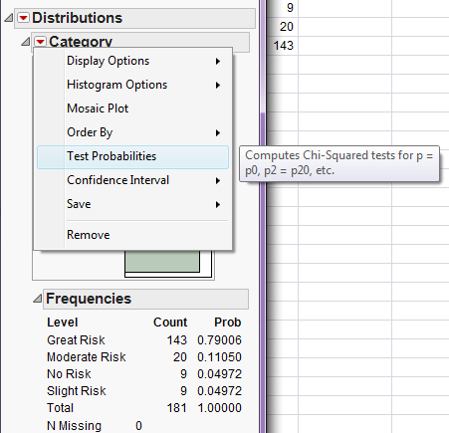
Enter the following:
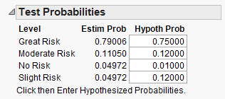
Click “Done” and JMP should return this output:
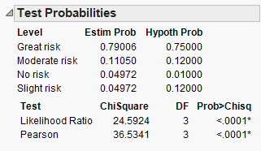
Note that the p-value associated with our chi-square test statistic (which was 36.5) is reported as <0.0001. This means that the p-value is so small that it is less than 1 in 10,000. The survey results provide very strong evidence that Fillmore County Grade 6 students deviate from historical statewide patterns.
Example 2.7 Revisited
To test the hypothesis that crimes were not occurring with equal probability over the four seasons, we can conduct the test as follows:
- First, we set up the hypotheses.
H_{o}: Crimes are equally dispersed over the four seasons
H_{a}: Crimes are not occurring with equal probability over the four seasons

- Then, we try to get an understanding of what to expect if the null is true. Recall that a chi-square distribution with 3 degrees of freedom tells us what values of the test statistic we expect to see when the null is true.

Question: Why is df = 3 in this case?
Here is the chi-square distribution with df =3.
- Finally, we determine whether the test statistic computed from our data is consistent with what is expected under the null hypothesis. Our test statistic is computed as follows:
 | Season |  |  |  | Total
 | Fall | Winter | Spring | Summer
Observed Count | 32 | 17 | 30 | 24 | 103
Expected count | 25.75 | 25.75 | 25.75 | 25.75 | 103
To find the p-value, we must determine how often we see test statistics such as 5.3 or higher by chance, even if the null is true. This probability can be visualized on the graph below (note that the total area under curve is 1.0).
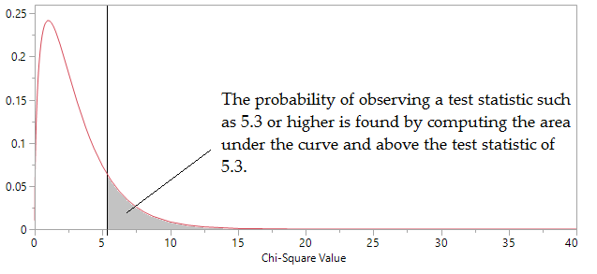
Recall that we will use JMP to find this p-value.
Enter the raw data:  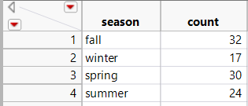 | Use Analyze > Fit Distribution.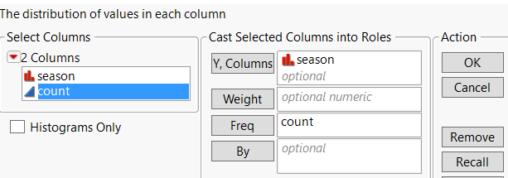
Test Probabilities:  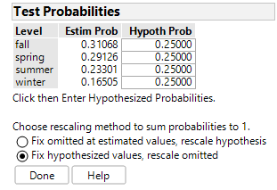 | The output:  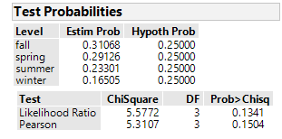
What is our conclusion?

