In this chapter, we will consider methods that allow us to make comparisons on numerical variables between two different groups. In general, these methods should be used to address research questions involving a categorical predictor variable (with two categories) and a numerical response variable. Two different cases will be considered: (1) When the samples are dependent (also called matched or paired), and (2) when the samples are independent.
COMPARING TWO POPULATION MEANS: DEPENDENT SAMPLES

The hypothesis testing procedures presented in this section should be used when the observations from the two groups being compared are dependent. Whether the observations are dependent is determined by how the data are collected – if each observational unit is measured twice, then the observations are dependent (i.e., matched or paired). To see this, consider the following example.
Example 6.1: Thanksgiving Holiday Weight Gain
In a 2006 study published in Nutrition Journal, researchers were interested in assessing potential changes that occur in body weight during the Thanksgiving holiday break in college students. This paper’s abstract indicates that “a total of 94 college students reported to the human body composition laboratory at the University of Oklahoma following a 6-hour fast with testing occurring prior to, and immediately following the Thanksgiving holiday break. Body weight was assessed using a balance beam scale while participants were dressed in minimal clothing.”
Source: Hull et al. The Effects of the Thanksgiving Holiday on Weight Gain. Nutrition Journal 2006, 5:29; doi:10.1186/1475-2891-5-29.

Research Question: On average, does the body weight of college students increase over the Thanksgiving holiday break?

The raw data from this study were not available; however, the data in the file ThanksgivingWeightData.jmp are similar to the actual results obtained by the researchers. A portion of these data is shown below:
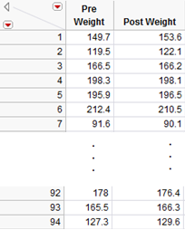
For illustration purposes only, let’s analyze the distribution of the pre- and post-weights separately.

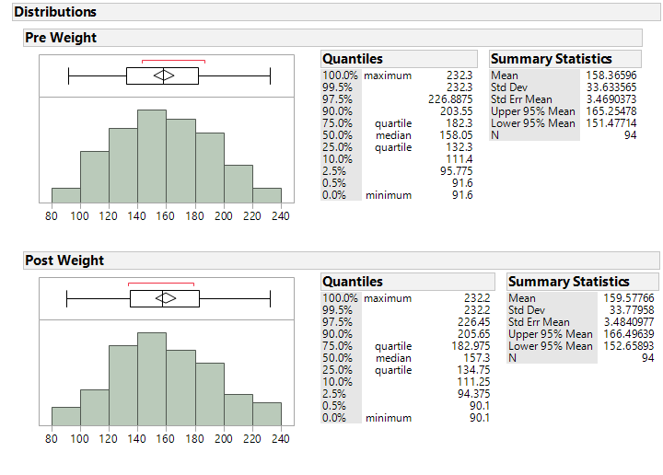

Questions:
- How do the mean weights compare from before to after Thanksgiving break?
- Consider the confidence intervals for the mean weight at each time period. What conclusion might you draw from these confidence intervals?

Comment: One of the problems with the above analysis approach (i.e., examining the two confidence intervals) is that it is treating the observations from the two time periods as if they are independent, or not related. For these data, however, the first pre-weight is clearly related to the first post-weight (the two measurements were made on the same person). Thus, these two samples are dependent.

In other words, some of the variability in the weight measurements might be due to differences between time periods (before vs. after Thanksgiving), but much of the variability in the observations is likely due to differences between people!
So, to control for the variability in weights from person to person (which will help us isolate the true differences between pre- and post-Thanksgiving break), we will work with the DIFFERENCES on each subject, instead. This will remove the structure of dependence between the pre- and post-Thanksgiving groups and will control for the fact that some people, in general, tend to weigh more (or less) than others. In the end, this helps us to isolate the differences in weight measurements that can be attributed to the effect of before vs. after break.
Calculating the Differences in JMP

First, open the file called ThanksgivingWeightData. To calculate the differences, create an additional column (double click on empty column next to “‘Post Weight”) and title it “Difference.” Right-click on the new column header and select Formula.
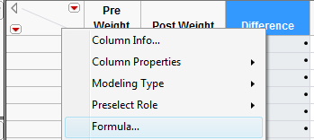
In the edit window, tell JMP to calculate the difference as follows:

Click Apply and then OK, and JMP returns the following (only the results for the first 10 subjects are shown below):

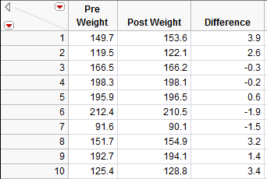

Questions:

- What does a positive difference of 3.9 indicate?
- What does a difference of -1.9 indicate?
To determine what the average difference is, we can analyze the distribution of the differences using the descriptive methods discussed in Chapter 4:
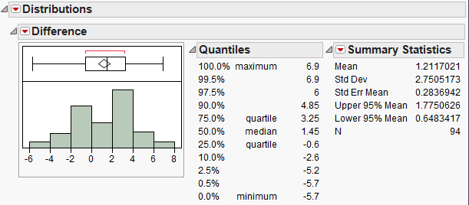
Questions:
- What is the average difference of the 94 subjects? Interpret this value.
- If Thanksgiving break had no effect on body weight, what would you expect these differences to be, on average?
- If the research hypothesis is correct (body weights of college students increase over Thanksgiving break), what would you expect these differences to be, on average?
Comment: Note that these differences are represented by a single column of data. So, you could view this as a problem involving a single numerical variable – the differences! Therefore, the hypothesis testing procedure is exactly the same as the procedure for testing claims about a single population mean we discussed in Chapter 5.

That is, the parameter of interest is the true population average of the differences which we will represent by μ_{difference}.

- Our best estimate for this parameter is the sample mean of the observed differences. We’ll call this quantity.

- The sample standard deviation of the differences will be denoted by s_{difference}.
We can carry out the hypothesis test as follows to determine whether body weights of college students tend to increase over Thanksgiving break.

Checking the Normality Assumption:

Recall that for the t-test to be valid, at least one of the following conditions must be met:

- Either the sample size (i.e., number of pairs) is sufficiently large (greater than about 30), or
- The distribution of the observed differences is approximately normal (which would indicate that the original population is normally distributed so that we can be certain the distribution of sample means is normally distributed even with a small sample size)

Question: Does the t-test appear to be a valid approach for testing this research question? Justify your reasoning.

Step 1: Set up the null and alternative hypotheses

H_{o}:
H_{a}:
Step 2: Find the t-statistic and the p-value

=

To calculate this test statistic and its associated p-value in JMP, use the methods discussed in Chapter 5:
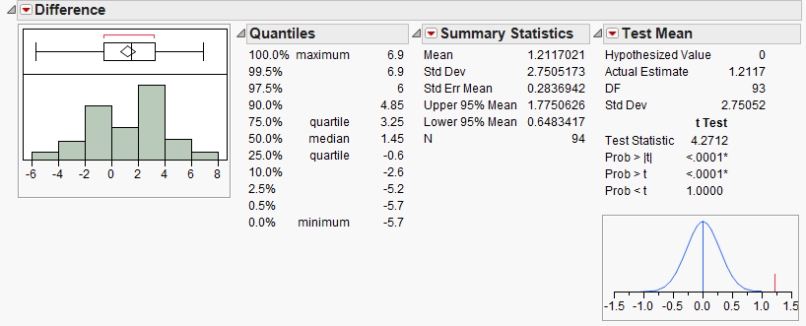
p-value =
Step 3: Write a conclusion in the context of the problem

Interpreting the 95% confidence interval for the mean difference

Comment: Suppose that when calculating the difference, you switched the order of the categories:

What effect would this have had on the analysis?
H_{o}:
H_{a}:

=
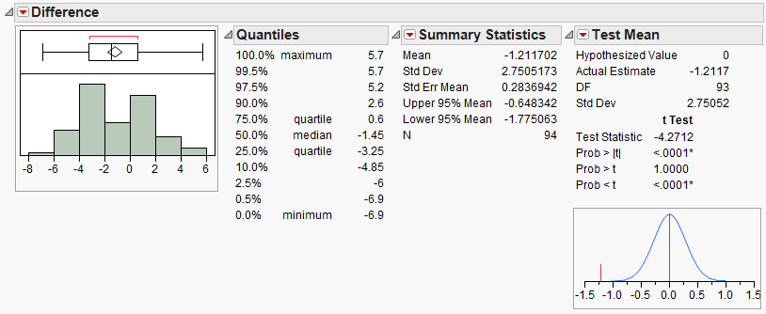
p-value =

Conclusion:

95% confidence interval for the mean difference:

Example 6.2: Systolic Blood Pressure and Captopril
The data in the file Captopril.jmp give the systolic and diastolic blood pressures for 15 patients with moderate essential hypertension, immediately before and two hours after taking a drug, captopril. Our interest is in investigating the response to the drug treatment.

Research Question: Is there a change in systolic blood pressure after taking captopril?

Question: Are these samples dependent or independent? Explain.

Check the assumptions behind the test
- Is the number of pairs sufficiently large?
- If not, is it reasonable to assume the differences in systolic and diastolic blood pressures are normally distributed?

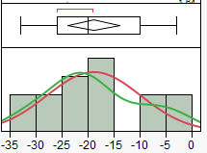 | 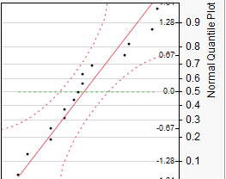

Step 1: Set up the null and alternative hypotheses

H₀:

H_{a}:

Step 2: Find the test statistic and the p-value
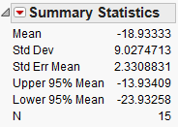 | =
Using JMP:
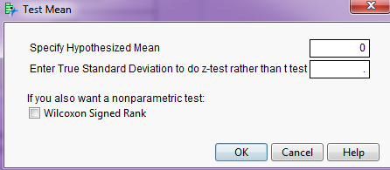  p-value: | 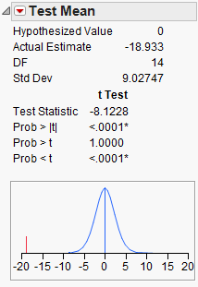
Step 3: Write a conclusion in the context of the problem

Finally, construct a 95% confidence interval for the average difference in systolic blood pressure means.

Questions:

- Interpret this confidence interval.
- Does this interval agree with the results of the hypothesis test? Explain.
Example 6.3: Systolic Blood Pressure and Captopril, Revisited
As we saw in Example 6.2, patients with moderate essential hypertension saw a decrease in systolic blood pressure. Note that we could also investigate the following question.

Research Question: Does the systolic blood pressure decrease by more than 10 mmHg?

Check the assumptions behind the test
- Is the number of pairs sufficiently large?
- If not, is it reasonable to assume the differences in systolic and diastolic blood pressures are normally distributed?

Step 1: Set up the null and alternative hypotheses

H₀:

H_{a}:

Step 2: Find the test statistic and the p-value
=
Using JMP:
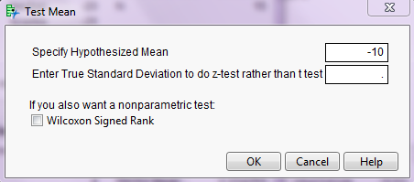

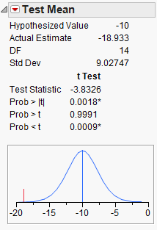
p-value:
Step 3: Write a conclusion in the context of the problem

Recall the 95% confidence interval for the average difference in systolic blood pressure means:

Does this interval agree with the results of the hypothesis test? Explain.

Example 6.4: Diastolic Blood Pressure and Captopril
Finally, we will use the Captopril data to investigate the following question.

Research Question: Does the diastolic blood pressure decrease by more than 5 mmHg?

Step 0: Check the assumptions behind the test
- Is the number of pairs sufficiently large?
- If not, is it reasonable to assume the differences in systolic and diastolic blood pressures are normally distributed?

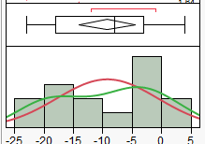 | 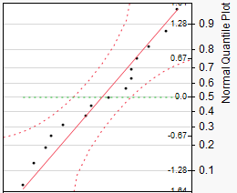

Step 1: Set up the null and alternative hypotheses

H₀:

H_{a}:

Step 2: Find the test statistic and the p-value
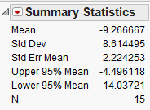 | =
Using JMP:
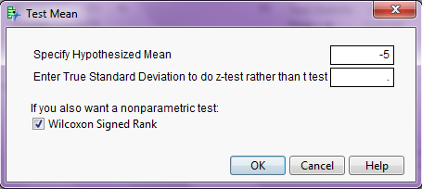  p-value: | 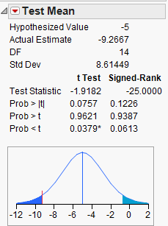
Step 3: Write a conclusion in the context of the problem

Find the 95% confidence interval for the average difference in systolic blood pressure means:

Does this interval agree with the results of the hypothesis test? Explain.

