Guide to Research Posters

Sources
- Colin Purrington “Designing Conference Posters” (http://colinpurrington.com/tips/poster-design)

What is a Poster?
“A big piece of paper (or wall-mounted monitor) that can communicate your research at a conference, and is composed of a short title, an introduction to your burning question, an overview of your novel approach, your amazing results in graphical form, some insightful discussion of aforementioned results, a listing of previously published articles that are important to your research, and some brief acknowledgement of the tremendous assistance and financial support conned from others — if all text is kept to a minimum, a person could fully read your‘ poster in under 5 minutes (really).”

Benefits of a Poster
- More personal interaction than a talk, more like a conversation than a lecture

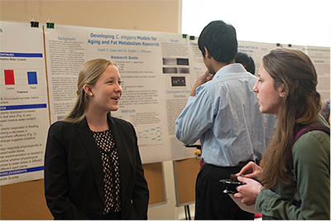
- If done well, can attract someone who otherwise isn’t interested in your field
- They function fine without you if you have to step away

Bare Essentials
- Maintain sufficient white space
- Keep column alignments logical
- Provide clear cues to your readers how they should travel through your poster elements
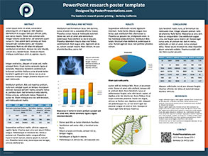 | 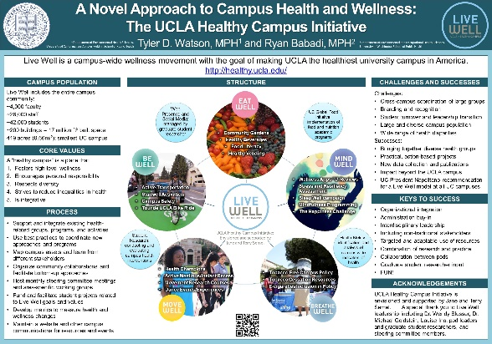

Basic Elements
- Title
Convey the idea, okay to be 1-2 lines long
- Abstract: May or may not be needed (depends on field of study)
Written for the poster to be indexed by the conference, not necessary on the actual poster (unless explicitly required)
- Introduction
Get the viewer interested in the question as quick as possible. Good place to put a photograph or illustration that communicates some aspect of your research question. ~200 words
- Methods/Build-Up/Motivation of Solution
Briefly describe your procedure, the motivating themes that led to your results, and/or any required background material. Use figures and flow charts to illustrate experimental design and/or flow of ideas if possible; mention statistical analyses that were used. ~200 words
- Results
State the main thing that the project discovered, i.e. your contribution whether in the form of a theorem, algorithm, relationship, etc. Include any pertinent figures that support or illustrate your results. ~200 words

- Example (optional)
If your research is very theoretical in nature, applying the ideas of the results section to a specific example can help the reader comprehend. If your research is already analyzing a specific case, then an example would be redundant and any findings should either be in the results or conclusion section
- Conclusion
Remind the reader (without sounding like you are reminding the reader) of the major result, state the relevance of your findings to other published work, and indicate future possible directions.
- References
Cite using same format you would in a paper. Also mention the paper associated to the poster (if there is one).
- Acknowledgements
Thank research mentor (full name) and anyone who gave you assistance, data or money to do the research and/or attend the conference. ~40 words
- Further Information
Give your contact info, web address, QR code, etc. that someone who is really interested can follow up on.

