Your Title (which should be descriptive)
Your Name, Winona State University
Abstract

Provide a brief overview of your entire work and findings.

Introduction (or Background)
Provide necessary background information and motivation for your work. Be sure to clearly state the research objective(s).

Methods (or Data and Methods)

Identify your data source, discuss data management/cleaning, and clearly identify all analysis methods used.

Results

Present relevant/important outcomes in a factual manner. Incorporate figures and/or tables amongst your text. Do not simply stash them all at the end of your paper in a separate section. Number your tables and figures, and give them appropriate titles (and captions if needed).
Figure 1. Regression of length vs. age.
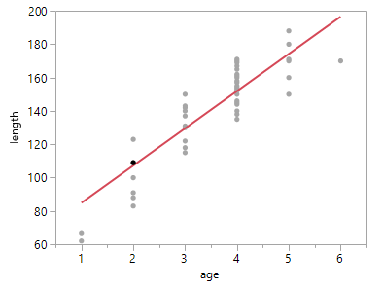
The regression of length on age, Length = 62.65 + 22.31$×$ Age

Conclusion (or Discussion and Conclusions)

Recap major results. Discuss the implications of your outcomes in context of the original research objective(s). Make recommendations for future work.

References

Use APA format
Target length: 3-5 pages.

