Abstract #1

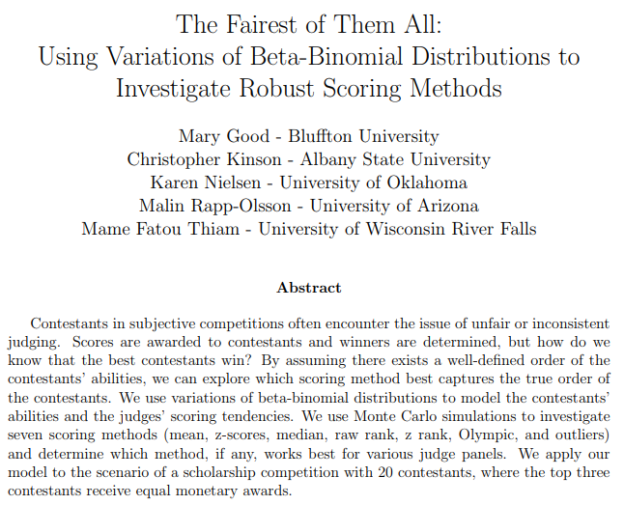

Abstract #2

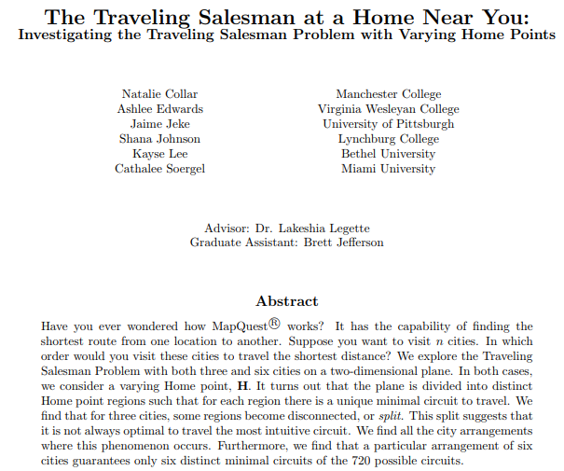

Abstract #3

Eloise Hilarides
"Using Weighting Schemes to Account for Coverage Bias in Internet Surveys"
Advisor: Michael Sheard (msheard@stlawu.edu)

Over the past decade, Internet surveys have become a popular method for collecting data about the general population. In 2005, the Harris Poll published findings which claimed that 74% of the United States Population had access to the Internet somewhere. While this number has steadily risen over recent years, bias still may be introduced if the population without Internet access is different from the Internet population in regards to the variables of interest. In this research we studied whether Internet users that only have access to the Internet outside their home can be useful in reducing bias by assuming that they are more similar to those without Internet access than the Internet population as a whole. We outline several weighting adjustment schemes aimed at reducing coverage bias. Data for this study was taken from the Computer and Internet Use Supplement of October 2003 administered by the Current Population Survey. We evaluate the schemes based on overall accuracy by considering the reduction in bias for ten variables of interest and the variability of estimates from the schemes. We find that several of the proposed schemes are successful in improving accuracy.

Abstract #4

Jamie Wolff
"Performance vs. Pick: A Study of the NBA Draft"
Advisor: Michael Schuckers (schuckers@stlawu.edu)

Millions of dollars are invested in the top draft picks of the National Basketball Association (NBA). A significant amount of deliberation and analysis is put into determining which athlete to select. Often teams make trades in order to better their position in the draft, or they "trade down" meaning trade away an early draft pick for more draft picks later on. By giving another team money, current players, draft picks, a team is hoping this lower number pick will be more productive than their higher number. This investigation will explore any significant differences among draft picks and what would be the advantage, if any, in drafting at one pick over another. We will use NBA career statistics (points per game, minutes per game, games played, all-star appearances) to assess draft decisions based on player productivity. Data from the 1994 through the 2007 seasons was compiled from Basketball-Reference.com. This study will divide the draft picks into eight zones (four in the first round and four in the second) and compare zones to find any significant differences. Results suggest that lottery picks are valuable and trading up or down may not be productive.

Abstract #5

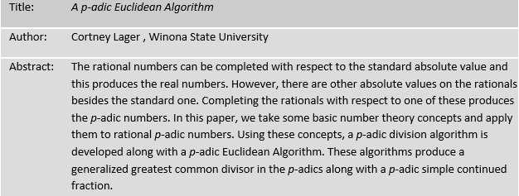

Abstract #6

Abstract #7

Abstract #8

