HyperChem 8.0.10 (Site License Version) Installation Instructions

NOTE: HyperChem is not available for Mac OS. If you want to run Hyperchem on your Mac you will need to install VMWare Fusion and run your Mac under the Windows OS. https://learn.winona.edu/VMware_Fusion

IMPORTANT: Turn off wireless before installing or launching HyperChem. Wireless will NOT work and must be turned off while using HyperChem. Plug your network cord into your computer to use HyperChem.

- Go to Start -> Run (In Windows 8, with the Start screen open type run and then click on the Run icon.
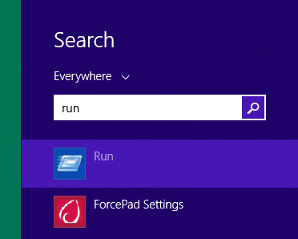

- Type in (or copy and paste): \\appsrv1\apps\hyper8install\ then click OK
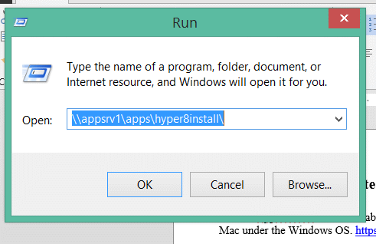

- Double click on Install_HyperChem_8.0.10
- Click OK
- Click Next
- Read the License agreement and click Yes to continue installing if you agree
- Choose StandAlone
- Click Next
- Make sure that Software-licensed is selected
- Click Next
- Enter your User Name in the User Name field (network name ex. AStudent09)
- Enter Company Name: Winona State University
- Enter (or copy and paste) Serial Number: 12-800-1591700097
- Click Next
- Review the Registration information on the screen. If everything is correct click Yes
- Enter Hypercube in the Dealer field
- Click Next
- Click Next
- Select Typical
- Click Next
- Uncheck “Yes I want to view the ReadMe file now.”
- Uncheck “Launch HyperChem 8”
- Click Finish
- Now the chem.exe file must be replaced with the site licensed version.
  - In the folder from step 1, open the folder named Site
  - Copy and Paste the chem.exe file from the Site folder to C:\Hyper80\Program. Select Copy and Replace when prompted.
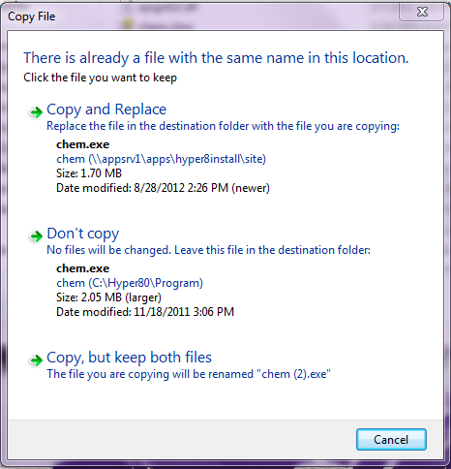
- Done.

Run HyperChem 8

When the above is done, go to start “All Programs”, find HyperChem Release 8.0 and run the “Green Beaker”-icon to start HyperChem. IMPORTANT: Turn off Wireless before Launching HyperChem.

In the future, you can copy/drag/paste the “Green Beaker”-icon as a short-cut onto your desktop for quicker access/start to HyperChem.

IMPORTANT: Turn off Wireless before Launching HyperChem.

Troubleshooting:

Problem: After installing Hyperchem you get a message like the one below on first launch

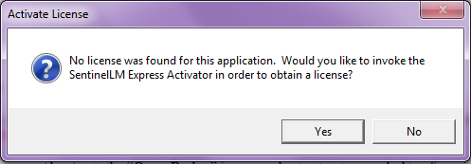

Solution: The site licensed version of chem.exe was not correctly copied to C:\Hyper80\Program. Repeat step 23 of the installation instructions.

Problem: You get the following message and HyperChem closes when you click OK.

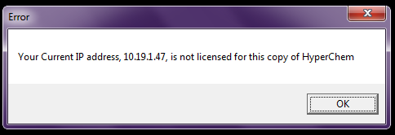

Solution 1: Make sure you have your network cable plugged in and wireless turned off. Hyperchem will only work on IP addresses that start with 199.17.xxx.xxx
Solution 2: If you have a Mac laptop running VMWare Windows 7 you MUST make sure that the network setting is set to Bridged.
- To check the setting move your mouse to the top of the screen until the vmware menu appears.
- Select Virtual Machine -> Network Adapter -> Check Bridged (Autodetect)
- Shutdown Windows and start it back up. This will ensure that Windows is using the network cable instead of wireless.

