HyperChem 8.0.10 (Site License Version) Installation Instructions Updated/revised 08/30/2013 (Ng)

Please read/understand the following before trying to install. Skip to step 23 if HyperChem is already installed.

IMPORTANT: Turn off wireless before installing or launching HyperChem. Wireless will NOT work and must be turned off while using HyperChem. Plug your network cord into your computer to use HyperChem.

- Go to Start -> Run and type in: \\appsrv1\apps\hyper8install\ Click OK or hit Enter.
- Double click on Install_HyperChem_8.0.10
- Click OK
- Click Next
- Read the License agreement and click Yes to continue installing if you agree
- Choose StandAlone
- Click Next
- Make sure that Software-licensed is selected
- Click Next
- Enter your User Name in the User Name field (network name ex. AStudent09)
- Enter Company Name: Winona State University
- Enter Serial Number: 12-800-1591700097 [Copy this number before installation so you can paste this.]
- Click Next
- Review the Registration information on the screen. If everything is correct click Yes
- Enter Hypercube in the Dealer field
- Click Next
- Click Next
- Select Typical
- Click Next
- Uncheck “Yes I want to view the ReadMe file now.”
- Uncheck “Launch HyperChem 8”
- Click Finish
- Now the chem.exe file must be replaced with the site licensed version.
  - In the folder from step 1, open the folder named Site
  - Copy and Paste the chem.exe file from the Site folder to C:\Hyper80\Program. Select Copy and Replace when prompted.
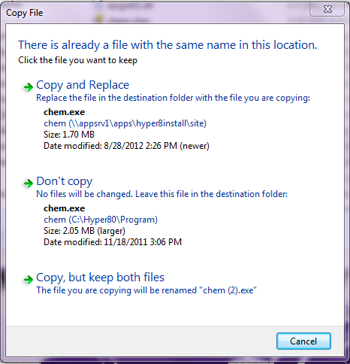
- Done.

Optional - Install Tutorials:
- Execute the Install_Tutorials from the \\appsrv1\apps\hyper8install\ folder to install Tutorials for HyperChem.
- Click Next
- Click Next
- Click Next
- Click Next
- Click Finish

Run HyperChem 8

When the above are done, go to start “All Programs”, find HyperChem Release 8.0 and run the “Green Beaker”-icon to start HyperChem. IMPORTANT: Turn off Wireless before Launching HyperChem.

In the future, you can copy/drag/paste the “Green Beaker”-icon as a short-cut onto your desktop for quicker access/start to HyperChem.

IMPORTANT: Turn off Wireless before Launching HyperChem.

Troubleshooting:

Problem: After installing Hyperchem you get a message like the one below on first launch

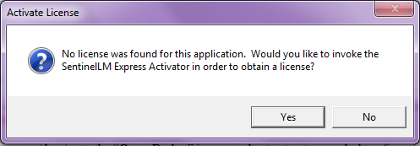

Solution: The site licensed version of chem.exe was not correctly copied to C:\Hyper80\Program. Repeat step 23 of the installation instructions.

Problem: You get the following message and HyperChem closes when you click OK.

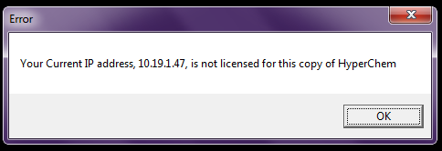

Solution 1: Make sure you have your network cable plugged in and wireless turned off. Hyperchem will only work on IP addresses that start with 199.17.xxx.xxx
Solution 2: If you have a Mac laptop running VMWare Windows 7 you MUST make sure that the network setting is set to Bridged.
- To check the setting move your mouse to the top of the screen until the vmware menu appears.
- Select Virtual Machine -> Network Adapter -> Check Bridged (Autodetect)
- Shutdown Windows and start it back up. This will ensure that Windows is using the network cable instead of wireless.

