CHEM 340, Spring 2021 Organic Chemistry Survey T. Nalli, Winona State Univ.

**Learning from Molecular Models I – Lewis Structures and VSEPR**

***Adapted from Dr. Mark Engen’s Chemistry 212 Lab Exercise***

**Textbook Reference – Chapter**

**BACKGROUND**

The detailed 3-D molecular structure of a molecule, i.e. the ”shape” is very important to determining the compound’s properties. Yet, shapes of molecules are can be difficult to visualize, partly because most basic training in geometry is limited to *plane* geometry and partly because of the difficulty of representing three-dimensional shapes on a flat sheet of paper. In this exercise you will practice drawing Lewis structures and using them to predict the shapes of some typical organic molecules, which you will then visualize with the help of molecular models.

The ability to predict molecular shape from the Lewis structure arises from the valence shell electron pair repulsion theory or **VSEPR**. This theory considers the environment of the central atom in a molecule and imagines first how the valence shell electron pairs (the VSEPs) of that central atom must be arranged in three-dimensional space around the atom to minimize repulsion among the electron pairs. The general principle is as follows: For a given number of VSEPs, the pairs will be oriented in three-dimensional space to be as *far away from each other as possible*. For example, if a central atom were to have only two pairs of valence electrons around it, the electron pairs would be expected to be 180° from each other.

The electron pairs (VSEPs) around the central atom come in two forms, **bonding pairs** (with atoms attached) and **nonbonding pairs** (lone pairs). The number of these determines the “electronic geometry” as shown in Table 1.

It is important to realize that the two electron pairs within a double bond are by, definition constrained, to the region between the two bonded atoms. In other words, they cannot be far away from each other so the four electrons involved in a double bond count as only one VSEP. Similarly, a triple bond uses 3 pairs of electrons but only counts as one VSEP when applying VSEPR theory.

It is important to distinguish between the electronic geometry of a molecule as determined by VSEPR) and the actual geometric shape of the molecule, i.e., the “molecular geometry”. For example, consider the case where the central atom has four VSEPs as in the following four molecules: hydrogen chloride, HCl; water, H2O; ammonia, NH3; and methane, CH4.



The central atom in each of these molecules is surrounded by four VSEPs and, according to VSEPR theory, these will be oriented in three-dimensional space to be as far away from each other as possible. Thus, the four electron pairs are located at the corners of a triangular pyramid or “**tetrahedron**”. <https://en.wikipedia.org/wiki/File:Tetrahedron.gif>

So in all four of these molecules the four VSEPS are tetrahedrally oriented, and are separated by bond angles of approximately 109.5° (the tetrahedral bond angle). However, because of the presence of non-bondingpairs three of the molecules are *not in actuality* tetrahedral. It is the number of both the bonding and non-bonding pairs that determines their geometry (the electronic geometry). However, lone pairs cannot beincluded in the description of the molecules’ shape, which by definition, only describes the arrangement of the atoms in the molecule.

For example, the HCl molecule could hardly be said to be tetrahedral in shape, since there are only two atoms in the molecule. HCl is linear even though the valence electron pairs of the chlorine atom are tetrahedrally oriented.

Similarly, the H2O molecule is not tetrahedral but rather is “bent” or nonlinear”, with the nonlinear shape a result of the tetrahedral orientation of the valence electron pairs of oxygen. Ammonia’s overall shape is trigonal pyramidal. Of these four molecules, only methane has both tetrahedrally oriented valence electron pairs and a molecular geometry that can be described as tetrahedral.

Figure 1. Methane, ammonia, and water structures showing both electronic geometries and molecular geometries. Copyright © 2016 John Wiley & Sons, Inc. All rights reserved.

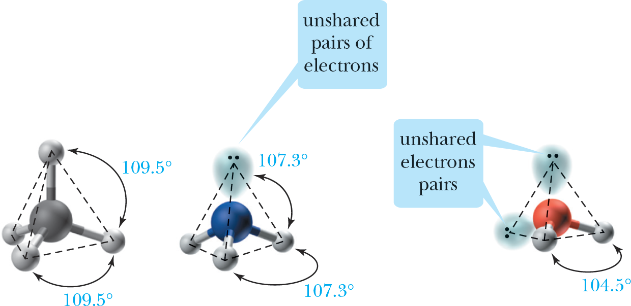

Procedure:

For the following list of molecules:

1. List the number of valence electrons.
2. Draw the Lewis structure.
3. Build Model
4. Determine the electronic geometry (use Table 1.).
5. Determine the molecular geometry (use Table 1.).
6. Sketch a representation of the models, and indicate the measured bond angles. Your sketches do not have to be fine artwork, but the overall shape of the molecule, as well as the position of all electron pairs on the central atom (both bonding and nonbonding), must bFe clear.

# Table 1.

|  |  |  |  |  |  |
| --- | --- | --- | --- | --- | --- |
| **# VSEPs** | **Electronic Geometry** | **# bonding areas** | **# lone pairs** | **Molecular Geometry** | **Drawing & Examples** |
| 2 | **linear AX2** | **2** | **0** | **linear** | **CO2** |
| 3 | **trigonal planar**  **AX3** | **3** | **0** | **trigonal planar** | **CH2O** |
| **2** | **1** | **bent** | **SO2** |
| 4 | **tetrahedral AX4** | **4** | **0** | **tetrahedral** | **CH3Br** |
| **3** | **1** | **trigonal pyramidal** | **NH3** |
| **2** | **2** | **bent** | **H2O** |
| 5 | **trigonal bipyramidal**  **AX5** | **5** | **0** | **trigonal bipyramidal** | **PCl5** |
| **4** | **1** | **see-saw** | **SF4** |
| **3** | **2** | **T-shaped** | **ClF3** |
| **2** | **3** | **linear** | **XeF2** |
| 6 | **octahedral AX6** | **6** | **0** | **octahedral** | **SF6** |
| **5** | **1** | **square pyramidal** | **BrF5** |
| **4** | **2** | **square planar**  **or**  **see-saw** | **XeF4** |

Data Sheets

Name Section Date

# MOLECULAR SHAPES AND MODELING

|  |  |  |  |  |
| --- | --- | --- | --- | --- |
| **CH4** | Lewis Structure | Electronic Geometry | Molecular Geometry | Sketch |
|  |
| Name |  |  |  |
| Valence e- |
| Polar |

|  |  |  |  |  |
| --- | --- | --- | --- | --- |
| **BeH2** | Lewis Structure | Electronic Geometry | Molecular Geometry | Sketch |
|  |
| Name |  |  |  |
| Valence e- |
| Polar |

|  |  |  |  |  |
| --- | --- | --- | --- | --- |
| **NCl3** | Lewis Structure | Electronic Geometry | Molecular Geometry | Sketch |
|  |
| Name |  |  |  |
| Valence e- |
| Polar |

|  |  |  |  |  |
| --- | --- | --- | --- | --- |
| **CH2Cl2** | Lewis Structure | Electronic Geometry | Molecular Geometry | Sketch |
|  |
| Name |  |  |  |
| Valence e- |
| Polar |

|  |  |  |  |  |
| --- | --- | --- | --- | --- |
| **CH2O** | Lewis Structure | Electronic Geometry | Molecular Geometry | Sketch |
|  |
| Name |  |  |  |
| Valence e- |
| Polar |

|  |  |  |  |  |
| --- | --- | --- | --- | --- |
| **BH3** | Lewis Structure | Electronic Geometry | Molecular Geometry | Sketch |
|  |
| Name |  |  |  |
| Valence e- |
| Polar |

|  |  |  |  |  |
| --- | --- | --- | --- | --- |
| **CO2** | Lewis Structure | Electronic Geometry | Molecular Geometry | Sketch |
|  |
| Name |  |  |  |
| Valence e- |
| Polar |

|  |  |  |  |  |
| --- | --- | --- | --- | --- |
| **C2H6** | Lewis Structure | Electronic Geometry | Molecular Geometry | Sketch |
|  |
| Name |  |  |  |
| Valence e- |
| Polar |

|  |  |  |  |  |
| --- | --- | --- | --- | --- |
| **CH3OH** | Lewis Structure | Electronic Geometry | Molecular Geometry | Sketch |
|  |
| Name |  |  |  |
| Valence e- |
| Polar |

|  |  |  |  |  |
| --- | --- | --- | --- | --- |
| **HCN** | Lewis Structure | Electronic Geometry | Molecular Geometry | Sketch |
|  |
| Name |  |  |  |
| Valence e- |
| Polar |

|  |  |  |  |  |
| --- | --- | --- | --- | --- |
| **C2H4** | Lewis Structure | Electronic Geometry | Molecular Geometry | Sketch |
|  |
| Name |  |  |  |
| Valence e- |
| Polar |

|  |  |  |  |  |
| --- | --- | --- | --- | --- |
| **N2H4** | Lewis Structure | Electronic Geometry | Molecular Geometry | Sketch |
|  |
| Name |  |  |  |
| Valence e- |
| Polar |

|  |  |  |  |  |
| --- | --- | --- | --- | --- |
| **H2SO4** | Lewis Structure | Electronic Geometry | Molecular Geometry | Sketch |
|  |
| Name |  |  |  |
| Valence e- |
| Polar |

|  |  |  |  |  |
| --- | --- | --- | --- | --- |
| **C3H4** | Lewis Structure | Electronic Geometry | Molecular Geometry | Sketch |
|  |
| Name |  |  |  |
| Valence e- |
| Polar |