CHEM 351, Spring 2017 Principles of Organic Chemistry II Lab Prof. T. Nalli, WSU

Learning from Molecular Models - The Diels-Alder Cycloaddition Reaction

Textbook Reference – Klein - chapter 17.1-17.2, 17.6-17.8

Overview

This work sheet introduces the Diels-Alder 4+2 cycloaddition reaction of a diene with a dienophile to form a cyclohexene ring. Models will demonstrate the geometric requirements for the diene, the stereospecificity of the reaction, and the endo selectivity principle.

Introduction

A Diels-Alder reaction in its simplest form is shown below. Although this specific reaction does not work well, it will be useful to examine it with models so that some basic principles can be learned.

(1)

Characteristics of Diels-Alder Reactions

1. Identify the bonds broken and formed in a Diels-Alder reaction. (Use eq 1 as an example.) Based on the bond strengths of these bonds are Diels-Alder reactions ordinarily exothermic or endothermic?

Several lines of experimental evidence (the instructor will present some of these in the lab) indicate that the Diels-Alder reaction has a concerted mechanism (a single step).

2. Use curved arrows to show electron flow in the above Diels-Alder reaction (eq 1).

3. Using dotted lines to represent partial bonds, draw a representation of the transition state of a Diels-Alder reaction. Identify some unique characteristics of this TS.

Geometric Requirement for the Diene in a Diels-Alder Reaction

Make models of the reactants, 1,3-butadiene (the diene) and ethene (the dienophile), and of the product, cyclohexene (the cycloadduct). Notice that the diene has two different planar conformers that result from rotation of the C-C single bond. It is well established that the planar conformations are the energy minima for single bond rotation in 1,3-butadiene.

4. Draw these two planar conformations showing all hydrogens.

5. Draw a PE diagram for rotation of the C2-C3 bond in 1,3-butadiene.

6. Why are the planar conformations energy minima?

One of the butadiene conformations is referred to as the s-cis conformer and the other as the s-trans conformer.

7. Why would it be improper to simply refer to these conformations as cis and trans?

Try to simulate the basic Diels-Alder reaction (eq 1) using your models. First try the s-cis conformer of the diene, then try the s-trans conformer. Remember that the mechanism is concerted, so all bonds being formed have to be formed simultaneously.

8. Which conformation of the diene works better in your attempted simulation? Can you generalize as to what types of dienes (conformation wise) are most reactive in Diels-Alder reactions?

Now make models and examine the s-cis conformations of the three stereoisomers of 2,4-hexadiene shown below.
9. Draw each of the above molecules in its s-cis conformation. (They are all shown as s-trans above.)

10. In which isomer is the s-cis conformation least strained? In which isomer is the s-cis conformation most strained? Explain.

11. The instructor will build models and carry out MO calculations on each of the 2,4-hexadiene conformers. Label the structures (drawn above) with the MO minimized energy value for each. Use the energy difference between the s-cis and s-trans for each stereoisomer pair as an approximation of ∆G for the bond rotation that interconverts the two. The ∆G determines the equilibrium constant for a reaction. (see Klein p 247). Calculate equilibrium constants for bond rotation.

12. In which of these stereoisomers does the highest percentage of the molecules exist as s-cis? Make a table that shows the percentage of each conformation for all three stereoisomers.

13. Predict the order of reactivity of the 2,4-hexadiene stereoisomers in Diels-Alder reactions.

14. α-Phellandrene and its closely related isomer, β-phellandrene, are fragrant compounds that occur naturally in the oils from various plants. One is very reactive as a Diels-Alder diene while the other is completely unreactive. Explain.
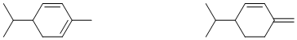

α-Phellandrene β-phellandrene

15. 1,3-Cyclopentadiene is a particularly reactive diene. Explain why.
Stereospecificity with Respect to the Diene

Now consider the reaction of each of the three 2,4-hexadiene stereoisomers with ethylene to form 3,6-dimethylcyclohexene.

16. Show an equation for this reaction (neglecting stereochemistry) in the space below.

Note that the product of the above reaction can exist as a cis or a trans isomer. Simulate the reaction with models as before, remembering it is concerted,

17. Which isomer(s) of the product would be formed if the cis, cis isomer of the diene reacted with ethene? (cis, trans, or both?)

18. Which isomer(s) of the product would be formed if the trans, trans isomer of the diene reacted with ethene? (cis, trans, or both?)

19. Which isomer(s) of the product would be formed if the cis, trans isomer of the diene reacted with ethene? (cis, trans, or both?)

20. Summarize your findings with respect to questions #16-18 using chemical equations to show the structures of the reactants and products in these three reactions.

Notice that each stereoisomer of the reactant diene gives a specific stereoisomer of the product. A reaction of this type is called a stereospecific reaction. Diels-Alder reactions are stereospecific in that the stereochemistry of the diene is maintained.

Stereospecificity with Respect to the Dienophile

Now take the methyl groups off your hexadiene models reforming the original butadiene model that we were working with at the start of the lab. Substitute the methyl groups for hydrogens on your ethene model so that you now have a model of cis-2-butene.

Simulate a Diels-Alder reaction of cis-2-butene with 1.3-butadiene to form 4,5-dimethylcyclohexene. Note that this product can exist as a cis or a trans isomer.

21. Which isomer(s) of the product would be formed by this reaction? (cis, trans, or both?)

Repeat the previous simulation using trans-2-butene.

22. Which isomer(s) of the product would be formed this reaction? (cis, trans, or both?)

23. Summarize your findings with respect to questions #20 and 21 using chemical equations to show the structures of the reactants and products in these two reactions.

What you have just seen is that Diels-Alder reactions are also stereospecific in the sense that the stereochemistry of the dienophile is maintained.

Endo Selectivity

1,3-Cyclopentadiene is so reactive as a diene that it reacts with another molecule of itself to form a compound commonly called dicyclopentadiene (see equation below). In this reaction, one molecule of the cyclopentadiene plays the role of the diene, while the other acts as the dienophile. (This reaction happens readily at room temperature. Therefore, pure samples of 1,3-cyclopentadiene to be used for other purposes need to be prepared just before use as they do not keep well.)
Make two models of 1,3-cyclopentadiene and simulate the Diels-Alder reaction described above. You should note well that there are two distinct possibilities for how the diene and dienophile approach each other in this reaction. To see these, focus on the double bond that is not involved in the reaction (in the dienophile). Picture the diene to be approaching from on top of the dienophile. The non-reacting double bond can either be directly below C2 and C3 of the diene (endo approach) or it can be closer to the CH₂ of the diene (exo approach) as
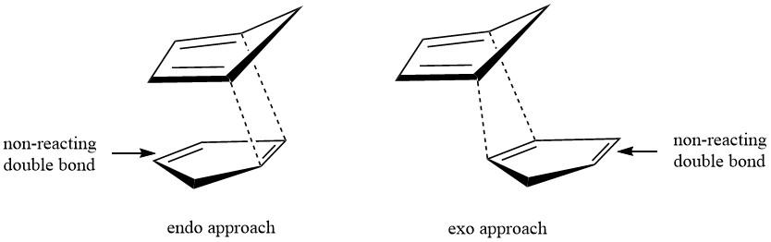
depicted below.

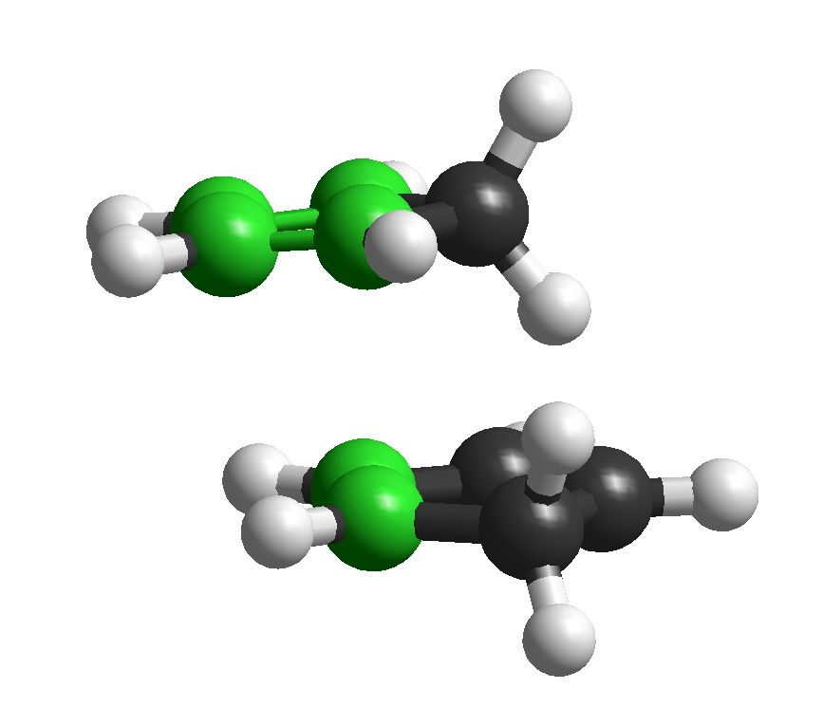
Alternatively, one may visualize the reaction using ball and stick models as shown below with the reacting carbons highlighted in green.
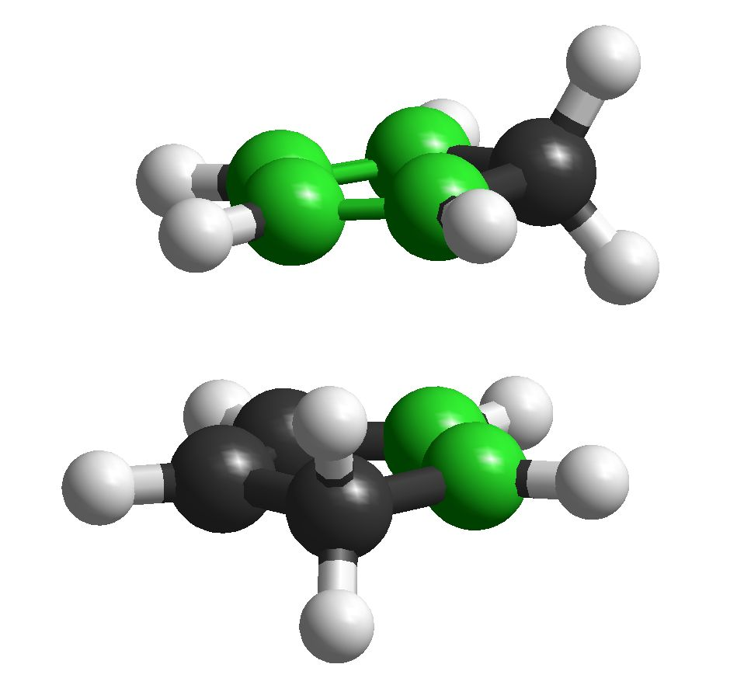

endo approach exo approach

Now make models of the resulting dicyclopentadiene products, both exo and endo, and examine them for any kinds of strain present.

24. Draw structural representations of the exo and endo isomers showing clearly the stereochemical aspects that distinguish them.

25. Which isomer of dicyclopentadiene is less strained? Explain why by diagraming strain interactions in the structures you drew above.

26. The endo product is usually the predominant product (usually on the order of 80-90%). Given this fact, is the reaction under thermodynamic or kinetic control? Explain and draw a potential diagram for the reaction.

27. Draw out approximations of the transition states for both endo and exo approach by copying the above diagrams and drawing in the p orbitals of the reacting pi bonds.

28. Use the transition state diagrams you just drew to explain why endo products are formed faster than exo products.

Additional Questions

Give the structure of the main product of each of the following Diels-Alder reactions. Make sure to show the stereochemistry of the products when unambiguous.
29.

30.

31.

32.

33.

34.

