CHEM 340, Spring 2023 Organic Chemistry Survey T. Nalli, Winona State Univ.

Learning from Molecular Models I – Lewis Structures, VSEPR, and Molecular Polarity

The detailed three-dimensional molecular structure of a molecule, i.e. the ”shape” is very important to determining the compound’s properties. Yet, shapes of molecules can be difficult to visualize, in part because of the difficulty of representing 3-D shapes on a flat sheet of paper. In this exercise you will practice drawing Lewis structures and using them to predict the shapes of some typical small molecules, which you will then visualize with the help of molecular models.

VSEPR Theory. The prediction of molecular shape from the Lewis structure is made possible by valence shell electron pair repulsion theory (VSEPR). This theory looks at the valence shell electron pairs (VSEPs) around the central atom in a molecule and posits that they will be arranged in three-dimensional space around that atom in a manner that minimizes the electron-electron repulsion between them. The general principle is simple: the VSEPs will be oriented in 3-D space to be as far away from each other as possible. For example, a central atom with only two VSEPs will situate them directly opposite from each other in a linear arrangement. A central atom with three VSEPs however will need to have its VSEPs closer together, causing a triangular arrangement. Thus, it is the number of VSEPs that is the primary determinant of molecular geometry.

Counting VSEPs. The electron pairs (VSEPs) around the central atom come in two forms, bonding pairs (with atoms attached) and nonbonding pairs (lone pairs). The number of these determines the “electronic geometry” as shown in Table 1. It is important to realize that the two electron pairs within a double bond are, by definition, constrained to the region between the two bonded atoms. In other words, they cannot be far away from each other so the four electrons involved in a double bond count as only one VSEP. Similarly, a triple bond uses 3 pairs of electrons but only counts as one VSEP when applying VSEPR theory. To summarize, each lone pair counts as one VSEP and each bond (be it a single, double or triple bond) counts as one VSEP.

Electronic Geometry vs Molecular Geometry. It is important to distinguish between the electronic geometry of a molecule and the actual geometric shape of the molecule, i.e., the “molecular geometry”. For example, consider the case where the central atom has four VSEPs as in the following four molecules: hydrogen chloride, HCl; water, H2O; ammonia, NH3; and methane, CH4.

The central atom in each of these molecules is surrounded by four VSEPs and, according to VSEPR theory, these will be oriented in three-dimensional space to be as far away from each other as possible. Thus, the four electron pairs are located at the corners of a triangular pyramid or “tetrahedron”. https://en.wikipedia.org/wiki/File:Tetrahedron.gif

So, in all four of these molecules the four VSEPS are tetrahedrally oriented, and are separated by angles of approx 109.5° (the tetrahedral bond angle). However, because of the presence of non-bonding pairs three of the molecules are not in actuality tetrahedral. It is the number of both the bonding and non-bonding pairs that determines their geometry (the electronic geometry). However, lone pairs cannot be included in the description of the molecules’ shape, which, by definition, only describes the arrangement of the atoms in the molecule.

For example, the HCl molecule could hardly be said to be tetrahedral in shape, since there are only two atoms in the molecule. HCl is linear even though the valence electron pairs of the chlorine atom are tetrahedrally oriented.

Similarly, the H2O molecule is not tetrahedral but rather is “bent” or nonlinear”, with the nonlinear shape a result of the tetrahedral orientation of the valence electron pairs of oxygen. Ammonia’s overall shape is trigonal pyramidal. Of these four molecules, only methane has both tetrahedrally oriented valence electron pairs and a molecular geometry that can be described as tetrahedral.

Figure 1. Methane (CH₄), ammonia (NH₃), water (H₂O), and hydrogen chloride (HCl) structures showing molecular geometries.
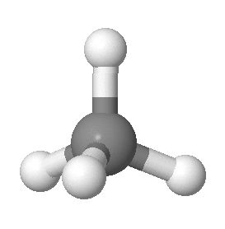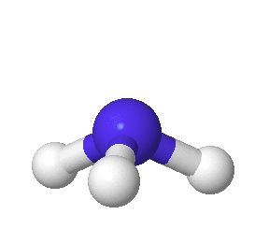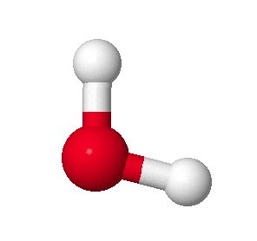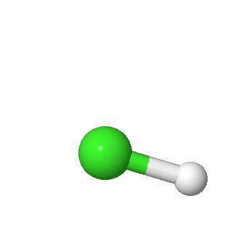

Molecular Polarity. Knowledge of the molecular geometry of a molecule in conjunction with the concept of bond polarity due to electronegativity differences between the bonded atoms allows the qualitative prediction of the molecular polarity of the compound. Please see one of the following references for an explanation.
Molecular Polarity - ww.khanacademy.org/science
www.tutor-homework.com/Chemistry_Help/Molecular_Geometry/Polar_Or_Nonpolar.html

Procedures. Draw a Lewis structure for each compound on the accompanying worksheet. Predict the electronic geometry using VSEPR theory. Build a model of the compound using “empty holes” as lone pairs. Draw out and describe the molecular geometry of the molecule/model labeling the approximate bond angles. Finally, indicate the presence of any bond dipoles using vector arrow and predict the overall molecular polarity.

Table 1 – Note: for #bonds single =1 , double = 1, triple =1
#bonds | # lone pairs | #VSEPs | Electronic  Geometry | # lone pairs | Molecular Geometry | Examples
2 | 0 | 2 | linear  180°, sp | 0 | linear | HCN, CO₂
3 | 0 | 3 | trigonal planar  120°, sp² | 0 | trigonal planar | CH₂O
2 | 1 |  |  | 1 | bent (not linear) | SO₂
4 | 0 | 4 | Tetrahedral  109.5°, sp³ | 0 | tetrahedral | CH₃Br
3 | 1 |  |  | 1 | trigonal pyramidal  (not planar) | NH₃
2 | 2 |  |  | 2 | bent (not linear) | H₂O
5 | 0 |  | trigonal bipyramidal  90°, 120°, sp³d | 0 | trigonal bipyramidal | PCl₅
4 | 1 |  |  | 1 | see-saw | SF₄
3 | 2 |  |  | 2 | T-shaped | ClF₃
2 | 3 |  |  | 3 | linear | XeF₂
6 | 0 | 6 | Octahedral  90°, sp³d² | 0 | octahedral | SF₆
5 | 1 |  |  | 1 | square pyramidal | BrF₅
4 | 2 |  |  | 2 | square planar  or  see-saw | XeF₄

