351 Organic Chemistry II Winona State University
Exam #2, March 3, 2017 Professor T. Nalli

Name__________________________________________

General Instructions: Write your name in the space provided above and on the provided Scan-tron form. Do not put your name anywhere else in this exam book.

Time limit is 55 min.

Grading: Grading will be on the basis of a highest possible score of 100 points.

I. Multiple Choice – 2 points each, 30 points total

II. Nomenclature – 2 points each, 10 points total

III. Reaction Products - 4 points each, 40 points total

IV. Synthesis - 5 points each, 10 points total

VI. Mechanism – 10 points

1. Which pentadiene isomer is the most stable?
A. 1,2-pentadiene B. (3E)-1,3- pentadiene C. (3Z)-1,3- pentadiene D. 1,4- pentadiene

2. Which of the following statements about benzene is incorrect?
A. All twelve atoms lie in the same plane.
B. The C-C bonds alternate in length between long and short.
C. All of the carbon atoms are sp² hybridized.
D. The molecule is a hybrid of two resonance forms.

3. Which of the following reacts with HNO₃/H₂SO₄ at the slowest rate?
A. PhCH₃ B. PhOEt C. PhCl D. PhSO₃H E. PhN(Me)₂

4. Which of the choices to #3 reacts the fastest?

5. Which of the following is the strongest acid?
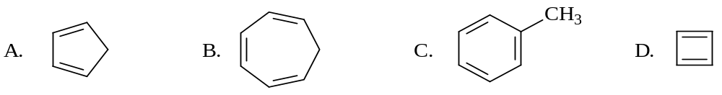

6. Which of these undergoes the fastest reaction with ethanol to form the ethoxy substituted compound (ROTs → ROEt)?

Refer to the following structures for questions 7-9.

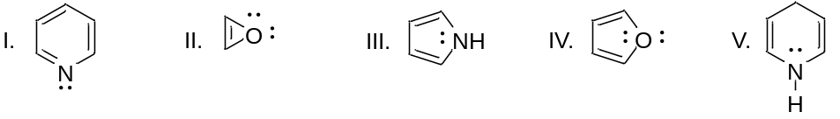

7. Which structure(s) is(are) aromatic?

A. I only B. I and III C. III and IV D. I, III, and IV E. II, III, and V

8. Which structure(s) is(are) antiaromatic?

A. II only B. I and II C. II and III D. I and IV E. I, III, and V

9. Which structure is not aromatic because it is not fully conjugated?

A. I B. II C. III D. IV E. V

10. How many nodes are present in the LUMO of octa-1,3,5,7-tetraene?

A. none B. 1 C. 2 D. 3 E. 4

11. Which of the following pairs of terms correctly characterize Diels-Alder reactions.

A. endothermic (∆H > 0) and entropically unfavorable (∆S < 0)

B. endothermic (∆H > 0) but entropically favorable (∆S > 0)

C. exothermic (∆H < 0) but entropically unfavorable (∆S < 0)

D. exothermic (∆H < 0) and entropically favorable (∆S > 0)

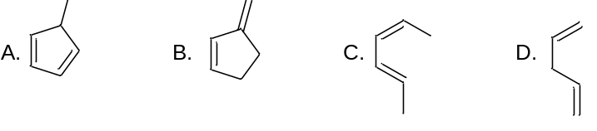12. Which of these is most reactive as a diene in Diels-Alder reactions?

13. Which of these is most reactive as a diene in Diels-Alder reactions?

14. Which dienophile is most reactive in Diels-Alder reactions?

A. CH₂=CH-CH₂SH B. CH₂=CH-CH₃ C. CH₂=CH-CN D. CH₂=CH-OCH₃

15. Which molecule reacts fastest with hydroxide ion in an S_{N}Ar mechanism?
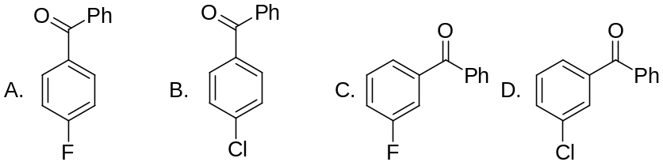

II. (a) Give the structure of each of the following compounds in the space provided below the names.
o-iodoaniline 2,6-di-tert-butylphenol m-chloroanisole

II.(b) Name each of the following.
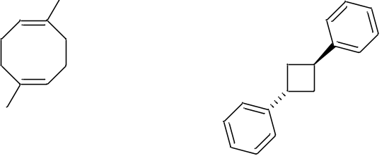
III. Give the structure of the major organic product(s) of each of the following reactions.
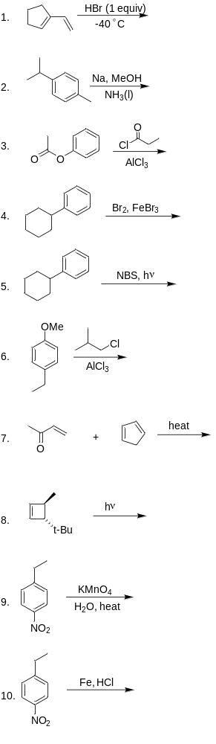
III. Write a sequence of reactions that shows how the compounds shown below could be synthesized in good yield starting with benzene.
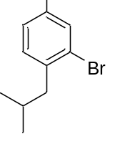

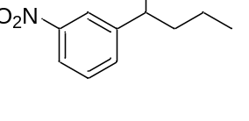

V. Write out the mechanism for the reaction shown using curved arrows to show electron flow. Show all key resonance structures of the intermediates.



