Name:_______PRACTICE TEST _________________
Anatomy and Physiology Final Exam
Unit Test 25 points USE A CLEAN SCANTRON FOR THE UNIT TEST
Multiple Choice: Choose the one best answer and put the answer on your scantron.
1) Which of the following is not associated with inflammation?
a) Heat, Pain, Redness, Swelling
b) Calor, dolor, rubor, tumor
c) Swelling that is cold to the touch
d) Cell including Macrophages and Neutrophils

2) Which type of the immune system is acquired based on prior exposures?
a) Avoidance response
b) Innate response
c) Antibody production
d) All of above

3) The _______phase of digestion is used to stimulate formation of stomach acids, create saliva and prepare the stomach to receive food.
a) Intestinal b) Cephalic c) Gastric

4) The vermiform appendix is attached to the cecum, if it were infected (appendicitis) you would typically expect pain on the ______side of the abdomen?
a) Right side b) Left Side

5) After consuming a super size French fries and a Big Mac for lunch, what carries most of the fat to the body?
A) Chylomicron B) Fatty acids dissolved in plasma C) Macrophages D) All of above

6) The acidity of the stomach leads to the formation of ________which enzymatically digests protein, this same acidity turns off (inactivates) a digestive enzyme called______.
a) Ligual amylase, Lactate dehydrogenase b) Lysozyme, Adenylyl cyclase c) Pepsin, Lingual amylase d) Insulin, Carbonic anhydrase e) Glycogen, Myosin kinase

7) The presence of food in the stomach and stretching of the stomach wall by food causes a set of cells of the stomach to secrete _____ to improve acid secretion and digestion.
a) Gastrin b) Serosa c) Lysozyme d) Polyps e) Glucagon

8) All of the following directly contribute to the absorptive surface area of the small intestine except…
a) circular folds b) villi c) gastric rugae d) its length

9) Saliva contains many things, but ________is the protein constituent and _________ is an enzyme that digests triglycerides in the acidic stomach..
a) Water, Bicarbonate b) Potassium, Mucus c) Bicarbonate, Pepsin
d) Lysozyme, trypsinogen e) Mucus, Lingual lipase

10) To chew corn-on-the-cob you would use you front _________ (teeth) to cut the corn off the cob.
a) Molars b) Premolars c) Incisors d) Alveolars e) Occlusals

11) The ____is a large pocket that is the first segment of the large intestine.
a) Ileocecal b) Cecum c) Ileum d) Duodenum e) Jejunum

12) The contraction of ________permits the movement of chyme distally.
a) Skeletal muscle b) Smooth muscle

13) The epithelial cells of the intestinal mucosa must be replaced (they have a high mitotic index) ABOUT every __________, this poses a major problem for folks undergoing chemotherapy for cancer or folks who have been exposed to lethal doses of radiation.
a) 5-7 minutes b) 5-7 hours c) 5-7 days d) 5-7 weeks e) Never

14) The _______is the region of the intestine with the highest rate of intrinsic autorhythmicity and the ________is the region has that has the slowest rate.
a) Colon, Fundus b) Ileum, Gallbladder c) Rectum, duodenum d) Duodenum, Colon

15) If bile could not be released from the gallbladder (and liver) because your hepatopancreatic sphincter was blocked by a gallstone, your feces would probably look ______in color and your skin might begin to look ______in color.
a) Orange, Brown b) Brown, Grey c) Grey, Orange d) Grey, Brown

16) _______are small finger-like structures on the individual simple columnar epithelial cells that line your intestine.
a) Polyps b) Rugae c) Haustra d) Micovilli e) Peristalsis

17) Which component of saliva is used to control acids created by bacteria?
a) Mucin b) Lingual amylase c) Bicarbonate d) Lysozyme

18) In terms of pancreatic secretions, insulin is an _______secretion and trypsinogen is an________________secretion.
a) Endocrine, Endocrine b) Exocrine, Endocrine c) Endocrine, Exocrine d) Exocrine, Exocrine

19) If you wanted to remove cholesterol from your body you could eat a diet rich in a kind of indigestible polysaccharide called__________________that is found in oatmeal.
a) Fiber b) Starch c) Glycogen d) All of above

20) Which of the following is not a function of the stomach.
a) Destroy bacteria in food b) Activate pepsinogen c) Mix chyme
d) Produce large amounts of hydrochloric acid e) Digest carbohydrates

21) What “bad” type of particle delivers cholesterol from the liver to the body?
a) Chylomicron b) Low Density Lipoprotein c) High Density Lipoprotein d) Albumin

22) ________is a digestive enzyme produced by the pancreas to help digest protein and __________ is a digestive enzyme produced by the cells of the small intestine to help digest carbohydrates.
a) Trypsinogen, Amylase b) Typsin, Lingual lipase c) Amylase, Carbonic anhydrase
d) Amylase, Lactase e) Enterokinase, Procarboxylpeptidase

23) ______________and _______________are two things the liver does NOT create or do?
a) Create digestive Enzymes and Fiber b) Create Bile salts and Bilirubin
c) Create bicarbonate and lecithin d) Create bicarbonate and recycle bile from enterohepatic circulation
e) Regulate blood glucose and create plasma proteins

24) Which of the following is not associated with the colon?
a) Haustra b) Absorption of bile salts c) Absorption of water
d) Absorption of carbohydrates e) Delivery of blood into hepatic portal vein

25) Tiny ________carry blood towards the central vein of each liver lobule.
a) Sinusoids b) Portal veins c) Canaliculi d) Arterioles

Unit Test Extra Credit: 2 points on the Back of the Scantron
What happens if you eat a greasy Whopper from Burger King with double cheese (lots of triglycerides)?
Start at the mouth, discuss digestion and end up discussing defecation at the anus.
Creating a sketch with arrows to these items/functions/locations may help you do this.

Name:____________________Comprehensive Test: 50 points Use a second clean scantron for this second part of the final exam.Multiple Choice (1 pt each): Choose the one best answer for each question and circle it on this test . Please double check your scantron for “smears”; get a clean scantron if you are unsure.

1) If you lost a large amount of blood due to having a leg cut-off, your adrenal gland would secrete a steroid called ________. This helps the posterior pituitary would secrete a peptide called ______. This directly or indirectly increases _________reabsorption in the collecting duct.
a) Testosterone, Erythropoietin, Potassium
b) Cortisone, Acetycholine, Sodium
c) Atrialnatiuretic factor, Epinephrine, Glucose
d) Aldosterone, Vasopressin (ADH), Water

2) A _______hormone (for example epinephrine or oxytocin) is a hormone secreted at the endings of special axons directly into the blood. a) Autocrine b) Endocrine c) Paracrine d) Exocrine e) Neuroendocrine

3) Persons without beta-cells in their pancreatic islets …….
a) Often have hypotension b) Cannot produce insulin
c) Have fewer adipocyte insulin receptors d) Do not respond to insulin normally

4) Specific hormones can bind specific receptors on target cells and activate g-proteins and phospholipase that create _____________inside the cell which causes special _________channels to open leading to smooth muscle contraction.
a) inositol triphosphate (IP₃), calcium b) Phosphodiesterase, Protein kinase
c) calcium, cAMP d) cAMP, dilation

5) The anterior pituitary secretes a hormone called _________that could increase body temperature.
a) Gonadotropin releasing hormone b) Thyrotropin c) Prolactin d) Antidiuretic hormone

6) Which pair of peptide hormones would have an antagonistic (opposite) effect relative to each other in the kidney?
a) Aldosterone and Angiotensin II b) Estrogen and Testosterone
c) Angiotensin II and Atrial natriuretic factor d) Luteinizing and Follicle stimulating hormones
e)All of above are antagonistic

7) Activation of the ______adrenergic receptor on a smooth muscle cell by epinephrine or norepinephrine would help improve airflow into your lungs if you had asthma.
a) Beta-1 b) Beta-2 c) Beta-3 d) Alpha-1 e) Alpha-2

8) Your hematocrit would probably become higher (30% 50%) if….
a) your kidney released more erythropoietin. b) you were very dehydrated c) you lived at high altitude d) you excreted excess amounts of sodium in your urine e) All of above

9) Which aspect of hemostasis does not occur after a cut?
a) Formation of fibrin b) Platelet degranulation c) Contraction of smooth muscle
d) Formation of plasmin e) All of above occur after a cut

10) Which cells would NOT become far more permeable to glucose (insulin sensitive) if insulin was present?
a) Brain cell b) Liver cells c) Adipocytes d) Skeletal muscle

11) Which organ does NOT secrete steroid hormones?
a) Adrenal cortex b) Pancreas c) Testicle d) Ovary e) All secrete steroid hormones?

12) When Dr Wilson hyperventilated (breathing rapidly and deeply), he became dizzy because his hemoglobin binding curve shifted to the left, causing hemoglobin to __________________during this demonstration.
A) have an increased oxygen binding affinity B) have a low oxygen binding affinity.
13) What ECG wave represents the electrical signature of ventricular repolarization?
a) T b) S c) R d) Q e) P

14) What structures permit all the cells of the myocardium to function as an electrical syncitium?
a) Gap junctions b) Synapses c) Desmosomes d) All of above

15) Failure of which ventricle would be most likely to cause fluid accumulation in the lung.
a) Left b) Right

16) Which of the following would NOT help a person compensate for anaphylactic shock?
a) Skeletal muscle pumping of venous blood b) Epinephrine release c) Vasoconstriction
d) Bradycardia e) Drinking water

17) During the ____phase of a cardiac cycle ventricular pressure is stable and volume is being reduced.
a) Ejection b) Diastolic c) Isovolumetric relaxation d) Isovolumetric contraction

18) If the radius of your large arteries was increased too much (vasodilation and syncope), blood flow might still be maintained in these arteries if the_________.
a) Tissue around vena cava cooled down b) Pressure gradient changed from 60 to 100 mmHg
c) Stroke volume changed to 140 ml d) they perform a valsalva maneuver (contract abdominal muscle)
e) All could help you maintain blood flow in the same arteries
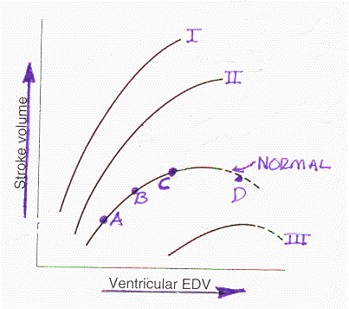
19) If you were at point “B” (See Above), if your end diastolic volume (EDV) decreased, your Frank-Starling curve would change to what point/shape/relationship, resulting in a ______in your cardiac output (heart rate is unchanged).
a) Curve I, Increase b) Curve III, Decrease c) Point A, Decrease d) Point C, Increase e) Point D, Decrease

20) If you started at point “B”, and had a scare (stimulation of sympathetic nervous system), what point or curve would you probably move to? a) A b) B c) II d) III

21) _______refers to a condition where you have a shortness of breath.
a) Anoxia b) Hyperemia c) Hypoxia d) Dyspnea

22) Oxygen in an alveoli would reach the blood in a capillary more rapidly if…..
a) Alveolar pO₂ was 90 mmHg and the pO₂ in the blood was 20 mmHg
b) Alveolar pO₂ was 110 mmHg and the pO₂ in the blood was 80 mmHg

23) Things that decrease the heart contractility (force of contraction) are said to have a _____effect because they ______ the intracellular calcium concentration of cardiac myocytes during depolarization.
a) Negative inotropic, Decrease b) Positive inotropic, Increase
c) Negative chronotropic, Decrease d) Positive chronotropic, Increase

24) What type of pneumothorax is characterized by the presence of a hole that serves as a one-way valve in the wall of the thorax? a) Closed b) Tension c) Open d) Any of above

25) Consider the CO₂ produced in an active tissue, how does it reach the lung?
About _____% of the CO₂ is turned into water soluble bicarbonate, _____% of the CO₂ dissolves in blood, about ___ % of the CO₂ is carried by hemoglobin.
a) 70%, 7%, 23% b) 7%, 23%, 70% c) 7%, 70%, 23% d) 70%, 23%, 7%

26) A short but healthy person (4 foot tall and 75 lbs) would probably have a tidal capacity, inspiratory reserve, expiratory reserve and vital capacity of about what?
a) TV=1L IRV= 4 L ERV=3 L VC= 8 L
b) TV=0.3 L IRV=1.5L ERV=1 L VC=2.8 L
c) TV=0.5 L IRV=3 L ERV=1.5 L VC=5 L
27) Which of the following is NOT a blood vessel that delivers oxygenated blood to your heart?
a) Circumflex b) Left Anterior Descending c) Right common coronary d) Vena cava e) Pulmonary veins

28) Almost all gas exchange occurs in what type of blood vessel and what lung structure?
a) Artery, Bronchiole b) Arteriole, Bronchi c) Capillary, Alveolus
d) Venule, Lymphatic duct e) Vein, Trachea

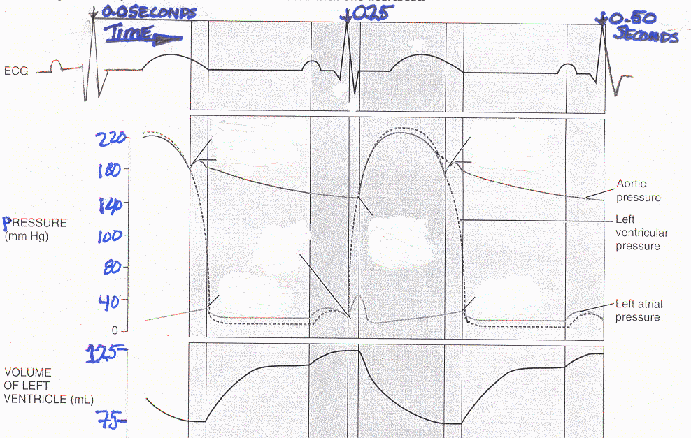
29) See Above: What is the cardiac output for this heart? (it will help to write out the math)
a) About 2.4 L/minute b) 4.8 L/minute c) About 12 L/minute b) About 24 L/minute
1 beat = 0.25 sec or 4 beats = 1 second or 4beats/sec X 60 sec/min = 240 beats/min
Stroke Volume = 125 ml- 75 ml = 50 ml Cardiac Output = 50 ml/beat X 240 beats/min = 12 Liters/minute
30) See Above: What is the approximate mean arterial pressure for this person? (it will help to write out the math)
a) 75 mmHg b) 125 mmHg c) 173 mmHg d) 222 mmHg e) Cannot determine with info given
MAP=(SystBP-DiastBP)/3 + Diast BP = ABOUT (220-150)/3 + 150 = 70/3+150 = 23 + 150 = 173mmHg
31) If you weighed 155 pounds and totally healthy, and had a tidal volume of 0.8 L, your breathing rate would probably be……
a) Slower than normal b) Normal c) Faster than normal

32) The typical person with two healthy kidneys produces about ____liters of glomerular filtrate/day and ____liters of urine per day. a) 180, 1.5 b) 90, 3 c) 180, 0.2 d) 125, 3

33) Which of the following prevents micturition (urination)?
a) Contraction of detrusser muscle of bladder
b) Contraction of the internal urethral sphincter
c) Contraction of the external urethral sphincter
d) B and C both prevent micturition

34) The glomerular filtration rate is autoregulated if your mean blood pressure is between about 60 and 150 mmHg. a) True b) False

35) If a tissue was swollen, cool to the touch, and “pitting” was observed after you pushed on it with your finger, this swelling would be called what?
a) Edema b) Inflammation c) Hemopoiesis

36) Decreasing the blood pressure in the capillaries of a sprained ankle would promote what?
a) Reabsorption and reduced swelling b) Filtration and increased swelling

37) If a short person produced 100 liters of glomerular filtrate in one day, how many liters of urine would you produce if you reabsorbed 90 percent of the GFR (assume hyperglycemia and glucouria)?
a) 1.0 L b) 2.0 L c) 5 L d) 10 L d) 20 L

38) Reabsorption of _______provides the best ability to increase water reabsorption in the gut or kidney.
a) Sodium b) Potassium

39) If you had metabolic acidosis and had to chronically remove large amounts of protons from the blood to keep your blood pH normal what organ system would be the best and last way to remove the excess protons (H+)?
a) Chemical buffers b) Respiratory system c) Kidney d) Liver

40) The most abundant cation in the intracellular fluid is_______and the most common cation in the blood plasma is _____________, this is critical for determining the cells membrane potential.
a) Calcium, Chloride b) Potassium, Sodium c) Sodium, Potassium d) Chloride, Phosphate

41) Assume you had severe hypotension and your body attempted to maintain blood pressure homeostasis by using angiotensin. The angiotensin I is converted to angiotensin II in the ______ by an enzyme called_____.
a) Kidney, Renin b) Lung, ACE c) Liver, Angiotensinogen d) Blood, Renin

42) Aldosterone, Cortisol, and Epinephrine are all secreted into the blood by what organ/gland to “help” you manage stress during Final Exams?
a) Adrenal gland b) Kidney c) Pituitary d) Pancreas

43) Which section of the kidney is permeable to glucose?
a) Proximal convoluted tubule b) Descending Loop c) Ascending Loop
d) Distal convoluted tubule e) Collecting duct

44) In the kidney, the vasa recta run deep into the _______and are most important when you are_______.
a) Cortex, Well hydrated b) Cortex, Dehydrate c) Medulla, Well hydrated d) Medulla, Dehydrated

On the back of the scantron 6 points (3 X 2 pts points)
If your arm was severed (cut off) and you lost 3 liters of blood prior to placing a tourniquet on the stump to stop further blood loss, what would happen to the physiology of your body?
Describe how the physiology of EACH of the following organ systems would change using 10-50 words for each organ system. You may need to write clearly to get this done in the space provided on the back of the scantron.
1) Endocrine: 2) Cardiovascular: 3) Respiratory: 4) Renal: Discuss any three of these four!

2 point Comprehensive Extra Credit at bottom of scantron:
What is the most important thing you leaned in AP 212 and why is it so important?
Use a minimum of 10 words to answer this.

