COMPLETE THIS EXERCISE AT HOME ON YOURSELF OR HAVE ANOTHER PERSON COMPLETE THE STEP-EXERCISE PART OF THIS ACTIVITY FOR YOU AND YOU CAN USE THEIR DATA FOR THE 10 POINT WRITE-UP. Please see Pages 1-3 at end of this lab- This assignment is Due on the Day of Lab Exam when you take test assuming WSU in session in my D2L drop box.
Biology 212: Anatomy and Physiology II

Lab #7: Exercise Physiology in Health and Disease

References: Saladin, KS: Anatomy and Physiology, The Unity of Form and Function 7th (2015)

Be sure you have read and understand Chapter 22 before beginning this lab.

INTRODUCTION:

Consider what happens to our bodies when we exercise. Questions that come to mind when we think about the effects of exercise are legion. How long can we exercise before we tire? Why do we sweat? Why are we tired and out of breath after an exercise session? Why do the blood vessels under the skin pop-up after exercise? Why does our breathing become deep and rapid at the peak of exercise? And while some of these effects are universal to all persons, some are unique to each individual. Remember that no two people deal with stress (even in the form of exercise) in the same way.

This is a fun laboratory activity where we will look at some of the physiology we have examined in the last month and “put things together” to explain what we see, what we feel and how we respond to exercise. Step-Tests are a common and simple way to expose a person to a standardized physical exercise challenge. We will use a Step-Test to attempt to estimate several physiological parameters related to exercise physiology. You will need to bring your textbook, class notes, calculator and a computer to lab in order to record your lab data.

In this exercise you will work in groups of 3-5 students on your own at home and consider the following 6 questions. You will then complete the exercise portion of this activity using a stair step at your current home, apartment, back porch or where-ever you like. We will NOT have lab for Wilson Bio 212 the week of March 16 due to concerns about COVID-19 (Corona Virus), you will hand in the work sheet at the end of hteis activity however when we take lab exam #2, tentatively Thursday March 26 at WSU in Winona. When your group has discussed them and written answers your laboratory instructor will approve your group to do the step-test portion of this laboratory. Quickly complete the step test and return to your table in lab to complete the calculations.

Objectives:
1) Consider as a how exercise influences physiology
2) Create a model of predicted tidal volumes and stroke volumes for a volunteer
3) Estimate physiological changes resulting from step-test exercise
4) Use percent change to describe observed changes in physiology
5) Prepare the worksheet for your lecture instructor and follow their instructions on how/when to turn this in

Physiological Concepts for Consideration by Your Laboratory Group:

1) Exercise and Body Temperature: As we do more work we use more energy particularly in the form of muscular contractions. With this additional work we release more heat. The body attempts to shed heat by dilating capillary beds directly under the skin and perfusing the skin’s dermal papillary region with warm blood so heat can be transferred to the epidermis and then to air or to water as the required ‘heat of vaporization’ when sweat evaporates from the surface of the skin. A reduction in body temperature is a sign that the body was successful in shedding this extra heat.

Questions for discussion:

a) What will happen to your heart rate and cardiac output when you exercise? Why/how?

b) Why does exercise generate heat in the body?

c) What does the generation of heat do with respect to changing where blood flow is distributed?

d) Why might some enzymes of contraction (i.e. actin/myosin) work more efficiently at a temperature that is slightly above the 37ºC average for a body at rest?

e) Why do you sweat when you exercise?

f) Why may the sweating begin after you have stopped performing the exercise?

g) How do the blood vessels under the skin of the arm become more distended (vasodilated) when you generate too much warmth?

Just because temperature “should” increase does not mean you can “measure” the change with the tools available. Cutaneous temperature change is tough to measure in lab.

2) Exercise and Cardiovascular Function: If you want to do more work, you need to circulate more blood and the oxygen it hopefully contains. An Olympic Athlete can get their cardiac output up to about 36 liters/minute. Based on having about 8% of your body weight composed of blood (8% of 70 kg is about 6 liters), this means the person would need to recycle every drop of blood through their heart and lung (36L/6L=6) six times per minute. WOW! Can you make similar calculations for yourself based on a 4-fold increase in cardiac output?

Questions for group discussion:

a) Why/how does the heart rate increase when you exercise?

b) What happens in the SA node (conduction cells) to permit the heart rate to increase or return to normal?

c) While heart rate can cause a change in cardiac output, what other processes can increase cardiac output when you exercise?

d) What local regulatory processes let the heart do more work when you exercise? (hint: see Regulation of Blood Pressure and Flow as well as Two Purposes of Vasomotion in Saladin)

e) What neural processes increase cardiac output when you exercise?

f) How does angiogenesis (creation of new blood vessels) let a regularly exercised heart perform more and more work?

3) Exercise and Respiratory Function: Oxygen is the “stuff of life” and the more oxygen we can supply to the mitochondria of our cells, the more ATP can be produced and the more work our bodies can do. Ultimately our respiratory rate and the depth of each breath determine how much oxygen the blood can deliver to the body by altering the gas composition in the alveoli.

Questions for group discussion:

a) What will happen to the tidal volume and breathing rate when you exercise? Why?

b) What is the Minute Respiratory Volume (TV x BR)? What should happen to the MRV during exercise? Why?

c) Where does most gas exchange occur in the lung? Why does the alveolar ventilation (L/minute) have to increase during exercise?

d) If you drive more blood through the lung during exercise, what would you expect to happen to the blood pressure in the pulmonary artery when you were exercising?

4) Combining Respiratory and Cardiovascular Physiology in Exercise: When you are at rest, the capillaries of the lung contain about 70-100 ml of blood at any given moment. This blood is close enough in proximity to the alveoli for gas exchange to occur in about 0.75 seconds (transit time). Each alveolus must be ventilated with oxygen-rich air and the surrounding capillary bed be perfused with oxygen-poor blood at the same time. There is a term called the “Ventilation-Perfusion” ratio that describes the pairing of pulmonary blood supply to alveolar gas volume. In short, a healthy person requires that about 1 liter of blood pass through the lung for every 0.8 liters of alveolar air ventilation. The ventilation-perfusion ratio is ideally 0.8 at rest.

Alveolar ventilation refers to the fact that only a percentage of the 500 ml in a typical tidal volume effectively reaches the alveoli where gas exchange can occur. Approximately 30% of the TV at rest reaches the alveoli and approximately 40% of the TV reaches the alveoli during exercise. As the size of a person’s tidal volume increases the percent of the tidal volume that reaches the alveoli improves. This partly explains why oxygenation is improved during exercise.

Questions for group discussion:
a) If a person had too much blood passing through the alveolar capillaries and not enough alveolar gas exchange to provide oxygen to the blood, what would you observe? (This is called a “Ventilation-Perfusion Mismatch”).

b) If a person had low cardiac output poor perfusion of the alveolar capillaries due to a heart attack affecting their right ventricle, but normal ventilation what would you observe? (This is also called “Ventilation-Perfusion Mismatch”)

c) Why can’t we increase only the cardiac output or only the minute respiratory rate to improve oxygen delivery when we exercise? Under these mismatch conditions why would some hemoglobin not reach full oxygenation?

d) In terms of the number of alveoli ventilated in a healthy person, why is alveolar ventilation better with larger tidal volumes?

5) Exercise and the VO₂ / VO₂ Max: Oxygen is a gas and all gases have a volume associated with them. Oxygen is often measured in cubic centimeters (1 cm³ = 1 ml) when it comes to measuring how much the body uses and delivers via the blood. Gases can also be measured as partial pressures (mmHg) if the gases are dissolved in a fluid like the blood, just as they are represented as partial pressures in the air e breath. Figure 22.17, 22 and 23 from Saladin will help you understand how gas diffusion gradients work in the lung and respiring (working) tissues such as the muscle or heart. The figures will help you understand how we deliver oxygen to the working tissue and return carbon dioxide to the lung for removal.

VO₂ is a term used to describe the amount of oxygen consumed by the body per minute, and of course this implies oxygen delivery from lung to blood to body as well. VO₂ Max represents the maximum amount of oxygen you could consume per minute and implies delivery from the lung to the body per minute. VO₂ Max assumes you are at your maximal heart rate and at maximal minute respiratory volume (optimal conditions).

Questions for group discussion:

a) How would your VO₂ change if you went from sitting in a chair to doing a step test?

b) What happens to the O₂ used by your body? What organelle in a cardiac myocyte or skeletal muscle cell performs oxidative phosphorylation?

c) Why is lactic acid formed when the VO₂ is insufficient and why does it appear in the bloodstream? Why does this occur right before you become exhausted and stop exercising?

d) What could happen to a person if you increased their heart rate enough to allow you to experimentally determine their VO₂ Max?

e) Why is it that a person who has a higher VO₂ Max will be able to do more exercise than a person with a low VO₂ Max?

Methods:

Overview: You have been asked to consider a set of questions about physiological responses to exercise and write predictions about what you expect to observe when you exercise. You must complete that section before you collect data in this section of the activity (write your brief answers/ speculations on this lab hand out for questions for Exercises 1-5).

You (or your volunteer- yes you can work in groups with one volunteer if you like or have another person be the volunteer who does the step activity) will now complete step test and collect physiological data from your volunteer. You will fill-in the “Step Test Data Table” with the data you collect during this laboratory exercise. You will need to make a few “ball park” estimates for some parameters (i.e., SV, TV, Alveolar Ventilation) that are more difficult to measure experimentally and well beyond the scope of this laboratory. Using these estimates and a few calculations, you will be able to illustrate how a variety of physiological parameters change during and after exercise.

- You will work on your own, with a volunteer or in a small group sharing data)..
- In this lab you will perform what is called a 3-min Step Test. This test consists of stepping up and down from a 16 ¼ inch step (The step you use NEED NOT be 16 inch, but it is nice if it is 16 inch (a standard stair step is about 10 inches, that could also work, we will have to improvise the best we can this week with COVID-19). The steps are made in time to the cadence of a metronome that will tick at 88 “beeps”/minute for women and 96 “beeps”/minute for men. (This is based on the assumptions that men tend to be more muscular, taller and have slightly longer legs -- so, to keep the relative workload the same, the step rate is slightly higher). The “beeps” will be synchronized with stepping one foot, then the other, up onto the step and then stepping one down then the other back down to the ground. This four-part cadence will be “foot1 up”-“foot2 and body up”-“foot1 and body down”-“foot 2 down”-and repeat.
- Use this online metronome and adjust the rate as needed: https://www.metronomeonline.com/
- Your team will measure physiological parameters at three times throughout the exercise:
    - For a 15 second period just prior to starting the 3-minute Step Test
    - For 15 seconds immediately after stopping the Step Test (Immediate Recovery)
    - For 15 seconds starting 10 minutes after stopping the step test (Full Recovery)

4. The following simultaneous measurements will be made for 15 seconds at the three times indicated above (practice before doing experiment!): Body temperature, Heart rate, and respiratory rate (breathing rate). Assign one team member to each of the variables. Having an additional member be the recorder and timer with the responsibility to tell the group when to start and stop, will make this easier.

a) Heart Rate: (measure beats/15 seconds)(60 seconds/minute)= beats/minute Measure pulse rate (assume heart rate is the same as pulse rate) this using the radial (wrist) pulse or by gently palpating the carotid artery on the neck if you like. (You can also obtain a pulse rate from the pulse oximeter, but it may not be as accurate as this manual process.) YOU WILL PROBABLY NOT HAVE ACCESS TO PULSE OXIMETER.

b) Breathing Rate: (Measure breaths/15 seconds)x(60 seconds/minute) = breaths/minute. Measure the respiratory rate by placing your hand on the volunteers shoulder and feeling/watching for inspirations.

c) We will not be able to do this because you are working off campus.
Oxygen saturation (%SpO₂₎: Finger pulse oximeter is a device that fits over the end of the index finger with the nail facing up (towards print) and finger pad facing down. An infrared or red light is directed through the tissue and the absorbance of the transmitted light is measured. Place finger in groove, close oximeter and record the pulse rate and the percent oxygen saturation of the blood in the finger after 15 seconds. Typically the saturation will be around 94-98%.
Pulse oximetry is a noninvasive method for monitoring a persons oxygen saturation (SO2). Its reading of SpO2 (peripheral oxygen saturation) is not always identical to the reading of SaO2 (arterial oxygen saturation in arterial blood gas analysis, but the two are correlated well enough that the safe, convenient, noninvasive, inexpensive pulse oximetry method is valuable for measuring oxygen saturation.

5. For the several other “ESTIMATES” requested, choose the value that seems most appropriate from the choices in the table below. Match your estimations with your volunteer. [For example, if your volunteer is 115 lb female, then her SV is probably 65 mL and her TV is closer to 0.4 L (see tables below). We will assume at rest, her alveolar ventilation is 30% of her tidal volume (0.3)(0.4 L). Immediate recovery is our closest approximation to what is happening during exercise and now we assume her alveolar ventilation is 40% of her tidal volume (0.4)(0.4 L).]

Use the following tables to estimate your resting SV and TV for completing this laboratory exercise.
Body Weight (lbs) | SV(mL) | Height (inches) | TV(L)
Less than 100-135 | 65 | 64” or less | 0.4
135-175 | 75 | 64 ½ ” - 68” | 0.5
175-more | 85 | 68 ½ ” – up | 0.6

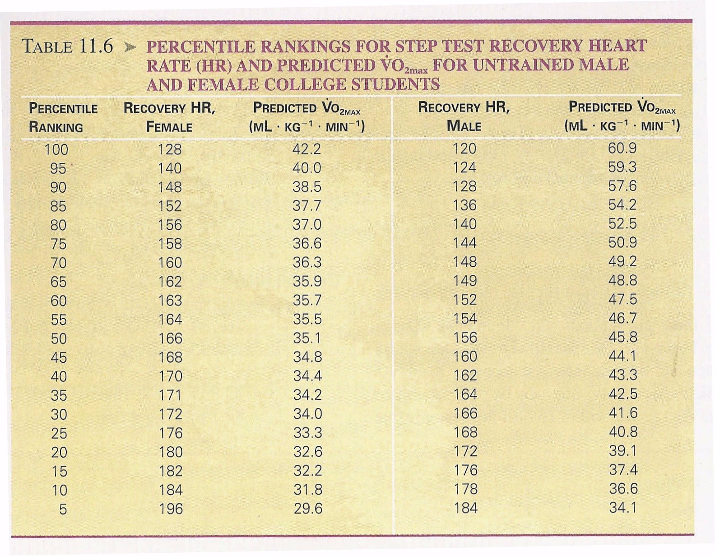

From: McArdle, Katch and Katch. Exercise Physiology 5th Edition (1991)

COMPLETE THE 3 page WORKSHEET AT END OF THIS PACKET 10 pts

Name:_________________________________ PAGE ONE

Lab Worksheet: Step Test Table, % Change, and Summary Questions

10 points: hand this in to your lecture instructor on Friday

The data tables and questions will be handed in with your laboratory exam scheduled for next week. Each group member will hand in their own assignment, though the group is to work together in order to collect and answer the questions. Questions this from assignment and the lab items may all be used on Lab Exam #2.
STEP TEST DATA TABLE: | Time of Measurement:
Physiological Parameters Examined:  Circle One: Male or Female  Weight: (1kg=2.2lbs)  lbs:____Kg: . | Pre-Step Test | 0-15 seconds (Immediate Recovery) | 10 minutes  Post Step  (Full Recovery)
Exact Time Measurements Made: | Pre: | Imm.Recov: | Full Recov:
Finger Pulse Oximeter: %SpO₂  Pulse Rate/minute | =  = | =  = | =  =
Estimate of your SV  (ml/beat), circle one  SV used in estimation (above table)  Estimated Cardiac Output (L/min) | 65-75-85  =  = | 80-100-120  =  = | 65-75-85  =  =
Breathing Rate (breaths/minute) | = | = | =
Estimation of TV (L), circle one  (estimate from above table)  Calculated Alveolar Ventilation =  %30-resting or 40% of TV when exercising: Estimated AV (ml) | 0.4 - 0.5 - 0.6  (TV) X (0.3)  = | 0.8 - 1.0 - 1.2  =  (TV) X (0.4)  = | 0.4 - 0.5 - 0.6  =  (TV) X (0.3)  =
Minute Respiratory Volume (L/min)
Alveolar Ventilation Rate (L/min)
Ventilation/Perfusion Ratio: MRV/CO | = | = | =
Calculated VO₂ Max (ml O₂/kg-min)  Men=111.33-(0.42xHR)  Women=65.81-(0.1847xHR) | XXXXXXX |  | XXXXXX
Total oxygen consumption (L O₂/min) by your entire body= (VO₂ Max )(Kg) | XXXXXXX | = | XXXXXX
Percentile Ranking: Recovery Time (%)  (See above Table 11.6 to get value) | XXXXXXX | = | XXXXXX
Should you be in the Olympics? Compare calculated Vo₂ with Predicted Vo₂ Yes/no | XXXXXXX | = | XXXXXX
How well did you think your estimates represented the real values in the table used above? Do your estimates appear to give realistic values? (20-40 words on back)

Name:_________________________________ PAGE TWO

Calculating Percent Change: This can be clinically relevant when you discuss how quickly a physiological parameter is improving or deteriorating in a patient over time. For instance, in an unfit person breathing and heart rate return to baseline very slowly, and in an aerobically fit athlete these values return to baseline relatively quickly. [(X₂ – X₁ )/X₁] X (100%)= Percent Change
Example Using heart rate changes:
Heart Rate (X₁)= 50 beats/minute Heart Rate (X₂) = 150 beats/minute [(150-50)/50] X (100%)= 200%

STEP TEST DATA TABLE: | Percent Change
Physiological Parameters Examined: | Pre Value vs.  When you stopped exercise | When you stopped exercise vs.  Full Recovery | Pre Value  vs.  Full Recovery
Pulse Rate
Estimated Cardiac Output (L/min)
Breathing Rate (breaths/minute)
Estimated AV (ml)
Minute Respiratory Volume (L/min)

Which percent changes were most surprising to you? Why? (20-40 words)
________________________________________________________________________________________________________________________________________________________________________________________________________________________________________________________________________________________________________________________

Name:_________________________________ PAGE THREE
Summary Observations from this Exercise:

A) What did you learn about Exercise and Cardiovascular Function? (20-40 words):
______________________________________________________________________________________________________________________________________________________________________________________________________________________________________________________________________________________________________________________________________________________________________________________________________

B) What did you learn about Exercise and Respiratory Function? (20-40 words)
____________________________________________________________________________________________________________________________________________________________________________________________________________________________________________________________

C) What did you learn about Respiratory and Cardiovascular interaction during Exercise? (20-40 words)
____________________________________________________________________________________________________________________________________________________________________________________________________________________________________________________________

D) What did you learn about Exercise and oxygen consumption? How are the VO₂ and VO₂ Max similar and different? (20-40 words)
____________________________________________________________________________________________________________________________________________________________________________________________________________________________________________________________

E)What is the difference between Tidal Volume and Alveolar Ventilation? Which is required for “gas-exchange?”_____________________________________________________________________________________________________________________________________________________________

F) Over All Understanding of Exercise Physiology: What are some of the most interesting things you learned from this lab? (20-40 words)
_________________________________________________________________________________________________________________________________________________________________________________________________________________________________________________________

